What needles are used?  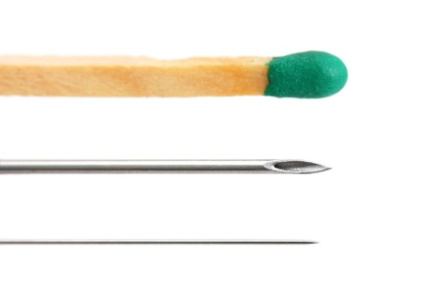  Dry needling is done with the same needles used for acupuncture. These needles are extremely thin (gauge: 0.18mm-0.30mm). All needles are sterile, individually packaged, and disposable.  Matchstick  Syringe  Dry Needle  Is Dry Needling Acupuncture?  Dry needling and acupuncture do use the same needles, but the techniques and guiding principles between dry needling and acupuncture are quite different. Licensed physical therapists, who undergo specialized training are authorized to perform dry needling in most states. Most health professionals who perform dry needling are not licensed acupuncturists and do not practice acupuncture. Most acupuncture education and treatment approaches are derived from traditional Chinese medicine practices. By comparison, dry needling is strictly based on Western medicine principles and research. | How does Dry Needling work with other treatments for TMD?  Dry needling is not intended to be used as a stand-alone treatment for TMD. Dry needling is only one tool used in combination with other treatments to address all aspects of an individual’s pain and dysfunction.  How do I know if Dry Needling is right for me?  It is important to consult a healthcare professional with training in Dry Needling and experience treating persons with TMD.  Where can I find out more about Dry Needling?  Additional information on Dry needling can be found online at the websites below:  https://www.apta.org/PTinMotion/2015/5/DryNeedling/  http://www.ptrenaissance.com/dry-needling-additional-info/  http://www.moveforwardpt.com/resources/detail/dry-needling-by-physical-therapist-what-you-should#.VeXk0yVVikq | 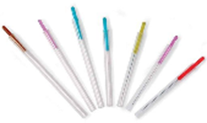  Therapeutic Dry Needling for Temporomandibular Disorders  Patient Education
What are Temporomandibular Disorders (TMD) ?  Temporomandibular disorders, commonly called "TMD," are a group of conditions that cause pain and dysfunction in the jaw joint and muscles that control jaw movement. Some estimates suggest TMD affect over 10 million Americans. Trauma to the jaw or temporomandibular joint plays a role in some TMD. In most cases, the exact cause of the condition is not clear. A variety of symptoms may be linked to TMD including:  -Muscle pain with chewing.  -Jaw muscle stiffness  -Limited movement or locking of the jaw  -Painful clicking, and popping in the jaw joint when opening or closing the mouth  What is Dry Needling?  Dry needling is an invasive procedure in which a very thin, solid needle is inserted through the skin and directly into the muscles at areas called “trigger points”. Trigger points are tight and painful knots in muscles which produce pain and weakness along with feeding into the pain cycle. Trigger points are tender to the touch and may cause pain in other parts of the body. | How does Dry Needling Work?  The exact mechanisms of dry needling are not fully understood. There are mechanical and biochemical effects including increased blood flow and increased oxygen to local tissues. Research has also shown that dry needling decreases some chemicals which cause pain and inflammation. It also appears to change the way the nervous system senses pain.  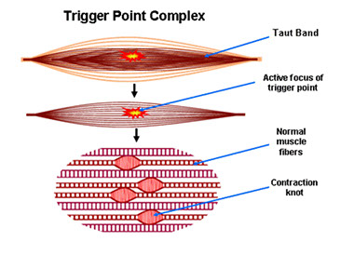  How can dry needling help persons with TMD?  An estimated 95% of persons with TMD have pain in muscles of the jaw. Research has shown that dry needling effectively decreases pain, improves muscle function, and increases jaw motion in persons diagnosed with TMD. | Is Dry Needling Painful?  Different people have different responses. Most people do not feel the needle when it is inserted. The needle used is much thinner than syringe needles used for injections. The “local twitch response” does create a very brief and somewhat painful response described by some as similar to a muscle cramp. This local twitch response is the goal of the treatment.  What should I expect after treatment with Dry Needling?  Different people have different responses following dry needling. Many patients report being sore after the procedure. The soreness is described as muscle soreness over the area treated and into the areas of referred symptoms. The soreness is usually less intense and different than the original pain. Typically, the soreness lasts between a few hours and two days.  How long does it take for Dry Needling to work?  Typically, it takes several visits to reach the full benefit of Dry needling. Many people start to experience pain relief and improved function after their first visit.

