



Room 4402C

Engineering Building 3

911 Oval Dr

North Carolina State University

Raleigh, NC 27606

rec.bme.unc.edu

A collaboration between the

University of North Carolina at Chapel Hill and North Carolina State University

Evaluation.

Design.

Innovation.

History

Initiative of the College of Engineering at NCSU and the School of Medicine at UNC, formed in 2011

A state technical assistance, education and research center that evaluates, designs, innovates, and promotes improved care and function for individuals with short and long term rehabilitation needs.

Mission

Improve the overall quality of life, personal and work environments, and products through careful study, analysis, research, design, and education of students and people with special needs.

What is the Rehabilitation Engineering Center?

“Rehabilitation research is uniquely positioned to integrate and translate the advances of science into benefits for people.”

-Stucki

Rehabilitation Engineering Center

**Rehabilitation**

**Engineering**

**Center**

DPT student and 3 senior ISE students developed 2 novel transfer boards

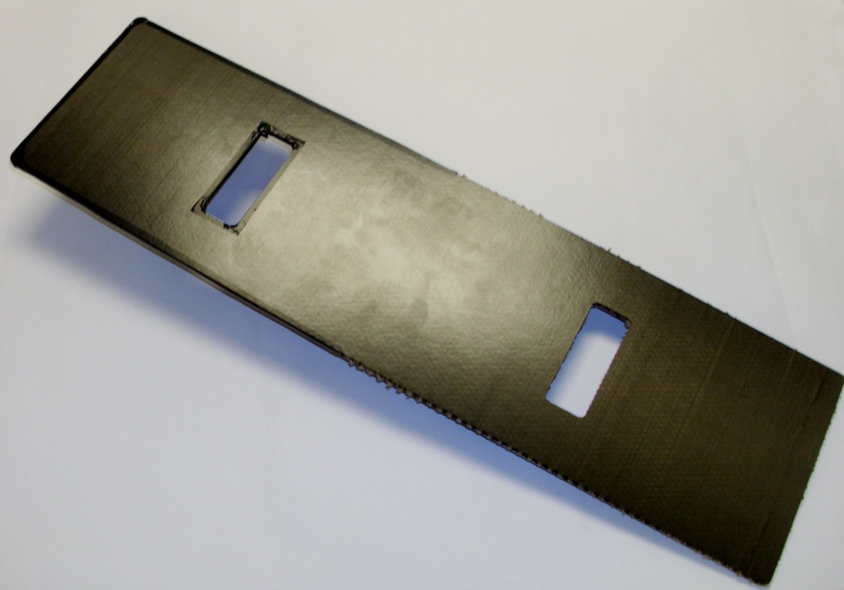

Carbon fiber version of the traditional board to decrease weight and increase usability for patients with impaired function

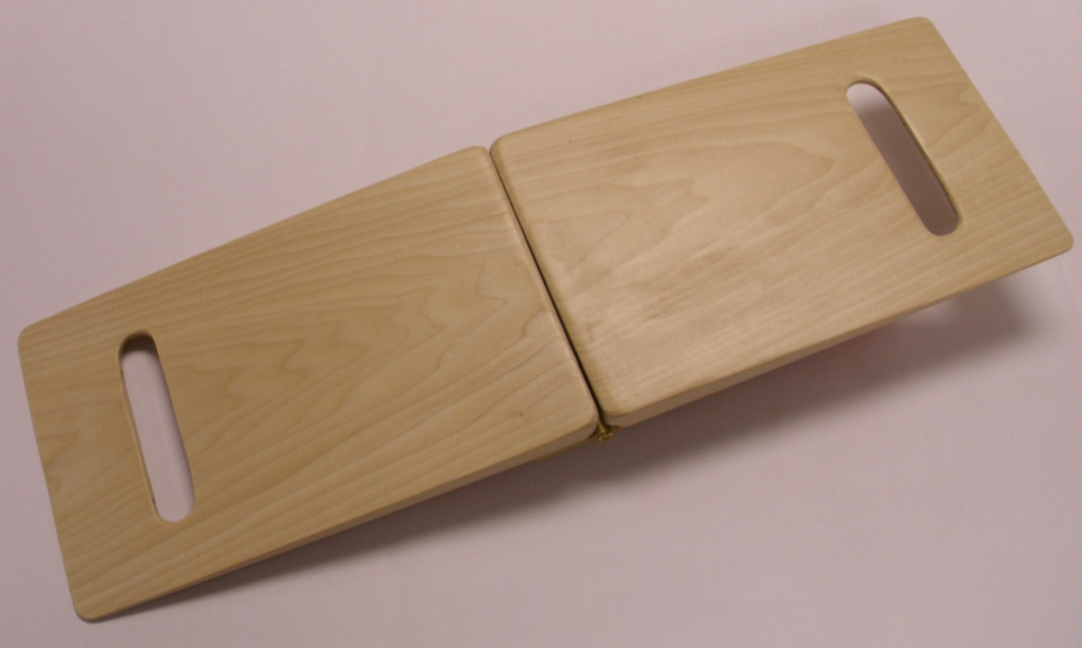

Wooden, collapsible hinged board with magnetic locking mechanism to enhance portability and storage

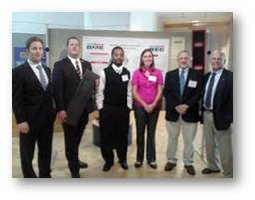

What’s your role?

Physical therapy students and engineering students work together to develop a product related to a patient need. The PT student serves as a consultant who provides clinical knowledge and design input. The engineering students facilitate item design and production.

PT students can draw from personal experience to develop a device or idea that meets a specific need. If you need help, talk with faculty, mentors, and peers for suggestions.

Conduct some market research to see if a similar product already exists, and determine that you have an idea that’s worth making.

How to find out more:

Rehabilitation Engineering Center website:

**http://rec.bme.unc.edu**

Contact Lisa Johnston at UNC:

* lisa_johnston@med.unc.edu
* 919-843-5723 (office)

**January**

●Table of requirements

**February**

●Brainstorming

●Select several options and determine specifications

●Pre-prototype

**March**

●Failure mode and effects analysis

●Prototyping and failure testing

●Product development

●Producibility

**April**

●Voice of the customer

●Final product and poster

Project timeline…

“The essence of interprofessional education is students learning with, from, and about each other.”

-Clark

The REC serves to….

• Coordinate design projects between UNC and NCSU

• Integrate the disparate fields of science and engineering

• Cultivate innovative research between UNC and NCSU

• Function as a clearing house for questions regarding special needs with rehabilitation

• Stimulate technology transfer and economic development within the field of biotechnology

Past project (2011-2012)