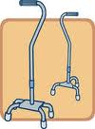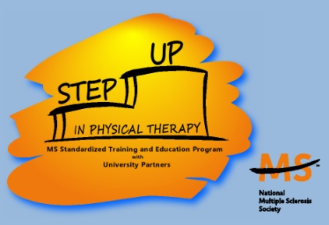

Physical therapy (PT) may be beneficial for helping patients manage various symptoms associated with MS and help prevent falls. Research shows positive outcomes of PT interventions used to manage fatigue, spasticity, heat sensitivity, functional mobility deficits, gait deviations, weakness and vestibular symptoms. Patients that are newly diagnosed with MS can utilize PT services for establishment of an appropriate wellness program to minimize or prevent secondary impairments and comorbidities that often occur in this population.

Evidence demonstrates that stretching improves spasticity in people with MS.

Research suggests that aquatic exercise reduces spasticity among people with MS.

PTs can provide patients with an individualized stretching regimen anytime during the MS diagnosis in order to maintain flexibility for prevention of contractures and improved ability to perform functional motor tasks.

Several studies show that functional electrical stimulation (FES) of the common peroneal nerve improves walking speed in patients with MS.

Research indicates that body-weight supported treadmill training improves walking speed in patients with MS.

Options for ongoing independent mobility may include gait training with body weight supported treadmill and the use of assistive devices, such as: orthotics, FES of the common peroneal nerve, canes, walkers, wheelchairs, or power scooters.

**Spasticity**

# Managing Symptoms of MS

**Fatigue**

Multiple studies show that appropriate levels of physical activity can decrease fatigue in patients with MS.

Physical activities that have a positive effect on fatigue include: aerobic, strengthening, aquatics and flexibility training.

#### Functional Mobility Deficits

The evidence suggests that physical performance improves following cooling therapy in patients with MS.

PTs can educate patients regarding ways to manage the heat via cooling devices, exercise environment, exercise volume and the need for appropriate rest periods.

**HHeat Sensitivity**

Cari Eicher SPT

April Fay SPT

Physical Therapy and Multiple Sclerosis

Several studies have found that approximately 50% of people with MS had a fall within the previous year. One study reported that 79% of fallers report recurrent falls. Studies have demonstrated balance impairments, lower extremity weakness, gait impairments, and use of an assistive device to be the top predictors for falls in MS. Functional assessments including the Berg Balance Scale, Timed Up and Go, and Dynamic Gait Index are used by physical therapists to predict fall risk.

Visit UNC Physical Therapy booth located near registration

Contact Information: April Fay: april_fay@med.unc.edu Cari Eicher: cari_eicher@med.unc.edu

**Lower Extremity Strengthening**

One study shows that patients with MS demonstrated lower peak torque velocity in their quadriceps and hamstrings as compared to healthy controls. These results were significant for concentric movement.

Evidence demonstrates that progressive resistance exercise for the lower extremities improve lower limb strength in people with MS.

Studies show that progressive resistance training improves knee extensor strength, functional capacity, and gait kinematics in patients with MS.

**Vestibular Intervention**

Balance and/or vestibular impairments are very common in patients with MS and have been found as one of the top contributors to falls.

Physical therapy interventions include sensory and motor elements to address the three components of balance: visual, somatosensory, and vestibular.

Multiple studies show that integration of balance and vestibular interventions improve scores on functional assessments used to predict falls in MS.

**Core Strengthening**

In addition to balance

exercises that work on

visual and proprioceptive

training, core strengthening has been shown to be an important component of a balance intervention program.

One study found that individualized core stability exercises improved aspects of static and dynamic balance as well as performance on the Timed Up and Go Test.

## Fall Prevention in MS

#### UNC Educational and Scholarship Track in Multiple Sclerosis

The *Education and Scholarship Track in*

*Multiple Sclerosis* is a unique collaboration

between the University of North Carolina,

Division of Physical Therapy and the Greater

Carolinas Chapter of the National MS Society.

This program is for doctoral physical therapy students interested in learning more about MS and becoming specialized in treating these patients.

Additional information and references available