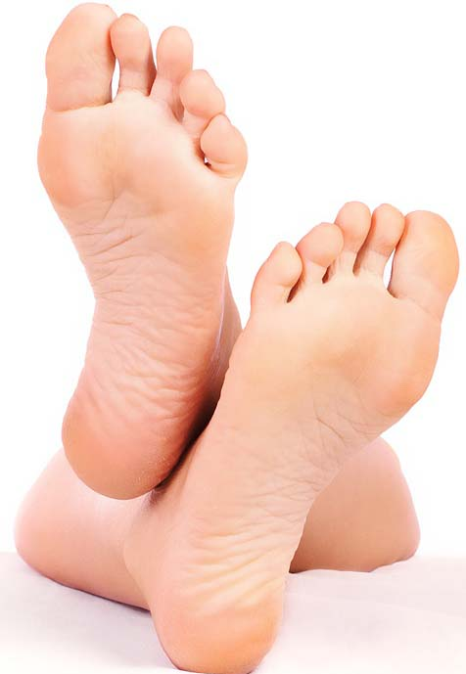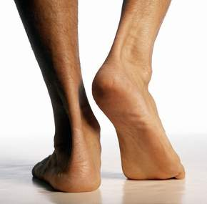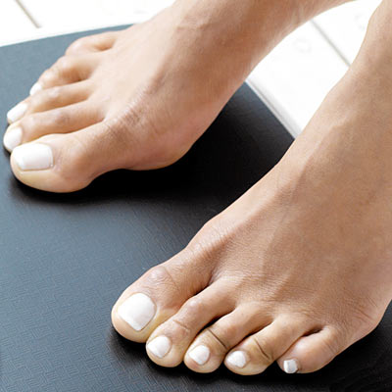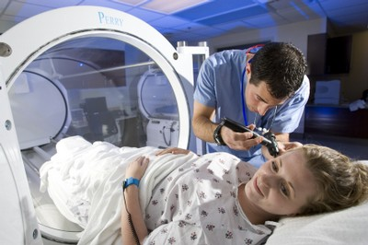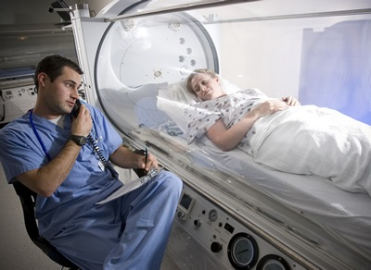

Diabetic Foot Care

and

SPT

University of North Carolina Chapel Hill

### What to Expect

During treatment, the air pressure in the room is two to three times normal air pressure. This might cause your ears to pop, like on an airplane or going up a mountain. This can be fixed with a yawn.

A session may last from one to two hours. A tech will be there at all times. You can talk with him or her through a speaker.

During your treatment, you can watch a movie, listen to music, nap – just lay back and relax.

After treatment, you may feel a little dizzy or lightheaded. This usually stops by the time you leave. If you drove to the hospital, you will be able to drive home.

Monitor blood sugar regularly

Stay active

Inspect your feet

Keep your skin soft and smooth

Keep your toenails trimmed

Elevate your feet

Protect your feet

Quit smoking

Wear shoes that fit

See your doctor every year

Call your doctor if you see any changes in your skin

Hyperbaric Oxygen Therapy

#### Care for diabetic foot wounds

* HBOT

Take Steps to Prevent Foot Ulcers

Libby Vaughn

### **For your safety, do not wear:**

Contact lenses

Makeup

Wigs or hairpieces

Nail polish

Skin lotions

Perfume, cologne, or aftershave

Jewelry and watches

Hair spray or oils

HBOT has been used to treat diabetic foot ulcers for over 50 years.

Your technician is certified and has specific training.

HBOT helps damaged cells heal faster and kills bacteria.

# Safe and effective

# Simple and painless

*Area Resources*

**Chapel Hill**

UNC Wound Healing Center

919-966-4131

**Durham**

Duke Center for Hyperbaric and Environmental Physiology

919-684-6726

**Raleigh**

WakeMed Wound Care

919-350-7876

Carolina Hyperbarics

919-720-4377

Rex Hospital Wound Healing Center

919-784-2580

Carolina Center for Integrative Medicine

919-571-4391

Hyperbaric oxygen therapy (HBOT) is a medical treatment. In HBOT, extra oxygen is pumped to your body. You breathe pure oxygen through a mask as you lay in a special air pod. This helps wounds heal and helps you fight infection.

From the outside, the air pod looks a lot like a submarine. The walls of the pod are clear to help you feel like you are in a big room. A two-way speaker lets you talk with your HBOT tech.

Treatments last about one hour. A full course runs 5 days per week for 8 weeks. Your doctor will make a plan that is right for you.

What is HBOT?