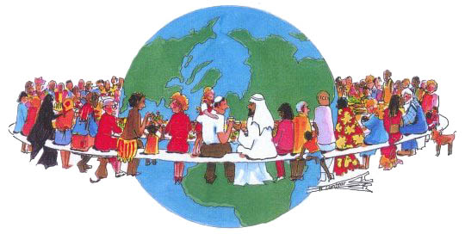

Let’s imagine that the Earth’s population was shrunk to a village of 100 people. With all ratios remaining the same, what would the world look like?
Fill in the following blanks with your best guess for the breakdown of that village.
Out of 100 people, how many would be: | Out of 100 people, how many would:
Asians_____ | Live in an Urban Area_____
European_____ | Live without Basic Sanitation_____
North Americans______ | Suffer from Malnutrition_____
South Americans and Caribbean_____
Female_____ | Own a Computer______
Male_____ | Have an internet connection_____
Non-Christian_____
Christian_____
Unable to Read_____ | 59% of the world’s wealth would be in the hands of how many people?_____

