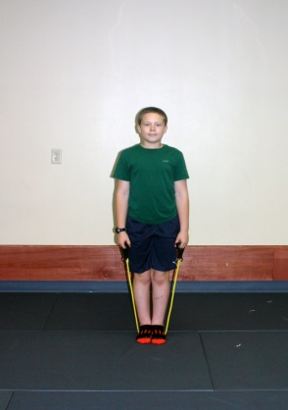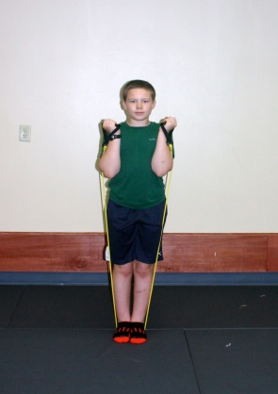
Stand on elastic, hold elastic in hand Pull up, bending at elbow
arms straight slowly return to starting position

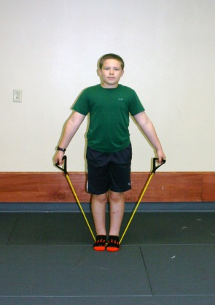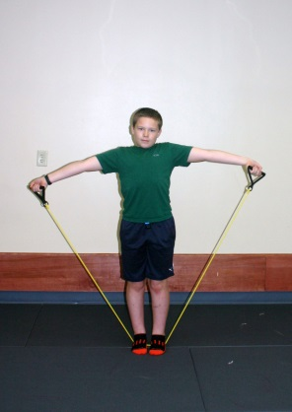
Stand on elastic, hold ends in both hands Keep elbows straight and lift arms
Arms at side, palms facing forward to shoulder level, slowly lower back down
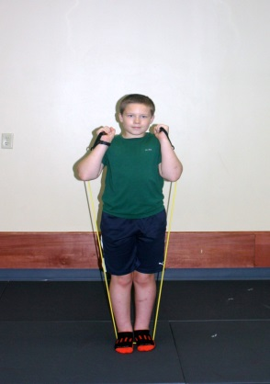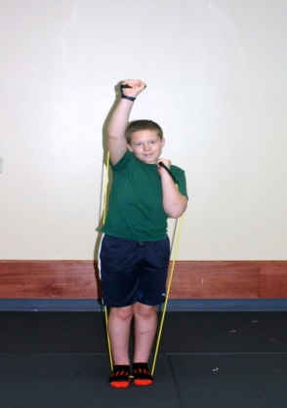
Stand on elastic, hold band in hand, Push one arm up and overhead
arms at side, elbows bent as shown slowly bring it down, repeat with other arm

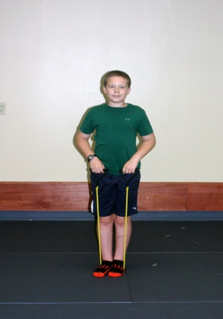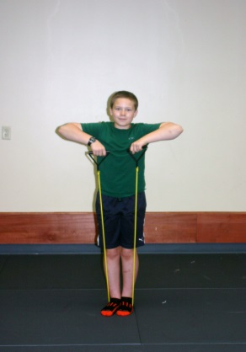
Stand on elastic, hold ends of band in hands Lift up toward chin, bending elbows
in front of hips keep hands close to chest, slowly lower

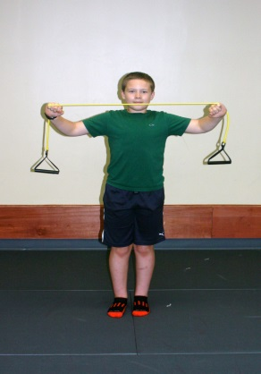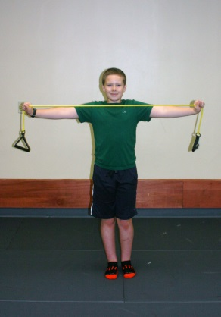
Hold elastic in hands out in front, Move arms away from each other, out to
keeping elbows straight sides, slowly return to starting position

* Perform 10 repetitions of all activities and then repeat the entire sequence again.

