Rehabilitation for the Overhead Athlete
Paige Kensrue SPT
Spring 2013

FATIGUE
Target the muscles that are going to be fatigued in play – MAKE IT FUNCTIONAL

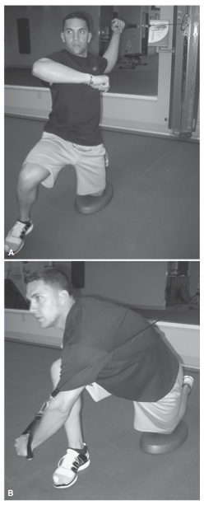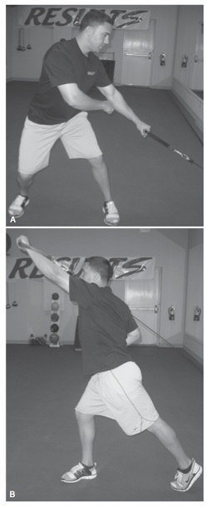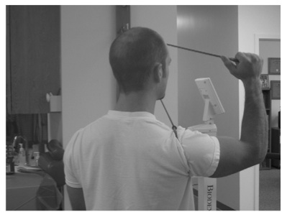

ECCENTRICS
Always important to consider eccentric and concentric demands!

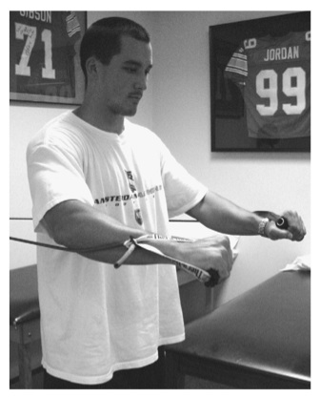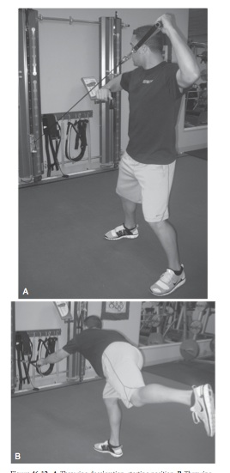

PLYOMETRICS
Use in the advanced stages of rehab to increase dynamic neuromuscular stabilization
- Ballistic Six Program
  - ER with theraband @ 0° shoulder abduction
  - ER with theraband @ 90° shoulder abduction
  - Overhead “soccer throw-in” with medicine ball
  - 90/90 ER side-throw
  - Deceleration baseball throw (can be done standing or half-kneeling)
  - Baseball throw
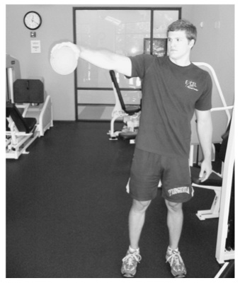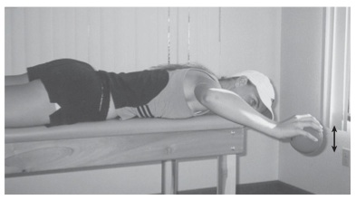

PROPRIOCEPTION
The athletes need to realize where their body is in space to activate the correct muscles
*Involves kinesthesia, joint position sense and neuromuscular control!

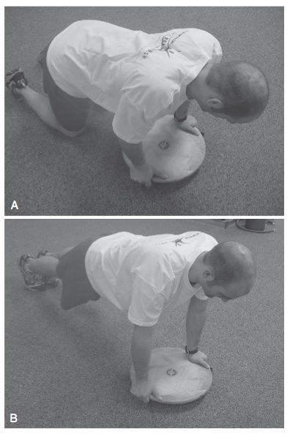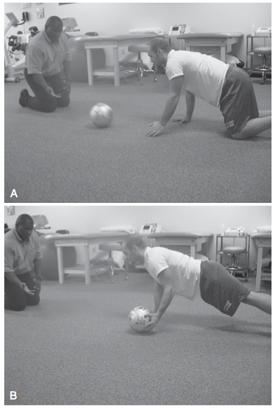

KINETIC CHAIN
Definitely do not want all of the force to come from the arm! Make the whole body work!

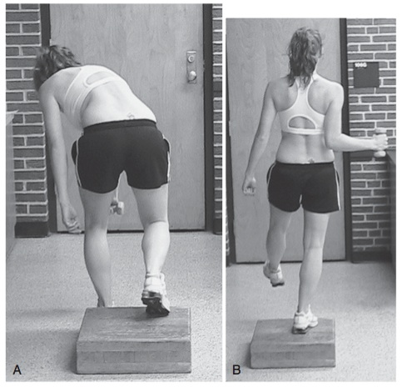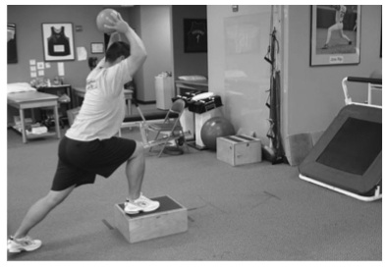

General Rehabilitation Flow Sheet for OH Athlete Shoulder Injuries
Kibler WB, McMullen J, Uhl T. Shoulder rehabilitation strategies, guidelines, and practice. Oper Tech Sports Med. 2012; 20: 103-112.

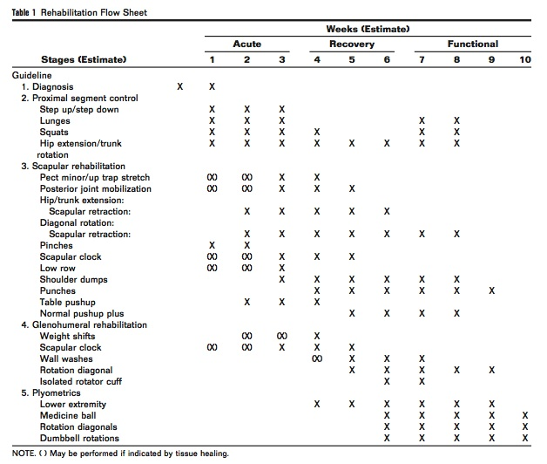

DUKE SPORTS MED PITCHER’S THROWING PROGRAM

Attention to mechanics
Throw on line, sub-max, comfort zone
Criteria for next level
No pain or stiffness when throwing
No pain or stiffness after throwing
Effortless motion
Accurate
Every other day – may go to every 3rd day if fatigue/soreness persists
3 days at each level

45 FEET:
First day
Warm-up throws at 20-45 feet
25 throws at 45 feet
1 set only
Rest next day
Warm-down throws
Level 2:
Warm-up throws at 20-45 feet
25 throws at 45 feet
2 sets
Rest 10 minutes between sets
Warm-down throws
Throw on alternate days

60 FEET:
Level 1
Warm-up throws at 20-60 feet
25 throws at 60 feet
2 sets
Rest 10 minutes between sets
Warm-down throws
Throw on alternate days
Level 2
Warm-up throws at 20-60 feet
25 throws at 60 feet
3 sets
Rest 5-10 minutes between sets
Warm-down throws
Throw on alternate day

90 FEET:
Level 1
Light warm-up throws at 20-90 feet
25 throws at 90 feet
2 sets
Rest 10 minutes between sets
Warm-down throws
Throw on alternate days.
Level 2
Light warm-up throws at 20-90 feet
25 throws at 90 feet
3 sets
Rest 5-10 minutes between sets
Warm-down throws
Throw on alternate days

105 FEET:
Level 1
Warm-up throws at 20-105 feet
25 throws at 105 feet
2 sets
Rest 10 minutes between sets
Warm-down throws
Throw on alternate days.
Level 2
Warm-up throws at 20-105 feet
25 throws at 105 feet
3 sets
Rest 5-10 minutes between sets
Warm-down throws
Throw on alternate days

120 FEET “Hat drills”
Level 1
Warm-up throws at 20-120 feet
Hat drill throws at 120 feet (25 throws)
2 sets
Rest 10 minutes between sets
Warm-down throws
Throw on alternate days
10 minute toss on off day
Level 2
Warm-up throws at 20-120 feet
Hat drill throws at 120 feet (25 throws)
3 sets
Rest 5-10 minutes between sets
Warm-down throws
Begin flat ground pitching at 45 feet
Throw on alternate days
10 minute toss on off day

MOUND PROGRAM:
Fast Ball (FB), Change (CH), Breaking Ball (BrB), Bullpen/Batting Practice (BP)

Level 1 Warm-up throws at 20-120 feet
1 set Hat drill throws at 120 feet 25 throws
Rest 10 minutes
Throw from mount (FB only) 25 throws
50 foot throw – move catcher forward
Warm-down throws
Throw on alternate days
10 minute toss on off day
Rotate as follows: Thr/Off/Thr/Off/Off/Thr/Off/Thr/Off/Off

Level 2 Warm-up throws at 20-120 feet
1 set Hat drill throws at 120 feet 25 throws
Rest 10 minutes
Throw from mount (FB, CH: 1 of 5 CH) 35 throws
55 foot throw – move catcher forward
Warm-down throws
Throw on alternate days
10 minute toss on off day
Rotate as follows: Thr/Off/Thr/Off/Off/Thr/Off/Thr/Off/Off

Level 3 Warm-up throws at 20-120 feet
1 set Hat drill throws at 120 feet 25 throws
Rest 10 minutes
Throw from mount (FB, CH: 1 of 5 CH) 40 throws
55 foot throw – move catcher forward
Warm-down throws
Throw on alternate days
10 minute toss on off day
Rotate as follows: Thr/Off/Thr/Off/Off/Thr/Off/Thr/Off/Off

Level 4 Routine warm-up
Short Bullpen (1 of 5 BrB) 8-10 minutes
Routine warm-down
10 minute toss on off day
Rotate as follows: BP/Off/BP/Off/Off/BP/Off/BP/Off/Off

Level 5 Routine warm-up
Short Bullpen (1 of 5 BrB) 10-12 minutes
Routine warm-down
10 minute toss on off day
Rotate as follows: BP/Off/BP/Off/Off/BP/Off/BP/Off/Off

Level 6 Routine warm-up
Full Bullpen 12-15 minutes
Routine warm-down
10 minute toss on off day
Rotate as follows: BP/Off/BP/Off/Off/BP/Off/BP/Off/Off

Level 7 Routine warm-up
Short Batting Practice 8-10 minutes
Routine warm-down
10 minute toss on off day
Rotate as follows: BP/Off/BP/Off/Off/BP/Off/BP/Off/Off

Level 8 Routine warm-up
Short Batting Practice 10-12 minutes
Routine warm-down
10 minute toss on off day
Rotate as follows: BP/Off/BP/Off/Off/BP/Off/BP/Off/Off

Level 9 Routine warm-up
Batting Practice/Simulated Game 12-15 minutes
Routine warm-down
10 minute toss on off day
Rotate as follows: BP/Off/BP/Off/Off/BP/Off/BP/Off/Off

Level 10 Routine Pre-game warm-up
Pitch in game (40 pitch count) 1-2 Innings
Routine Post-game warm-down
Increase pitch count and innings based on progress

Pitchers Post Injury Throwing Program

Goal:
To establish a total body awareness and control of his throwing movement before being allowed to return to normal pitching duties.

Phase 1:
Player starts at a distance of 15 steps, 2-3 sets of 25 throws on a line with 5 minutes recovery between sets.

PASS – FAIL:

If the player can complete this task pain-free, then he may progress to Phase 2 and start the progressive throwing program. If the player can not complete Phase 1 or shows signs of poor range of motion, pain and discomfort – the program must stop at this point. The player will then return to the training room or physical therapy clinic for more treatment and functional work.

Coaching Point:

During all phases of the throwing program, the player must use correct footwork and proper throwing mechanics. This is a must and needs to be monitored to ensure that a controllable amount of stress is placed on the injured area.

Phase 2:
The player shoulder be going through this program, 2 days on, 1 day off. The player will perform only 1 step per day. The player must be pain-free, throw with good arm mechanics/footwork, and have good accuracy (75% of throws must hit in the center chest area) before the athlete may progress to the next step.

Pain with Throwing:

If the athlete experiences pain while throwing, he is to stop throwing at that point of the program, take the day off and drop back one phase in the throwing program the following day.

If the athlete experiences pain or soreness after throwing and the next day it does not improve after warm-up throwing, take the day off and drop back one phase in the throwing program the following day.

If the athlete does not experience pain or soreness while throwing, but experiences some soreness the following day and the soreness disappears after warm-up throwing, continue with the program at that step or phase. If the athlete experiences severe or chronic pain or soreness, he returns to the training room for more treatment and functional work. The athlete may need 1-2 days or more of rest and treatment before he returns to the throwing program. The athlete must be pain-free before he returns to the throwing program. If the athlete has been shut down from throwing for a period of time, he should drop back one to two phases or more in the throwing program from where he experienced pain.

Rehab Program

The athlete should throw first, perform the Hitting Progression program second (if position player), rehab exercises third, and finally finish with the strength and conditioning program (with modifications per injury).

