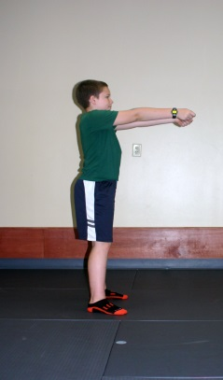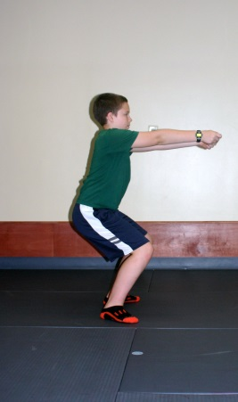
Partner squats – Hold hands out in front Bend knees and lower body down
Make sure your knees do not go beyond your toes
Stand up and repeat 10 times

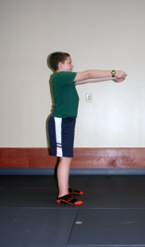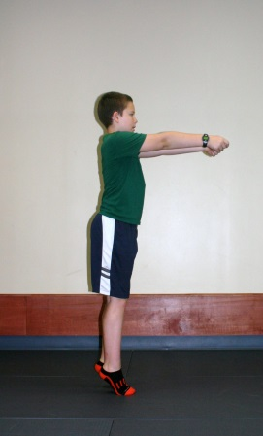
Partner calf raises – Hold hands out in front Raise your body up onto toes, hold, slowly
lower back down. Repeat 10 times, do again
after doing second set of squats.

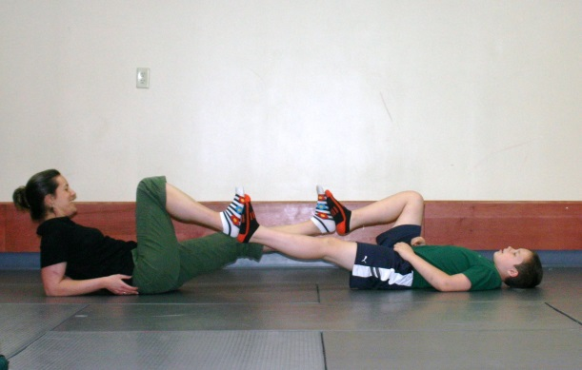
Partner bicycles – Lie on back, place feet against your partners. Tighten stomach muscles, keeping
back flat on floor. Straighten one leg and bend the other and move your legs together back and forth
like you are pedaling a bike – making sure to keep your back flat on ground. Repeat this 10 times.

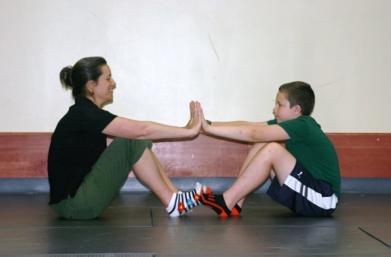
Start in sitting position with hands Slowly lean backwards keeping back straight
touching in front. Repeat 10 times.
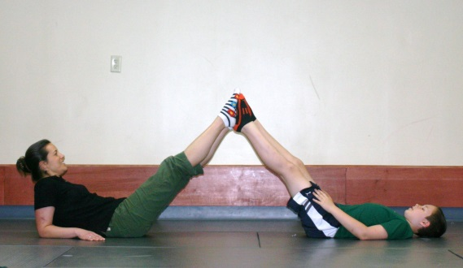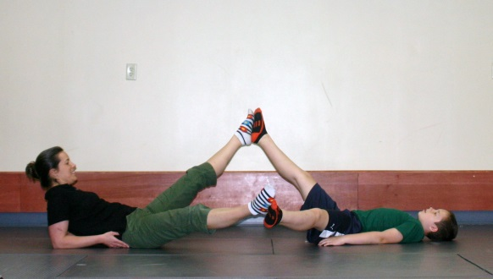
Tick tock – Lie on back with legs straight Together, lower one leg down and out to side
and feet touching. Bring back to middle, lower other leg to other side
Repeat 5 times to each side.

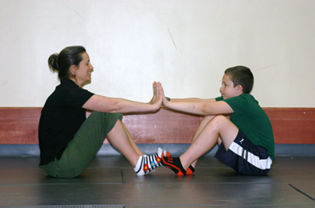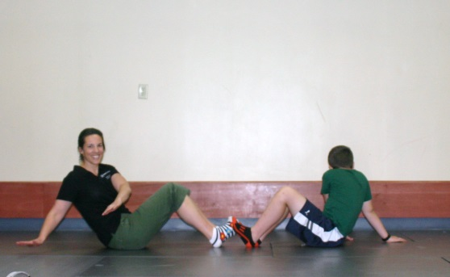
Sit with hands touching out in front Tighten stomach muscles, lean back, turn body
and reach arms to side. Come back to middle,
touch hands, then reach to other side.
Repeat 5 times to each side.

