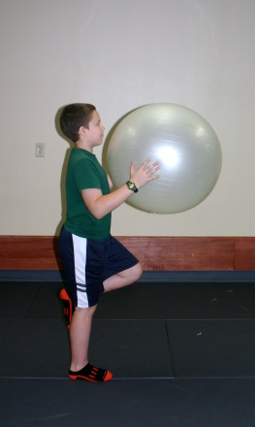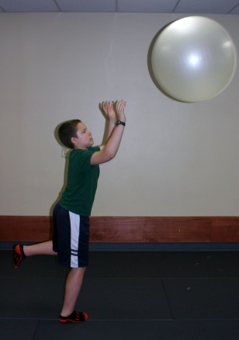
Stand on one leg, hold ball in hands Throw ball to partner, have them throw it back.
Repeat 10 times, switch legs, repeat another 10 times.

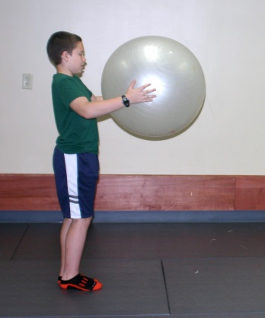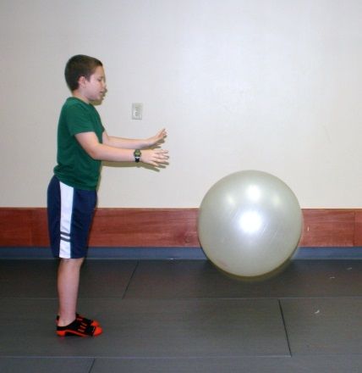
Hold ball at chest height and bounce (fairly hard) to your partner. Have partner bounce it back to you.
Try to catch it before it gets higher than the height of your waist.

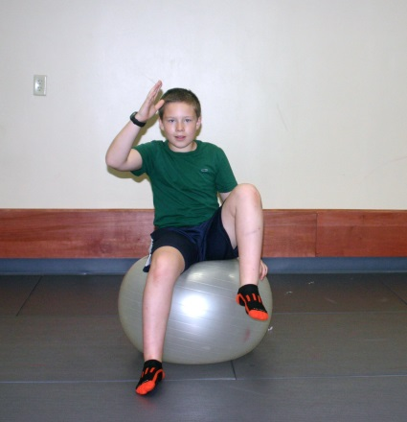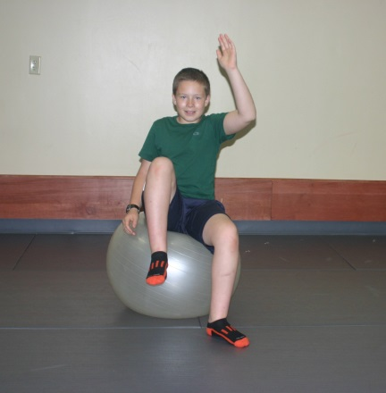

Sit on ball with hips and knees Then lift the right leg and left arm
at 90 degrees as shown. Lift up left Repeat 10 times with each arm and leg
leg and right arm, keeping stomach
muscles tight and back straight

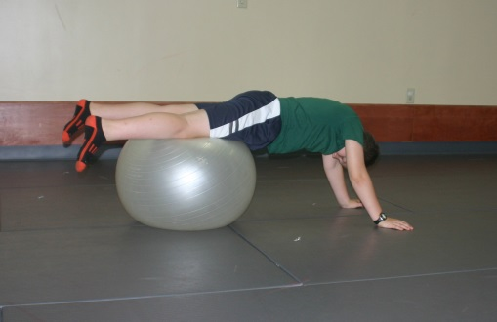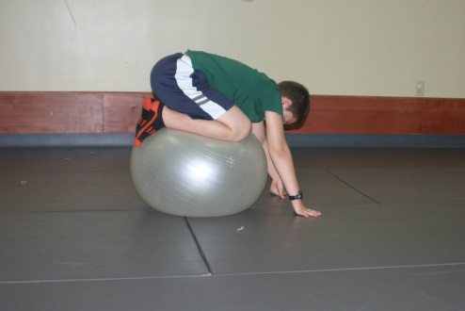
Lie with your stomach on the ball, walk your arms out so the ball is under your knees. Have partner
help hold the ball if unsteady. Tighten stomach muscles, pull knees up, and tuck under body. If this is
too difficult just walk your hands out and back several times, holding stomach up and back straight.

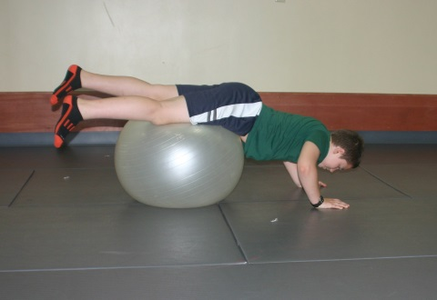

Lie with your stomach on the ball, walk your arms out so the ball is under your knees. Have partner
help hold the ball if unsteady. Perform 10 push-ups. Switch and have your partner do the same with
you helping to hold the ball for them.

