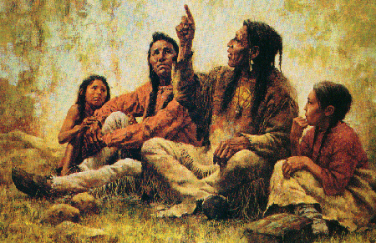

Read the following story regarding the Kalima Tribe:
This is a typical morning in the life of the members of the Kalima, a tribe that inhabits a dense, hot, humid jungle. The members of the tribe gather into formation after washing and dressing. They are in line. Most of the men are at the front of the line, though a few take up the rear. They walk from the sleeping village to the eating village, about an hour away.
Once they arrive there, the eldest man takes the eldest woman by the hair of the head. He moves her head so that her forehead hits the ground four times. Once that has been accomplished, nearly all the males, except the younger men and the children, are served their breakfast. Once they have finished eating and have had a while to digest their food, the women and children may eat.
Discussion/Questions:
1. Given what you know about the morning’s activities, what would you estimate
2. How much do you think they are valued in this society?
3. What about the role of men?

Now, here is a further explanation of the morning’s activities:
        - The people go from the sleeping village to the eating village because it is considered unclean to eat in a place in which one has slept.

        - Most of the men head up the line, with a few taking up the rear, because there are numerous wild and carnivorous beasts along the trail, as well as a neighboring tribe that is hostile. This is for the protection of the women and children, the most highly esteemed members of the society. The women are esteemed mostly because they are able to bear children. Children are also highly esteemed as being newly arrived from the spirit world and the only chance for the tribe continuing to exist for future generations. The tribe considers it less of a loss to lose several men than to lose even one woman or child.

        - The older men eat first because food poisoning is common in the climate of their land. Again, it is better for many older men to get sick or even die than for even one woman or child to suffer such fates, but younger men who can still hunt, go to battle, and procreate are allowed the privilege of eating when the women and children do.

        - The eldest woman is the most revered member of the tribe. The eldest man takes her by the hair to perform the thanksgiving ritual before eating because it would be an affront for him to touch her body. Only she can perform the ritual. No man is worthy of it. (They may need to be reminded that you never said he hit her forehead hard on the ground. Many people imagine this just because they find the situation so culturally remote and have decided early on that the women are being mistreated.)

Discussion/Questions:

1. Were your views correct prior to knowing the norms of the Kalima society?
2. What are your thoughts now that you were provided with additional information?

