Do Preventative Knee Braces Actually Prevent Knee Injury?
Information for College and High School Football Players
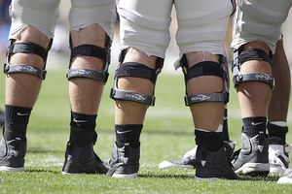
- Why wear a preventative knee brace?
  - Football has the highest injury rate of any high school sport; the majority of injuries occur to the knee.
  - The medial collateral ligament (MCL) is the most commonly injured knee structure.
  - Offensive linemen are at the greatest risk of knee injury. Defensive linemen, tight ends and linebackers are also at an increased risk compared to quarterbacks, wide receivers, running backs, defensive backs and specialists.
  - Injuries are much more likely to occur in games than during practices.

- What is a preventative knee brace?
  - Preventative knee braces, also called prophylactic knee braces, are worn on the knees of athletes without a prior knee injury or known instability to prevent or reducing the severity of an injury to the ligaments of the knee.

- What are preventative knee braces designed to protect?
  - Injuries in football usually result from contact to the outside part of the knee, causing the knee to “cave in” (see image below).

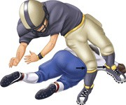
  - The MCL resists impact to the outside of the knee, and is one of four cruciate ligaments, which connect the long bone of the thigh (femur) to the long bone of the lower leg (tibia).

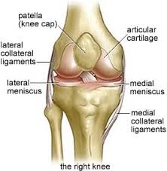

  - These braces are designed to limit the amount of inward bending in order to protect the MCL, and also the anterior cruciate ligament (ACL) and medial meniscus, which are frequently injured in football players.

- What does the research on preventative knee braces tell us?
  - Research from laboratory studies does not definitively support or discourage the use of braces to prevent knee injury.
  - Some studies suggest these braces may cushion the knee from a direct blow to the outside of the knee, but the effect on ligament protection is unclear.
  - Research that compares knee injury statistics between braced and unbraced football players does not indicate a protective benefit from knee bracing.
  - Wearing a knee brace does not appear to reduce the severity of knee injury, and some research suggests that it may actually increase the risk of knee injury.
  - Research does not endorse the use of any braced developed by any knee brace manufacturer over another.
  - The American Academy of Orthopaedic Surgeons (AAOS) does not support the use of preventative knee braces to prevent knee injury in football players.

