EXERCISE TIPS
Example Stretches
Hold a stretch for at least 30 seconds; Repeat 2 times. Can be performed daily.
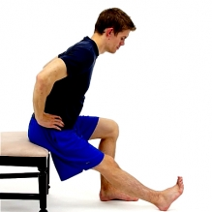  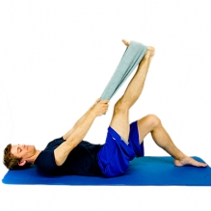 | HAMSTRING STRETCH (Pick 1 option)  Option 1: While seated, rest your heel on the floor with your knee straight and gently lean forward until a stretch is felt behind you knee/thigh.  Option 2: While lying down on your back, hook a towel or strap under your foot and draw up your leg until a stretch is felt under your leg/calf area. Keep your knee in a straightened position during the stretch.
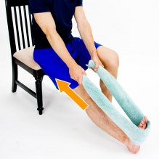  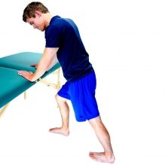 | CALF STRETCH (Pick 1 option)  Option 1: While sitting, use a towel or other strap looped around your foot. Gently pull your ankle toward you until a stretch is felt along the back of your lower leg.  Option 2: While standing and leaning against a wall, place one foot back behind you and bend the front knee until a gentle stretch is felt on the back of the lower leg. Your back knee should be straight the entire time.
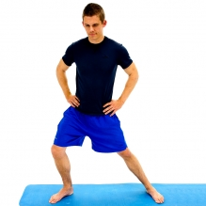  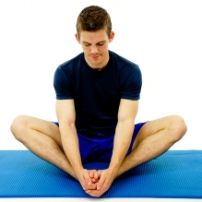 | ADDUCTOR STRETCH (Pick 1 option)  Option 1: Start in a standing position and feet spread wide apart. Next, slowly bend your knee to allow for a gentle stretch of the opposite leg.  Maintain a straight knee on the target leg the entire time. You should feel a stretch on the inner thigh.  Option 2: While seated, bend your knees and place the bottom of your feet together.  Next, slowly let your knees lower towards the floor until a stretch is felt at your inner thighs..
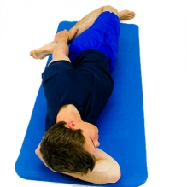  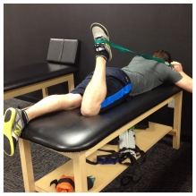 | QUAD STRETCH (Pick 1 option)  Option 1: While lying on your side reach back and hold your top foot and bend your knee until a stretch is felt in the front of your thigh.  Alternate Position (Not Pictured):  While lying on your back at the side of your bed, allow one leg to hang off the side of the bed to feel the stretch in the top of your thigh of the leg that is hanging.  Option 2: Lie on your stomach; hook a strap around your foot/ankle. Gently pull your heel towards your bottom until a stretch is felt in the front of the thigh. Keep your back relaxed and your hips flat on the table.

Example Strengthening Exercises
Goal of 8-15 reps in a set; Repeat 1-3 sets.
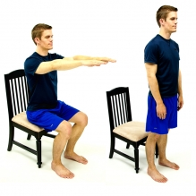 | SIT TO STAND / STAND TO SIT  Start by sitting in a chair. Next, raise up to standing without using your hands for support (if possible). Have a stable surface in front of you for safety (table, counter).
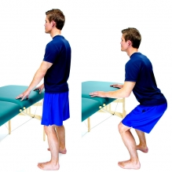 | MINI-SQUATS  While standing with feet shoulder width apart and in front of a stable support for balance assist if needed, bend your knees and lower your body towards the floor. Your body weight should mostly be directed through the heels of your feet. Return to a standing position.  Knees should bend in line with the 2nd toe and not pass the front of the foot.
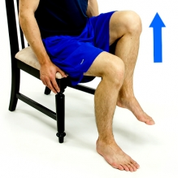 | SEATED MARCHING  While seated in a chair, draw up your knee, set it down and then alternate to your other side.
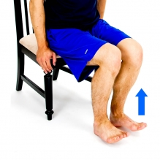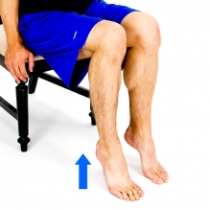  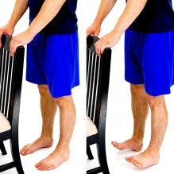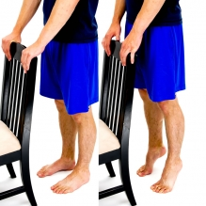 | TOES RAISES/HEEL RAISES (Pick 1 option)  Option 1: Start with your feet on the ground. Next, raise up both forefeet and toes as shown as you bend at your ankle. Keep your heels on the ground the entire time.  Next, raise up your heels as you press your toes down. Keep your toes on the ground the entire time.  Option 2: While standing in front of a stable surface, raise up your toes while your heels stay on the ground.  Next, raise up on your toes as you lift your heels off the ground.
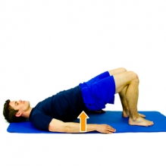 | BRIDGING  While lying on your back, tighten your lower abdominals, squeeze your buttocks and then raise your hips off the floor/bed as creating a "Bridge" with your body.
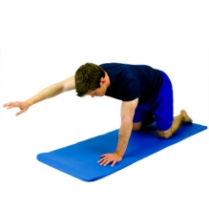 | QUADRUPED ALTERNATE ARM  While in a quadruped position (hands and knees on ground with your back straight), slowly raise up an arm out in front of you. Keep back flat throughout motion, and your knees and hips shouldn’t move.  Alternate Position (Not Pictured):  While in quadruped, raise your leg straight behind you (hands stay on the floor). Keep your shoulders, back, and hips level throughout motion. Repeat with other leg.

Example Balance Exercises
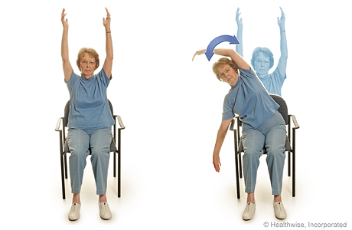 | SEATED REACHING  While sitting in stable chair, raise arms overhead, forward, to the side, until you feel your core engage to maintain your balance.
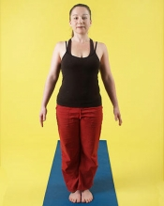 | BALANCE WITH FEET TOGETHER  Standing by your kitchen or bathroom counter, stand with your feet together and let go off the counter (if appropriate). To increase challenge you could practice turning your head back and forth or stand with eyes closed.
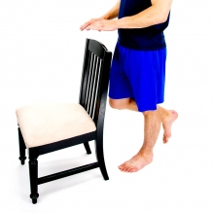 | SINGLE LEG STANCE  While standing in front of stable surface, stand on one leg and maintain your balance.

Specific Recommendations:
- 2-3 days a week
  - Strengthening: Goal of 8-15 reps in a set; Repeat 1-3 sets.
  - Aerobic: Goal of 10-40 mins, with intermittent rest as needed.
  - Stretching: Hold stretches for at least 30 seconds; Repeat 2 times.
  - Balance
- Moderate Intensity
  - Between “light” and “somewhat hard”
  - Noticeable increase in breathing
  - “Light”= conversation possible
  - “Somewhat hard”= conversation is more difficult
- Rest Breaks

If you hear a voice within you say “you cannot paint,” then by all means paint and that voice will be silenced. - Vincent Van Gogh
The only person you are destined to become is the person you decide to be. - Ralph Waldo Emerson
Start where you are. Use what you have. Do what you can. - Arthur Ashe

