Spina Bifida: Should I expect this child to walk?¹

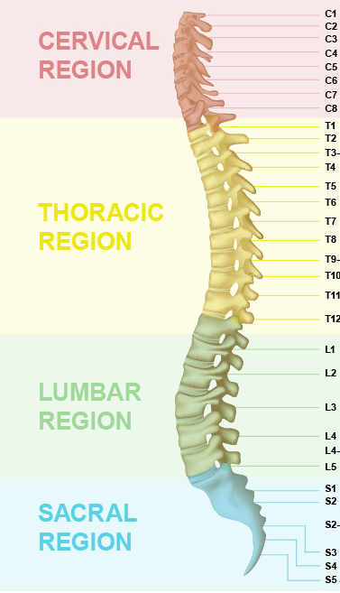

Function Level | Muscle Strength | Expected Ambulation | Lesion Level
I | Weak foot muscles; grade 4-5 plantarflexion strength | Community ambulation, no orthoses; ability to keep up with peers | Low-lesion: S2
II | Grade 3 or less plantarflexion strength; grade 3 or more knee flexion strength, grade 2-3 hip extension and abduction strength | Community ambulation with orthoses; no walking aid; wheelchair use for long distances only | Low-lesion: L5-S1
III | Grade 4-5 hip flexion and knee extension strength; grade 3 or less knee flexion strength; grade 1 hip extension, hip abduction, and below-knee muscles | Household ambulation with orthoses and walking aid; wheelchair use for outdoors and long distances | Low-lesion: L3-L4
IV | No knee extension activity; grade 2 or less hip flexion strength; grade 3-4 pelvic elevation strength | Household ambulation with orthoses and walking aid; wheelchair use for both indoors and outdoors | High-lesion:  L1-L2
V | No muscle activity in lower limbs; no pelvic elevation | Non-functional ambulation; ambulation during therapy and for limited time at home/in school; wheelchair use for primary mobility | High-lesion:  Thoracic

MUSCLE STRENGTH GRADES: 1 = TRACE (can feel a contraction, no movement)
2 = POOR (able to move in gravity-minimized position)
3 = FAIR (able to move against gravity)
4 = GOOD (able to hold against moderate resistance)
5 = NORMAL (able to hold against maximum resistance)
¹Bartonek A, Saraste H. Factors influencing ambulation in myelomeningocele: a cross-sectional study. Developmental Medicine & Child Neurology. 2001; 43: 253-260.

