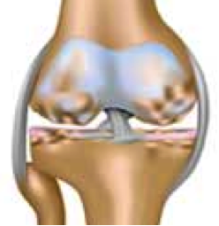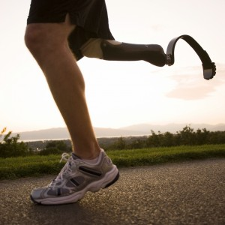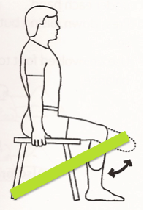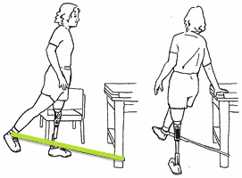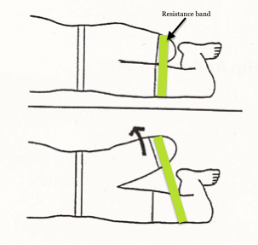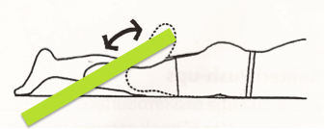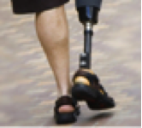

Resources:

CDC Osteoarthritis

<http://www.cdc.gov/arthritis/basics/osteoarthritis.htm>

CDC Weight Loss

<http://www.cdc.gov/HEALTHYWEIGHT/LOSING_WEIGHT/INDEX.HTML>

Osteoarthritis (OA) is the breakdown of tissues that protect joints (articular cartilage) and bone with wear and tear. With an increase in load on the joint, the bone hardens. The articular cartilage is compressed between the two hardened surfaces. This break down causes joint stiffness and pain. 1

**Causes in Amputees:**

* Spending more time on the intact leg in walking and other activities. 2
* Poor fitting or aligned prosthetic device. 1
* Strength differences between the amputated leg to intact leg.  3

Preventing Osteoarthritis (OA) in Amputees

9

7

## What is Osteoarthritis?

UNC DPT 2014

M. Taylor Reed

**Knee Extension** (BKA)

Sit in a chair with resistance band around residual limb or ankle

Start with your knees bent. Straighten one knee as far as possible.

Slowly lower it to the start position.

Repeat 2x10 on each leg.

**Hip Extension** (AKA, BKA)

Standing with support and resistance band around ankle.

Bring leg back slowly.

Repeat 2x10 on each leg.

**Hip Abduction** (AKA, BKA)

Lie on your side with resistance band around legs.

Lift leg upwards keeping hip straight.

Repeat 2x10 on each leg.

**Knee Flexion (BKA)**

Lie on your stomach with resistance band around residual limb or ankle.

Bend your knee up towards your buttocks.

Slowly lower your leg.

Repeat 2x10 on each leg.

### Strength Program 6

Some simple ways to prevent OA include weight loss, activity modification, and strengthening. Weight loss can decrease the risk of OA by 50% by decreasing the load felt in the joints. 4 Altering activities involving bending the joint or carrying objects can decrease the risk of OA by 15-30%. 4 Strengthening both the intact limb and the amputated limb will help achieve equal time on both legs, decreasing the work of the intact limb. 5

Below is a simple exercise program to strengthen both legs. Each exercise should be done on both legs, 2-3 sets of 10-12 repetitions. Low resistance bands or light cuff weights should be used initially. As the exercise gets easier, increase the resistance or cuff weight to make the exercises more challenging.

# Prevention:

8