Spina Bifida
Strengthening Exercises for Young Children

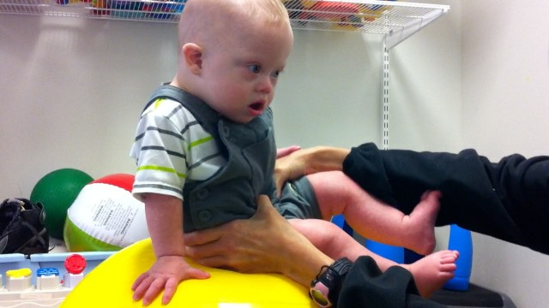
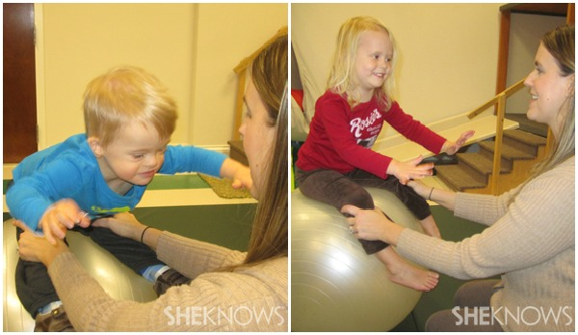
Core

Upper Extremities
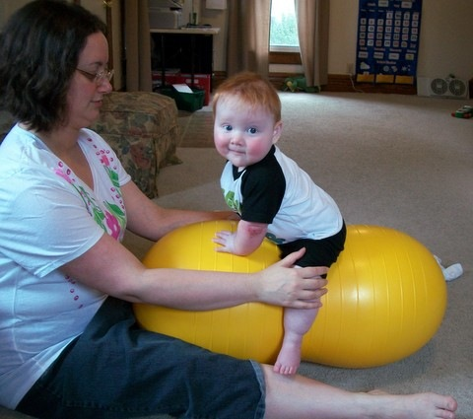

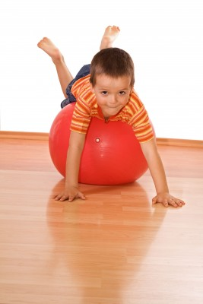

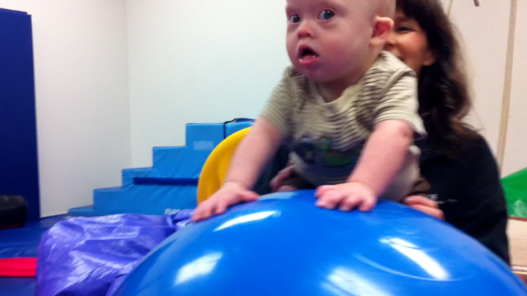

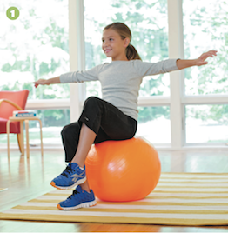
Hip Flexors

Images from:
http://www.milestonemom.com/how-to-make-your-child-physically-strong/
http://www.sheknows.com/how-to/articles/825727/5-exercises-kids-love
http://noahsdad.com/learning-crawl-exercise-ball/
http://masonsbjournal.blogspot.com/2012/09/physical-therapy-with-peanut.html
http://starfishtherapies.wordpress.com/tag/therapy-ball/

