Spina Bifida:
Stretching Exercises to Prevent Contractures

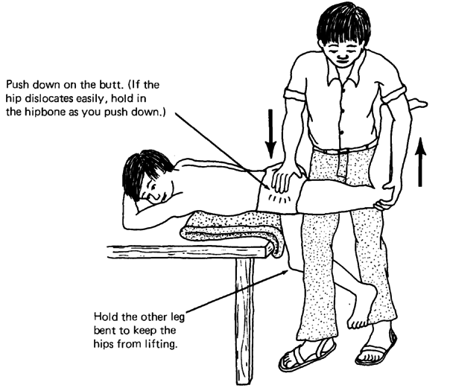
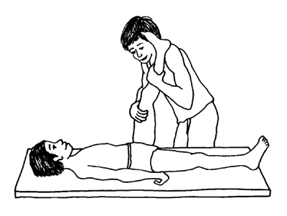
Hip flexors Hamstrings

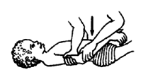
Heel cord Elbow flexors
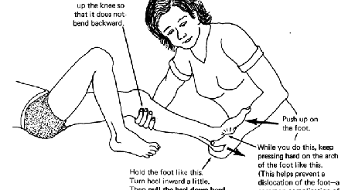

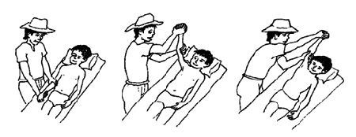
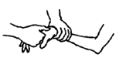
Shoulders Wrists

Hold each stretch for 30-60 seconds. Perform daily.

Images from: http://www.dinf.ne.jp/doc/english/global/david/dwe002/dwe00244.html#385

