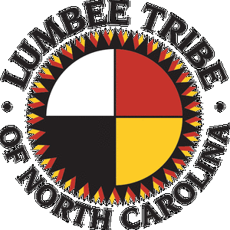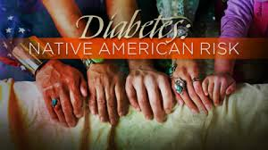

Managing and Preventing Diabetes Mellitus in

Native Americans

Joslyn Chavis, SPT

A Lumbee Indian of NC

Taking Control of Our Health

## References:

## Resources:

## Resources:

1. American Diabetes Association: Standards of Medical Care in Diabetes-*Diabetes Care. 2008; 31 (Suppl.1)*
2. Mayo Clinic. Diabetes basics. <http://www.mayoclinic.org/diseases-conditions/diabetes/basics/definition/con-20033091>.
3. Wellness in Native America. www.americanindianinstitute.wordpress.com‬. (2nd photo)
4. Indian Health Service. Improving the quality of health care 2004: measuring successes and challenges—Government Performance and Results Act Executive Summary. Rockville, MD: Indian Health Service, 2004.
5. U.S. Department of Health and Human Services, Indian Health Services, Division of Diabetes Treatment and Prevention: Diabetes in American Indians and Alaska Natives. Washington, 2007.
6. American Diabetes Association. Food and Fitness.

<http://www.diabetes.org/food-and-fitness/>

1. Mitchell FM. Reframing Diabetes in American Indian Communities: A social Determinants of Health Perspective. Health Soc Work. 2012 May;37(2):71-9

Here’s a list of resources you can check out for more information about diabetes:

**Websites:**

1. [www.diabetes.org](http://www.diabetes.org)
2. www.ndep.mih.gov
3. www.dlife.com
4. [www.cdc.gov/diabetes](http://www.cdc.gov/diabetes)
5. <http://www.diabeteseducator.org/DiabetesEducation/Patient_Resources/>
6. <http://www.joslin.harvard.edu>

**Local Resources:**

1. Diabetes Community Center of Robeson County

4300 Fayetteville Rd. Lumberton, NC 28358

910-618-0655

1-800-703-2680(toll free)

***Start Moving***

* Try to engage in 30 minutes of physical activity 5 times a week
* Try activities like walking, riding a bike, or any activity that gets you moving that you enjoy.

***Get Together***

* Have kids? Try taking them to the park or to the track with you.
* Find a family or friend that will exercise with you.

***Eat Better (6)***

* Drink 8 glasses of water every day.
* Eat more fruits and veggies.

***Get Help***

* Contact your doctor to see if you are at risk for diabetes.
* Talk to a physical therapist about a health and wellness plan designed just for you.
* Use available resources to educate yourself on diabetes and begin making healthy lifestyle changes today.

Managing & Preventing Diabetes (1)

* Increase physical activity
* Start/maintain a healthy diet
* Regularly check feet for cuts, blisters, or sores
* Monitor blood glucose (fasting:126mg/dl)
* Refrain from smoking

fjfjfjf

Start MOVING!

Get TOGETHER!

Eat BETTER!

Get HELP!

Diabetes is a condition in which the body does not use or store glucose (sugar) correctly. Insulin is a hormone used by the body to get glucose into our cells. Someone with diabetes cannot make enough insulin or cannot use the insulin they have properly.1,2

Common risk factors for developing diabetes includes: lack of physical activity, family history of diabetes, obesity, hypertension, & high cholesterol. There are two main types of diabetes, Type 1 and Type 2. Type 2 is the most common type of diabetes.1

***Facts about Native Americans & Diabetes (3,4)***

* Diabetes is growing amongst Native Americans.
* We are 3 times more likely to have diabetes than a Caucasian.
* Over 16% of our people aged 20 years or older have diabetes. In some tribes this percentage is increased to 30-50%.

***Make a Change***

* **JOIN THE FIGHT TODAY!**
* As Natives Americans, we pride ourselves on values, culture and family. Lets continue building our strong heritage by fighting against diabetes.

# What is Diabetes?