People with Alzheimer’s disease become increasingly unable to take care of themselves. However, the disease progresses differently in each person. Assessing the home for safety could potentially reduce the risk of falls.

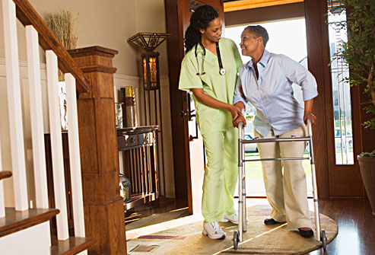

4 Things to Prevent Falls:
- Exercise to Improve balance or strength

- Have your healthcare provider review all medicines

- Have your vision checked

- Make your home safer

This material was adapted for older adults with Alzheimer’s from the “What You Can Do to Prevent Falls” brochure developed by the CDC for older adults at: http://www.cdc.gov/HomeandRecreationalSafety/Falls/compendium/4.4.1_appendixD1.html#stage2
Alzheimer’s Caregiving Tips

Fall Prevention
and
Home Safety

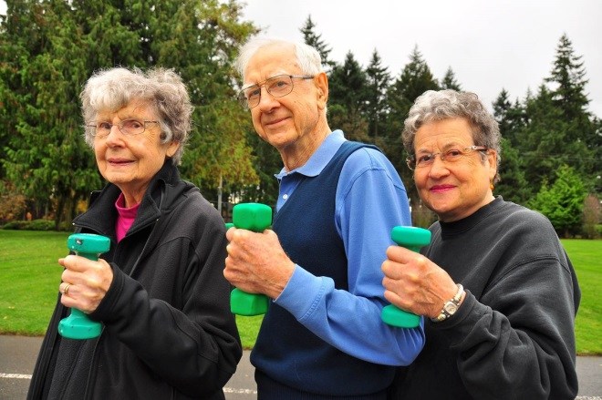

Fall Prevention

4 Things to Prevent Falls
- Exercise to improve balance and strength
- Exercises that improve balance & make your legs stronger lower your chances of falling.

- Lack of exercise leads to weakness & increases your chances of falling.

- Ask your doctor or healthcare provider about the best type of exercise program for you.

- Have your medicines reviewed
- Have your doctor or pharmacist check all your medications (including prescription and over-the-counter) for possible interactions and side effects -- like drowsiness, dizziness, and cognitive "slowing" -- that can increase falls risk.
- Have your vision checked
- Poor vision can increase your chances of falling.

- See an eye doctor at least once a year & update your eyeglasses.

- You may be wearing the wrong glasses or have a condition like glaucoma
- Make your home safer

- Remove things you can trip over (like papers, books, & shoes) from stairs & places where you walk.

- Remove small throw rugs or use double-sided tape to keep the rugs from slipping.

- Keep items you use often where you can reach them without using a step stool.

- Have grab bars put in next to & inside the tub or shower and next to the toilet.

- Use non-slip mats in the bathtub & on shower floors. Always use shoes.

- Improve the lighting in your home especially on stairs.

- Have handrails put in on both sides of all staircases.

