General recommendations: remember to breathe, take breaks if you need to, always try to engage your core muscles while exercising.
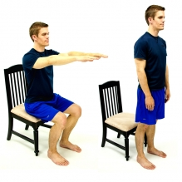
Sit<>stand
Description: stand up from a sitting position and then
sit back down. Try not to let your knees come together.
If you are having difficulty, you can reach out with
your arms or put your “nose over your toes” as you
stand up.
Level 1: place both hands on the arm rests as you stand
Level 2: place 1 hand on the arm rest
Level 3: place hands across chest

Other progressions:
more reps, use handheld weights, place feet closer together, close eyes, lower seat height

Squats
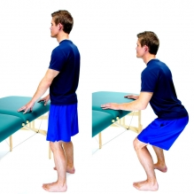
Description: with a chair behind you, squat down as far
as you can. If you cannot go far, that’s ok. Keep your
head and chest pointed forward: if you were looking in
the mirror, you should be able to see the design on your
shirt. Try not to let your knees come together as you
squat: keep them shoulder-width apart.
Level 1: hold support surface with both hands
Level 2: hold support surface with 1 hand
Level 3: no hands on support surface

Other progressions:
use handheld weights, squat down lower

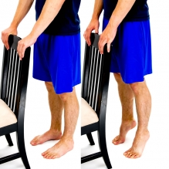
Heel Raises
Description: while standing, raise your heels off the
ground. Make sure to have a support surface in front of
you and a chair behind you. Note: you will work more
on strength during level 1 and work more on balance with
levels 2 & 3.
Level 1: hold support surface with both hands
Level 2: hold support surface with 1 hand
Level 3: no hands on support surface or just finger touch

Other progressions:
hold weights, walk back and forth on your toes, do single leg heel raises (very advanced)

Toe Raises
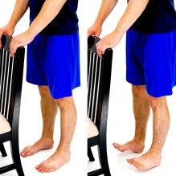
Description: while standing, raise your toes off the
ground. Make sure to have a support surface in front of
you and a chair behind you. Note: you will work more
on strength during level 1 and work more on balance with
levels 2 & 3.
Level 1: hold support surface with both hands
Level 2: hold support surface with 1 hand
Level 3: no hands on support surface or just finger touch

Other progressions:
hold weights, walk back and forth on your heels

Side Stepping
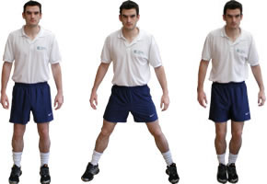
Description: standing up, step to the side, hold for 3
seconds, then bring the other foot to meet the first.
Remember to stand tall and engage your core muscles.
You do not have to step as wide as the man in the picture.
Level 1: two hand support
Level 2: one hand support or light touch support
Level 3: no hand support or wider step

Other progressions:
Wrap theraband around your ankles as you step (very advanced)

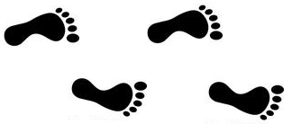
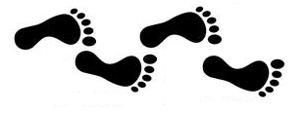
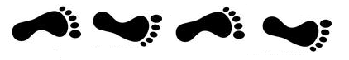
Walking with small base of support

Level 1
Level 2
Level 3
Description: Turn so that you can hold on
support surface with one hand. Walk a few
steps forward and a few steps backwards while
holding onto your support surface.
Level 1: small 6-inch base of support
Level 2: walking “train tracks”
Level 3: walking heel to toe

Other progressions: light touch support;
walking while raising 1 foot at a time.

Marching in place
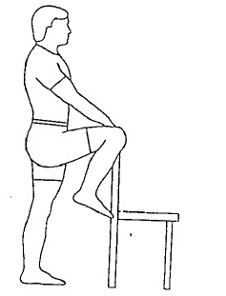
Description: sit/stand in front of support surface
and lift 1 knee at a time. Lift as high as you can.
Level 1 will strengthen the intended muscle; Level
3 incorporates a balance component.
Level 1: seated marching
Level 2: stand with 1 or 2 hand support
Level 3: stand with light touch or no support

Other progressions: ankle weights; march on a
folded towel

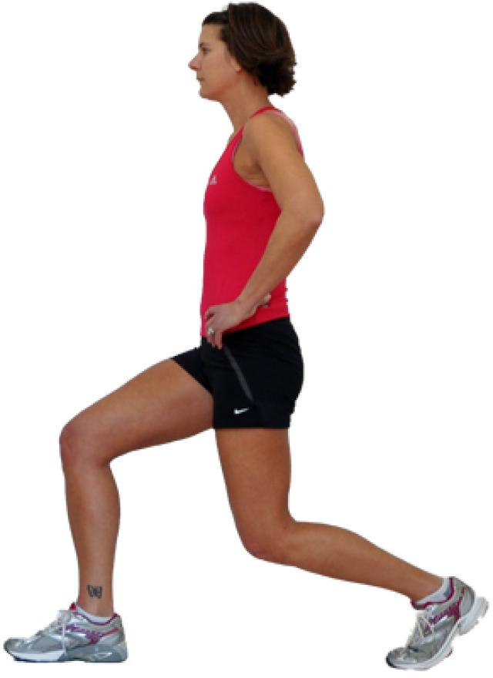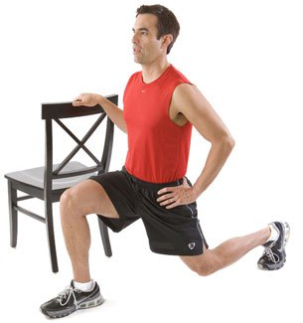
LEVEL 1 LEVEL 3

Forward/Backward Stepping or Lunge
Description: with the support surface to
your left or your right, take a larger-than-normal
step forwards or backwards, hold for 3 seconds,
then bring the other foot to meet the first.
Level 1: small step forward, 1 hand support
Level 2: larger step
Level 3: no hand support, large step/lunge

Other progression: hold hand weights

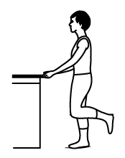
Standing Knee Extension
Description: Stand next to support surface,
bring one foot towards your buttocks, hold for
3 seconds, and repeat with the other leg. Level
1 focuses on strength; Level 2-3 on balance.
Level 1: two hand support
Level 2: one hand support or light touch support
Level 3: no hand support/or light touch

Other progression: ankle weights; stand on folded towel.

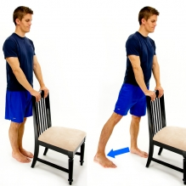
Standing Hip Abduction
Description: kick your leg out to the side, making sure to
keep your toe pointed inward on the foot that you are
kicking with. Level 1 focuses on strength, Level 3 more on
balance
Level 1: two hand support
Level 2: one hand support or light touch support
Level 3: no hand support/or light touch

Other progression: ankle weights; stand on folded towel

Specific Recommendations:
- Monitor your fatigue and take rest breaks as appropriate. If you cannot function the rest of the day, you have done too much at 1 time.
- Consider cooling garments like a cooling vest or a neck cooler
- Recommended Activity
  - 30 minutes of moderate-intensity aerobic activity 2x/wk
  - Strength Training 2-3x/wk
    - Recommended 8-12 reps and multiple sets if you can. If you are not fatigued you can do more
    - Work All major muscle groups
  - Flexibility Exercise 2-3x/wk
    - Hold stretches for 30 seconds each
    - May need to stretch daily or even multiple times per day
  - Balance & Coordination Exercises 20-30 min/day
    - See a physical therapist for specific balance deficits and exercises
- Definition of Moderate Intensity Activity
  - On a scale to 1-10, moderate activity is between 4 and 7 (i.e. “somewhat hard”).
  - You can also use your target heart rate range by calculating 50-70% of your maximum heart rate (your max heart rate = 220-age). Estimates can also be found at http://www.heart.org/HEARTORG/GettingHealthy/PhysicalActivity/FitnessBasics/Target-Heart-Rates_UCM_434341_Article.jsp.
  - Noticeable increase in breathing

