Improvements Desired | Game | Goals of Game | Length of each round | Comments | Pace
Improve UE flexibility:  - IR/ER  - Abduction  - Adduction  - Flexion  - Horizontal adduction  - UE multiplanar movements  Increase eye-hand coordination  This game is heavy on UE movements and can be played while seated in a chair. If the player plays standing up, s/he can also practice weightshifting | Rallyball  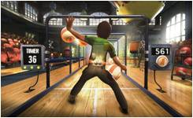 | Hit the balls towards the end of the court  Keep the balls in play and prevent them from bouncing off the screen  Use the entire body to block balls  Use UEs and LEs to send the balls towards the targets at the end of the hallway | 2 mins per round  Bonus time can be added, depending on score | The game requires significant and multiplanar movements of the UEs  UE movements are similar to those required in playing tennis  Minimal use of the LEs is required  One ball can split into multiple balls, increasing the number of targets and difficulty | This game is relatively fast-paced but the player can play it while sitting down

Improvements Desired | Game | Goals of Game | Length of each round | Comments | Pace
Improve weight-shifting  - Sideways  - Forward/backward  Improve UE flexibility  - Abduction  - Adduction  - Forward flexion  Improve eye-hand coordination | Space Pop  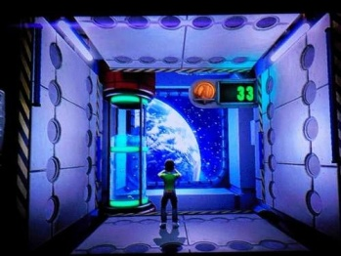 | Transparent balls (soap bubbles) pop out from round holes located on the walls, floor and ceiling  Pop the bubbles by simply touching them  Step forward to pop the bubbles further away  Flap arm quickly to levitate off the floor and prick bubbles floating overhead  Holding UEs at 90 deg of abduction will allow the player to float  Adducting UEs will make the player sink back down | 2 mins per round  Bonus time may be added, depending on score | This game is very well-suited for patients who need to work on weight-shifting as if offers numerous opportunities to step forward, backwards and sideways | This game is slow-paced

Improvements Desired | Game | Goals of Game | Length of each round | Comments | Pace
Improve UE flexibility  - Forward flexion  - Abduction  Improve weigh-shifting  - Sideways  - Forward/backward  - Diagonally | 20,000 Leaks  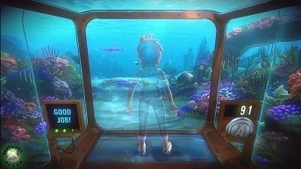 | The player uses hands and feet to plugs leaks that develop in the walls and floor of the aquarium  Each round of play is divided into 3 “waves”, with each wave requiring more movements to plug the leaks | 2 mins  Bonus time may be added, depending on score | Gradual progression in difficulty:  - In the first wave, leaks develop only on the front wall: shoulder forward flexion is required to plug the holes  - In the second wave, leaks will develop on the front wall and in the floor. Stepping will also be required to plug floor leaks  - In the third wave, leaks will also develop on the side walls, so shoulder abduction will be required | This game is slow-paced

Improvements Desired | Game | Goals of Game | Length of each round | Comments | Pace
Improve weigh-shifting  - Sideways  - Forward/backward  - Diagonally  Trunk flexibility and whole-body movements | River Rush | The player makes small steps to the left/right to control the raft so that it can make contact with pins scattered along the way  Trunk motions (leaning to one side) and small jumps can also be used for steering | 90 secs  Bonus time may be added, depending on score | This game can be played with relatively little involvement of the UEs | This game is fast-paced
Improve weigh-shifting  - Sideways  - Forward/backward  - Diagonally  Trunk flexibility (leaning side to side, forward flexion) and whole-body movements (squatting) | Reflex Ridge  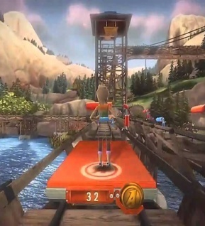 | The player moves his body to avoid obstacles on the course  The player grabs pins that are scattered along the way | 2 mins  Bonus time may be added, depending on score | As with River Rush, this game requires significant weightshifting and trunk motion  UEs can be exercised by asking the player to grab the pins that appear along the way | This game is fast-paced

