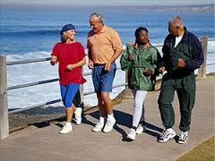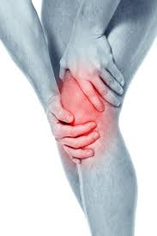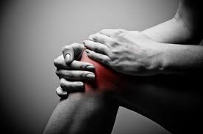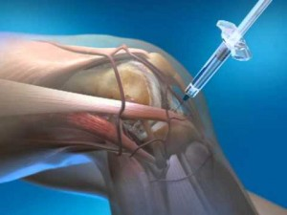

CDC Recommendations

* 2hours and 30 minutes moderate-intensity aerobic per week
* Muscle strengthening exercises at least 2 days per week

**Low-impact aerobic activities**

Brisk walking

Cycling

Swimming

Water aerobics

Dancing

**Strengthening exercises** Weight training

Exercise class

**Balance exercises**

Tai-chi

Yoga

Balance group exercise

# Exercise

Exercise is critical for managing symptoms of knee OA. Improving lower body strength and decreasing bodyweight can significantly reduce pain and improve function. Studies have found 1lb of weight loss equates to a 4 lbs decrease in knee pressure during daily activities. Adherence to a regular schedule is the major predictor long-term of pain reduction and improved function. Finding enjoyable forms of low impact exercise is key for those looking to experience long-term benefits.

## Exercise Recommendations

Managing Knee Osteoarthritis

### 2015 Capstone

### Jayson Hull

### UNC at Chapel Hill

### Department of Physical Therapy

**Injections**

***Platelet-Rich Plasma***

* ***Concentration of platelets thought to “jump start” natural healing process***
* ***Has not been shown to regrow articular cartilage***
* ***Series of 2-4 injections***
* ***Last up to 6 months***

***Gel injections***

* ***Supplements loss of the synovial fluid***
* ***Last 6-8 weeks***

***Cortisone***

* ***Powerful anti-inflammatory***
* ***Causes soft-tissue damage***
* ***Last up to 8 weeks***

**Arthroscopy debridement (AD)**

AD is the removal of damaged cartilage or bone. This procedure has ***not*** been shown to improve pain or function in patients with knee OA.

**Total knee Replacement**

Effectiveness of common treatments

Osteoarthritis (OA) is the most prevalent musculoskeletal disorder associated with functional impairment and disability, most commonly affecting the knee. Knee OA is a chronic disease of the entire joint, including articular cartilage, meniscus, ligament, and muscle. The narrowing of the joint space due to degeneration of articular cartilage causes bone on bone friction, which can lead to pain. Patients with symptomatic knee OA are likely to experience difficultly performing activities of daily living such as walking, negotiating stairs, kneeling, and standing up from a chair. The incidence of knee OA increases with age and further higher average weight. Knee OA is being diagnosed at a much younger age than it was about 20 years ago, likely due to the aging of the population and the rate of obesity or overweight in the general population. Risk factors that can predispose a person to developing knee OA, include hip or knee malalignment, previous knee injury, age, body weight, and lack of lower body strength. Treatment options for knee OA vary from exercise, lifestyle modifications, intra-articular injections and total joint replacements. Understanding what to expect from each intervention allows each individual to effectively manage his or her symptoms.

# Knee Osteoarthritis