Device and Manufacturer | Picture | Anterior or Posterior | Uses | Features | Drawbacks | Cost  Base price
2-Wheeled Kaye Walker  Kaye Products Inc. | 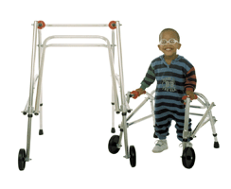  http://kayeproducts.com/2-wheeled-walkers/ | Anterior or posterior | -Can be used as a simple frame or additions for increased support are available.  -Useful to conserve energy and improve alignment  -Used for patients who can bear weight through LR | -The device is foldable  -6 sizes available, accommodating adults up to 250lbs  -Many additions available to customized device  -Seat option available | -Does not come with “all-terrain” tires  -Kit required to change some models from anterior to posterior | Small child $220.10  Large  $339.83
4-Wheeled Kaye Walker  Kaye Products Inc. | 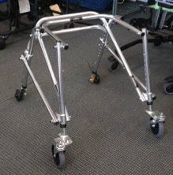 | Anterior or posterior | -Can be used as a simple frame or additions for increased support available.  -Useful to conserve energy and improve alignment  -Improved velocity and cadence as patients roll with movement | -Foldable with various additions available to customize device  -Maximum weight capacity of 250lbs depending on frame chosen  -Wider frame options available  -Options available with seat | -Does not come with “all-terrain” tires  -Kit required to change some models from anterior to posterior facing walkers | Small child $262.20  Large  $381.97
Kaye Anterior Support Walker  Kaye Products Inc. | 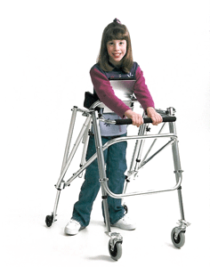  http://kayeproducts.com/kaye-anterior-support-walkers/ | Anterior | -Useful for patients who require additional balance support but can bear weight through legs  -Developed for patients with spasticity, athetosis or ataxia | -Three sizes available  -Foldable, comes with side cushions  -Wheels can be set to prevent swivel or rolling backwards  -Models with forearm supports available in 4 sizes | -Not easily adjusted for less support | X-small $460.24  Large $501.99
Yogi Gait Trainer  Ottobock | 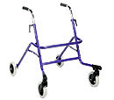  http://www.ottobock.com/cps/rde/xchg/ob_com_en/hs.xsl/1377.html | Anterior | -Basic 4-wheeled anterior gait trainer  -Aluminum | -Lightweight and foldable  -Steerable front wheels that can be locked to remove swivel  -Two sizes available  -A seat can be added | -Cannot be adapted to be significantly more supportive  -The light weight may not be stable enough for more involved patients | Size 1: $1,019  Size 2: $1,137
Walk Star  Ottobock | 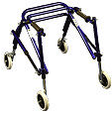  http://www.ottobock.com/cps/rde/xchg/ob_com_en/hs.xsl/1377.html | Posterior | -Basic 4-wheeled posterior gait trainer  -Aluminum  - Can be adjusted for height and can grow | -Lightweight and foldable  -Steerable front wheels can be added but are not standard.  -Wheels can be locked to remove swivel  -A seat can be added  -Smallest size accommodates a toddler | -Cannot be adapted to be significantly more supportive  -The light weight may not be stable enough for more involved patients  -Sizing information only available in German online. | Size ½ $1,442  Size 4 $1,591
Anterior Safety Roller  Drive Medical | 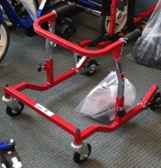 | Anterior but there is also a posterior version | -Can be used as a simple walker or can have minor adjustments added for increase stability | -Many options for growth and 8 sizes with the largest pediatric size accommodating 400lbs and bariatric adult sizes accommodating 1000lbs  -Some frames have adjustable width  -Pushing down on the frame activates the break  -Wheels can be used for indoor or outdoor  -Foldable for easy transport | -Few adjustments for increased stability available  -Cannot switch from anterior to posterior support | Tyke: $290  1000 XL: $380
Glider Walker  Drive Medical | 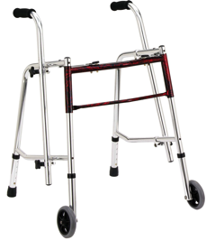  http://www.drivemedical.com/index.php/glider-walker-861.html | Anterior | -Basic anterior, 2- wheeled walker with option for platform attachments but no other additions. | -Lightweight and available in three sizes.  -Adjustable handles that can be rotated inward  -Height adjustable | -Maximum weight capacity of 175lbs  -Does not fold  -Cannot be adjusted for more support | ~$168
Kaye Suspension Walker | 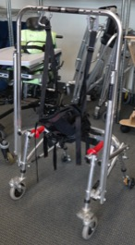 | Anterior | -Suspension reduces the amount of weight bearing through LE  -Four | -Four sizes available  -Wheels can be locked to prevent swivel  -Can be used in partial or full weight bearing  -Device can fit over treadmills with an adapter | -Must be used with a harness that must be purchased separately  -Largest harness size accommodates up to 200lbs | Suspension system without harness small: $1,396.50  Large: $1,953
Crocodile  Snug Seat | 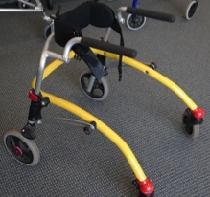 | Posterior | -Useful as a basic posterior gait trainer or as a more supportive option | -Can be adjusted to allow for increased support  -Available in 3 sizes  -Foldable, easily adjustable  -On/off anti-reverse wheel stops | -Max weight of 176.25lbs | Size1: $725  Size3: $1,195
Gator  Snug Seat | 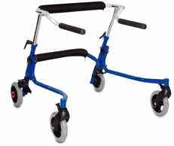  http://www.snugseat.com/products/walking/gator/c-23/c-72/p-208/?sku=49183 | Posterior | -Can be used as a basic posterior gait trainer or as a more supportive option  -Heavier than a Crocodile | - Increased weight means increased stability  -Easily removable accessories  -Foldable | -Only available in one size with a max weight of 70.5lbs  -Fewer additions available | $450
Nurmi Neo  Ottobock | 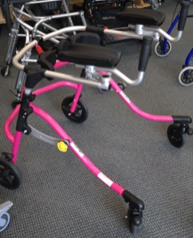 | Posterior | -Can be used as a simple frame, posterior gait trainer | -Foldable  -Lightweight  -Wheels can be adjusted to prevent rolling backward  -Many accessories available and can be grown with child | -Information online regarding size is currently only available in German  -Some adjustments available to increase stability but cannot be changed to a highly supportive device | Size 1: $587  Size 3: $624
Trekker Gait Trainer  Drive Medical | 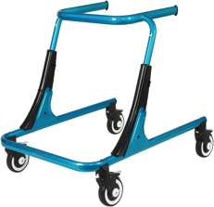  http://www.drivemedical.com/index.php/trekker-gait-trainers-838.html | Anterior or Posterior | -Can be adjusted to be more supportive or can be used with the simple fame and handles for less support | -Comes in three sizes- the largest accommodates 200lbs  - The device height can be easily adjusted  -All accessories can be added or removed easily without tools  -Swivel casters can be locked and the resistance can be altered | -Costly if using without additional support  -Not available in adult sizing | Tyke~ $775*  Youth~ $1,320*
Pacer  Rifton | 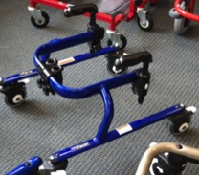 | Anterior or Posterior | -Can be used as a simple frame with handles or with additions for support  -Wheels can be adjusted for drag, direction control, swivel lock and breaks | -Comes in 5 sizes allowing accommodation of up to 275lbs  -Many additions available and prompts can be attached in many places on the frame.  -Larger sizes are foldable  -Easy to adjust | -The smaller sizes do not fold  -Accessories must be added on for the device to be used | Mini frame: $635-  XL size: $2,225
Luminator gait trainer  Drive Medical | 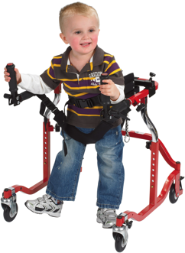  http://www.drivemedical.com/index.php/luminator-posterioranterior-gait-trainer-842.html | Anterior or posterior | -Useful for patients who require a more supportive device | -Available in three sizes including pediatric and adult so weight limit is up to 400lbs  -Many accessories available  -Height adjustable | -Must chose anterior or posterior when ordering- cannot be changed  -Not easily adjusted for less support | ~$750*
Star Posterior/ Comet Anterior gait trainer | 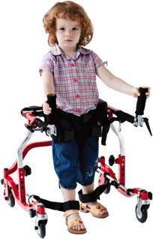  http://www.drivemedical.com/index.php/star-posterior-gait-trainer-839.html | Anterior or posterior but cannot be reversed | -Similar to the Luminator but more supportive  -Comes with ankle prompts to prevent scissoring | -Available in three sizes including pediatric and adult so weight limit is up to 400lbs  -Many accessories available  -Height adjustable | -Must chose anterior or posterior when ordering  - May not adjust small enough for young patients | ~$990*
Mustang  Gait trainer  Snug Seat | 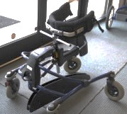 | Anterior or posterior | -Company recommends use for children with CP.  - Center support raises and lowers with movement | -Wide and stable  -Adjustable seat for forward tilt if used anteriorly and full upright support if used posteriorly  -Variety of additions available including seat | -The largest size accommodates up to 176lbs  -Length from 29.25-43 inches  -Large space between the child and the environment if used anteriorly | Size 1: $1,935  Size 4: $3,260
Pony Gait Trainer  Snug Seat | 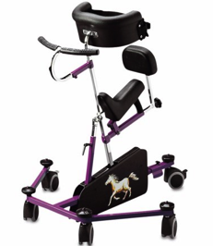 | Anterior support | -Pelvic and chest support  -Anti-scissoring center support  -For children requiring increased support | -Four sizes available  -Seat lean adjustable  -Back support to maintain position  -Brakes on casters  -Variety of additions available  -Bronco is built the same way but has four large wheels | -Does not fold  -Can only be used indoors  -Largest size accommodates up to 165lbs  -Heavy frame  -Small wheels | Pony size 0: $2,325  Pony size 3:  $2,675  Bronco size0: $2,645  Bronco size2: $2,750
Grillo  Innovation In Motion | 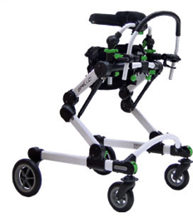  http://www.mobility-usa.com/grillo.htm | Anterior or posterior | - High level of support with pelvis and chest supports and harness  -4-wheels | -Available in two sizes for anterior options and two sizes for posterior option  -Foldable for transport  -Tilt option available  -Height is highly adjustable to allow for growth | -Largest size only accommodates 198lbs  -Cannot easily be adjusted for less support | Size one/two: $1,950  Size five: $2,700
Mulholland Walkabout | 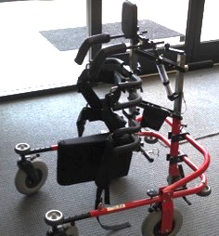 | Posterior | -Considered a dynamic stander and weight-relieving gait-trainer because it moves up and down with ambulation  -Designed to be used by individuals who cannot fully bear weight through LEs | - The device separates into pieces for transport  -The length of the based can be adjusted and the  -All four wheels come with standard swivel locks  -The spring can be adjusted to alter weight relief  - Comes in four different sizes  -The center column can tilt for additional accommodation | - The largest size does not accommodate more than 140lbs and weights 45lbs. | 3D Junior Model $1,794  3/4C Junior $4,257  4C Adult $4,257
Gait Master  Mulholland | 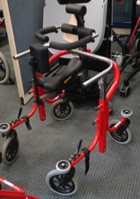 | Posterior support | - A more supportive option. Supports thorax and pelvis for patients who require postural assistance.  - The system lifts to reduce weight bearing throughout gait | -The device is foldable  -Available in two sizes with no-back breaks on the rear casters.  -Recommended weight limit for the larges size of 200lbs | -May not come in small enough option for young children  -Cannot easily be adapted to become less supportive if the child improves. | Child frame ~ $2,602*  Adult Frame~ $3,025*
Meywalk  Meyland-Smith | 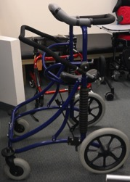 | Anterior | -Spring-suspended gait trainer  -Comes with trunk support and seat for increased stability | -5 sizes available  -Many accessories available for customization  -Can be used outdoors but is primarily for indoor use  -Largest size accommodates 100kgs  -Hand-bar can be adjusted for patient comfort and needs | -Cannot easily be adjusted to allow for minimal support  -Smallest size is recommended for children age 6 | Miniwalk I: $2,997  Meywalk 2000 Large: $3,795  Meywalk MK4 Medium  $4,314
Kidwalk  Ottobock | 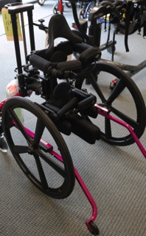 | Posterior | -Considered a dynamic walking aid  -Pelvis and torso support for standing  -Useful for dystonia, spasticity, and hypotonia | - Can be used outdoors and adjusted without tools  -Child can push wheels like a wheelchair and move forward while moving feet  -When not pushing wheels, hands are free  -Can alter tilt and device moves up and down with movement  -Many accessories available | -Cannot be adjusted to be less supportive  -The largest of two sizes does not accommodate more than 90lbs  -Does not fold. | KidWalk: $2,795  KidWalk II: $3,395

The information presented here was found in manufacturer catalogs and on manufacturer websites. Devices are generally printed in order from least supportive to most supportive.

*Cost reflects most recent information available through various online ordering sources

This information was collected in the spring of 2015. Cost and device options will likely change in future years.

