To create a gmail account:

1. Go to www.gmail.com or click the following link: www.gmail.com

2. Look at the top right-hand part of the page and click “Create an account”

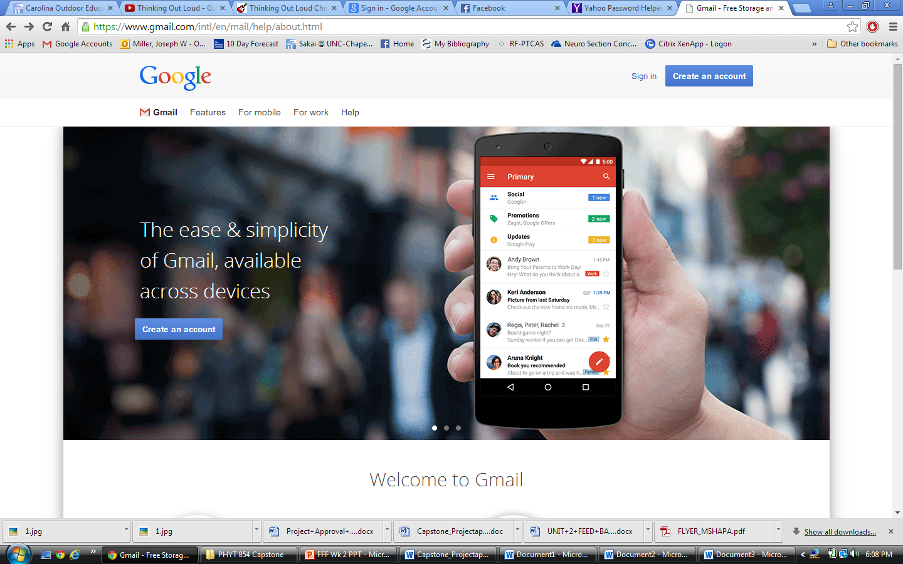

3. On the next page, fill out all of the required information including your name, user name, and password. Some of the information is optional such as your cell phone number. You may have to get creative with your username because someone may have already chosen your desired username. Try putting numbers before or after your username if you are having a hard time generating a username. For instance, the username josephmiller is already taken, but josephmiller2015 is not taken. The webpage will tell you if your desired name is taken. Follow the directions on the webpage and then click “Next Step” at the bottom of the page. If you see red print, it means you need to change something before going on to the next step.

4. From this webpage, you can add a profile picture to your Google+ account or customize your profile:
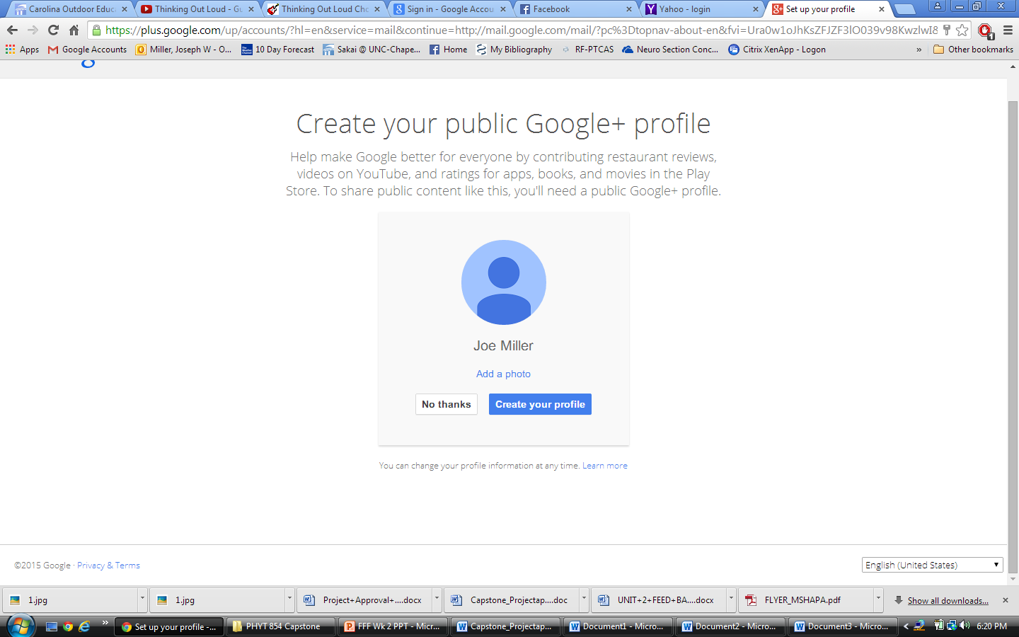

If you would like to add a profile picture, click “Add a photo” and follow the directions. You will need a photo file from your computer in order to do this.
Otherwise click “Create your profile”

Feel free to play around with your new account. It may seem overwhelming, but gmail is actually very user friendly. Scroll around the different areas of the screen and hold your mouse over an icon to see what it does.

CONGRADULATIONS! You have successfully created a gmail account. Once you have created this account, please contact me either by phone or by email so that I can add you to the Google+ community group.

Joe Miller
josephmw@med.unc.edu
336-429-1201

