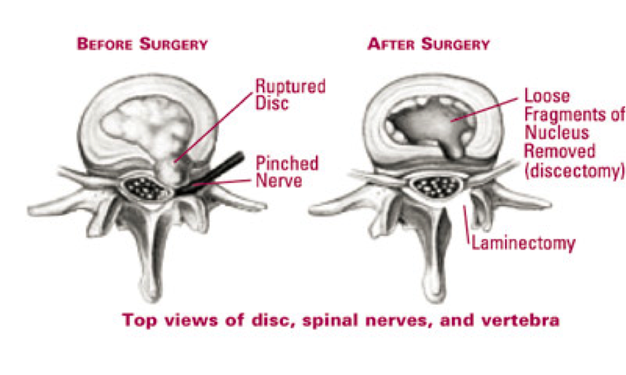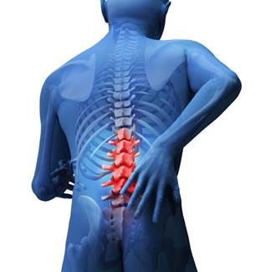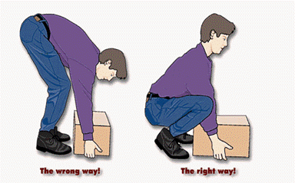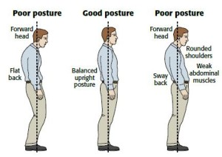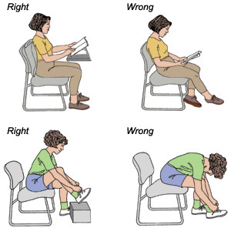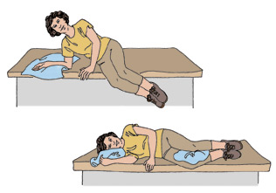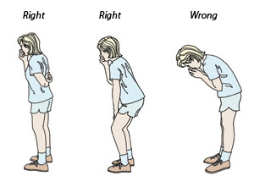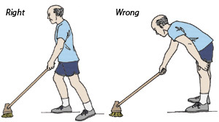

UNC Healthcare

If you want to learn more about appropriate exercises and return to daily function, please call UNC Therapy Services at UNC Imaging and Spine Center at (919) 957- 6759 to set up an appointment with a qualified spine physical therapist.

Your doctor recommended this procedure based on your symptoms and imaging:

**Discectomy**: The surgical removal of ruptured disc fragments, the cushion that sits between two backbones, which pinch on a nerve and cause leg pain and weakness.

**Laminectomy**: A surgical procedure that removes a portion of the backbone (vertebra) called the lamina.

The goal is to create more room for the nerve to exit the spine and relieve pressure on the nerve.

Fore more info, please visit this link:

http://www.spine-health.com/treatment/back-surgery/microdiscectomy-microdecompression-spine-surgery

TIPS FOR RETURN TO NORMAL FUNCTION

* Try to walk daily for exercise.
* Let your symptoms guide how much activity you can tolerate.
* Take breaks from sitting, household activities and work duties on a regular basis.

For questions about your recovery, please contact your surgeon’s office at UNC Imaging and Spine center at

(919) 957 - 6789.

* **Patient Education Brochure**
* **Lumbar discectomy / laminectomy**

LIFTING:

Keep the weight close to your body.

Bend your knees.

Keep the arch in your back.

Don’t move the weight as you are squatting.

POSTURE:

Sit with good posture at all times, a rolled up towel or lumbar support pillow can help you. Limit your sitting to no more than 30 minutes.

Precautions

GETTING IN AND OUT OF BED:

Bend your knees. Roll onto your side, shoulders and knees together. Drop your feet out of the bed and use your hands to push yourself to the upright position.

STANDING:

Keep your head over your shoulders.

Don’t lean forward from the waist.

COUGHING or SNEEZING:

Don’t stoop forward and brace your back by keeping the arch in it.

* CLEANING:
* When you vacuum, rake, sweep or mop, keep the cleaning tool close to your body and move your feet. Always face your work directly to keep from twisting your back.

Following this surgery, it is recommended that you adhere to the following restrictions and postural guidelines:

No bending, no twisting, no lifting over 10 lbs, no running and no participating in sports. Your surgeon will clear you when you are ready to engage in these activities again.