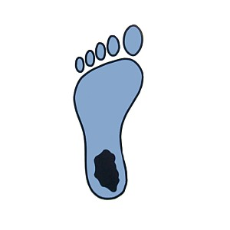
Running Related Injuries:
Symptoms and Referral Guide
Michelle Treffer, SPT 2015

Symptoms: | Red Flags: Refer To PT or MD
General
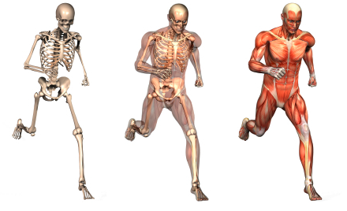 | - Extreme pain  - Persistent pain (more than 6 weeks)  - Persistent pain at rest  - Constitutional: Fever, malaise, weight loss, fatigue  - Unexplained weakness  - Numbness/tingling
Plantar Fasciitis or Heel Pain
- Heel pain  - Tender to palpation at medial tubercle of calcaneus  - Insidious onset  - Pain worst with first morning steps | - Pain with activity that progressively worsens to include pain at rest  - Nerve entrapment (burning sensation/tingling/numbness)  - Pain in middle of heel (rather than medial side)  - Pain in back of heel
Achilles Tendinopathy
- Pain 2-5 cm above insertion  - Swelling or tenderness above the tendon  - Nodules on the tendon  - Pain eventually becomes constant during exercise | - Recent use of fluoroquinolone (Cipro)  - Recent corticosteroid injections  - Any other systemic treatments that affect blood flow (e.g., for diabetes, rheumatoid arthritis)  - Inability to dorsiflex the foot
MTSS or Shin Pain
- Bilateral presence  - Diffuse pain on the lower medial third of the calf (towards ankle)  - Pain with plantar flexion and inversion  - Pain may lessen during running but become worse after running | - Exercise related “tightness” on outside or calf in absence of point tenderness  - Localized point tenderness, especially if toward front
PFSS: Persistent Knee Pain/ Stiffness
- Stiff upon rising after sitting for extended time  - Swelling and point tenderness around kneecap  - Feeling of knee “giving way”  - Popping, grinding or snapping under the kneecap | - Pain persists longer than 6 weeks despite active attempts at remedy

