Positive Pain Coping Strategies for Knee Osteoarthritis

General Overview:
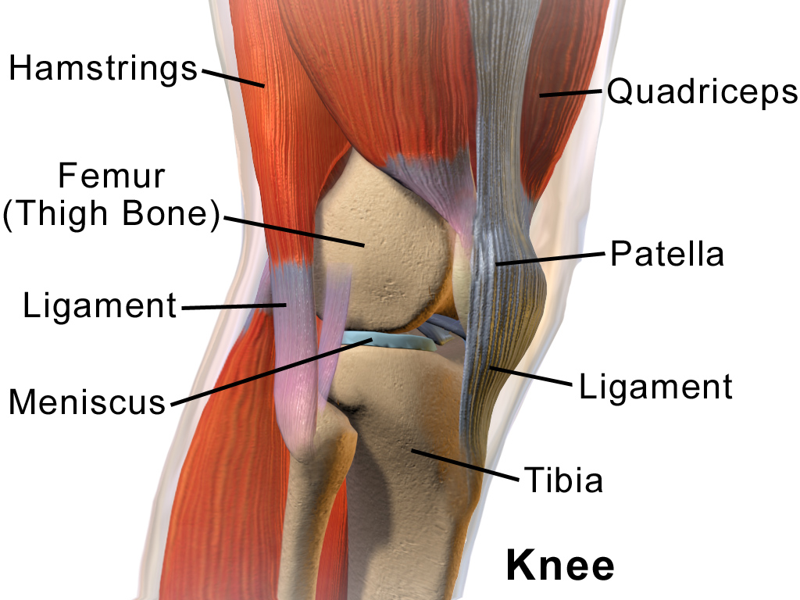
Knee osteoarthritis is a degenerative disease that commonly occurs in older adults over the age of 60.
Risk factors include overuse, trauma, genetic factors or knee structure.

Treatment Options:
- Physical therapy
  - Individualized exercise program
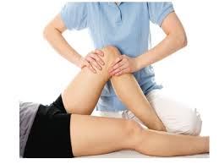
    - Lower body strengthening program
    - Balance program
    - Aerobic exercise
  - Aquatic therapy
  - Joint mobilizations and massage
  - Knee brace
  - Shoe modifications
  - Assistive device use
  - Education
- Lifestyle Modification
  - Exercise
    - 150 min of moderate exercise/week
    - Resource: http://www.arthritis.org/living-with-arthritis/exercise/
  - Weight loss
- Surgery, medication, injections

Pain Science:
- Pain is initially caused by tissue damage
- Central sensitization: Brain and spinal cord changes can increase the body’s response to continued, chronic pain signals
- Gate Control Theory: Nerve signals to the brain that can change how we experience pain
  - Examples:
    - Feeling fear/anxiety increase pain
    - Using ice/heat, distracting yourself can decrease the pain

Pain Coping Strategies:

Pacing  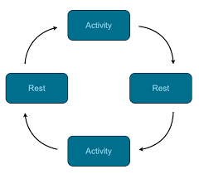 | Schedule out how much time it will take to do an activity. Alternate between activity and rest periods when performing activity.
Activity Persistence | Continue to perform an activity despite the initial pain sensation
Pleasant Activity Scheduling | Plan activities throughout the day that you can look forward to and enjoy
Distraction | Use visual, auditory or guided imagery to distract yourself from the pain.  Focus your attention on an unaffected body part and imagine warming up that body part.
Relaxation Response | Perform progressive muscle relaxation  Perform deep breathing techniques
Identifying and Challenging Negative Thoughts | Notice negative thoughts during increased periods of pain. Challenge negative thought with questions. Counteract negative thoughts with self soothing statements.
Goal - Setting | Write out monthly exercise goals, track progress toward goal and have an accountability partner.
Self - Efficacy | Believe that you are able to accomplish the steps required to complete a task.  Ways to improve self efficacy:  - Complete a task successfully  - Receive positive feedback  - Be in tune with your physiologic state  - Watch others with knee OA complete the same task

