Ejercicios a casa

**Fácil** -------------------------------------------------------------------------------------------- **Difícil**

**Fuerza**: Haga 3 sets de 10 repeticiones

Sentadilla en la pared 🡪 Escalón 🡪 Puente 🡪 Estocada 🡪 Sentadilla/estocada con un salto

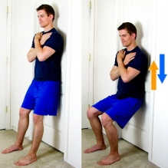 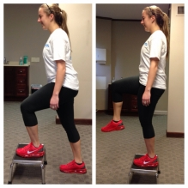 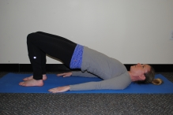 [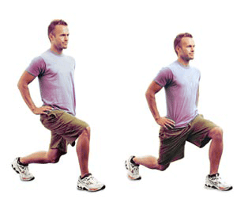](http://www.google.com/url?sa=i&rct=j&q=&esrc=s&source=images&cd=&cad=rja&uact=8&ved=0ahUKEwjfqLOjiqDMAhUHHh4KHQpSByIQjRwIBw&url=http://www.crita.org/hgh/exercises-that-release-it-fast/&bvm=bv.119967911,bs.2,d.dmo&psig=AFQjCNGI3LXvwG69X9AvJSNwOITDSyIdZg&ust=1461340094404758) [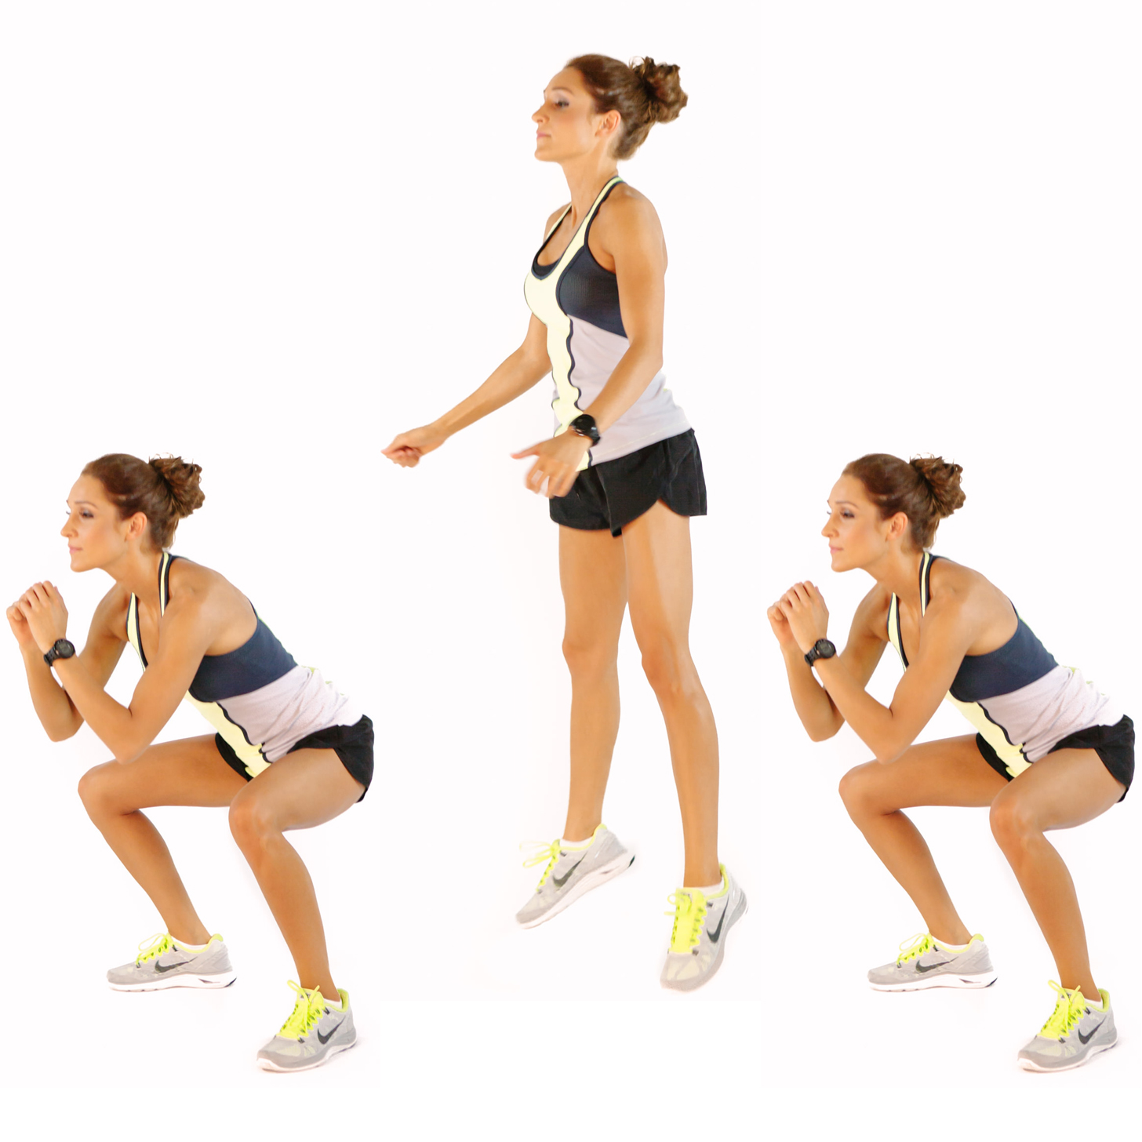](http://www.google.com/url?sa=i&rct=j&q=&esrc=s&source=images&cd=&cad=rja&uact=8&ved=0ahUKEwjAqL7ni6DMAhXHrB4KHbxrDUAQjRwIBw&url=http://www.popsugar.com.au/fitness/photo-gallery/35930476/image/35930482/Double-Pulse-Jump-Squats-20-Reps&bvm=bv.119967911,d.dmo&psig=AFQjCNF0O7_GCyF5o2cmL_rC49XjSElv7g&ust=1461340515940266)

**Equilibrio**: Mantenga el equilibrio por 30 segundos

Un pie detrás del otro 🡪 (ojos cerrados) 🡪 Parado en una pierna 🡪 (ojos cerrados) 🡪 Parado en una almohada 🡪 (ojos cerrados) 🡪 Alcanzar con la pierna

[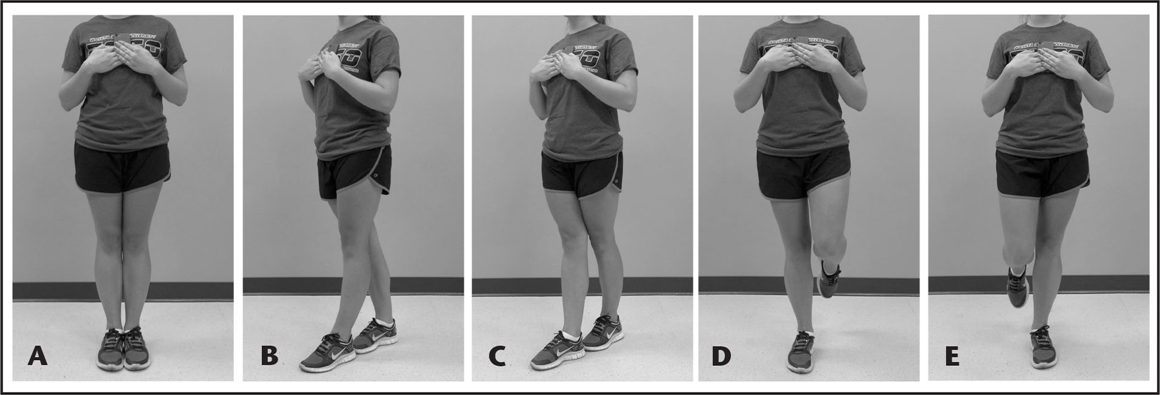](http://www.google.com/url?sa=i&rct=j&q=&esrc=s&source=images&cd=&cad=rja&uact=8&ved=0ahUKEwiVxdG7hKDMAhULWh4KHYPACNMQjRwIBw&url=http://www.healio.com/orthopedics/journals/atshc/2015-5-7-3/%7b1e9fb2a1-71cc-498b-930b-98f1c3214ae5%7d/comparison-of-the-sway-balance-mobile-application-to-the-abbreviated-balance-error-scoring-system&psig=AFQjCNHCHMxaKEWv26lRu0-FU_9qjDOk-w&ust=1461338525919730) [](http://www.google.com/url?sa=i&rct=j&q=&esrc=s&source=images&cd=&cad=rja&uact=8&ved=0ahUKEwiVxdG7hKDMAhULWh4KHYPACNMQjRwIBw&url=http://www.healio.com/orthopedics/journals/atshc/2015-5-7-3/%7b1e9fb2a1-71cc-498b-930b-98f1c3214ae5%7d/comparison-of-the-sway-balance-mobile-application-to-the-abbreviated-balance-error-scoring-system&psig=AFQjCNHCHMxaKEWv26lRu0-FU_9qjDOk-w&ust=1461338525919730) 