Pose (Asana) | Benefit | Cues
Mountain Pose (Tadasana) | -Mountain pose is an excellent pose to work on proper posture, breathing, and engaging the postural and abdominal muscles.  -This provides a good opportunity to work on pelvic tilts in order to find neutral pelvic alignment | -Root through the big toe, little toe, and center of the heels  -Engage the thighs, kneecaps lift, and inner thighs spin back (IR)  -Lower abdomen draws in an up, tailbone extends down toward hamstrings  -Shoulders soften back and down allowing arms and hands to fall by sides with palms facing out (ER)
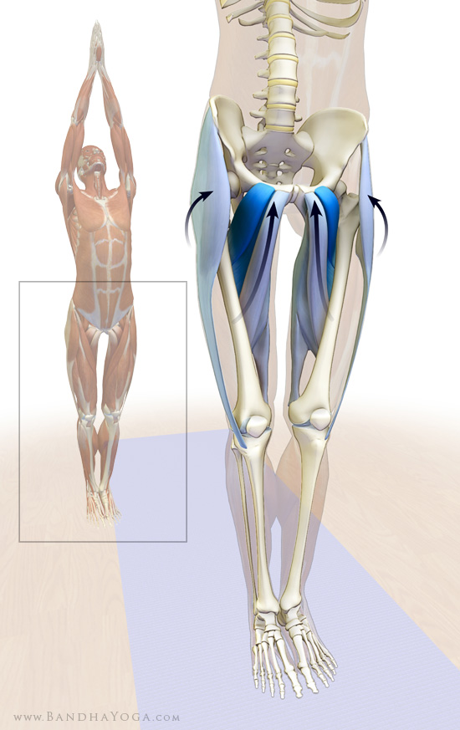
Easy Cross-Legged Pose (Sukhasana) | -Sitting up in Easy Cross-Legged Pose aids to bring the spinal column into alignment, so that the vertebral bodies and their discs support the torso; expanding the chest forward enhances breathing.  -With practice this can lead to a comfortable, easy position that is reflected on the central nervous system.  -The latissimus dorsi orginiates from the back of the iliac crest, activating this muscle also tilts the pelvis forward. | -Root through the sits bones and lengthen through the crown of the head  -Draw the shoulder blades down the back and broaden the chest  -Rest your hands on your knees, palms faced up or down  -Tip: sitting on a blanket, block, or bolster will help with maintaining proper posture by keeping the hips higher than the knees
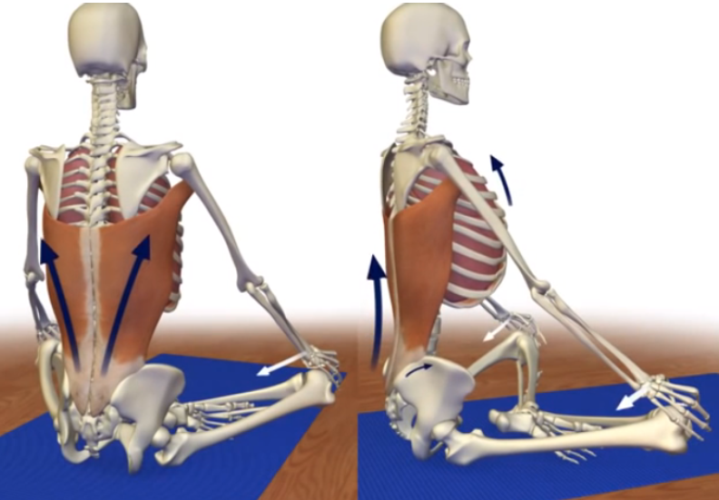
Downward Facing Dog (Adho Mukha Svanasana) | -Stretches the shoulders, hamstrings, calves, arches, and hands.  -Strengthens arms and legs.  -Helps energize the body, calms the brain and relieves stress.  -Can be therapeutic for high blood pressure, asthma, sciatica, sinusitis. | -Press you legs straight and press your thighs toward the back of the room  -Press your chest towards your thighs and tilt your pelvis up.  -Move your belly in towards your spine, draw the lower ribs in, and lift your sits bones up to the ceiling.  -Your neck can be in a neutral position and gaze at your naval or a spot on the wall behind you
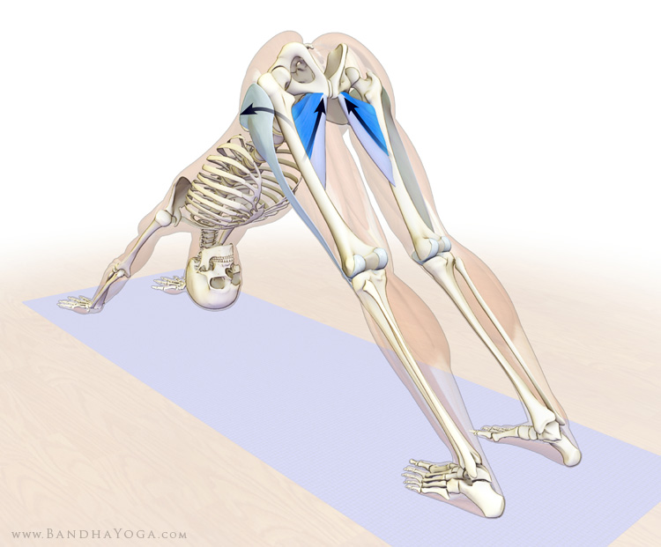
Rock the Baby Pose | -Stretches the glutes  -Stretches and strengthens the groin  -Relaxes the lower body from upper thighs to the ankles  -Opens and stretches the hips | -Pick up your right leg and bend your right elbow around your right knee. Bend your left elbow around your right foot. Your leg will be cradled in your elbow crease.  -Your shin will be parallel to the ground  -Allow shoulders to relax away from your ears  -Push sits bones into the ground and lengthen through the crown of the head.
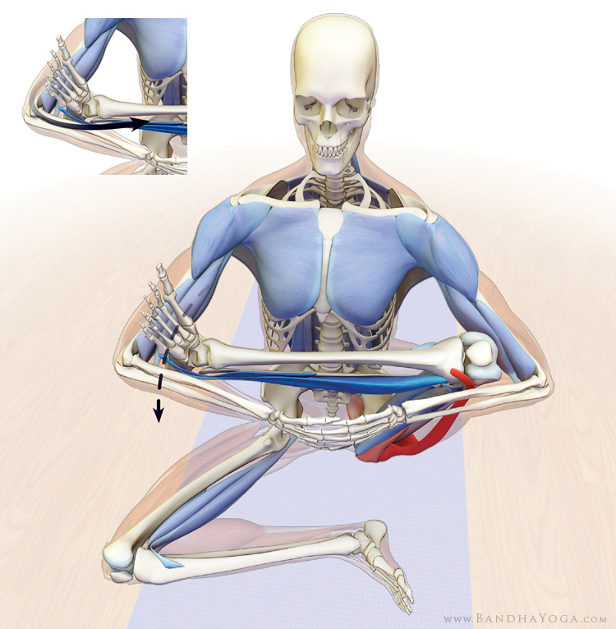
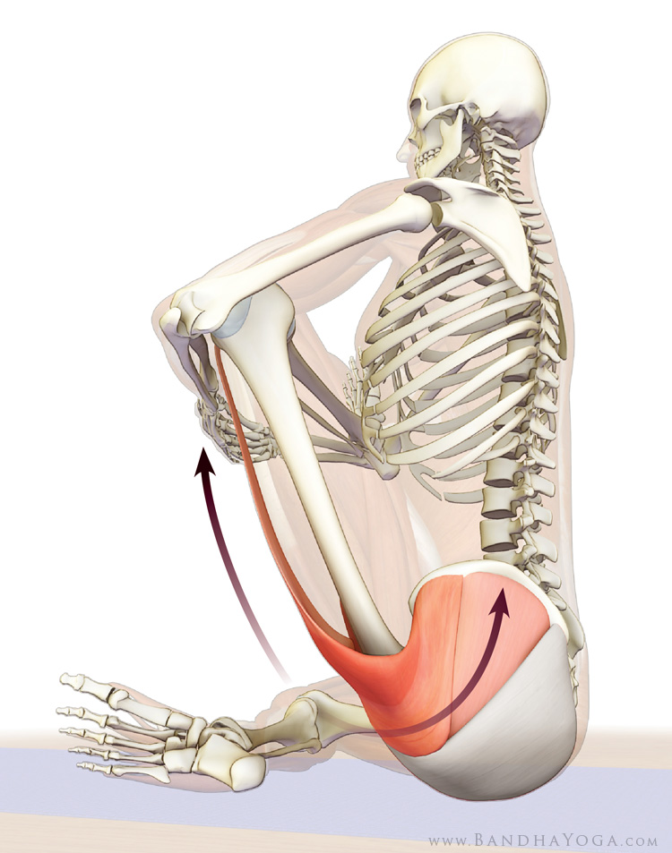
Pigeon Pose (Eka Pada Rajakapotasana) | -Stretches the thighs, groin, psoas, abdomen, chest & shoulders, and neck  -Opens shoulders and chest | -Can begin from downward facing dog. Step one foot forward to the opposite wrist and then drop the knee and hip down onto the mat.  -Allow the back leg to descend down onto the mat  -Can stay upright with arms extended, or may choose to fold forward onto forearms (deeper stretch)
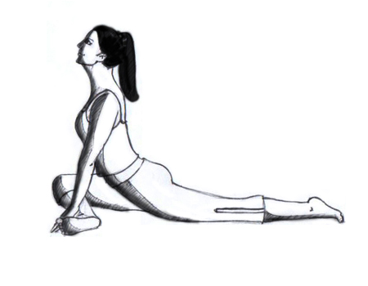
Four Limbed Staff Pose (Chaturanga Dandasana) | -Tilting the pelvis back and down relieves hyperextension of the lumbar through joint coupling. This is known as “lumbo-pelvic rhythm,” wherein tilting the pelvis forward or back extends or flexes the lumbar, respectively.  -This posture works to engage the abdominal muscles, postural muscles, pectorals and triceps.  -Modifications may include lowering knees to the ground or performing a high plank. | -Firmly engaging the abdominals and then incorporating contraction of the gluteus, gently tuck the tailbone to engage the gluteus maximus and contract the abdominals as you exhale and lower into Chaturanga.  -Hug your elbows in towards your sides as you lower.
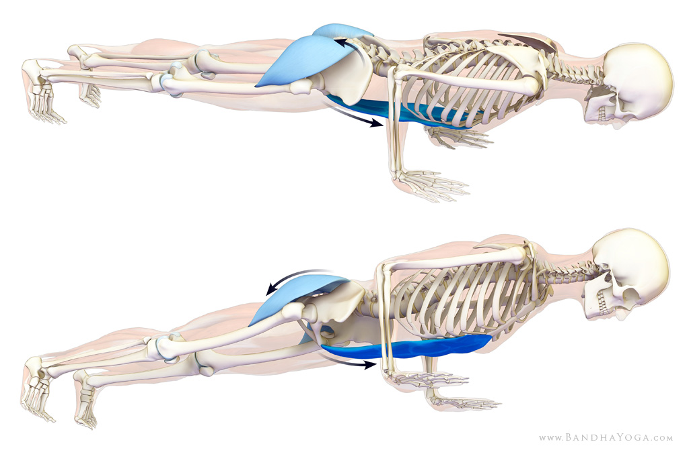
Child’s Pose (Balasana) | -Child’s pose is a restorative pose and a great position to work on expansive breathing. It calms the brain and helps relieve stress and fatigue.  -Gently stretches this hips, thighs, and ankles.  -Can also help to relieve back and neck pain if the head and torso are supported. | -Spread your fingers wide  -Move your shoulders away from your ears  -Press you seat towards your heels  -Press tops of your feet into the mat
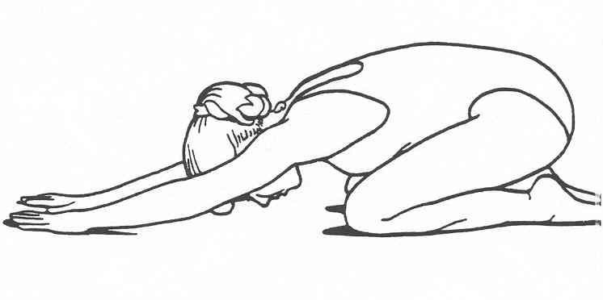
Cat-Cow | -Starts to increased spinal flexibily and prepare it for movement in the yoga practice  -Connects the body movement with the breath  -Opens chest, throat, shoulders  -Can be a good place to work on pelvic tilts and finding a neutral pelvic alignment | -On your hands and knees, place your palms beneath your shoulders and your knees beneath your hips  -Start with a neutral spine, and with your inhale bring your head and chest up toward the ceiling and point your tailbone toward the ceiling (cow)  -With your exhale round the spine, tuck your tailbone under, and look toward your navel (cat)  -repeat this process with the breath
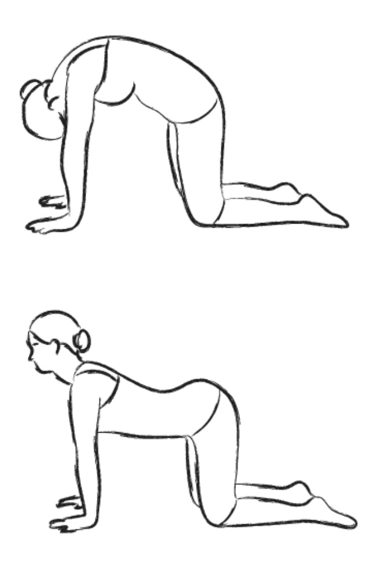
Happy Baby Pose (Urdhva Mukha Upavista Konasana) | -Gently stretches the inner groin and the back spine.  -Calms the brain and helps relieve stress and fatigue | - Inhale and bring your knees to your chest  - Hold on to the inner edges of your feet with your thighs facing down towards your heels  -Very gently, use your hands to pull your feet, knees, and quadriceps to the floor  -Roll your tailbone down toward your spine into the floor.
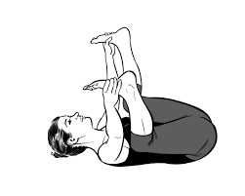
Reclining Bound Angle Pose (Supta Baddha Konasana) | -Stretches the inner thighs, groins, and knees  -Helps relieve symptoms of stress, mild depression, menstruation, and menopause  -Restorative pose; with proper props a person can remain comfortably in this position for awhile and work on breathing  -Modifications to this pose include putting a blanket or blocks underneath the knees if they do not come to the ground, or if the stretch in the groin is too great | -Bring the soles of your feed together and let your knees open to the edges of your mat  -Allow the arms to fall by your sides, palms face up and shoulder blades dropping heavy into the mat.  -Or place on hand at the heart and one hand at the belly and focus on the flow of breath moving in an out of the body (good position to work on diaphragmatic breathing)
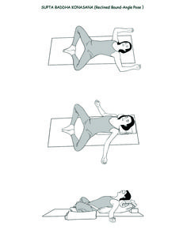
Supine Twists (Supta Jathara Parivartanasana) | -Stretches the back muscles and spine  -Stimulates the kidneys, abdominal organs, urinary bladders, and intestines  -Releases stress  -If the knee is straightened, it stretches hamstrings | -Lie on your back and bring your right knee into your chest  -Reach your right arm out to the side  -Use your left hand to guide your right knee across the body so that you are resting on or towards the left side of your body  -Keep shoulder blades on the floor & gaze over your right fingertips
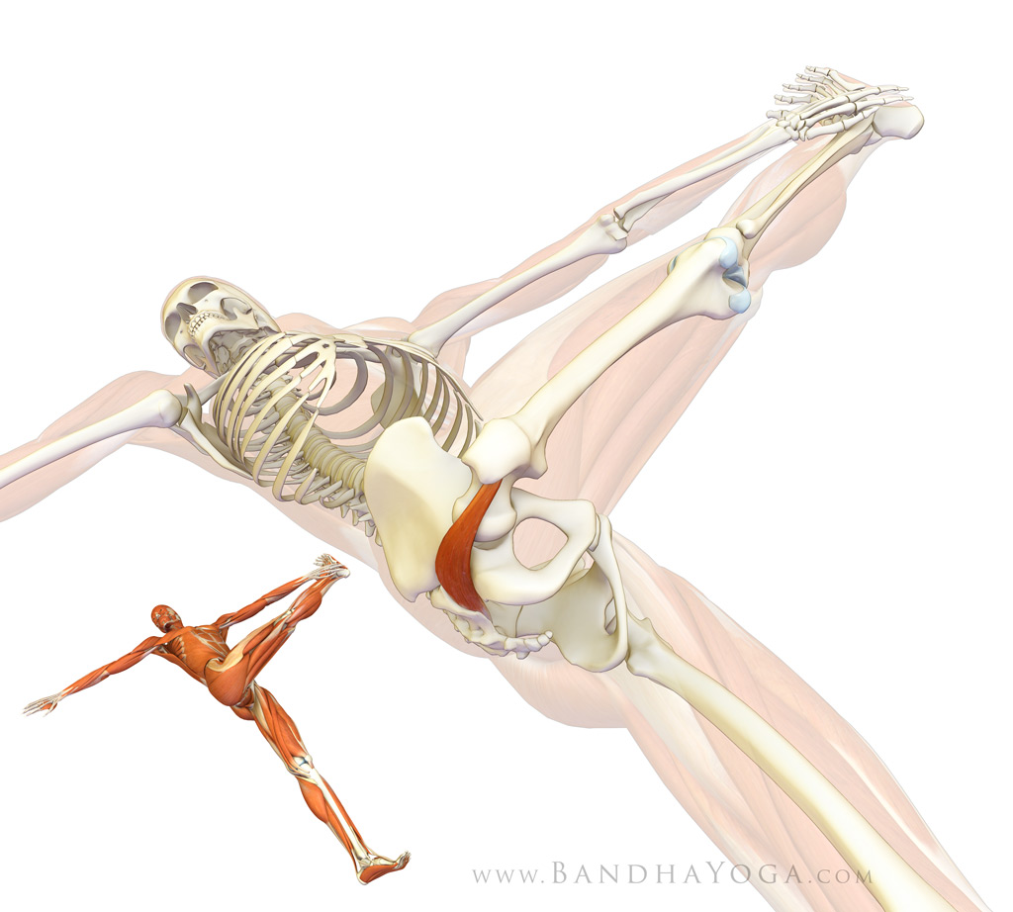
Warrior I (Virabhadrasana I) | -The prime mover muscle for this action is the gluteus maximus.  -One of the synergists for extending the hip is the adductor magnus muscle. Attempting to drag the foot towards the midline engages this muscle in the pose. The foot remains constrained on the mat and does not actually move, however, the force of contracting the adductor magnus decreases the angle between the femur and the pelvis, as shown. The result is that the pelvis turns (instead of the foot moving). In addition, the hip extends more effectively.  -All of this produces a unique opening in the front of the pelvis that stretches the hip flexors, including the psoas muscle | -From mountain pose, step one foot back at a 45° and press it flat into the ground  -Bend the front knee until it is over the ankle  -The back leg is straight, and can either be in alignment with the front leg, or a bit wider if that is more comfortable.  -Square your hips over your torso, so that your chest is facing the front leg  -Lift both hands up overhead, and relax the shoulders down the back of the spine
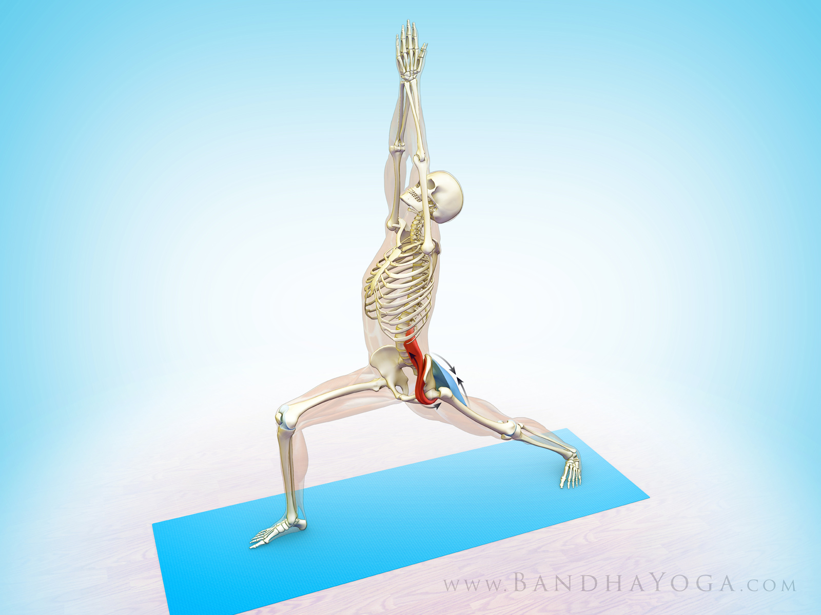
Yogic Squat (Malasana) | -Hip opening pose  -Stretches the thighs, groin, and psoas  -Allows for full relaxation of pelvic floor  -Helps to improve balance  -May help to relieve menstrual discomfort | -From mountain pose (standing up straight) lower down into a squat position  -Widen your knees apart and stretch your arms forward between them  -Once your upper arms touch inside of your knees, bring your hands into prayer position  -If your heels don’t come all the way down to the floor, place a blanket or roll the mat under the heels so that they are in firm contact with the ground/blanket
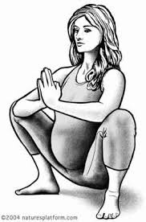
Lizard Pose (Utthan Pristhasana) | -Hip opening pose  -Individuals can gain both physical and emotional release  -Stretches thighs, groin, psoas, chest, and shoulders | -From Downward Facing Dog, step right foot between your hands and come into a runner’s lung  - Place both hands to the left of the right foot, and walk the right foot out a couple of inches  -Can stay here, or can lower down onto forearms if that is comfortable  -Also an option of letting the right knee fall to the side and rest on outside edge of right foot
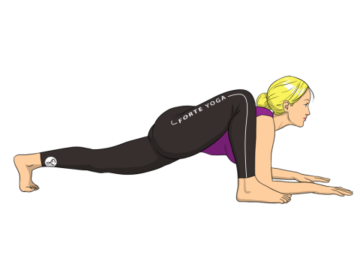
Warrior II (Virabhadrasana II) | -Co-activation of the adductor and abductor muscles can increase proprioception and stability through the hip joint | -From mountain pose, step one foot back at a 45° and press it flat into the ground  -Bend the front knee until it is over the ankle  -Imagine pressing the inside of knee into an immoveable object while at the same time pressing the outside of the knee into a similar object  -Torso should be facing the side wall, lift arms in line with torso  -Gaze out over the front middle finger
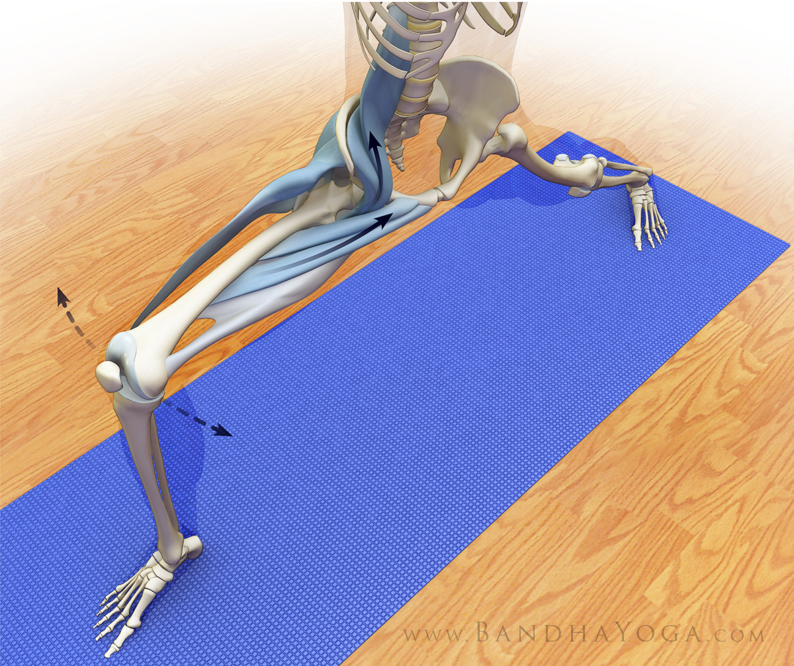
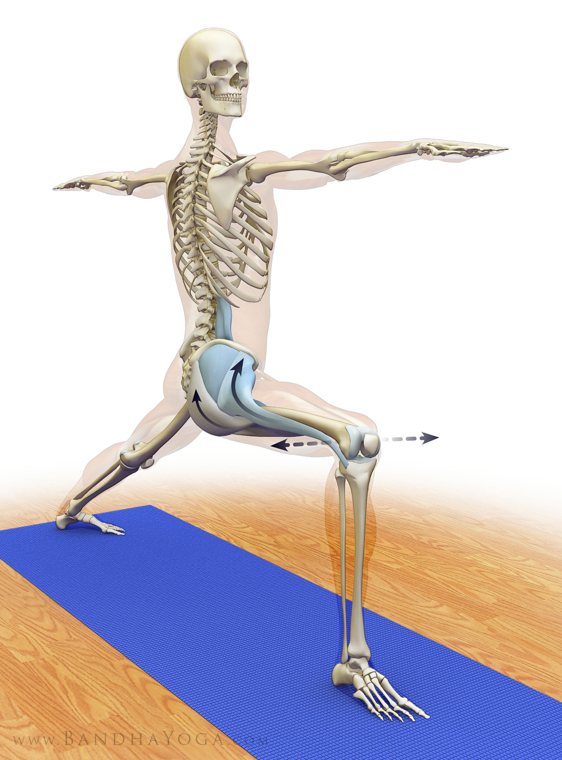
Long R. The Daily Bandha: Scientific Keys to Unlock the Practice of Yoga. Available at: http://www.dailybandha.com
Johnson M. Skill in Action Yoga Teacher Training Manual. Created: September 2014.
