Finding a Specialized PT for Neurologic Conditions
1.) Go to: http://www.abpts.org/home.aspx
2.) Click: “Find a Specialist”
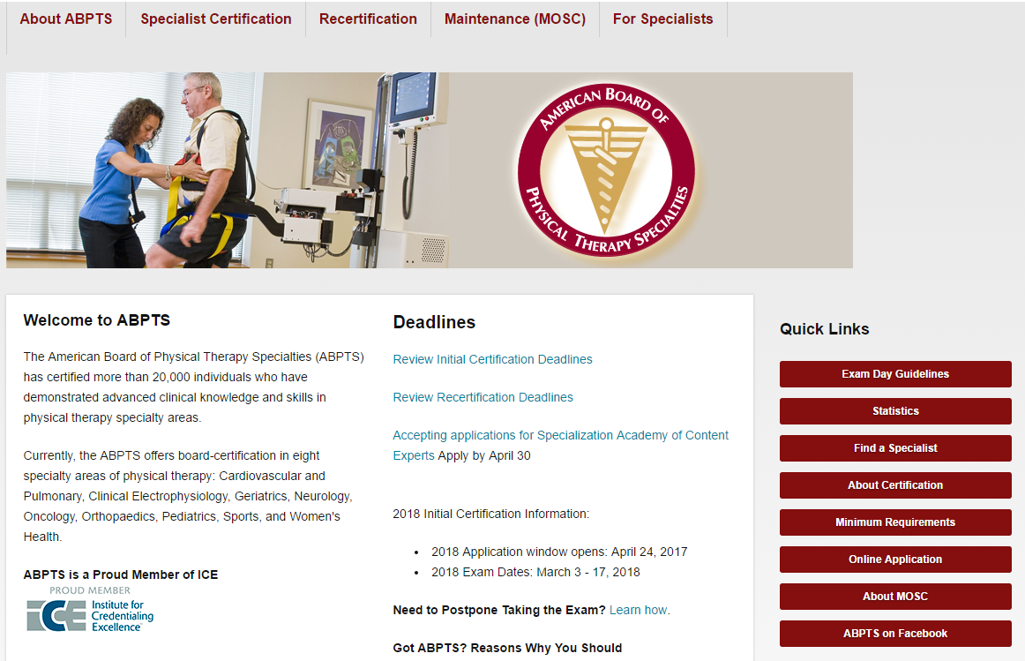
3.) Under the Search heading, click “Search the Directory of Board Certified Specialists”
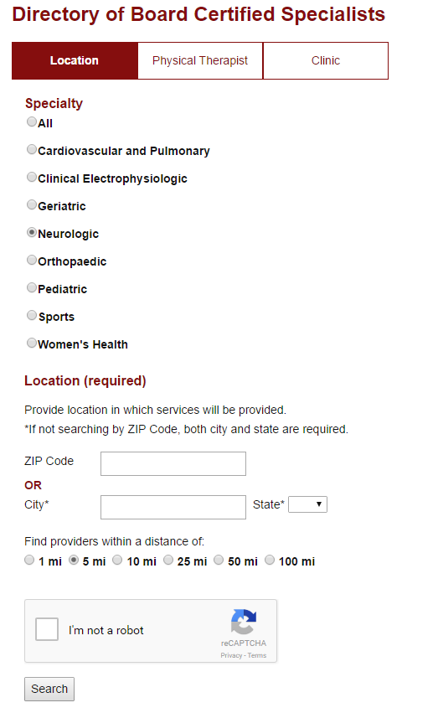
4.) In the Directory, select “Neurologic” from the list of specialties.
5.) Under location, enter your zip code or city and state.
6.) Select the distance you’re willing to travel for providers.
7.) Click the “I’m not a robot” box, and search.

