Internal referrals to the PT, OT and/or Speech at the Center for Rehabilitation Care
Adult and Pediatric Neurology, Vestibular, Balance, Geriatrics, Pelvic Health, Lymphedema
1. Search for AMB PT, AMB OT or AMB Speech:
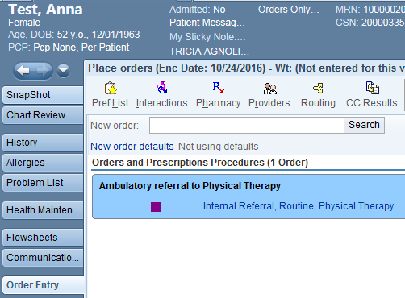

2. Select UNCH Rehab Therapies PT (or OT or SP)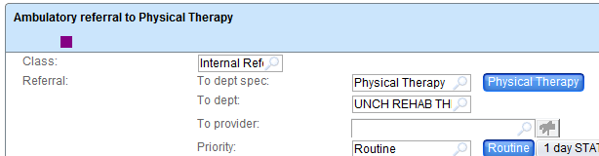

Not selecting a location will send the referral to your front desk staff to process, causing a delay in us receiving the order. We will call all patients within 48 hours of receiving the order to schedule an appointment.
3. For speech, you must select the reason for the referral.
4. Add any comments in the comments section to clarify need for therapy services (if needed).
5. Accept orders
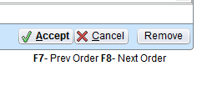
6. Sign orders
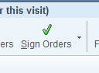
6. Select appropriate diagnosis for the order and accept.
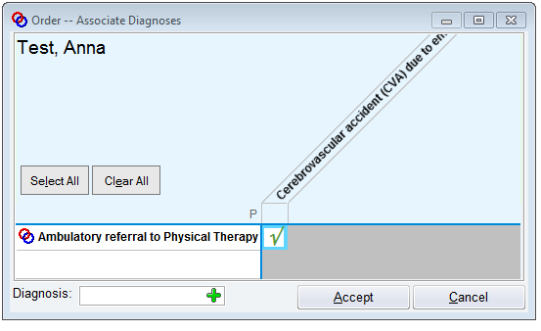

If you have any questions regarding the referral process, please contact us at 984-974-9700.

