Quick Reference Guide: Cranial Molding Devices in the NICU

Device | Image | Description | Advantages | Contraindications | Infant Weight/Age | Evidence-Based Support
Frederick T. Frog  http://www.usa.philips.com/healthcare/product/HC989805603341/frederick-t-frog-positioning-aid |  | Frog-shaped device that contains polyethylene beads to provide weighted boundaries for the trunk, head, and extremities  Specific uses for cranial molding:  Prevent cervical extension in prone, maintain midline head orientation in supine, and promote stability and containment of the head in side-lying | Covers can be disposable or machine washable  Beads are adjustable to achieve desired position | Full weight of device (456.3 g) should not be placed on infant | Not specified | None available
Gel-E Donut  http://www.usa.philips.com/healthcare/product/HC92025/gel-positioning-aids-family-of-gelfilled-infant-positioning-products |  | A round, gel-filled pillow used to promote skin integrity and prevent cranial molding deformities due to prolonged immobility | Available in multiple sizes  Disposable covers | Redesigned with a non-porous skin in 2015 following concerns of mold | Not specified | A study comparing interface pressures of various pediatric support surfaces found that a foam overlay alone and in conjunction with the Gel-E Donut produces the lowest occipital pressure in infants <2 years of age.¹ The Gel-E Donut alone is less effective at decreasing occipital pressure than when used in combination with the foam overlay.¹
Sundance Fluidized Full-body Mattress  http://sundancesolutions.com/neonatal/ | 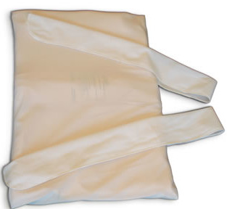 | A fluidized, mattress-like device that supports the infant’s entire body and can be molded to provide developmentally supportive positioning in supine, side-lying, or prone | Fluid has “zero flow” from gravity, allowing contoured support for the desired position  Available in multiple sizes | Choose appropriate size based on weight and activity level | Medium: preterm infants <1500 g if active or <1800 g if inactive or swaddled  Large: active preterm infants 1500-1800 g; all larger infants | None available
Sundance Fluidized Utility Positioner  http://sundancesolutions.com/neonatal/ | 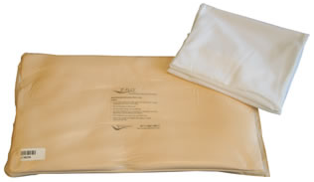 | A fluidized, pillow-shaped device that supports the infant’s head, neck, and shoulders while in the supine, side-lying, or prone position | Fluid has “zero flow” from gravity, allowing contoured support for the desired position  Available in multiple sizes | Choose appropriate size based on weight | Small:  1000-2000 g  Medium:  >2000 g | A randomized controlled trial found that rotating between the fluidized utility positioner and the cranial cup device is associated with decreased development of deformational plagiocephaly in the NICU compared to use of the fluidized utility positioner alone.²
DandleROO  http://www.dandlelionmedical.com/products/dandle-roo/ |  | A containment device made of stretchable cotton that creates a womb-like environment by allowing extension of the extremities while providing a gentle force to return the body and head to midline flexion  Not specifically indicated for cranial molding, but provides containment to the head in supine, prone, and side-lying positions | Available in multiple sizes  Can be washed and reused | Not specified | Designed specifically for preterm infants | In a survey of NICU clinicians, the DandleROO was identified as the “ideal method of neonatal positioning” by 62% of nurses and 86% of therapists, and it was named the easiest method of positioning to utilize in the NICU by 44% of nurses and 57% of therapists.³
Tortle Midliner  http://tortlemedical.com | 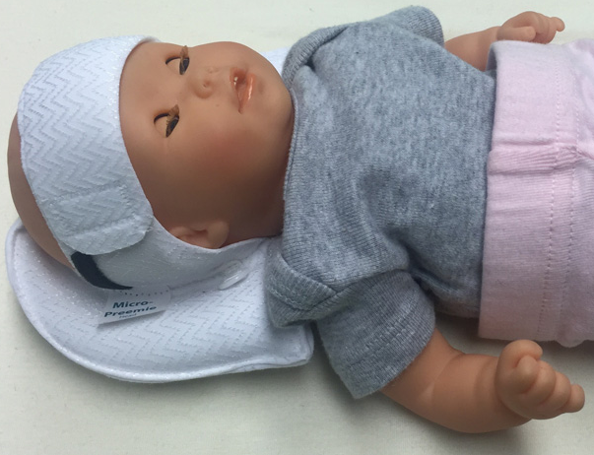 | A soft, lightweight beanie with two adjustable support rolls and a Velcro front opening  Used to prevent head preference issues and cranial asymmetry in supine, side-lying, and prone positions | Available in multiple sizes  Does not have to be removed for x-ray | Not specified | ≤ 3000 g | None available
Tortle Air  http://tortlemedical.com | 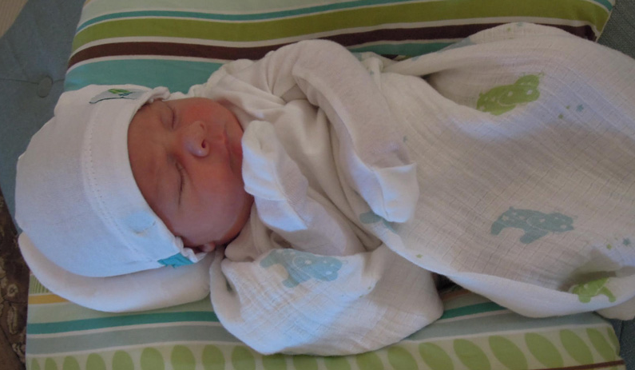 | A soft, lightweight beanie with one adjustable support roll and a Velcro front opening  Used to prevent head preference issues and cranial asymmetry in supine, side-lying, and prone positions | Available in multiple sizes  Does not have to be removed for x-ray | Not specified | ≤ 9000 g | None available
Cranial Cup  http://www.bostonbrace.com/Content/Plagio_Cradle_1.asp |  | An orthotic device made up of a plastic base overlaid with up to four layers of polyethylene foam  Contains a concave portion for the head in order to encourage normal cranial development  Supports the body in supine and semi-side-lying positions | Foam layers can be removed to adjust the fit of the device as the infant grows  Washable cover | Cannot utilize prone position  Not for use with infants who have brachycephaly  Not designed for infants weighing <1000 | ≥ 1000 g | A randomized controlled trial found that rotating between the cranial cup and a fluidized utility positioner is associated with increased prevention of plagiocephaly in the NICU compared to use of the fluidized positioner alone.²  A prospective study found that the cranial cup is effective for normalizing head shape in hospitalized premature infants; however, this study did not have a control group for comparison.⁴

- McLane K, Krouskop T, McCord S, Fraley J. Comparison of Interface Pressures in the Pediatric Population Among Various Support Surfaces. Journal of Wound, Ostomy and Continence Nursing. 2002;29(5):242-251. doi:10.1097/00152192-200209000-00007.
- DeGrazia M, Giambanco D, Hamn G, Ditzel A, Tucker L, Gauvreau K. Prevention of Deformational Plagiocephaly in Hospitalized Infants Using a New Orthotic Device. Journal of Obstetric, Gynecologic & Neonatal Nursing. 2015;44(1):28-41. doi:10.1111/1552-6909.12523.
- Zarem C, Crapnell T, Tiltges L, et al. Neonatal Nurses' and Therapists' Perceptions of Positioning for Preterm Infants in the Neonatal Intensive Care Unit. Neonatal Network: The Journal of Neonatal Nursing. 2013;32(2):110-116. doi:10.1891/0730-0832.32.2.110.
- Knorr A, Gauvreau K, Porter C, Serino E, DeGrazia M. Use of the Cranial Cup to Correct Positional Head Shape Deformities in Hospitalized Premature Infants. Journal of Obstetric, Gynecologic & Neonatal Nursing. 2016;45(4):542-552. doi:10.1016/j.jogn.2016.03.141.

