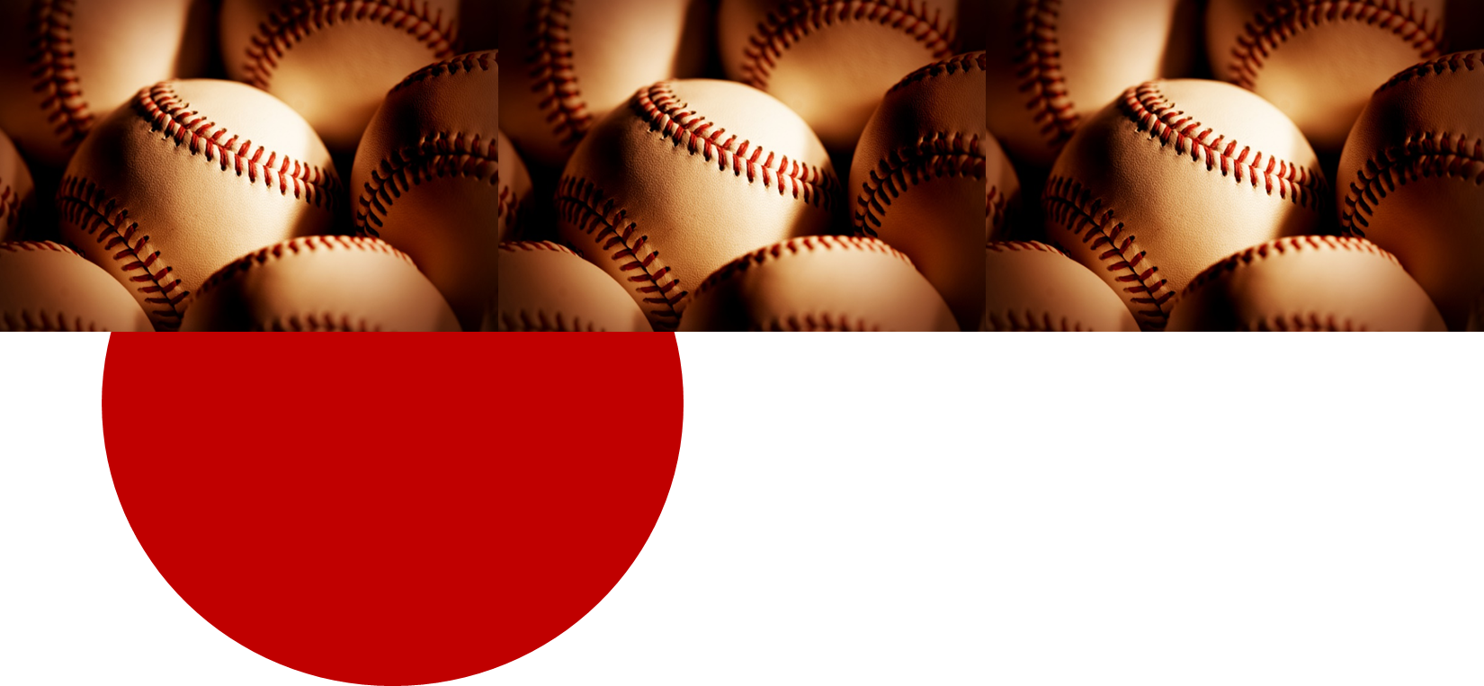

By: Lauren Kozar UNC DPT Student

Lauren_Kozar@med.unc.edu

The Physical Therapist’s Guide to the Baseball Pitcher’s Elbow

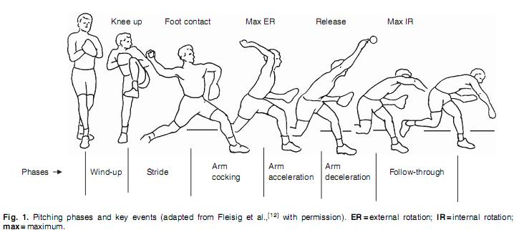

Pitching Mechanics –

A comprehensive understanding of the fundamental mechanics to baseball pitching

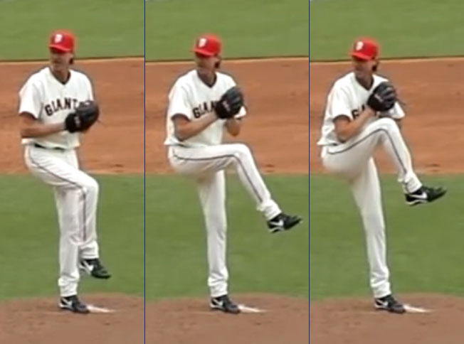

Definition: initial movement to max knee lift

Mechanics:

* Shoulders should be aligned between **2nd base** and **home plate** with pitcher’s **hands at chest height** in order to establish and maintain a stable COG
* Stance leg maintains position of balance in slight knee flexion15
  + Weak quads or hip abductors = unstable base

Faulty Mechanics:

* Poor balance at max knee lift due

to poor LE strength and trunk control

* Early forward movement toward home

plate

* COG that is positioned posteriorly

Key Facts:

* Sets the timing and tone of the remainder of the pitch
* Low risk of upper extremity injury 2/2 low muscle activity in the ROC, scapular stabilizers, and deltoid

Stage 1: THE WIND-UP1,2,3

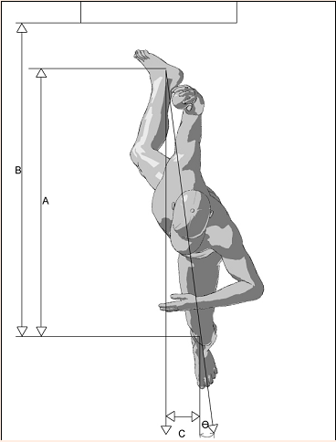

Purpose: develop linear velocity towards home plate

Mechanics:

* Begins at max knee lift
* Concludes when the stride leg makes contact with the ground

15° Angle b/w mound and foot

3rd BASE

2nd BASE

* During this motion:
  + Shoulder abduction = **90 ± 10º**
  + Elbow flexed to **80-100º** and pronated so that the ball faces b/w 2nd and 3rd base
  + Hand is on **TOP** of the ball
  + Stride Length = **85-100%** of body height
    - Knee and hip extensors **eccentrically** complete stride to foot contact
  + Stride Hip = ER
  + Stance Hip = IR
  + Hip abductors maintain stable pelvis
  + Stride direction (foot angle) = approx. 15º away from center of mound
  + Foot direction should be towards home plate or slightly towards 3rd base (picture is wrong)

Stage 2: THE STRIDE1,2,3,4



* Stance leg: reduced hip flexor and hip internal rotator extensibility; reduced strength in TFL, gluteus medius, and hamstrings
* Trunk rotation prior to scapular positioning, which should be upwardly rotated and retracted
* Inadequate stride foot direction
* Inadequate stride direction (foot angle)
* Inadequate knee flexion angle
* Reduced shoulder abduction
  + Look at elbow height - if lower than shoulder height they are not achieving adequate shoulder abduction

Faulty Mechanics:

* Stride leg: reduced hamstring extensibility; reduced hip ER; reduced strength in gluteus maximus/minimums, piriformis, and obturator internus

Stage 2: THE STRIDE1,2,3,4

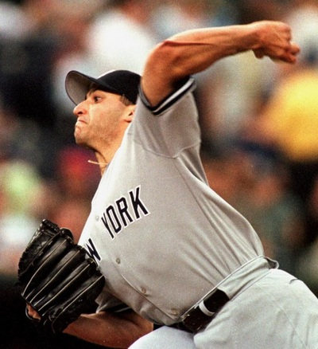

Definition: begins when stride foot makes contact with ground and concludes when the arm is maximally ER

Mechanics:

* Pelvis rotates toward target followed by trunk rotation
* Knee extends on the stride leg creating a stable base for trunk rotation and flexion
* Abdominal obliques prevent excessive hyperextension of lumbar spine
  + The internal oblique fires on the lead leg, and the external oblique fires on the stance leg
* Scapula retracts and tilts upward
* Max ER = 165-185º
* Shoulder abducted to 90-95°
* Elbow flexed to 95°

Stage 3: ARM COCKING1,3,4

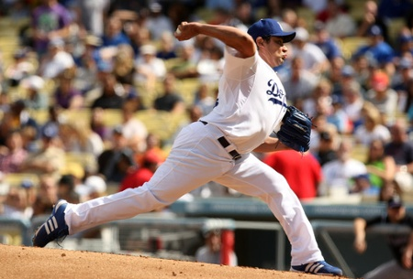

This position of max ER occurs at terminal arm cocking, and is known as the:

**CRITICAL MOMENT.**

* **Valgus torque at elbow = 64 Nm-120 Nm**
  + UCL absorbs 55% of this force BUT can only withstand 35 Nm
* **High GH joints as well**

Stage 3: ARM COCKING1,3,4,5

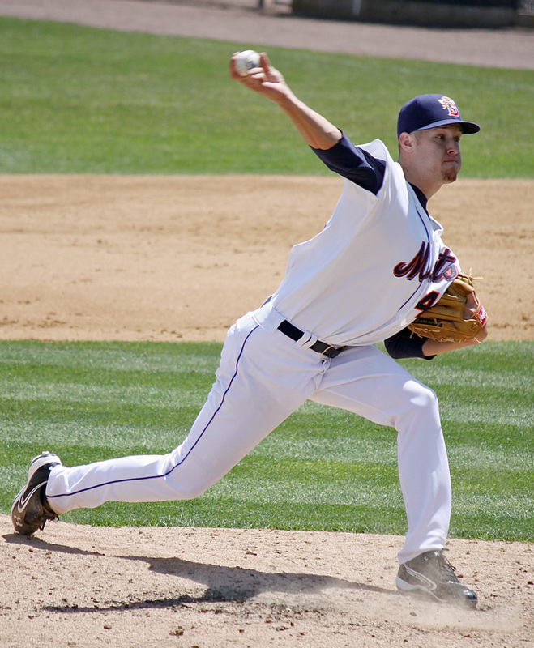

Definition: begins at max ER and ends at the moment of ball release

Mechanics:

* The trunk moves from hyperextension to about 32-55° of flexion
* The stride leg continues to extend
* The shoulder rapidly (~10,000°/sec) moves into IR and horizontal adduction
  + Muscles responsible for powerful IR = subscapularis, pec major, and latissimus dorsi
* The elbow extends rapidly (3,000°/sec)
* At ball release:
  + Elbow is in approx. 25° flexion
  + Shoulder is in 90-100° abduction
  + Forearm is pronated to 90°
  + Wrist is flexed
  + Scapula moves into a protracted position

Faulty Mechanics:

* Excessive lateral trunk lean, which can cause a hand-on-top ball release
* Reduced lateral trunk lean, which can cause side-arm throwing

Stage 4: ARM ACCELERATION1,3,4,6

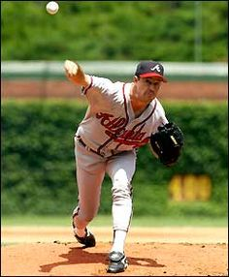

Definition: begins with ball release and concludes with max IR of the shoulder

Mechanics:

* Arm horizontally adducts across body as arm continues to IR
* End shoulder position = max IR, 35° horizontal add, and 100° abduction
* Stance foot is entirely off the ground
* Trunk rotates over the lead leg
* Elbow extension is primarily decelerated by eccentric contraction of the elbow flexors
  + Compression forces @ elbow can reach

as high as **90% of the pitcher’s BW**

* Scapula de-rotates from the upward position

and returns to an anterior tilted position

* Produces the **greatest** forces on the gleno-

humeral joint

* + - 400 N posterior shear force
  + 300 N inferior sheer force
  + >1000 N of compressive forces
  + Distraction force: 71-124% of BW

Stage 5: ARM DECELERATION1,3,4,7,8

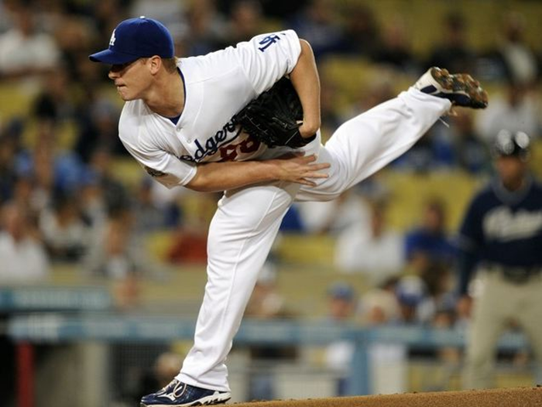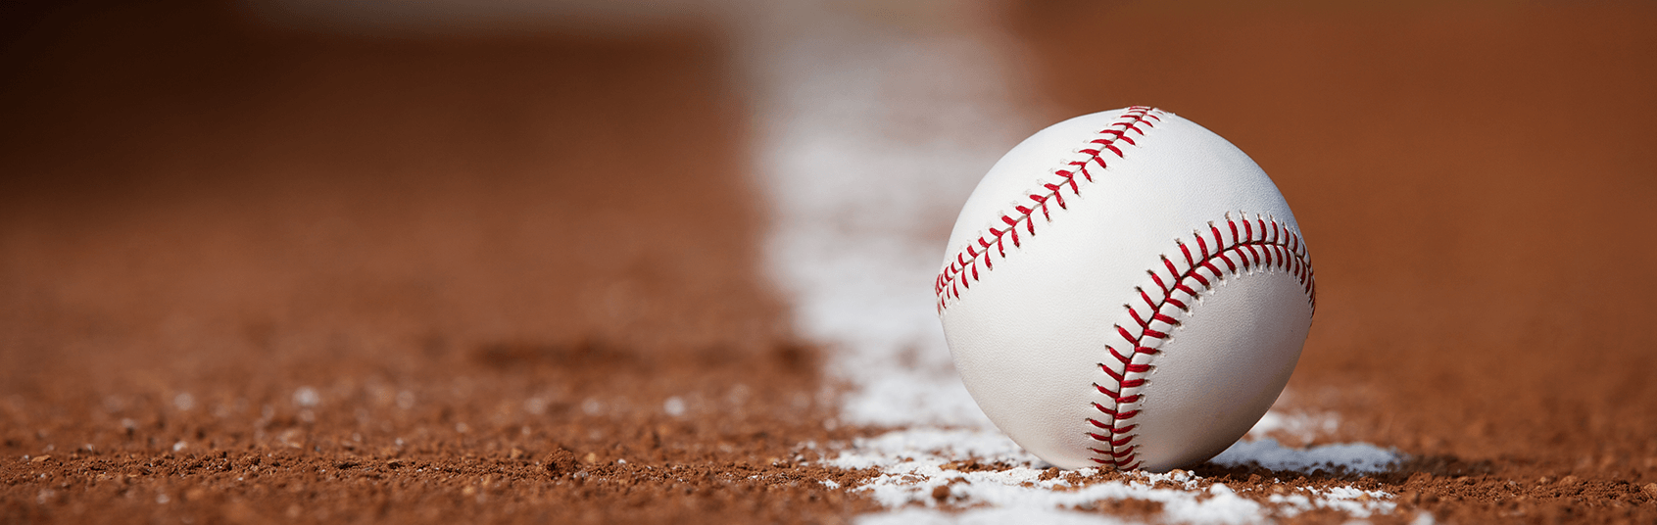

Definition: continued deceleration and flexion of the trunk over the stride foot

Mechanics:

* Deltoid and rotator cuff decelerate the shoulder
* Ending arm position: approx. 60° of horizontal adduction
* Ending body position: fielding position

Stage 6: FOLLOW-THROUGH1,4

YOUTH PITCHERS

ELITE PITCHERS

Risk factors for UCL reconstruction by pitching experience

**GIRD13,21**

Kinetic chain deficits13,15

**Technique flaws6,10,19,,12**

Higher pitch count/game

Diagnosis – Subjective Exam22,23,24

**Acute:** sudden “pop” followed by a drop in velocity

**Chronic (more common):** episodic medial and/or posteromedial elbow pain for more than 1 year

History of Present Condition

Symptoms Condition

**Acute and Chronic:**

* + Decreased velocity, control, and endurance OR loss of ability to throw
  + Pain in medial or posteromedial elbow during late cocking, acceleration, and deceleration

**Chronic:**

* + Neuropraxia to ulnar nerve due to valgus extension overload during the deceleration phase (40% of cases)

Inspection Condition

Diagnosis – Objective Exam22

* Patient will be TTP at or near UCL origin
  + Possibly TTP in posteromedial elbow
* Assess the integrity of flexor-pronator mass
* Evaluate for cubital tunnel syndrome

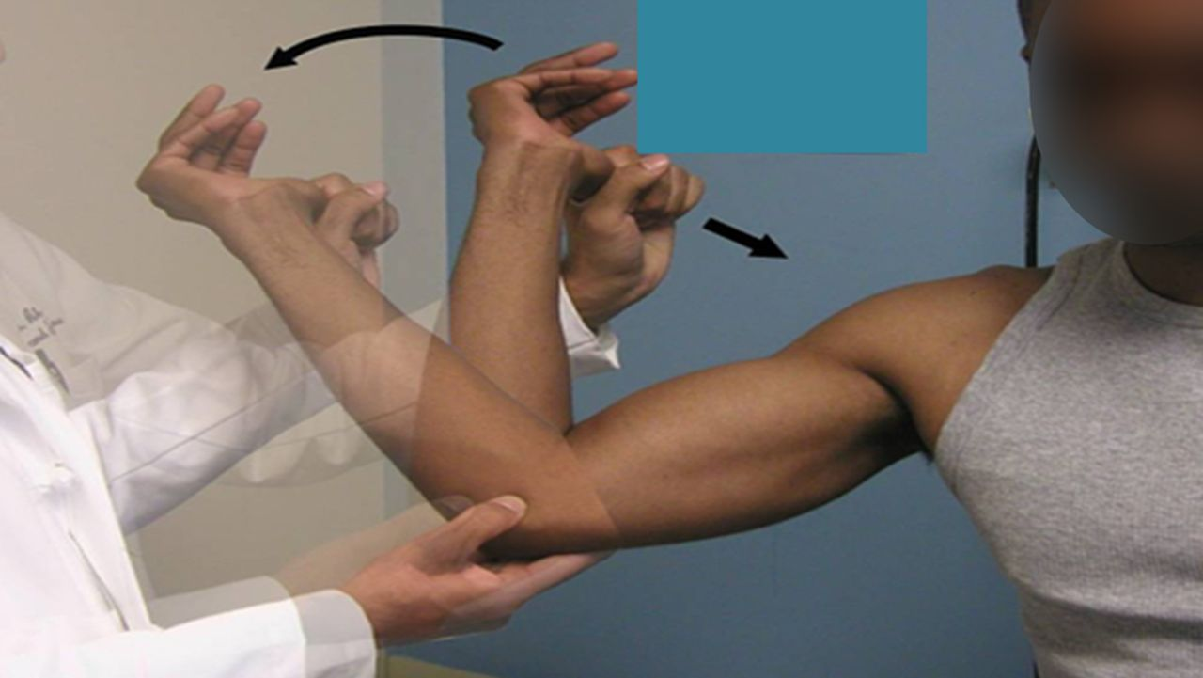

Symptoms Condition

* Valgus Stress Test
* Milking Maneuver
* Moving Valgus Stress Test

Anakwenze OA, Iyengar JJ, Ahmad CS. Treatment of Medical Collateral Ligament Injuries of the Elbow with Use of the “Tommy John” Operation: Indications and Results. JBJS Reviews. 2014; 2(6):e3.

Surgical Interventions15,25,26,27,28,29,30

Characteristics, Return to Play Rates, and Complication Rates



TWO MOST COMMON

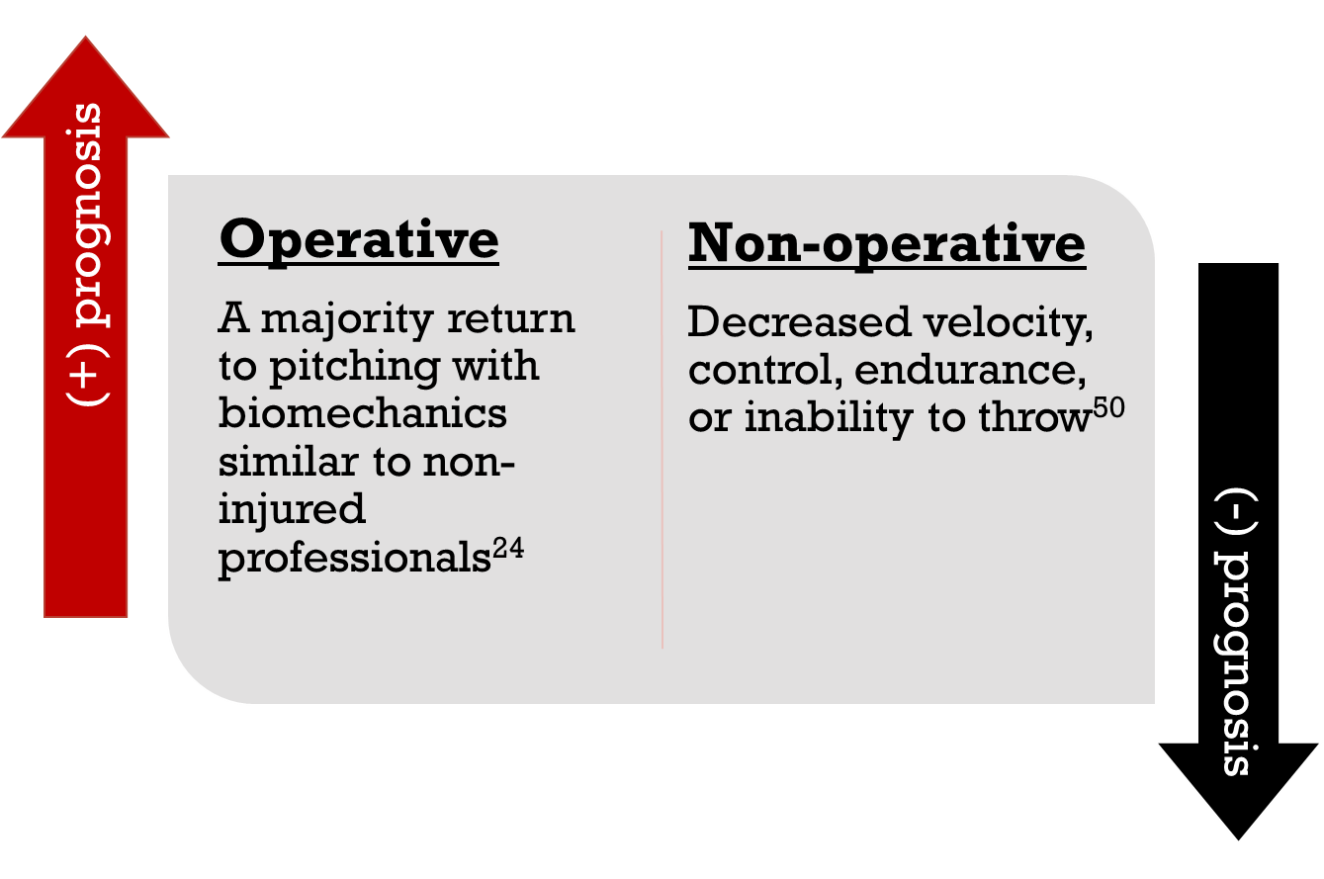

3. No studies differentiate between the effects of different UCL reconstruction techniques

2. No statistically significant difference in pitching performance between pitchers with and without a history of UCL reconstruction

1. UCL reconstruction is not usually career ending

Outcome measure 🡪 Pitching Performance Statistics:31,32,33

2. No statistically significant difference in pitching performance between pitchers with and without a history of UCL reconstruction

3. No studies differentiate between the effects of different UCL reconstruction techniques

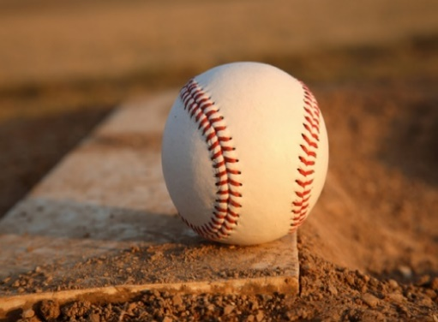

Post-Operative Rehab

**Modified Jobe vs. Docking Procedure**

Key Similarities between Rehab Techniques:34,35,36

* Restore normal UE ROM
* Restore Posterior Shoulder Flexibility
* Normalize NM Function – need a posterior strengthening bias
* Improve endurance
* Improve power and speed
* Address kinetic chain
* Isolated forearm strengthening
* Return to throwing needs to be gradual, individualized, and allows for adequate rest/recovery

Key Differences between Rehab Techniques:

* Splint vs brace - Modified Jobe post-op protocol requires a posterior splint during post-op week 1, while the Docking Procedure utilizes a functional brace post-op day 1.
* Restoration of full wrist AROM - Modified Jobe post-op protocol limits wrist AROM to flexion and extension for at least the first 2 weeks, but the Docking Procedure post-op protocol allows for immediate restoration of wrist AROM in all directions.
* Initiation of elbow isometrics – Modified Jobe post-op protocol allows initiation of elbow isometrics at 2 weeks, but the Docking Procedure does not allow elbow isometrics until weeks 4-6 weeks



Post-Operative Rehab

**Modified Jobe vs. Docking Procedure**

Key Differences between Rehab Techniques:

* Initiation of elbow isotonics - During weeks 4-5 following the Modified Jobe the patient can begin light resistance exercises, but those that had the Docking Procedure must refrain from isotonics until weeks 6 through 12
* Initiation of low load, long duration stretching into elbow extension – Low load, long duration stretching into elbow extension can be imitated during weeks 4-5 following the Modified Jobe, but it must be withheld until post-op weeks 6-12 following the Docking Procedure
* Timing of core strengthening - Modified Jobe emphasizes earlier core strengthening (post op weeks 9-11) than the Docking Procedure (post-op weeks 12-16).
* Initiation of plyometircs - The Modified Jobe post-op protocol initiates plyometric upper extremity exercises about 3 weeks before the Docking Procedure post-op protocol.
* Initiation of throwing – Although the overall Modified Jobe post-op protocol advances more quickly than that of the Docking Procedure, throwing is actually initiated about 2 weeks earlier in the Docking Procedure post-op protocol (18 weeks vs 16 weeks).
* Initiation of hitting – hitting progressions are added significantly earlier in the Modified Jobe post-op protocol (post-op weeks 12-13 vs week 20).



Modified Jobe (Tommy John)

**Post-Operative Rehabilitation**

**Phase 1:** Immediate Post-Operative Phase

(Weeks 1-3)34,35

Goals:

* Protect the healing tissue
* Minimize pain and inflammation
* Limit muscular atrophy

Modified Jobe (Tommy John)

**Phase 1:** **Immediate Post-Operative Phase (Weeks 1-3)34,35**

**Week 1:**

|  |  |
| --- | --- |
| **Wound care** | Sterile gauze used at incision site. Check brace for rubbing or irritation.  Compression garment at elbow to be used with physician’s authorization (2-3 days) |
| **Posterior Splint** | Set at **90º of elbow flexion** |
| **ROM** | Wrist AROM for flexion and extension  Hamstring flexibility if gracilis tendon graft was utilized |
| **Upper Extremity Strength** | Gripping exercises  Bicep isometrics  Shoulder isometrics **EXCEPT** for internal rotation **AND** external rotation |
| **Trunk/Core** | Thoracic Extension  Side lying Thoracic Rotation  Pelvic Tilts – supine, seated, standing, single leg stance as able |
| **Lower Extremity Strength** | Hamstring Strength – eccentrics  Hip Abduction – side steps, SL abduction, clamshells  Hip Extension – glute sets, bridges, hip extension |
| **Breathing Exercises** | Teach proper breathing patterns- no accessory breathing  Progress from supine to functional positions |
| **Balance** | Progressive, safe exercises in kneeling, half kneeling, and single leg |
| **Posture** | Education on proper posture throughout each session |
| **Modalities** | Cryotherapy and e-stim for swelling control at elbow and graft site |
| **Cardiovascular** | Stationary bike without upper body support |

**Week 2:**

|  |  |
| --- | --- |
| **Brace** | Set at 30º-90º of elbow flexion |
| **ROM** | Wrist AROM except for flexion and extension  Elbow AROM in brace. |
| **Upper Extremity Strength** | Initiate wrist isometrics  Initiate elbow extension isometrics  Continue shoulder isometrics **EXCEPT** for internal rotation and external rotation  Light rhythmic stabilization at end range of elbow extension  Scapular retraction exercise with T-band |
| **Trunk/Core** | Continue previous exercises/mobility  Progress as able without weight bearing or stress on elbow  No holding med balls/weights |
| **Lower extremity Strength** | Continue previous activities with safe progressions |
| **Modalities** | Cryotherapy and light compression |

**Week 3:**

|  |  |
| --- | --- |
| **Brace** | Set at 10º-120º of elbow flexion |
| **ROM** | Full wrist AROM  Gradually increase elbow AROM in brace if no pain or pinch is reported |
| **Upper Extremity Strength** | Continue to do the exercises from week 2 |
| **Trunk/Core** | Continue previous exercises/mobility  Progress as able without weight bearing or stress on elbow  No holding med balls/weights |
| **Conditioning** | Begin light cycling- avoid gracilis graft irritation. Core strengthening avoiding any upper extremity stress. May begin lower extremity strengthening (hold if gracilis graft used) |

**Criteria for Advancement to Phase 2:**

* Meet ROM guidelines
* Low, controlled pain
* Consistently low swelling



Goals:

* Promote healing of the tissue
* Control pain and inflammation
* Gradually increase elbow ROM until it is within normal limits
* Good scapular control with exercises
* 5/5 shoulder strength with MMT
* Progress generally conditioning, including lower extremity strength work

Modified Jobe (Tommy John)

**Post-Operative Rehabilitation**

**Phase 2:** Intermediate Phase

(Weeks 4-8)34,35

Modified Jobe (Tommy John)

|  |  |
| --- | --- |
| **Brace** | Set at 10º -110º |
| **ROM** | Continue wrist and elbow AROM in brace  Low load long duration stretch, maintaining forearm in a neutral position, if elbow extension is lacking.  Shoulder internal rotation flexibility as indicated |
| **Upper Extremity Strength** | Continue gripping exercises  Initiate light resistance exercises – use ankle weights around wrists vs dumbbells/bands if possible   * Wrist resistance exercises in flexion, extension, pronation and supination * Elbow resistance exercises in flexion and extension * Shoulder program for rotator cuff strengthening   + Prone Series – row/ extension/ flexion/ horizontal abduction   + Standing - flexion/ abduction/ scaption   + **Initiate IR and ER ISOMETRICS in neutral**   + Protraction supine – manual resistance proximal to the elbow   + UBE – low resistance |
| **Manual Therapy** | Scar massage |
| **Conditioning** | Initiate Elliptical and /or stepper for aerobics  Begin leg press and mini lunges (gracilis graft)  Continue Core strengthening program – no planks |

**Phase 2:** **Intermediate Phase (Weeks 4-8)**

**Weeks 4-5:**

|  |  |
| --- | --- |
| **Brace**  **Weeks 6-7:** | Discontinue brace |
| **ROM** | Full AROM/PROM for the elbow  Joint mobilizations as needed at end range with distraction  Shoulder Total Arc of Motion (IR+ER at 90): dominant = non dominant |
| **Upper Extremity Strength** | Progress shoulder and elbow strengthening exercises   * Elbow progressive resistance exercises using dumb bells and manual resistance * Push up plus on Swiss ball, but elbows **MUST** remain straight * Side lying external Rotation with dumbbells/ankle weights * Thera band exercises - shoulder internal rotation/ external rotation/ horizontal abduction - **AVOID VALGUS STRESS TO THE ELBOW** * Manual resistance exercises (concentric and eccentric) - prone row/horizontal abduction in neutral/ external rotation/ internal rotation/ flexion at 105º in the thumb up position. * Rhythmic stabilization at multiple angles * Thrower’s 10 exercises |
| **Conditioning**  **Week 8:** | Continue progressing the elliptical and /or stepper for aerobics OR initiate running on safe surfaces if the patient did not have a gracilis graft  Continue LE and core strengthening |

|  |  |
| --- | --- |
| **Upper Extremity Strength** | Continue to progress shoulder and elbow strengthening exercises   * Seated row and lat pull down * Prone row with external rotation * Prone quick drops – flexion/ external rotation/ horizontal abduction * Thera-band at 90/90 - external rotation/ internal rotation **(perform slowly avoiding valgus stress at the elbow)** * Rhythmic Stabilization in the 90/90 position and through the D2 PNF - holding at elbow * T-Band at 0 degrees shoulder abduction – IR and ER |
| **Conditioning** | Same as week 6-7  Begin hamstring open chain exercises if a gracilis graft was used |

**Criteria for Advancement to Phase 3:**

* Full elbow AROM
* Total ARC of Motion: dominant – non-dominant
* Low, controlled pain
* Minimal swelling
* UE MMT 5/5 for: shoulder ER and IR at neutral; shoulder horizontal abduction; shoulder flexion; shoulder scaption; shoulder extension; and overhead flexion
* LE MMT 5/5 for: the hip, knees and ankles in all planes
* ER/IR ratio of 67%
* Ankle DF equal bilaterally
* 50º of bilaterally trunk rotation

**Week 8:**



**Phase 3:** Advanced Strengthening

(Weeks 9-16)34,35

Goals:

* Maintain full elbow ROM
* Increase strength, power, and endurance without exacerbation
* Improve muscular control
* Gradually initiate sporting activates
* Patient able to tolerate general conditioning progressions

Modified Jobe (Tommy John)

**Post-Operative Rehabilitation**

|  |  |
| --- | --- |
| **ROM** | Full AROM/PROM for elbow |
| **Upper Extremity Strength** | Continue to progress shoulder and elbow strengthening exercises   * Elbow – **initiate eccentric flexion/extension exercises** and continue concentric strengthening progression * Shoulder – continue concentric strengthening program * Manual resistance D2 PNF pattern with resistance proximal to the elbow. * Body blade – at the 90/90 position for external rotation and in internal rotation * Body blade through the throwing motion. * Continue to do rhythmic Stabilization at the 90/90 position and through the D2 PNF pattern. |
| **Conditioning** | Patient may **begin doing planks** for core strengthening  May begin jogging if a gracilis graft was used  **Weeks 10-16:** Continue to progress upper extremity, lower extremity, and core strengthening (**AVOID** pec fly’s and push-ups) + aerobic activity  Continue LE strengthening progression |

|  |  |
| --- | --- |
| **Body Blade** | internal/external rotation at 0 degrees shoulder abduction  flexion and scaption at 90 degrees shoulder abduction |
| **Plyometrics** | **Initiate and progress double arm plyometrics**   * Double arm ball toss – start at chest height 2-3kg ball * Overhead Soccer Throw * Wall dribbles – semi circle * Ball chops * Free throws- 3kg ball (100-200 reps) against a wall |

**Phase 3:** **Advanced Strengthening (Weeks 9-18)34,35**

**Week 10-11:**

**Week 9:**

Modified Jobe (Tommy John)

|  |  |
| --- | --- |
| **Upper Extremity Strengthening** | Initiate over-the-shoulder deceleration exercise with 1kg ball  Begin closed chain shoulder stability exercises |
| **Functional Exercise** | **Initiate interval hitting program** |
| **Plyometrics** | **Initiate and progress single arm plyometrics**   * Initiate over-the-shoulder deceleration exercise with 1kg ball * Begin closed chain shoulder stability exercises * Plyometrics T-band ER/IR quick contractions. * 90/90 wall dribbles |

|  |  |
| --- | --- |
| **Functional Exercise** | **Initiate light throwing**   * 15 ft baseball throws into wall for mechanics   + Ensure adequate elbow elevation above the shoulder for over the top throwing mechanics.   + Finish throw with ample deceleration ROM from the shoulder back and trunk |

|  |  |
| --- | --- |
| **Isokinetic Testing** | IR/ER testing to be performed at 90, 180 and 300 deg./sec |

PP

**Weeks 16-18:**

**Weeks 14-15:**

**Weeks 12-13:**



Modified Jobe (Tommy John)

**Post-Operative Rehabilitation**

**Phase 4:** Return-to-Activity Phase

(Weeks 18+)34,35

Goals:

* Continue to maintain full upper extremity ROM
* Continue to increase strength, power, and endurance in UE musculature
* Gradual return-to-sport activities if the patient achieves the acceptable isokinetic test results for glenohumeral internal and external rotators
  + Shoulder non-dominant to dominant side strength to be 90%
  + Shoulder external rotators to be 65% of internal rotators.

|  |  |
| --- | --- |
| **Functional Activities** | Begin throwing progression with monitored mechanics avoiding medial elbow stress. – Requires physician clearance to initiate   * Maintain elbow elevation above shoulder height. * Curl hop to be used when initiating throws of 90 ft and greater. * Deceleration to include good back and trunk flexion ROM |

**Phase 4:** **Advanced Strengthening (Weeks 18+)34,35**

**Weeks 18+:**

Modified Jobe (Tommy John)



Docking Procedure

**Post-Operative Rehabilitation**

**Post-Operative Phase 1: Weeks 1-434**

Goals:

* Protect healing tissue
* Minimize pain and swelling
* Immediate restoration of elbow ROM
* Independent HEP

|  |  |
| --- | --- |
| **Brace** | Brace set at 30º-90º of flexion |
| **Precautions** | Brace should be worn at all times  No PROM of the elbow  Avoid valgus stress |
| **Treatment Strategies** | Wrist AROM  Elbow AROM in brace  Shoulder/Scapula isometrics  Gripping exercises  Cryotherapy  Home Exercise Plan |

**Criteria for Advancement to Phase 2:**

* Elbow AROM: 30º-90º
* Low, controlled pain
* Minimal swelling

**Post-Operative Phase 1: Weeks 1-434**

Docking Procedure



Goals:

* Promote healing of repaired tissue
* Continue to minimize pain and swelling
* Achieve 15º-115º for elbow AROM

**Post-Operative Phase 2: Weeks 4-634**

**Post-Operative Rehabilitation**

Docking Procedure

|  |  |
| --- | --- |
| **Brace** | Brace set to 15º-115º |
| **Precautions** | Brace should be worn at all times  No PROM of the elbow  Avoid valgus stress |
| **Treatment Strategies** | Continue AROM in brace  Begin pain-free isometrics in brace (deltoid, wrist flexion/extension, elbow flexion/extension)  Manual scapular stabilization exercises with proximal resistance  Modify Home Exercise Program |

**Criteria for Advancement to Phase 3:**

* Elbow AROM: 15º-115º
* Low, controlled pain
* Minimal swelling

**Post-Operative Phase 2: Weeks 4-634**

Docking Procedure



Goals:

* Restore full elbow ROM
* All upper extremity strength 5/5
* Begin to restore upper extremity endurance

**Post-Operative Phase 3: Weeks 6-1234**

**Post-Operative Rehabilitation**

Docking Procedure

Docking Procedure

|  |  |
| --- | --- |
| **Brace** | **Discontinue** |
| **Precautions** | Avoid PROM  Minimize valgus stress  Avoid pain with therapeutic exercise |
| **Treatment Strategies** | Continue elbow AROM  Low load, long duration stretch into elbow extension  Begin isotonics for scapula, shoulder, elbow, forearm, and wrist   * Begin internal/external rotation strengthening at 8 weeks * Begin forearm pronation/supination strengthening at 8 weeks   UBE  Scapular stabilization exercises  PNF patterns for strengthening and stabilization  Initiate eccentric training when strength is adequate  Modalities as needed  Modify Home Exercise Program |

**Criteria for Advancement to Phase 4:**

* Pain-free
* Full elbow ROM
* All UE strength 5/5 on MMT

**Post-Operative Phase 3: Weeks 6-1234**



Goals:

* Restore full UE strength and flexibility
* Restore normal neuromuscular function
* **Prepare** for return to activity

Docking Procedure

**Post-Operative Rehabilitation**

**Post-Operative Phase 4: Weeks 12-1634**

**Post-Operative Phase 4: Weeks 12-1634**

Docking Procedure

**Criteria for Advancement to Phase 5:**

* Complete plyometrics without symptoms
* Normal UE flexibility

|  |  |
| --- | --- |
| **Precautions** | Pain-free plyometrics |
| **Treatment Strategies** | Advance internal and external rotation exercises to the 90/90 position  Establish a flexibility program to restore full flexibility in the upper extremity  Continue to perform upper extremity neuromuscular drills and endurance activities  Begin upper extremity plyometrics  Implement LE and trunk strengthening |



Goals:

* Return to activity
* Prevent re-injury

Docking Procedure

**Post-Operative Rehabilitation**

**Post-Operative Phase 5: Months 4-934**

|  |  |
| --- | --- |
| **Precautions** | Avoid significant pain with throwing or hitting  Avoid loss of strength and flexibility |
| **Treatment Strategies** | Begin interval throwing program at four months  Begin hitting program at 5 months  Continue flexibility exercises  Continue strengthening program |

**Criteria for Discharge**

* Pain-free
* Independent with Home Exercise Program
* Independent with throwing/hitting program

Docking Procedure

**Post-Operative Phase 5: Months 4-934**

In order to begin the program, the athletes MUST meet the following criteria:

* Obtain clearance from a physician
* Pain-free
* Full ROM at the shoulder and elbow
* Must have completed a strengthening program for the upper body, lower body, and core

The Ohio State University has an excellent RETURN TO THROWING GUIDELINE designed to guide baseball athletes through a progressive plan to safely return them to pitching. The program gradually increase the throwing distance and volume, while utilizing the best available to evidence to optimize patient safety and success. This program should always be completed under the supervision of a medical professional (physician, physical therapist, or athletic trainer. The guidelines below are taken directly from The Ohio State’s Medical Webpage.

The Ohio State University

Return to Throwing Guidelines37

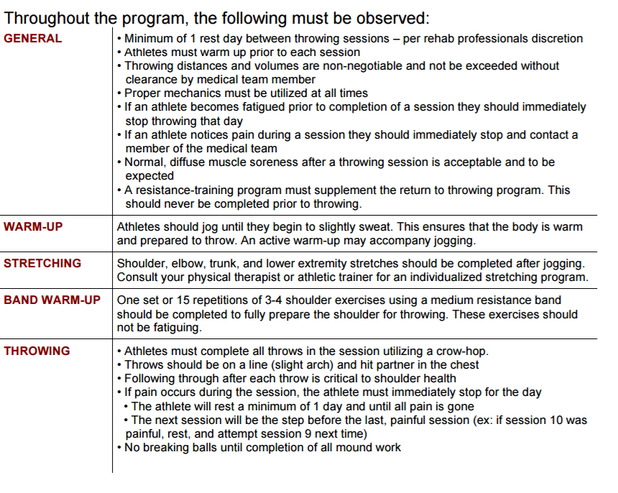

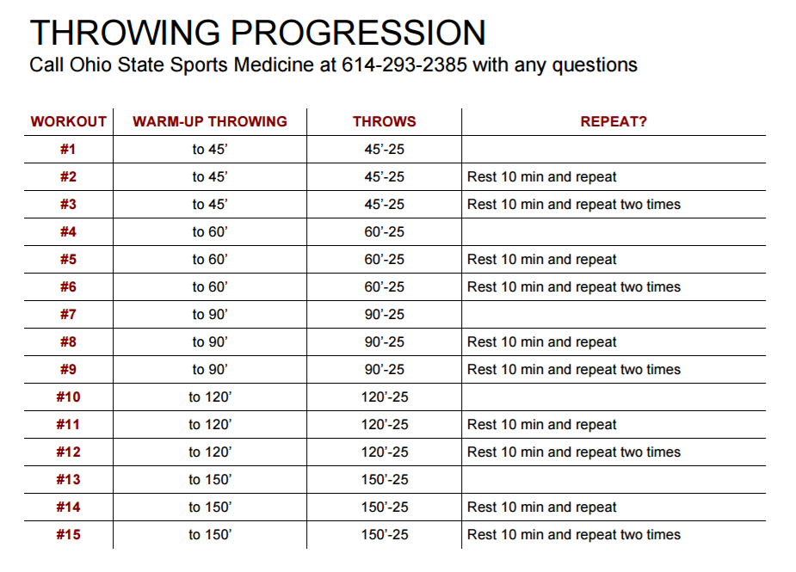

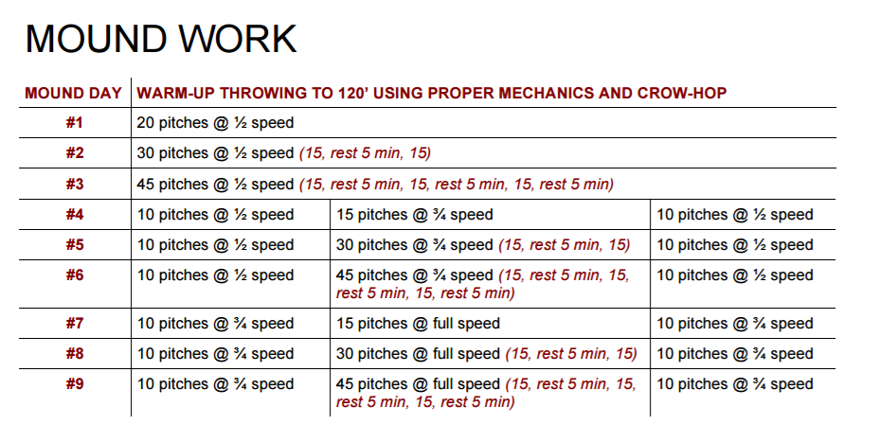

Work Cited

1. Sgori T. Biomechanics: are our bodies made to throw a baseball? Lecture Presented at: HSS Sports Medicine Symposium; April 8th, 2016; New York City, NY.
2. Escamilla R, Andrews JR. Shoulder Muscle Recruitment Patterns and Biomechanics during Upper Extremity Sports. Sports Med 2009; 39 (7): 569-590.
3. Calabrese GJ. Pitching mechanics, revisited. Int J Supports Phys Ther. 2013; 8(5): 652-660.
4. Seroyer ST, Nho SJ, Bach BR, Bush-Joseph CA, Nicholson GP, Romeo AA. The kinetic chain in overhead pitching: its potential role for performance enhancement and injury prevention. Sports Health. 2010; 2(2):135-146.
5. Fortenbaugh D, Fleisig GS, Andrews. Baseball pitching biomechanics in relation to injury risk and performance. Sports Health. 2009 Jul; 1(4): 314–320. doi:  10.1177/1941738109338546.
6. Werner SL, Murray TA, Hwakins RJ, Gill TJ. Relationship between throwing mechanics and elbow valgus in professional baseball pitchers. J Shoulder Elbow Surg. 2002;11:151-155.
7. Werner SL, Fleisig GS, Dillman CJ, Andrews JR. Biomechanics of the elbow during baseball pitching. J Orthop Sports Phys Ther. 1993 Jun;17(6):274-8.
8. Ellis S. Pitching Faults. The Complete Pitcher. http://www.thecompletepitcher.com/pitching_faults.htm Accessed April 1, 2017.
9. Sakata J, Nakamura E, Suzukawa M, Akaike A, Shimiizu K. Physical risk factors for a medial elbow injury in junior baseball players a prospective cohort study of 353 players. AJSM. 2017; 45(1):136-143
10. Fleisig GS, Andrews JR. Prevention of elbow injuries in youth baseball. *Sports Health*. 2012;4(5):419-424.
11. Fleisig GS, Andrews JR, Cutter GR, Weber A, Loftice J, McMichael C, Hassell N, Lyman S. Risk of serious injury for young baseball pitchers: a 10 year prospective study. *AJSM*. 2010; 39(2):253-257.
12. Solomito M, Garibay EJ, Woods JR, Ounpuu S, Nissen CW. Lateral trunk lean in pitchers affects both ball velocity and upper extremity joint motions. AJSM. 2015; 43(5):1235-1240
13. Garrison JC, Cole MA, Conway JE, Macko MJ, Thigpen C, Shanley E. Shoulder range of motion deficits in baseball players with an ulnar collateral ligament tear. American Journal of Sports Medicine. 2012; 40(11):2597-2603
14. Davis JT,  Limpisvasti O, Fluhme D, Mohr KJ, Yocum LA, Elattrache NS, Jobe FW. The effect of pitching biomechanics on the upper extremity in youth and adolescent baseball pitchers*. Am J Sports Med.* 2009 Aug;37(8):1484-91. doi: 10.1177/0363546509340226.
15. Altcheck DW. Biomechanics: are our bodies made to throw a baseball? Lecture Presented at: HSS Sports Medicine Symposium; April 8th, 2016; New York City, NY
16. Polster JM, Bullen J, Obuchowski NA, Bryan JA, Soloff L, Schickendantz. Relationship between humeral torsion and inury in professional baseball pitchers. The American Journal of Sports Medicine. 2013; 41(9):2015-2021.
17. Noonan TJ, Thigpen CA, Bailey LB, Wyland DJ, Kissenberth M, Hawkins RJ, Shanley E. Humeral torsion as a risk factor for shoulder and elbow injury in professional baseball pitchers. *Am J Sports Med*. 2016 Sep;44(9):2214-9. doi: 10.1177/0363546516648438.
18. Whiteside D, Martini DN, Lepley AS, Zemicke RF, Goulet GC. Predictors of ulnar collateral ligament reconstruction in major league baseball pitchers. The American Journal of Sports Medicine. 2016; 44(9)2202-2209.
19. Anz A, Bushnell BD, Griffin LP, Noonan TJ, Torry MR, Hawkins RJ. Correlation of torque and elbow injury in professional baseball pitchers. *The American Journal of Sports Medicine.* 2010; 38(7):1368-1374.
20. Keller RA, Marshall NE, Guest JM, Okoroha KR, Jung EK, Moutzouros V. Major league baseball pitch velocity and pitch type associated with risk of ulnar collateral ligament injury. Journal of Shoulder and Elbow Surgery. 2016; 25(4):671-675.

Work Cited

1. Dines JS, Frank JB, Akerman M, Yocum LA. Glenohumeral internal rotation deficits in baseball players with ulnar collateral ligament insufficiency. The American Journal of Sports Medicine. 2009; 37(3):566-570.
2. Miller m, Hatch D. Medial UCL injury and valgus instability. OrthoBullets. http://www.orthobullets.com/sports/3079/medial-ucl-injury-and-valgus-instability. Published July 12, 2015. Accessed April 11, 2016.
3. Langer P, Fadale P, Hulstyn M. Evolution of the treatment options of ulnar collateral ligament injuries of the elbow. *Br J Sports Med.* 2006 Jun; 40(6): 499–506.
4. Sjsu D. Forearm and elbow pathologies. Lecture presented at: Kaiser Permanente Medical Group Santa Teresa Medical Center; Spring 2008; San Jose, Ca
5. Watson JN, McQueen P, Hutchinson MR. A systematic review of ulnar collateral ligament reconstruction techniques. *Am J Sports Med*. 2014;42(10):2510-2516. doi:10.1177/0363546513509051
6. Redler LH, Degen RM, McDonald LS, Altcheck DW, Dines JS. Elbow ulnar collateral ligament injuries in athletes: can we improve our outcomes? *World J Orthop*. 2016 Apr 18; 7(4): 229–243.
7. Bowers AL, Dines JS, Dines DM, Altcheck DW. Elbow medial ulnar collateral ligament reconstruction: Clinical relevance and the docking technique. *Journal of Shoulder and Elbow Surgery.* 2010. 19(2); 110-117. doi:10.1016/j.jse.2010.01.005.
8. Rohrbough JT, Altchek DW, Hyman J, Williams RJ, Botts JD. Medial collateral ligament reconstruction of the elbow using the docking technique. *Am J Sports Med*. 2002;30:541–548
9. Vitale MA, Ahmad CS. The outcome of elbow ulnar collateral ligament reconstruction in overhead athletes: a systematic review. Am J Sports Med. 2008;36:1193–1205
10. Paletta GA, Wright RW. The modified docking procedure for elbow ulnar collateral ligament reconstruction: 2 year follow-up in elite throwers. *The American Journal of Sports Medicine.* 2006.
11. Erickson BJ, Gupta AK, Harris JD, et al. Rate of return to pitching and performance after Tommy John surgery in Major League Baseball pitchers. *Am J Sports Med*. 2014;42(3):536-543. doi:10.1177/0363546513510890.
12. Gibson BW, Webner D, Huffman GR, Sennett BJ. Ulnar collateral ligament reconstruction in major league baseball pitchers. *Am J Sports Med*. 2007;35(4):575-581. doi:10.1177/0363546506296737
13. Wymore L, Chin P, Geary C, et al. Performance and Injury Characteristics of Pitchers Entering the Major League Baseball Draft After Ulnar Collateral Ligament Reconstruction. *Am J Sports Med*. August 2016. doi:10.1177/0363546516659305
14. Ellenbecker TS, Wilk KE, Altchek DW, Andrews JR. Current concepts in rehabilitation following ulnar collateral ligament reconstruction. *Sports Health*. 2009; 301-313.
15. Wexner Medical Center. Ulnar Collateral Ligament Reconstruction Guideline. Wexner Medical. https://wexnermedical.osu.edu/~/media/Files/WexnerMedical/Patient-Care/Healthcare-Services/Sports-Medicine/Education/Medical-Professionals/UlnarCollateralLigamentReconstruction.pdf?la=en. Accessed April 12th, 2017

**Work Cited**

1. Levinson M. Rehabilitation and return to play following UCL reconstruction: the HSS experience. Lecture Presented at: HSS Sports Medicine Symposium; April 8th, 2016; New York City, NY
2. The Ohio State University Wexner Medical Center. Throwing Progression. Wexner Medical. https://wexnermedical.osu.edu/~/media/Files/WexnerMedical/Patient-Care/Healthcare-Services/Sports-Medicine/Education/Medical-Professionals/ThrowingProgressionBaseball.pdf?la=en. Accessed April 15, 2017.