Sample strengthening Exercise Routine:

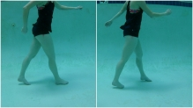¹

Warm up: Walking Forward

Walk forward in the pool. Make sure to stand up tall. You may walk with a water walker or push a water wheel chair to provide support. Walk for 5 to 8 minutes at a comfortable pace.

Calf Stretch

Place your foot where the pool slopes upward so that your toes are higher you’re your heel. Lean forward. You should feel a gentle stretch in the back of your calf. Hold the position 30 seconds, take a break and then repeat for 30 seconds 2 times more.

¹

Hamstring Stretch:

Place foot on step. Slowly lean forward, keeping back straight and bending at hips until a stretch is felt in back of leg. Hold the stretch for 30 seconds then take a ten second break and repeat once more.

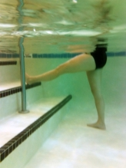¹

Sideways walking
Face the pool wall. Take sideways steps with your body and toes facing the wall. Take 10-20 steps in 1 direction and then return.
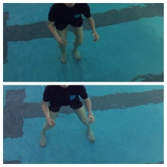¹

Mini-Squats: Holding on and facing the wall. Squat down like you would sit in chair part way. Repeat ten times and rest for 30 seconds. Repeat this cycle 2x more.
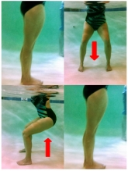¹

4 way hip : Goal to strengthen your hips- hold onto the wall for balance

Repeat the following cycle three times with each leg (resting 30 seconds in between cycles):
1 CYCLE consists 1 set in all 4 positions:
Position 1: start standing with feet together cross one leg in front of the other return to standing with feet together: repeat 10 times
Position 2: start standing with feet together and kick one leg straight out in front of the other one: repeat 10 times
Position 3: Start standing with feet together and kick one leg out to the side: repeat 10 times
Position 4: Start standing with feet together and kick one out straight behind: repeat 10 times
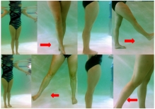¹

Heel Raise:
Holding onto the side of the pool. Raise yourself up on your toes: repeat 10 times and take 30 seconds rest. Then repeat the cycle: of 10 repetitions and 30 seconds rest 2 times more.

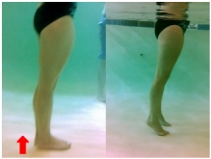¹

Alternating Bicep Curls with Paddle Resistance
Standing tall, arms at side and palms up alternate flexing your arm toward your shoulder against the water’s resistance. Perform 20 repetitions and rest for 30 seconds. Repeat the 20 repetitions and rest 2x more.

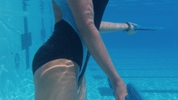¹

Horizontal Adduction/Abduction: standing in the water (if unstable can stand with back against the wall and lean against the wall.) Feet are shoulder width apart with knees slightly bent.

To increase the resistance hold pool dumbbells.
Repetition: start with arms on the surface of the water straight out to the side (T position) then bring arms together in front of you and return arms to staring T position. Perform ten repetitions and rest 30 seconds. Repeat this cycle 2x more.
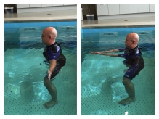

Balance: perform this near the side of the pool so that you can hold on if you loose your balance.

Option 1: noodle in front of you to hold with your hands on the water’s surface, feet together your side faces the side of the pool. Hold 30 seconds. Repeat 2x more.

Option 2: one foot in front of the other foot in a line (see photo bellow) Hold 30 seconds. Repeat 2x more.
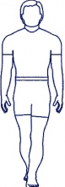

Option 3: same as above but balance on one foot for 30 seconds.

warm down: 5 minutes of water walking getting slower and slower

References: Pictures from:
1. HEP2go. HEP2go exercise. https://www.hep2go.com/index_b.php?userRef=gciaake. Accessed April 1, 2017.

