The Buddy Club
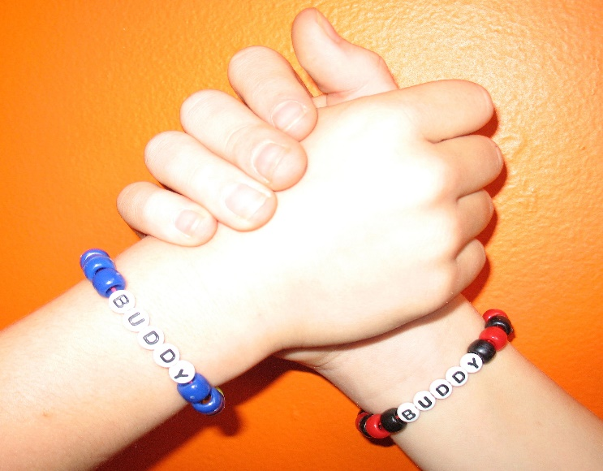
Leadership, Citizenship, and Friendship

The Buddy Club has arrived at your school! Join us for games, fitness activities, arts and crafts, and music while making new friends.
WHO: Everyone is invited!
WHEN: Mondays 11:50am-12:30pm
WHERE: School Gym

This is the school club that promotes leadership, citizenship, and friendship through movement and social activities for the entire student body! Sign up in the gym and become a member today!

