Aquatic Therapy (AT) for Patients with Neurological Disease
Precautions:¹
- Cardiovascular disease
- Cardiopulmonary disease
- History of CVA or Epilepsy
- Incontinence
- Cold or influenza
- Fever
- Skin conditions
- Chlorine allergy
- Tracheotomy
- Urinary incontinence
- Hydrophobia
- Diarrhea
- Vomiting

Contra-indications:¹
- Urinary tract infection
- Uncontrolled epilepsy
- Actively bleeding wounds
- Active Hepatitis A infection
- Certain unstable heart conditions such as: myocarditis and uncontrolled angina

Indications for Aquatic Therapy

- To relieve pain¹
- To reduce muscle spasm
- To relax
- To increase joint range of motion
- To re-educate muscles
- To strengthen weak muscles²
- To improve functional mobility
- To improve circulation
- To improve balance⁸

Properties of Water:
- Buoyancy: when a body is immersed in water, it experiences an upward force equal to the weight of volume of water displaced³
- Hydrostatic Pressure: Pressure that the water exerts on the body
- Water Resistance:
- Shape resistance: object moving in water experiences resistance in the direction of movement, and lower pressure behind
- Wave resistance:³ Experience resistance with colliding waves from moving water
- Friction:³ Force acting opposite to the relative motion of the object.
- Turbulence: Violent/unsteady movement of air or water.
- Thermodynamics: Water has high heat capacity and is a good conductor: transfers heat to the body quickly

Types of Aquatic therapy:⁵
- Ai Chi
- Aquatic PNF
- Bad Ragaz Ring Method
- Halliwick Method
- Watsu

Evidence for Aquatic Therapy:
There is a need for larger, higher quality randomized controlled trials
- Multiple Sclerosis: Small RCTs, some evidence that aquatic therapy improves fatigue⁶, health related quality of life⁷ decreases in pain, and muscle spasms⁶
- Parkinson’s: One RCT found that AT group had increase in dynamic balance, TUG, and BSS compared to the control group⁸
- Stroke: AT may improve strength in paretic limb⁹ and balance¹⁰

⁴
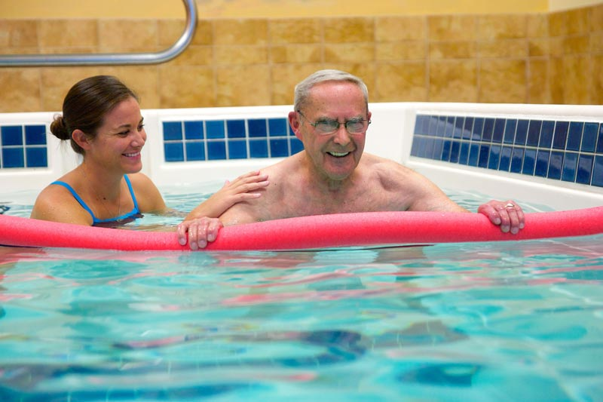

Abbreviations:
RCT=Randomized Controlled Trial
AT = Aquatic Therapy

References:
1. P Howell D, Ramage E. Australian guidelines for aquatic physiotherapists working in and/or managing hydrotherapy pools .
2. Bayraktar D, Guclu-gunduz A, Yazici G, Lambeck J. Effects of Ai-Chi on balance , functional mobility , strength and fatigue in patients with multiple sclerosis : A pilot study. 2013;33:431-437. doi:10.3233/NRE-130974.
3. Torres-ronda L, Schelling X. The Properties of Water and their Applications for Training by. 2014;44(December):237-248.
4. Therapy BP. Aquatic Therapy. http://www.biosports.net/services/aquatic-therapy.php. Accessed April 3, 2017.
5. Aquaticnet.com. Article - How to define aquatic specially techniques. http://www.aquaticnet.com/Article - How to define aquatic specially techniques.htm. Accessed January 12, 2017.
6. Mar A, Matar GA, Lara-palomo I, Saavedra-hern M, Arroyo-morales M, Moreno-lorenzo C. Hydrotherapy for the Treatment of Pain in People with Multiple Sclerosis : A Randomized Controlled Trial. 2012;2012. doi:10.1155/2012/473963.
7. kargarfar, Mehdi, Etemadifar, Masoud, Baker, Peter, Mehrabi, Maryam, Hayatbakhsh R. Effect of Aquatic Exercise Training on Fatigue and Health-Related Quality of Life in Patients With. 2012;93(October):1701-1708.
8. Vivas J, Arias P, Cudeiro J. Aquatic Therapy Versus Conventional Land-Based Therapy for Parkinson ’ s Disease : An Open-Label Pilot Study. YAPMR. 2011;92(8):1202-1210. doi:10.1016/j.apmr.2011.03.017.
9. Zhang, Wang Y, Huang L-P, Bai, B, Zhou, S, Yim,M-M, Zhao, H , Zhou X-N. for Subacute Stroke Patients by Enhancing Muscular Strength of Paretic Lower Limbs Without. 2016;95(11):840-849. doi:10.1097/PHM.0000000000000512.
10. Chan K, Phadke CP, Stremler D, et al. Topics in Stroke Rehabilitation The effect of water-based exercises on balance in persons post-stroke : a randomized controlled trial. Top Stroke Rehabil. 2017;9357(March):1-8. doi:10.1080/10749357.2016.1251742.

