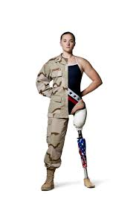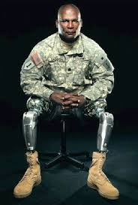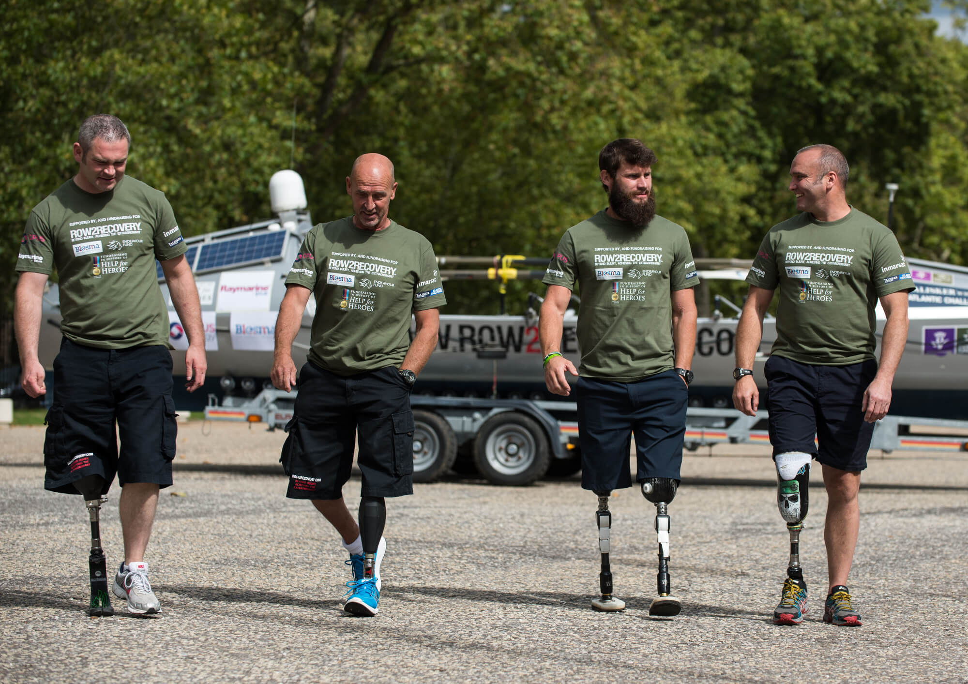

🙞 🙜

Charles George Veterans Administration Medical Center

1100 Tunnel Road

Asheville, NC 28805

🙞 🙜

### Charles George

### VA Medical Center

### Asheville, NC

What to expect

Amputee Clinic

**What are the Standards for Prosthetic Limb Trial?**

The veteran should be able to do the following tasks with limited help:

* Transfer: stand up from a chair without help.
* Ambulate: walk with a walker for at least 20 feet with limited help.
* Activity Tolerance: stand with a walker for 5 minutes without sitting.
* Mental health: follow instructions that have multiple steps.

The veteran should have no wounds on either leg. A brief mental health assessment may be necessary.

**What is Amputee Clinic?**

**Amputee Clinic** is a clinic for veterans who have undergone lower limb amputation surgery and are ready to be assessed whether they meet the standards to try an artificial limb called a ‘**prosthetic limb'**.

The Amputee Clinic team includes:

* A **physiatrist** (medical doctor who specializes in treating illnesses that affect how we move). The physiatrist will assess your general health, strength, skin care, and the sensation in your hands and feet.
* **A prosthetist** (specialist who makes the prosthetic limb). The prosthetist will help decide what prosthetic limb is best suited for your walking abilities.
* A **physical or kinesio therapist** (specialists who teach you how to walk with the prosthetic limb). The therapist will assess your activity tolerance, range of motion and your ability to correctly follow directions.

The purpose of Amputee Clinic is to determine if the veteran will be able to safely use the prosthetic limb.

**Approved for Prosthetic Limb Trial? Now what?**

If approved by the Amputee Clinic, the veteran will be fitted with a prototype prosthetic limb called a **‘test socket’**.

The veteran will:

* Be admitted to the **Community Living Center** (CLC) to learn how to use the prosthetic limb safely.
* Learn how to manage changes in the skin and volume of the limb, which can happen with walking.
* Be assessed for how safe they are with walking and managing the increased responsibilities of the prosthetic limb.

If the veteran demonstrates the ability to manage these responsibilities, the test socket will be changed to a permanent socket before the veteran is discharged home with it.