Progressive Return to Activity for Service Members with Mild Traumatic Brain Injury: Walter Reed National Military Medical Center Education and Implementation

Written by Caroline Cleveland
2018

PHYT 854 Educational Program Capstone Project
University of North Carolina at Chapel Hill, Doctor of Physical Therapy Program

Background
Traumatic Brain Injuries (TBI) are categorized as severe, moderate, and mild. Of the 18,311 TBIs sustained among U.S. military service members (SM) in 2017, 1% were severe, 14% were moderate, and 85% were mild. These categories are distinguishable based on loss of consciousness, altered mental status, and post traumatic amnesia (PTA). For instance, a TBI is categorized as severe if the SM loses consciousness or demonstrates a disoriented state for over 24 hours or experiences PTA for more than seven days. Conversely, a TBI is categorized as mild if the SM loses consciousness for up to 30 minutes, demonstrates a disoriented state for less than 24 hours, or experiences PTA for less than 24 hours. Moderate TBI is categorized between severe and mild.¹
Military TBIs have many etiologies, including motor vehicle accidents which continues to be a leading cause of mild TBIs (mTBI), also termed concussions, both in and outside the military.² Similar to civilian athletes, both formal combative training and informal sports are also significant causes of mTBI in SMs.³ Ultimately, the leading cause of military mTBI in the garrison environment remains airborne operations and falls, and the leading cause of military mTBI in the deployed environment remains blasts, such as from improvised explosive devices and rocket propelled grenades.³
Although the majority of military injuries effect the musculoskeletal system, 15% of SMs sustain at least one mTBI during their military career.⁴ Additionally, mTBI is both a complex and difficult injury to treat, and continuous focused research is still slowly illuminating the extent of the injury and mechanisms of recovery in both field and tactical athletes.² Due to the difficulty of diagnosis, the mission first culture of the military, and warfighters’ self-sacrificing mindset, mTBIs often go untreated and effects often compound overs years of arduous service without appropriate rehabilitation. Left undiagnosed and untreated, repeated mTBI may lead to progressive and accelerated age-related neurodegeneration in affected SMs, although the science on this theory remains unclear at this time.² As the nature of military operations makes it impossible to prevent all mTBIs, early diagnosis, targeted primary care treatment and, when needed, rehabilitation services may serve as a form of prevention; by ensuring brain recovery before SMs return-to-duty, the potential for the compounding effects of multiple mTBI can be mitigated. Thus, awareness and implementation of current evidence-based clinical practice guidelines are paramount to intervene against the mitigatable burdens that may impact the SM, the mission, their unit, and their family.

Gaps in Previous Guidance
Military post-mTBI clinical guidance was formerly based primarily on the Zurich Consensus statements from the International Conference on Concussion in Sport,^{5,6} as reflected in the VA/DoD clinical practice guideline (CPG)⁷ and the DoD Concussion Management Algorithm (CMA).⁸ However, several gaps existed in this guidance. First, the guidance was based on evidence and subject matter expert opinion regarding identification and treatment for mTBI as it applies to civilian athletes. These athletes were not subject to the same physical, sensory, cognitive and environmental demands as the tactical athletes who operate in austere environments under hostile conditions. Second, former guidance required that SMs be completely asymptomatic before gradually returning to duty. Therefore, it was necessary to replace the asymptomatic requirement with a symptom resolution requirement, defined as a “return to self-reported preconcussion symptom baseline”.⁹
Third and perhaps most pertinent, previous guidance did not offer definitive directives for SM whose symptoms did not resolve spontaneously and immediately following injury. The general directive remained to rest, but the blanket use of rest did not specify parameters or domains (i.e. physical, cognitive). This lack of specificity represented a serious gap because, while rest has its benefits for healing after mTBI, prolonged rest has deleterious effects on both the brain and body (i.e. pain, fatigue, vestibular dysfunction).¹⁰ Lack of exertion through activities that are too far below symptomatic threshold heartrates (HR) may fail to habituate and rehabilitate the brain and autonomic nervous system function, contributing to prolonged symptoms.¹¹ Lack of exertional habituation can also contribute to fear avoidance, which may psychosomatically exacerbate an increased number of symptoms at a lower HR.¹¹
High-intensity physical exercise can also have deleterious effects during the first days to weeks post-mTBI, exacerbating several symptoms for hours to days and often prolonging recovery time.¹² However, evidence suggests that 20 minutes of non-contact aerobic exercise at moderate intensities just below symptomatic threshold HR can increase symptomatic threshold HR by 20% of theoretical maximum heartrate (TMHR).¹¹ In this way, moderate intensity exercise can actually improve physical and cognitive exertional symptoms post-mTBI. Furthermore, moderate intensity exercise usually does not exacerbate more than one symptom, and the exacerbation dissipates within minutes of exercise cessation.¹² Therefore, graded exercise below symptomatic threshold HR and symptom exacerbation appears to benefit individuals with persistent symptoms beyond 24 hours of rest.⁹

Filling the Gaps with Evidence and Expertise
In light of the gaps in guidance, a standardized and specific activity progression tailored to meet the needs of SM’s whose symptoms did not resolve after a predetermined rest period was identified as a military necessity. This prompted the formation of the Progressive Return to Activity Following Mild TBI Working Group (PAWG) to synthesize current literature, relevant protocols, and expert opinion from all military branches and across the civilian sport related concussion (SRC) community. The group examined evidence that included research with subjects that were at least 16 years old and spanned both civilian athletic and military populations. Civilian populations had to form a significant foundation for guidance development due to the scarcity of evidence in military populations. Five relevant and widely accepted protocols were also examined, each of which involved an exercise progression over two to six stages, including the Zurich consensus,^{5,6} US Army Special Operations Command Guidelines for Post-Concussion Rehabilitation,¹³ TBI Exertional Testing Procedure for the Joint Theater Trauma System CPG for Management of mTBI/Concussion in the Deployed Setting,¹⁴ Graduated Exertional Return to Play Protocol from University of North Carolina at Chapel Hill,¹⁵ and British Columbia Concussion Rehabilitation Program.¹⁶
Ultimately, the group adapted the Zurich consensus statements’ protocol to coordinate with military policy related to concussion, to reflect the unique structure and function of military paradigms, to address cognitive and vestibular components of mTBI, and to specifically define rest and activity parameters. Furthermore, while keeping the project grounded in existing evidence, the group contributed their clinical expertise to interpret inconclusive research findings in three key areas. First, the group included outcome measures to monitor exertion and symptoms. (See Measures.) They also, included considerations of pre-injury symptoms and symptoms from other conditions that overlapped with mTBI symptoms that may not have been directly related to the injury, such as fatigue, stress, dehydration, and caffeine and nicotine use and withdrawal.^{7,17-19} For instance, exertion often causes fatigue in non-concussed individuals.²⁰ Second, the group defined the duration and nature of rest and the types of activity recommended or discouraged at each level. Finally, they made recommendations regarding progression between stages, when to hold a SM at a stage, when to return to the previous stage of recovery, and when to refer for specialty care due to lack of progress.⁹ (See Stages below.)

Progressive Return to Activity (PRA)
Eligibility
PRA is the current standard of care for the following SMs within the first 24 hours of their mTBI: (1) SMs who have sustained their first mTBI in a 12 month and whose symptoms either do not resolve following an initial 24 to 48 hours of rest or return during exertional testing following an initial 24 to 48 hours of rest; (2) SMs who have sustained their second mTBI in a 12 month period and are mandated to participate in PRA in accordance with Department of Defense Instruction 6490.11: Policy Guidance for Management of mTBI.²¹⁻²³ The latter SMs are prescribed an automatic 48 hours of rest and remain at Stage 2 for at least 5 days before progressing. (See Figure 1 and Figure 1A.) SMs who have sustained three or more mTBIs in a 12 month period are not appropriate for PRA and are instead referred to a higher level or care, such as neurology, for a “comprehensive concussion evaluation” and intervention. Likewise, SMs whose mTBI(s) are older than 24 hours are not appropriate for PRA.
Primary Care Management
Aligned with the CMA, the PRA guidelines begin with the primary care manager (PCM) educating the SM via the Acute Concussion Educational Brochure²⁴ and prescribing 24 hours of rest to all SMs immediately following their mTBI. SMs who have experienced their second mTBI in a 12 month period are prescribed an additional 24 hours – totally 48 hours – of rest. SMs who have experienced their third mTBI in a 12 month period are educated, prescribed 24 hours of rest, and referred to a higher level of care. It is important to note that all SMs are prescribed at least 24 hours of rest after an acute mTBI.
Following prescribed rest after a first concussion, PCMs evaluate for the presence and severity of mTBI symptoms using the Neurobehavioral Symptom Inventory (NSI). Scores of >1 or scores greater than the SMs pre-injury baseline are used to determine next steps. If all symptoms are less than or equal to 1 on the NSI after initial rest following a first concussion, then the PRA clinical recommendation for PCMs directs conducting an exertional test, which also completes guidance in accordance with the CMA.⁶ If exertional testing does not elicit symptoms, then the SM may be cleared for a full return to duty. However, if exertional testing elicits an increase in symptoms, the PCM may either (1) prescribe a self-guided PRA protocol or (2) refer the SM to a rehab provider to supervise the PRA protocol. Again, it is important to note that SMs for whom this is their second concussion in the past 12 months should receive the PRA intervention even if they do not present with increased symptoms after their 48 hours of rest, and they are to remain at Stage 2 for an additional five days. (See Figure 1 and Figure 1A.) Likewise, their PCM may either prescribe a self-guided protocol or refer to a rehab provider to supervise the protocol.
Referral to Rehab Provider
The following sections outline the PRA protocol as supervised by a rehabilitation provider. Rehab providers should include a review of the Patient Educational Tool²⁵ in their initial education intervention. Note that the sequence of rehab supervised protocol is the same as the self-guided protocol, and there are additional measures that define and direct progression through the stages.
The PRA protocol is a six stage progression of synchronous physical, cognitive, and balance activities. The physical progression advances aerobic and anaerobic exertion, while the cognitive progression advances attention, memory, executive function, and high level processing. The balance progression advances vestibular function through head movement, body movement, and gaze stability, as well as dynamic balance associated with agility and high level mobility. Each of these domains impact specific warfighting tasks that are standard requirements across all military occupations, such as running, using a weapon, and decision-making. The progression begins with 24 hours of rest in Stage 1, advances in activity time and intensity through Stage 5, and culminates in a full return to duty at Stage 6. Each stage is a minimum of one day, thus, the progression may be completed in as little as six days for a SM’s first concussion or 10 days for a SM’s second concussion. Nevertheless, SMs should progress through the stages based on their individual response to each stage and the overall guidance; therefore, the exact time frame for full progression is not definitive.⁹
Measures
Prior to activity each day, symptoms are assessed using the 22 item Neurobehavioral Symptom Inventory (NSI), and, in the rehabilitation process, using resting HR and blood pressure (BP) as well. In order to progress to the next stage, all the NSI item must be less than or equal to 1 with no new symptoms being reported since the previous day. In addition, resting HR must be at or below 100 beats per minute (bpm), and resting BP must be at or below 140/90 millimeters of mercury (mmHg). Each stage is guided by a predetermined RPE and percentage of TMHR, which is individualized based on SM age and preinjury fitness level.
If any of these criteria are unmet, then the SM is to rest for the remainder of the day and then return to the previous stage at which the criteria were met the following day. Of note, if the SM is unable to progress from any given stage after seven days at that stage, then they should be referred back to a higher level of care, such as neurology or brain injury medicine.
Stages
See clinical recommendation and clinical support tools titled Progressive Return to Activity Following Acute Concussion/Mild Traumatic Brain Injury: Guidance for the Rehabilitation Provider in Deployed and Non-deployed Settings.^{22,26} Stages are also outlined in the Patient Education Tool.²⁵
Referral Back to Primary or Higher Care
The following red flags indicate a need for urgent neuroimaging and/or medical care: altered consciousness, seizures, repeated vomiting, double vision, worsening headache, disorientation to people or place, unusual behavior such as confusion or irritation, slurred speech, unsteadiness on feet, weakness or numbness in arms or legs, progressively declining neurological exam, pupillary asymmetry.⁹ If presenting with any of these red flags, the SM must be referred to the ER for neuroimaging with follow up by the PCM and potential referral to a higher level of medical care.²⁷ Note these symptoms are most likely to emerge during the first several hours post-mTBI.
In addition to red flags requiring immediate referral back to the PCM or higher level of care, indicators for less urgent referrals are required if: the SM does not progress for 7 days, symptoms worsen, or the SM is still symptomatic following exertional testing at stage 5.⁹ While referrals are per PCM judgement, they may include specialists to assess neurological, cardiological, audiological, or neuro-optometric causes of continued impairment (i.e. autonomic, vestibular, etc). Thus, it would not be appropriate for the SM to return to the PCM to simply repeat the PRA with the PCM but rather to investigate limitations beyond pure exertional.
Resources
The Defense and Veterans Brain Injury Center offers an extensive archive of education materials tailored toward meeting the needs of clinicians, patients and family members dealing with TBI at dvbic.dcoe.mil/resources. Materials specific to PRA can be accessed at dvbic.dcoe.mil/resources/progressive-return-to-activity. Of these materials, the following are of particular use to the rehabilitation provider:
- DVBIC & DCoE for Psychological Health and Traumatic Brain Injury. Progressive Return to Activity Following Acute Concussion/Mild Traumatic Brain Injury: Guidance for the Rehabilitation Provider in Deployed and Non-deployed Settings. DCoE Clinical Recommendation, 2014. https://dvbic.dcoe.mil/files/resources/2013_PRA_Rehab_CR_FINAL.pdf.²²
- DVBIC & DCoE for Psychological Health and Traumatic Brain Injury. Progressive Return to Activity Following Acute Concussion/Mild Traumatic Brain Injury: Guidance for the Rehabilitation Provider in Deployed and Non-deployed Settings. DCoE Clinical Support Tool, 2014. https://dvbic.dcoe.mil/files/resources/2013_PRA_Rehab_CST_FINAL.pdf.²⁶
- Patient Activity Guidance After Concussion: Patient Education Tool. https://dvbic.dcoe.mil/files/resources/2013_PRA_Rehab_PES_FINAL.pdf.²⁵
The following resources are designed more for PCMs, but they may also serve as useful references for the rehabilitation provider:
- Acute Concussion Educational Brochure. https://www.pritzkermilitary.org/files/9213/8583/7166/900023.pdf.²⁴
- Return to Activity Educational Brochure: Guidance for Service Members with Symptoms Following a Concussion. https://dvbic.dcoe.mil/files/resources/dvbic_4306_rta-broch-guidance-for-sms_2017-06-22.pdf.²⁸
- Neuroimaging following Mild Traumatic Brain Injury in the Non-Deployed Setting. https://dvbic.dcoe.mil/files/resources/2013_Neuroimaging_Recs_CR_07_08_13_1350.pdf.²⁷
- Department of Defense Instruction 6490.11: Policy Guidance for Management of Mild Traumatic Brain Injury/Concussion in the Deployed Setting. https://www.hsdl.org/?abstract&did=722999.²³
Patient “education is the single most effective intervention following acute mTBI, showing greatest decreases in the number and duration of symptoms”.^{22,29} This is at least in part because education sets the stage for recovery by addressing SM’s fears and anxieties, setting expectations for adherence and accountability, and empowering patients self-management techniques and necessary steps toward recovery. Additionally, due to impairments related to an mTBI, it is important to inform caregivers about the same education and clinical guidance in order to empower them to support their loved one during the recovery process. There are many additional educational resources available to augment these educational efforts. Rehabilitation providers can access the following patient education materials, as well as many other helpful documents, from dvbic.dcoe.mil/resources. Many resources are downloadable, and all resources are free of charge.

Implementation
As a DoD affiliate and the leading institution for military rehabilitation, Walter Reed National Military Medical Center (WRNMMC) represents a vital hub for PRA implementation within the military medical community. Although the overall incidence of mTBI has declined in recent years,⁴ advanced screening techniques enable more accurate and earlier diagnosis. Additionally, SMs with previous concussions that were either unreported or undiagnosed during years of high operational tempo, are entering into the medical system with Persistent Post Concussive Syndrome (PPCS) requiring more involved and lengthier episodes of care such as those offered within WRNMMC. With the still significantly high numbers of SMs with mTBI,⁴ the PRA principles remain applicable to all primary care and rehabilitation providers, and ongoing clinical education remains a critical tool to ensure implementation of current evidence based practice.
This WRNMMC educational intervention is also intended to contribute to a larger study examining the use of education to influence primary care provider’s PRA knowledge and implementation. By collecting rehabilitation providers’ data relevant to their knowledge and current practice prior to in-servicing and their knowledge and anticipated practice after in-servicing, this project seeks to determine the effectiveness of education in influencing PRA implementation. In this way, this project and the promotion of the PRA CR Tools may also contribute to larger TBI efforts relevant to both military and civilian populations.³⁰

Conclusion
Ultimately, the greatest measure of the need for this rehabilitation guidance may not be adequately represented by percentages or statistics of the millions of dollars spent or even thousands of warfighters and families affected by mTBI. Rather, it is the potentially life-altering detrimental impact of mTBI and the added influence of impact of care that is either insufficient or contradictory to evidence based guidance on each individual service member that matters most.³¹ The establishment of the VA marked our nation’s promise to meet this need, and we as a nation are bound to that promise until the need is met.

Figures
Figure 1: PRA Guidance for PCMs²²
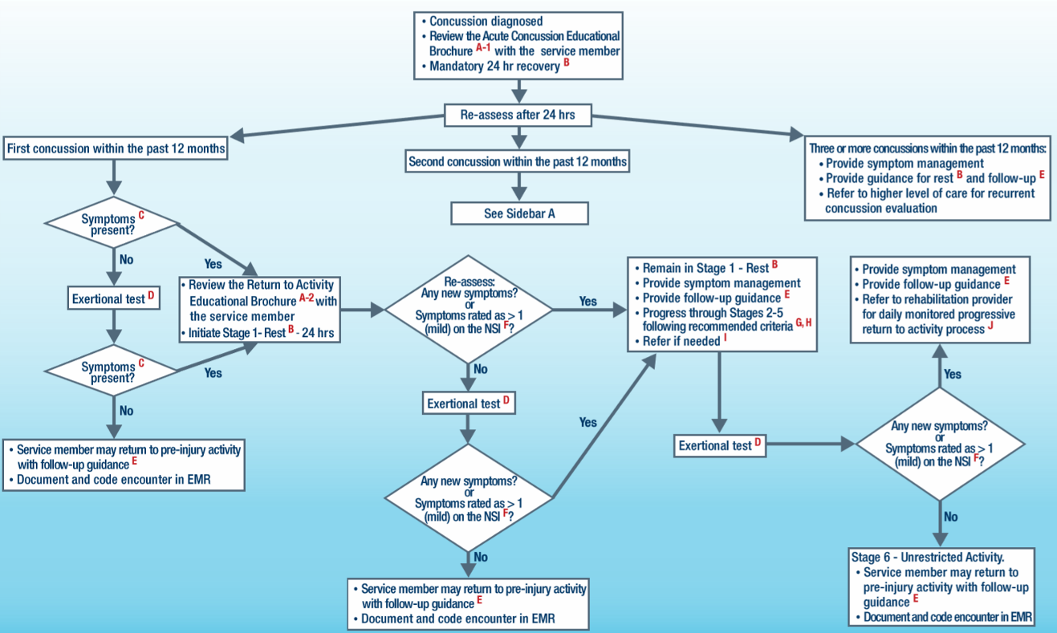
Figure 1A: Sidebar A – PRA for second concussion within the past 12 months²²
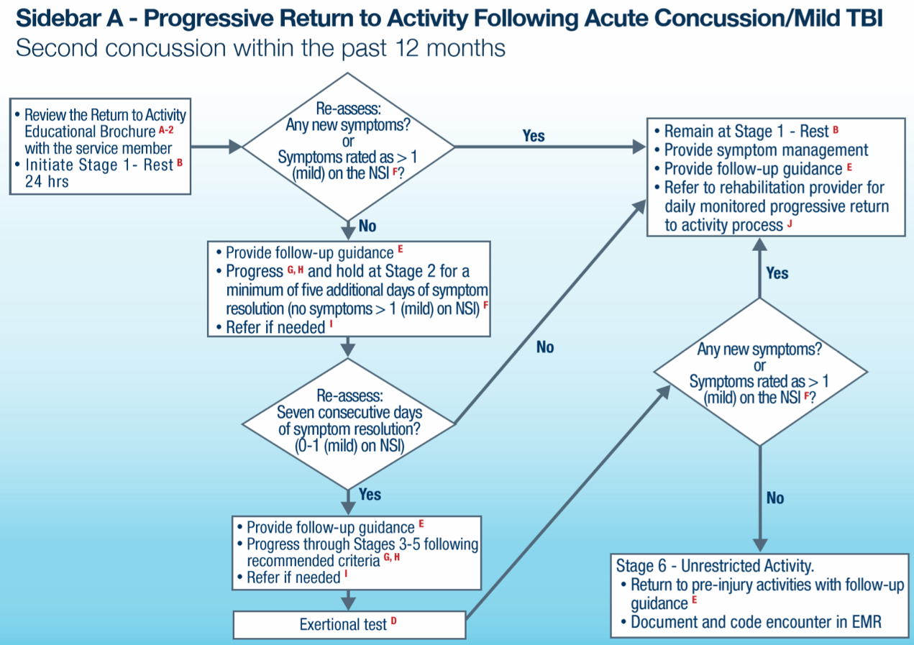
References
¹ Defense Veterans Brain Injury Center. DoD Worldwide Numbers for TBI Worldwide Totals. 2017.
² McKee A et al. Military-related traumatic brain injury and neurodegeneration. Alzheimer’s and Dementia. 10;3:S242-S253.
³ Williams V et al. Diagnoses of traumatic brain injury not clearly associated with deployment, active component, U.S. Armed Forces, 2001-2016. Medical Surveillance Monthly Report. 2017. 24;3:2-8.
⁴ Chapman JC, Diaz-Arrastia R. Military traumatic brain injury: a review. Alzheimer’s and Dementia. 2014;10:S97-S104.
⁵ McCrory P, Meeuwisse W, Johnston K, et al. Consensus statement on concussion in sport – the 3rd International Conference in Sport held in Zurich, November 2008. S Afr J Sports Med. 2009;21(2):36-46.
⁶ McCrory P, Meeuwisse W, Aubry M, et al. Consensus statement on concussion in sport – the 4th International Conference on Concussion in Sport held in Zurich, November 2012. Br J Sports Med. 2013;47:250-258.
⁷ Management of Concussion/mTBI Working Group. VA/DoD clinical practice guideline for management of concussion/mild traumatic brain injury. J Rehabil Res Dev. 2009;46(6):CP1-68.
⁸ Defense Centers of Excellence for Psychological Health and Traumatic Brain Injury. Concussion Management in Deployed Settings version 4.0. 2012.
⁹ McCulloch K, Goldman S, Lowe L, et al. Development of clinical recommendations for progressive return to activity after military mild traumatic brain injury: guidance for rehabilitation providers. J Head Trauma Rehabil. 2015;30(1):56-67.
¹⁰ Silverberg N, Iverson G. Is rest after concussion “the best medicine?” Recommendations following concussion in athletes, civilians and military service members. J Head Trauma. 2013;28(4):250-259
¹¹ Leddy J, Cox J, Baker J, Wack D, Pendergast D, Zivadinov R, Willer B. Exercise treatment for postconcussion syndrome: a pilot study of changes in functional magnetic resonance imaging activation, physiology, and symptoms. J Head Trauma Rehab. 2013;28(4):241-249
¹² Maerlender A, Rieman W, Lichtenstein J, Condiracci C. Programmed physical exertion in recovery from sports-related concussion: a randomized pilot study. Dev Neuropsychol. 2015;40(5):273-278
¹³ Lutz R, Kane S, Lay J. Evidence-based diagnosis and management of mTBI in forward deployed settings: the genesis of the USASOC neurocognitive testing and postinjury evaluation and treatment program. J Spec Oper Med. 2010;10(1):23.
¹⁴ Defense and Veterans Brain Injury Center. Joint theater trauma system clinical practice guideline: Management of mild traumatic brain injury (mTBI)/concussion in the deployed setting. Joint Theater Trauma System; 2008:7-8.
¹⁵ University of North Carolina at Chapel Hill. The University of North Carolina at Chapel Hill Sport Concussion Policy. NC: Matthew Gfeller Sport-Related TBI Research Center; 2010.
¹⁶ Gaetz M, Iveron G. Sex differences in self-reported symptoms of aerobic exercise in non-injured athletes: implications for concussion management programmes. Br J Sports Med. 2009;43(7):508-513.
¹⁷ Giza C, Kutcher J, Ashwal S, et al. Summary of evidence-based guidelines update: evaluation and management of concussion in sports. Neurol. 2013;80(24):2250-2257.
¹⁸ Lovallo W, Wilson M, Vincent A, et al. Blood pressure response to caffeine shows imcomplete tolerance after short term regular consumption. Hypertension. 2004;43:760-765
¹⁹ Guidice R, Izzo R, Manzi M, et al. Lifestyle related risk factors, smoking status, and cardiovascular disease. High Blood Pressure & Cardiovas Prev. 2012;19(2):85-92.
²⁰ Alla S, Sullivan J, McCrory P. Defining asymptomatic status following sports concussion: fact or fallacy? Brit J Sports Med. 2012;46:562-569
²¹ DVBIC & DCoE for Psychological Health and Traumatic Brain Injury. Progressive Return to Activity Following Acute Concussion/Mild Traumatic Brain Injury: Guidance for the Rehabilitation Provider in Deployed and Non-deployed Settings. DCoE Clinical Recommendation, 2014.
²² DVBIC & DCoE for Psychological Health and Traumatic Brain Injury. Progressive Return to Activity Following Acute Concussion/ Mild Traumatic Brain Injury: Guidance for the Primary Care Manager in Deployed and Non-deployed Settings. DCoE Clinical Recommendation, 2014
²³ Department of Defense Instruction 6490.11: Policy Guidance for Management of Mild Traumatic Brain Injury/Concussion in the Deployed Setting. Department of Defense, 2012.
²⁴ Acute Concussion Educational Brochure: Information for Anyone Newly Diagnosed With a Concussion. Version 5.0. DVBIC. 2012.
²⁵ Patient Activity Guidance After Concussion: Patient Education Tool. DVBIC. 2014.
²⁶ DVBIC & DCoE for Psychological Health and Traumatic Brain Injury. Progressive Return to Activity Following Acute Concussion/Mild Traumatic Brain Injury: Guidance for the Rehabilitation Provider in Deployed and Non-deployed Settings. DCoE Clinical Support Tool, 2014.
²⁷ Neuroimaging following MildTraumatic Brain Injury in the Non-Deployed Setting. DcoE Clinical Recommendation, 2013.
²⁸ Return to Activity Educational Brochure: Guidance for Service Members with Symptoms Following a Concussion. DVBIC. 2017.
²⁹ Ponsford J, Willmott C, Rothwell A, et al. Impact of early intervention on outcome following mild head injury in adults. J Neurol Neurosurg Psych. 2002;73:330-332.
³⁰ Gregory E, West T, Cole W, et al. Use of a multi-level mixed method approach to study the effectiveness of a primary care progression return to activity protocol after acute mild traumatic brain injury/concussion in the military. Contemp Clin Trials. 2017;52:95-100.
³¹ Tanielian T et al. Invisible Wounds of War: Psychological and Cognitive Injuries, Their Consequences, and Services to Assist Recovery. Santa Monica, CA: RAND Corporation, 2008.

