Pelvic Girdle Pain

# Is there help for pelvic girdle pain?

## Conditions that may cause pelvic girdle pain

🙞 🙜

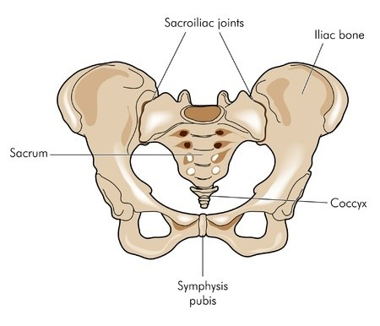

Symphysis Pubis Dysfunction: pain in the front of the pelvis (pubic bone) that is caused by too much separation occurring in the joint.

Sacroiliac Joint Dysfunction: these joints connect the triangle shaped sacrum at the bottom of the spine to the ilium. Pain occurs if the supporting ligaments become too “loose” during pregnancy.

🙞 🙜

### Managing Symptoms During Pregnancy

Resources

U.S Department of Health and Human Services https://www.womenshealth.gov/pregnancy

American Physical Therapy Association: PT in Motion publication <http://www.apta.org/PTinMotion/2017/12/Feature/WhatToExpect/>

Your physical therapist can use treatments to help to decrease or prevent pain. Some effective treatments are:

* Exercise
* Use of an non-elastic pelvic brace
* Your physical therapist can also teach you how to modify activities such as bending and lifting to decrease symptoms

#### Treatment with a physical therapist can help pelvic girdle pain!

* 25% of women have postpartum pelvic girdle pain
* Symptoms resolve completely in 93% of women by 3 months postpartum

# What causes pelvic girdle pain during pregnancy?

**Pelvic girdle pain is very common during pregnancy**

## Pelvic Girdle Pain Facts

**Some women are more at risk for pelvic girdle pain**

* Women who perform strenuous and repeated bending, lifting, or twisting
* Women with a previous pelvic injury
* Women who have experienced pelvic pain before becoming pregnant

**Most women have complete improvement of symptoms**

* Up to 50% of women will experience pelvic girdle pain during pregnancy
* Pain usually begins around the 18th week of pregnancy

Symptoms of Pelvic Girdle Pain

Pelvic girdle pain is very common during pregnancy. There are many changes that occur in a woman’s body during pregnancy. These changes can cause pelvic girdle pain in a woman who is pregnant or who has just had a baby. During pregnancy a woman’s pelvis becomes wider and looser to make room for a growing baby. The pelvis is able to widen because of a hormone called relaxin that is released during pregnancy. Other causes of pelvic girdle pain are the weight of the growing baby and changes in posture that occur as a woman’s body progresses through pregnancy.

* Pain in the hips, buttocks, groin, or pubic area
* Dull, sharp, stabbing, or burning pain
* Pain may even go down into the legs
* Pain might be worse with certain activities:
* Going up or down stairs
* Changing positions in bed
* Getting up from a sitting position