Exercise Handout for Anterior Glenohumeral Dislocation

Although participation in sport declines as adults age, there are still many older adults who like to participate in sporting activities such as swimming, tennis, golf, etc. ¹ When treating active older adults with anterior glenohumeral dislocation, it is important to incorporate sport specific exercises into the care plan. Poor physical health can lead to decreased participation in sport and physical activity, which can lead to overall health decline.¹ When older adults sustain an injury, it is very important to work towards returning them back to their prior level of function to prevent health decline and maintain functional independence.
The American College of Sports Medicine recommend regular physical activity in adults over the age of 65 in order to prevent chronic diseases and slow the aging process. ² The position statement also reports that older adults can make similar muscle strength gains as younger participants when completing moderate resistance exercise training.² Despite this evidence, the current literature for anterior shoulder dislocation in older adults primarily focuses on decreasing pain and regaining full range of motion, and have less emphasis on shoulder rehabilitation to return to sport or higher level functional activity. ^{3,4} Adults who want to return to playing sports or recreational overhead activity will require a combination of scapular strengthening, rotator cuff strengthening, shoulder stabilization and strengthening, and core strengthening. ^{5,6}
The following exercise protocol was developed using resources from current available anterior shoulder dislocation protocols. ^{7,8} Frequency and duration of the exercises should be determined specifically for each patient depending on their current deficits and limitations. Photos used in the protocol were used from the PT Helper Iphone application. The exercises provided focus on scapular strengthening and stabilization, rotator cuff strengthening, and sport specific items such as throwing, rotational movements, and core strengthening. Physical therapists are welcome to add additional exercises to a patient’s plan of care, and the exercises provided can be modified if necessary.

Anterior Glenohumeral Dislocation Exercise Handout

Phase I: 0-4 weeks after injury
Goals: Regain full motion, and decrease pain and inflammation.
Precautions: No external rotation > 60 degrees, no horizontal abduction past 0 degrees, no hand behind back
Exercises: Active range of motion exercises, shoulder isometrics, elbow/wrist strengthening.

- Forward/Backward Shoulder Circles

- Towel or Pole Internal Rotation Stretch
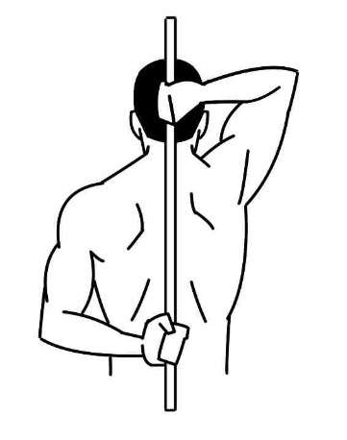
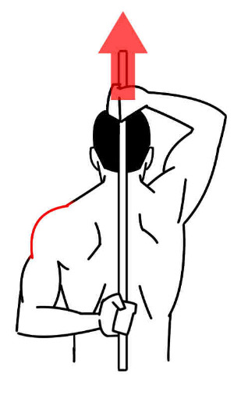

- Bicep Curls

- Active Assisted Shoulder Flexion Laying Down

- Active Assisted Shoulder Abduction Laying Down

- Active Assisted Shoulder Internal and External Rotation Laying Down
Phase II: 4-8 weeks after injury
Goals: Increase scapular and shoulder stability, increase strength, and maintain full motion.
Precautions: No overhead resisted exercise, avoid plyometric exercises
Exercises: Incorporate rotator cuff strengthening and scapular stabilization and strengthening.

- Standing Mid Rows

- Ball on the Wall Circles
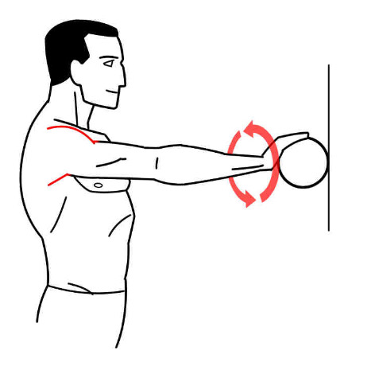
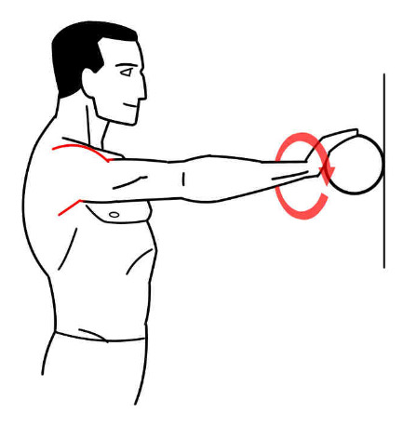
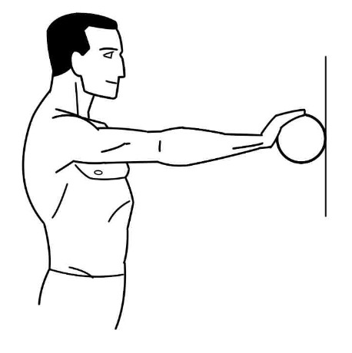

- Resisted Shoulder Internal Rotation

- Resisted Shoulder External Rotation

- Resisted Shoulder Abduction
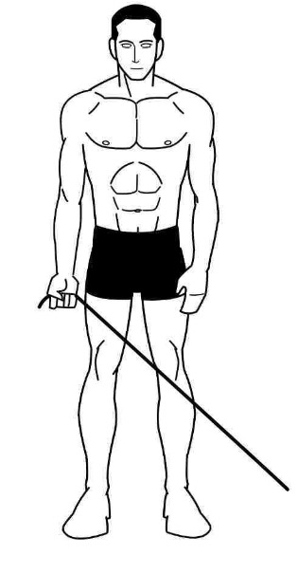
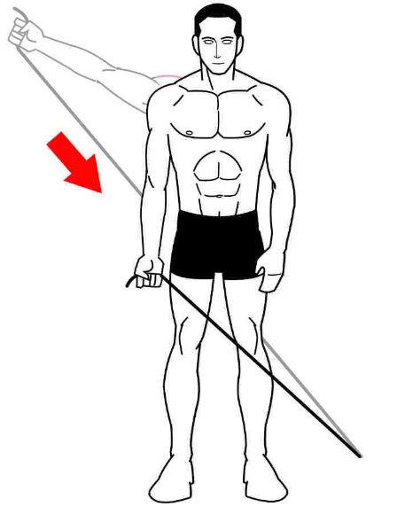
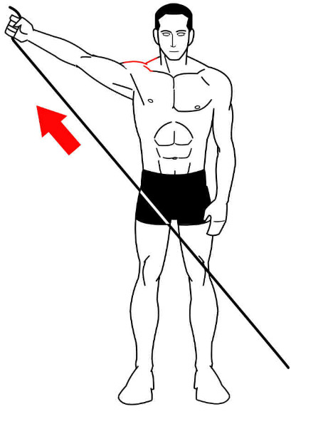

- Wall Push Up
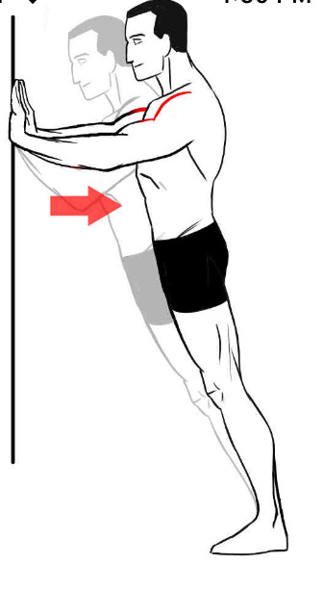
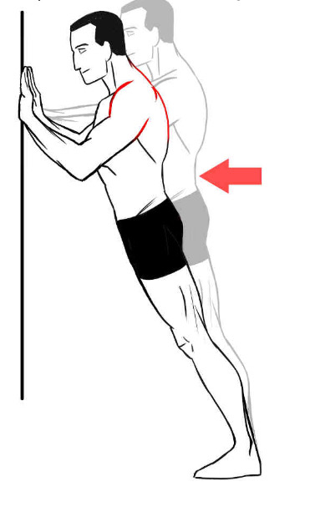
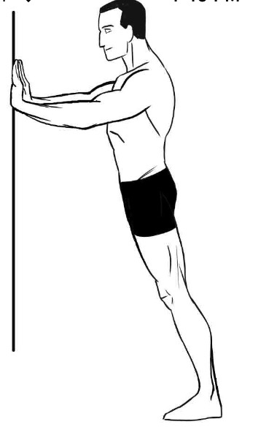

Phase III: 8-12 weeks after injury
Goals: Progress stability, increase overall strength, and begin return to sport specific or recreational activity.
Precautions: Slow progression of strength and proprioception exercises focusing on functional return.
Exercises: Sport specific and functional overhead activities/strengthening

- Crossover Cable
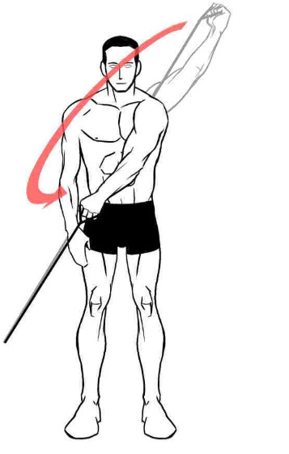
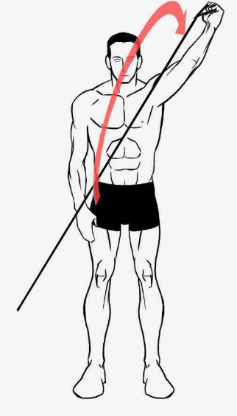
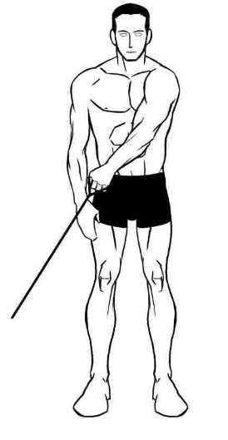

- Standing Cable Wood Chop
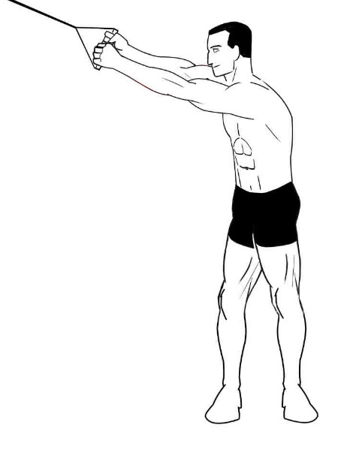
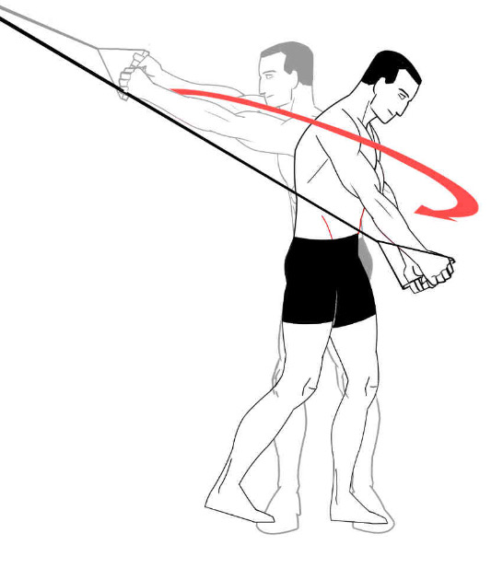

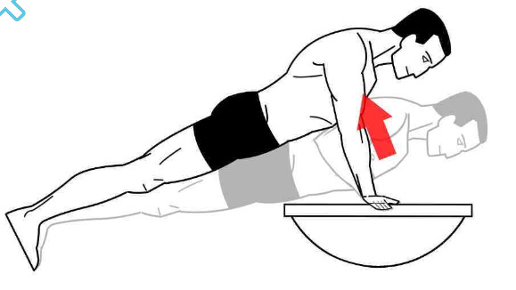
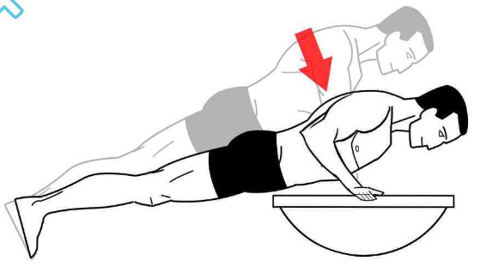
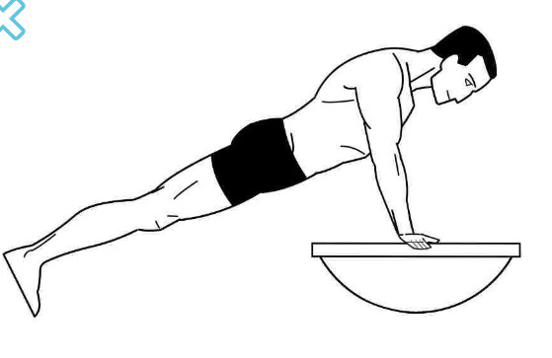
- BOSU Push Ups

- Lat Pull Down
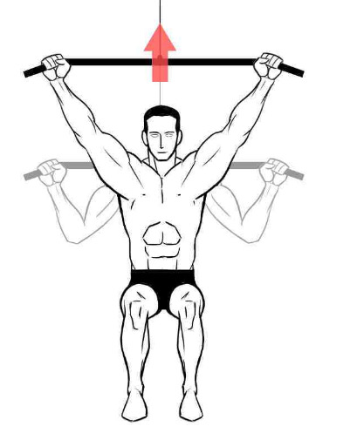
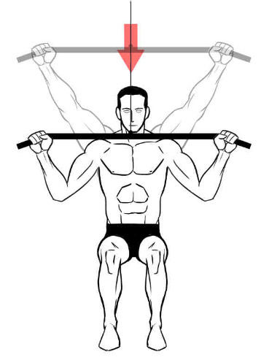
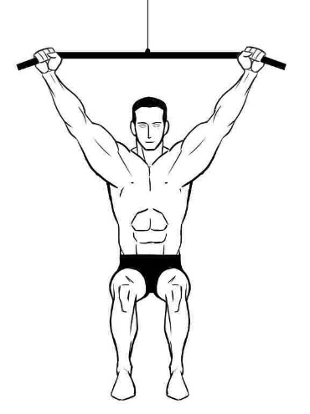

- Resisted Internal and External Rotation at 90 degrees Abduction
- Prior to progressing from 0-90 degrees of abduction, the patient should first be monitored in 0 degrees. This exercise at 90 degrees abduction can be a vulnerable position to anterior inferior dislocation. If they are able to tolerate at 0 degrees without any difficulty, then progress to 30 degrees and then 60 degree prior to the full 90. Monitor patient’s progress at each level to determine that it is safe to progress.
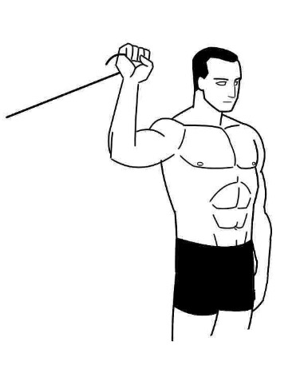
Internal External
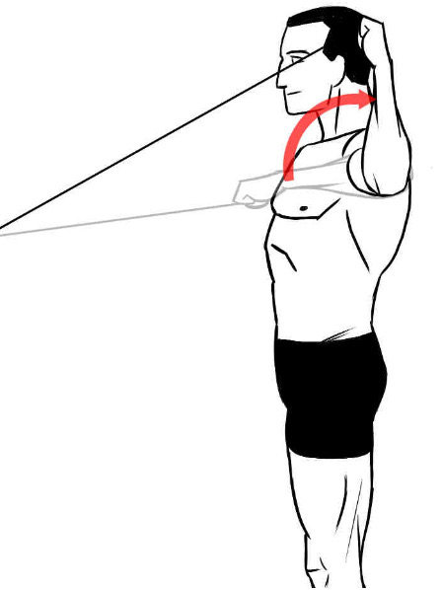
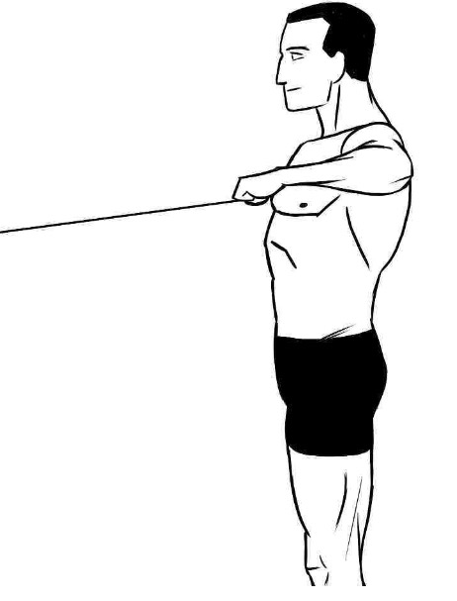
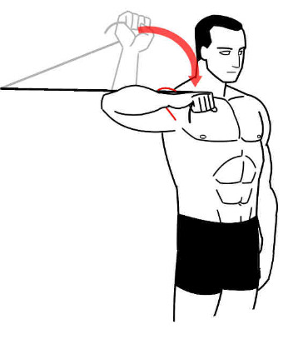

- Plank or Modified Plank
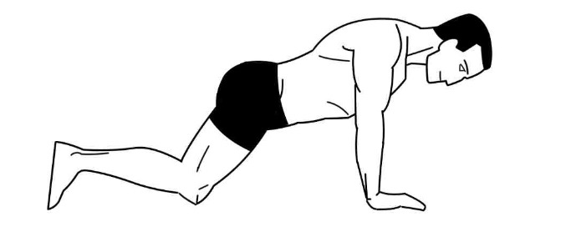
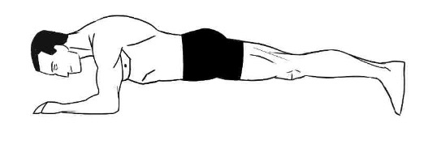

References:
1. Jenkin CR, Eime RM, Westerbeek H, O’Sullivan G, van Uffelen JGZ. Sport and ageing: a systematic review of the determinants and trends of participation in sport for older adults. BMC Public Health 2017;17(1):976. doi:10.1186/s12889-017-4970-8.
2. American College of Sports Medicine, Chodzko-Zajko WJ, Proctor DN, et al. American College of Sports Medicine position stand. Exercise and physical activity for older adults. Med. Sci. Sports Exerc. 2009;41(7):1510-1530. doi:10.1249/MSS.0b013e3181a0c95c.
3. Shin S-J, Yun Y-H, Kim DJ, Yoo JD. Treatment of traumatic anterior shoulder dislocation in patients older than 60 years. Am. J. Sports Med. 2012;40(4):822-827. doi:10.1177/0363546511434522.
4. Murthi AM, Ramirez MA. Shoulder dislocation in the older patient. J. Am. Acad. Orthop. Surg. 2012;20(10):615-622. doi:10.5435/JAAOS-20-10-615.
5. Brumitt J, Dale RB. Integrating shoulder and core exercises when rehabilitating athletes performing overhead activities. N. Am. J. Sports Phys. Ther. 2009;4(3):132-138.
6. Brumitt J. Scapular-stabilization exercises: early-intervention prescription. Athl Ther Today 2006;11(5):15-18.
7. Stewart MD B. Anterior Shoulder Dislocation/Subluxation Conservative Rehabilitation Program. Shoreline Orthopaedics. Available at: http://www.shorelineortho.com/pdfs/0-StewartAnteriorShoulderDislocation.pdf. Accessed February 28, 2019.
8. Anterior Shoulder Dislocation Protocol . Vernon Memorial Healthcare, Physical Therpay/Sports Medicine. Available at: http://www.vmh.org/sites/default/files/ANTERIORSHOULDERDISLOCATIONPROTOCOL.pdf. Accessed February 28, 2019.

