PART 1 - RUNNING EXERCISES: perform each exercise twice
Perform through 6 cones, each 6 meters apart (total 36 meters)
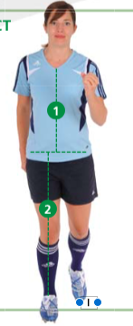  1) Running STRAIGHT AHEAD: | 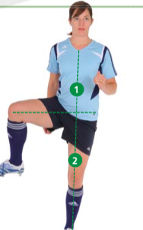  2) Running HIP OUT: | 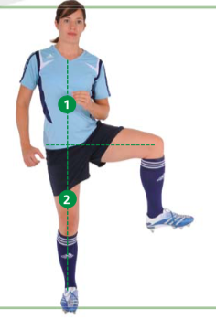  3) Running HIP IN:
4) Running CIRCLING PARTNER:  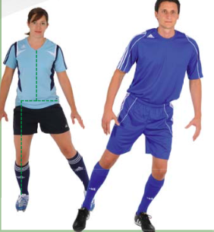 | 5) Running JUMPING WITH SHOULDER CONTACT:  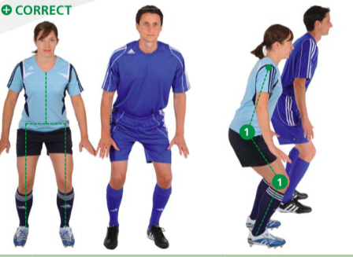 | 6) Running QUICK FORWARDS AND BACKWARDS SPRINTS  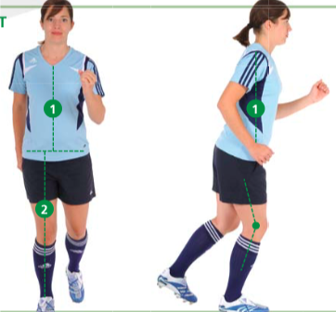
PART 2- STRENGTH, PLYOMETRICS, AND BALANCE EXERCISES
Start at “beginner level” progress each exercise when it can be performed without difficulty
Beginner | Intermediate | Advanced
7.1 The Bench STATIC:  3 sets, 40-60 sec hold  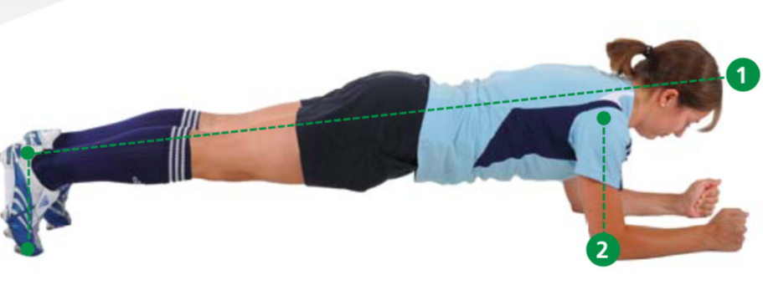 | 7.2 The Bench ALTENATE LEGS:  3 sets, 40-60 sec  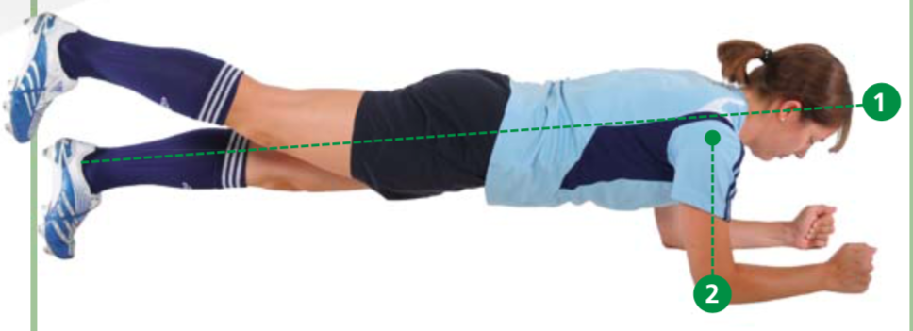  Alternate lifting each leg, with a 2 second hold | 7.3 The Bench ONE LEG LIFT AND HOLD:  3 sets, 20-30 seconds each  Lift one leg 4-6 inches of the ground and hold
Keys: a) shoulders, back and hips in a line b) elbows under shoulders c) keep hips steady; Do NOT sway or arch your back,
8.1 Sideways Bench STATIC:  3 sets, 20-30 sec hold each side  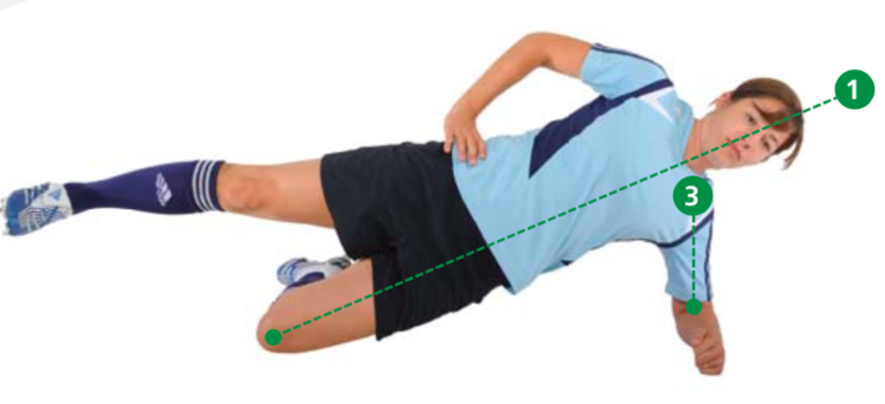 | 8.2 Sideways Bench RAISE & LOWER HIP  3 sets, 20-30 sec each side  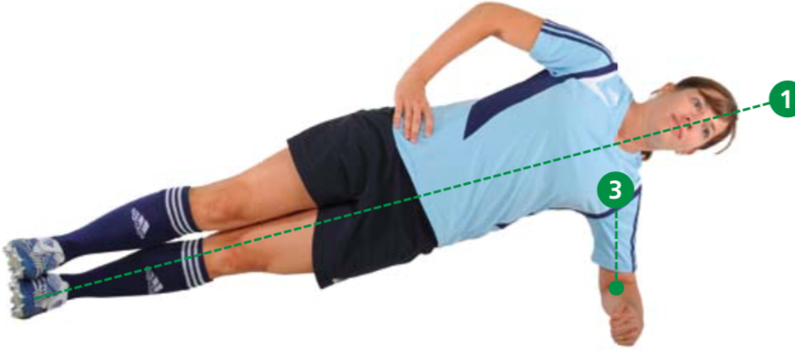  Same as (a) except bottom leg is straight, feet are stacked. | 8.3 Sideways Bench WITH LEG LIFT:  3 sets, 20-30 sec each side  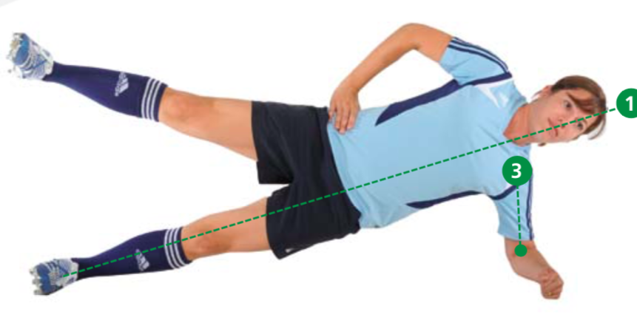  Same as (b) except lift your top leg and slowly lower it down. Repeat.
Keys: a) your shoulder, hip and top leg should be in in a line b) elbows under shoulders
9.1 Hamstrings BEGINNER:  1 set (3-5 reps)  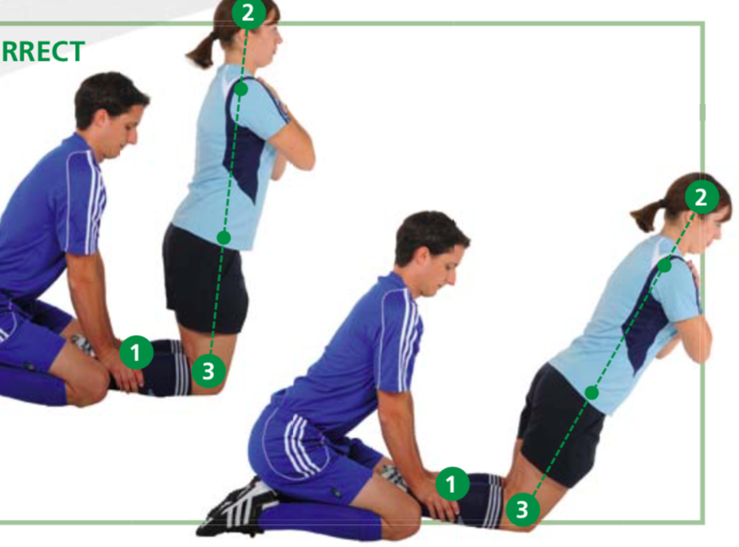 | 9.2 Hamstrings INTERMEDIATE:  1 set (7-10 reps) | 9.3 Hamstrings ADVANCED:  1 set ( 12-15 reps)
Keys: your head, torso, hips and thighs should be in in a line b) movement occurs only at the knees c) start slowly
10.1 Single-Leg Stance HOLD THE BALL:  2 sets (30 sec on each leg)  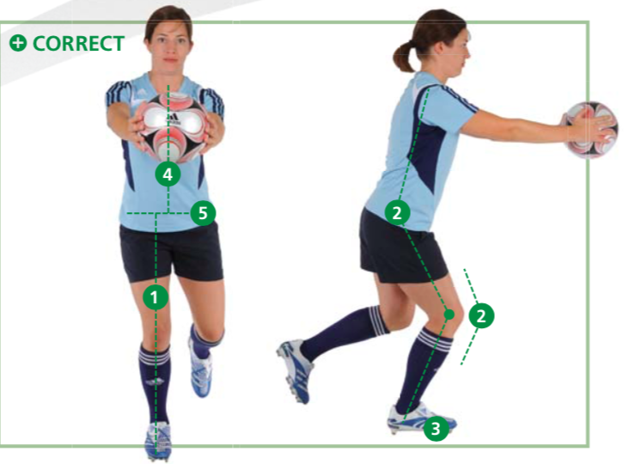 | 10.2 Single-Leg Balance THROWING BALL WITH PARTNER: 2 sets (30 sec on each leg)  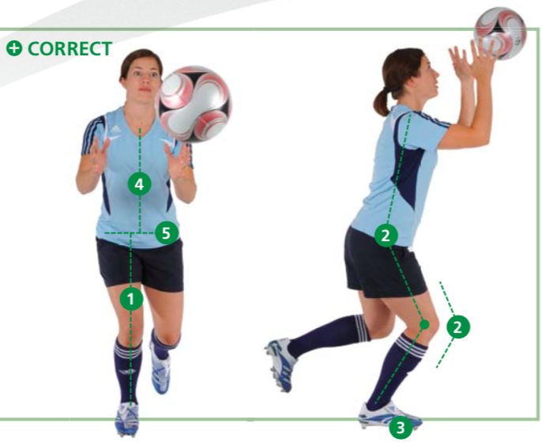 | 10.3 Single-Leg Balance TEST YOUR PARTNER: 2 sets (30 sec. on each leg)  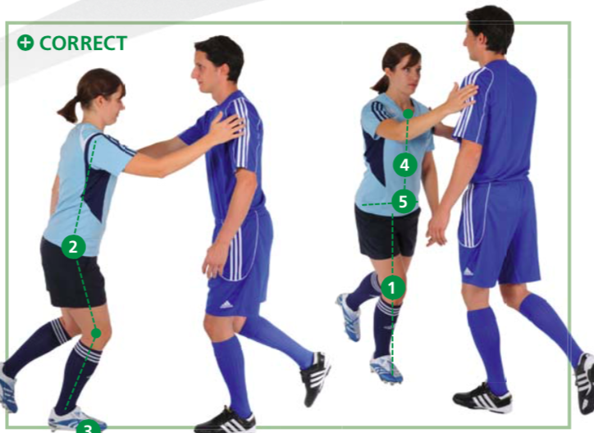
Keys: a) keep your hip and knee bent b) maintain weight on the ball of your foot c) keep your hips level
11.1 Squats WITH TOE RAISE:  2 sets (30 sec each)  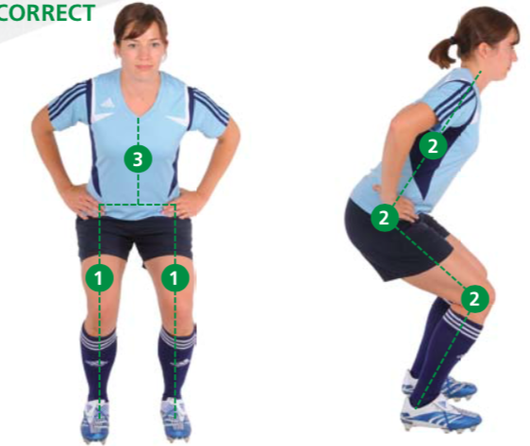 | 11.2 Squats WALKING LUNGES:  2 sets (10 each side)  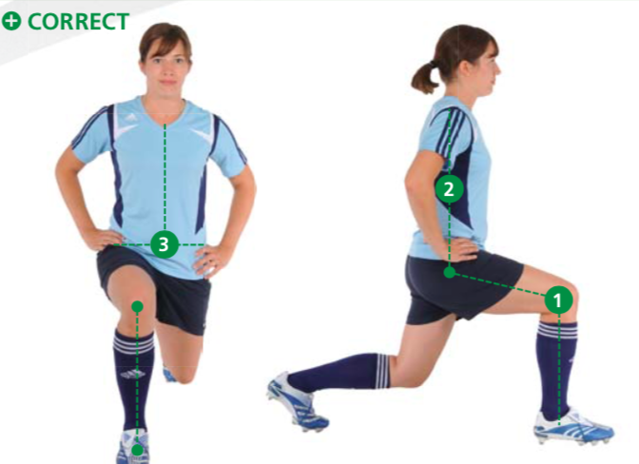 | 11.3 Squats ONE-LEG SQUATS:  2 sets (10 on each side)  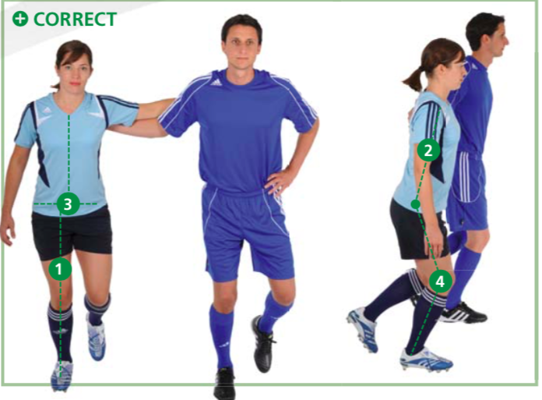
Keys: a) bend your knees to 90* b) keep your hips level c) do not let your knees buckle inwards
12.1 Jumping - VERTICAL JUMPS:  2 sets (30 sec)  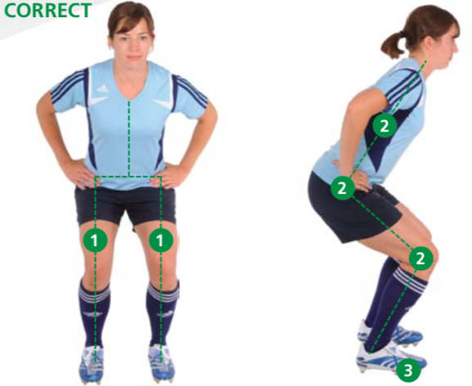 | 12.2 Jumping – LATERAL JUMPS:  2 sets (30 sec each)  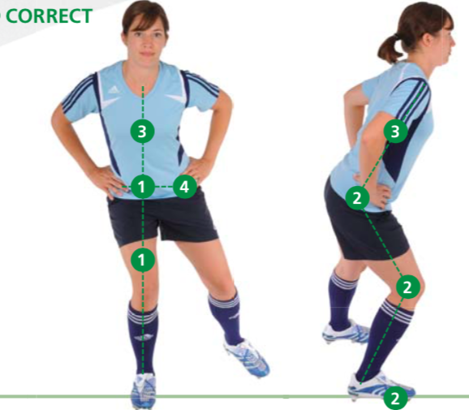 | 12.3 Jumping – BOX JUMPS:  2 sets (30 sec each)  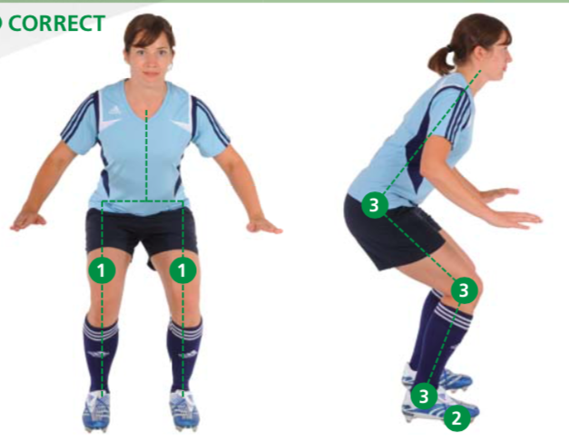
Keys: a) jump off both feet and land on the balls of your feet b) maintain feet hip width apart c) land with knees and hips bent
PART 3 - RUNNING EXERCISES: perform each exercise twice
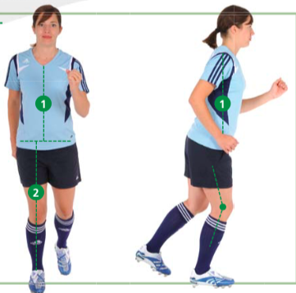
13) Running ACROSS THE PITCH: Run 40 meters at 75-89% max speed, then jog the rest of the way to midfield. Slow jog back
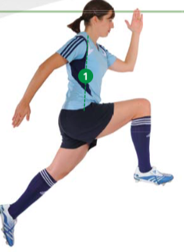
14) Running BOUNDING: 6-8 bounding strides with high knee lift, then jog the rest of the way to midfield. Slow jog back

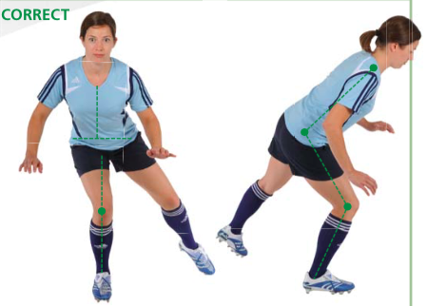
15) Running PLANT AND CUT: Run 5-7 steps (80-90% max speed) cut on your right leg towards your left. Repeat and cut to the opposite side. Repeat all the way to midfield. Slow jog back.

** All images and descriptions from the 11+ manual: FIFA Medical Assessment and research centre, Bizzini M. A complete warm-up programme to prevent injuries. http://www.yrsa.ca/pdf/Fifa11/11plus_workbook_e.pdf

Key Features: 11+

What is the 11+ Program?
- A comprehensive soccer specific warmup protocol developed to reduce the risk of soccer-related injuries¹
- Consists of 15 exercises, takes ~20 minutes complete
- Potential to reduce the risk of soccer injuries by 30-46%^{1,2,3}
- Potential to reduces the risk of severe injuries by up to 50%¹
- Easy to follow program that can be implemented by coaches
- Designed for players 14 years and older
- Complete the entire program before each training session, and the running components (part 1 and 3) before each game.

Compliance matters…. best if performed $≥$ 2 times/week
- Compliance is negatively correlated with injury risk⁵
- High compliance lowers the risk of injuries by 35% versus moderate to low compliance^{4,5}
- Compliance associated with increased balance⁴

Alternative Options for Progression:¹ correct performance of each exercise is key
- A) Progress part 2 when the player can perform the exercise correctly for the given number of sets and reps without difficulty (*preferred model)
- B) All players on a team progress at the same time when it seems appropriate to progress the group on a specific exercise
- C) All players progress to the next level for every exercise after 3-4 weeks.

Additional Resources:
- 11+ Full Manual: http://www.yrsa.ca/pdf/Fifa11/11plus_workbook_e.pdf
- WakeMed: https://www.wakemed.org/ncfc-improve-your-power-performance
  - Linked video and handouts explaining the exercises
- Alex Morgan and Cobi Jones Video demos: https://www.youtube.com/playlist?list=PL-W9Gn-XDQ_pIeE4mo1mgBb4OwyGc0UGU
- FIFA Medical, Training and Health video demos: #62-88 https://www.youtube.com/playlist?list=PL2333815695D8E22B

References:
1. FIFA Medical Assessment and research centre, Bizzini M. A complete warm-up programme to prevent injuries.
2. Silvers-Granelli H, Mandelbaum B, Adeniji O, et al. Efficacy of the FIFA 11+ injury prevention program in the collegiate male soccer player. Am J Sports Med 2015;43(11):2628-2637. doi:10.1177/0363546515602009
3. Thorborg K, Krommes KK, Esteve E, Clausen MB, Bartels EM, Rathleff MS. Effect of specific exercise-based football injury prevention programmes on the overall injury rate in football: a systematic review and meta-analysis of the FIFA 11 and 11+ programmes. Br J Sports Med 2017;51(7):562-571.
4. Steffen K, Emery CA, Romiti M, et al. High adherence to a neuromuscular injury prevention programme (FIFA 11+) improves functional balance and reduces injury risk in Canadian youth female football players: a cluster randomised trial. Br J Sports Med 2013;47(12):794-802. doi:10.1136/bjsports-2012-091886.
5. Silvers-Granelli HJ, Bizzini M, Arundale A, Mandelbaum BR, Snyder-Mackler L. Higher compliance to a neuromuscular injury prevention program improves overall injury rate in male football players. Knee Surg Sports Traumatol Arthrosc 2018;26(7):1975-1983. doi:10.1007/s00167-018-4895-5.

