Prevention of the Most Common Shoulder Injuries in Tennis Players

Incidence and Prevalence
High level tennis players are at high risk of shoulder injury due to the extensive forces associated with the overhead (OH) motions in the sport. Injuries of the upper extremity (UE) associated with playing competitive tennis are usually chronic in nature and believed to be secondary to repetitive use.¹⁻³ A study investigating the epidemiology of National Collegiate Athletic Association (NCAA) male’s and female’s tennis injuries concluded that tennis has a higher prevalence of UE injuries compared to other NCAA sports.⁴ At the professional level it has been reported that over 50% of withdrawals and retirements from competition, including both the Association of Tennis Professionals (ATP) and Women's Tennis Association (WTA) is a result of injury, with shoulder injuries being the second most frequent cause.⁵ In addition, evidence suggests that the incidence of tennis injury ranges from 0.05-2.9 injuries per player each year and overuse shoulder injuries contribute to 4-17% of all tennis injuries.^{4,6} Looking at OH sport in general, the incidence of shoulder injury is between 0.2/1000 hours and 1.8/1000 hours.⁷
Internal impingement is identified as the leading cause of chronic shoulder pain in the OH athlete.^{8,9} Rotator cuff (RC) tears are also a very common source of pain and dysfunction. They can occur independently secondary to repetitive OH motion, as well as in conjunction with internal impingement. Specifically, posterosuperior RC tears at the junction of the supraspinatus and infraspinatus tendon attachment to the humerus represent one of the hallmarks of internal impingement.^{8,9} Given the high prevalence of these two pathologies seen in OH athletes, they will be the main focus of this paper. A good understanding of the anatomy of the shoulder complex, the biomechanics and pathomechanics of the tennis serve and OH motion, including the function of the kinetic chain, will help improve the physical therapist’s (PT’s) clinical decision making and allow optimal rehabilitation and prevention of overuse shoulder injuries. It is imperative that PTs recognize early signs of shoulder dysfunctions, and are knowledgeable of diagnostic screening tools and treatment methods, as early intervention can help prevent the development of a serious pathology and aid in a faster and more optimal return to sport (RTS).¹⁰

Anatomy
The shoulder joint involves the articulation of the humeral head and the glenoid cavity of the scapula and is also known as the glenohumeral (GH) joint. The GH joint is a ball-and-socket joint with three degrees of freedom.¹¹ This is the most mobile joint in the body offering extensive range of motion (ROM) at the cost of static and dynamic stability.¹¹ The glenoid fossa is much smaller and shallower than the humeral head, consisting of a surface area that is 25-30% of the humeral head surface area.¹¹ The glenoid labrum is a fibrous ring that surrounds the periphery of the glenoid and deepens the glenoid cavity approximately 50% in all directions to increase contact area and enhance joint stability.¹¹
The GH joint capsule is thin and relatively loose to allow for full ROM. The GH ligaments, the coracohumeral ligament and the posterior capsule provide passive support to stabilize the bony structures during the OH motion.¹¹ The inferior GH ligament consists of an axillary pouch that acts as a “sling,” with an anterior and posterior band on either side.^{10,11} During external rotation (ER) the anterior band tightens and the sling moves anteriorly providing a restraint to inferior and anterior displacement.¹⁰ During internal rotation (IR) the posterior band tightens and the sling moves posteriorly preventing posterior displacement. A dysfunction of this mechanism increases risk of internal impingement.¹⁰ In addition, the deltoid and RC muscles provide active support to the GH joint.¹¹ Injury to any of these muscles can disrupt normal shoulder kinematics and affect GH joint stability.¹² The supraspinatus and infraspinatus muscles are more prone to injury as there are relatively hypovascular.¹¹
The scapulothoracic (ST) joint is one of the articulations of the shoulder joint. It is not considered a “true” anatomical joint but a functional joint, as it is an articulation of the scapula with the thorax via musculature.¹¹ The wide range of movement available at the shoulder joint is partially due to the large movement available at the ST joint. Additionally, thoracic mobility and dynamic scapula stability is essential during the OH motion.^{2,13}

Biomechanics
The tennis serve motion can be examined via an eight-stage model that consists of three distinct phases: preparation, acceleration and follow-through phase (Appendix 1).¹⁴ The OH motion performed during a volleyball serve or spike and a baseball pitch are very similar to the OH tennis motion. Since the literature examining the biomechanics of a tennis serve is considerably less, concepts of the biomechanics behind the baseball pitch and volleyball serve will be utilized to analyze the tennis serve in more depth. Nonetheless, there are some key differences including the planes of motion, the non-dominant arm tossing the ball, the altered lever arm secondary to the tennis racket, the trajectory of forces produced and released, the technical components of the tennis serve, as well as the different types of serves that the PT must consider during evaluation.¹⁴
The preparation phase consists of the first four stages of the model and the primary goal of this phase is to store energy.¹⁴ The first stage, also known as the start, consists of minimal muscular activation in the shoulder and scapular regions.¹⁴ The aim of this stage is to produce optimal body alignment that will further allow the athlete to utilize the ground reaction force (GRF) throughout the serve motion and generate power.¹⁴ The second stage begins the instant the ball is released from the player’s non-dominant hand and is known as the release stage.¹⁴ In a right-handed tennis player there is very little activation of the left erector spinae muscles with an increase in activity of the right erector spinae muscles throughout the motion.¹⁴ It is important that the ball toss is slightly lateral in relation to the position of the server for the player to achieve ball contact at ~100° shoulder abduction.¹⁴ This will allow for optimal positioning to achieve power and reduce risk of injury.
The third stage is known as the loading stage that aims to load and prepare the body to generate potential energy and high-speed movements.^{14,15} Evidence suggests that a greater serve speed is associated with greater muscle force during loading.^{14,15} This stage consists of two types of lower body loading techniques or foot positions: the foot-up and the foot-back serving technique.¹⁴ For both techniques the back leg functions to provide the upward and forward push while the front leg functions as a stabilizer for rotational momentum.¹⁴ Both techniques result in similar ball velocities and it is often up to the player’s preference as to what technique they use.¹⁴ The foot-up technique results in higher vertical GRFs that allow the player to reach a greater height compared to the foot-back technique.¹⁴ On the other hand, the foot-back technique includes a wider base of support, which allows for a greater squat depth.¹⁴ It also requires greater front knee extension (65.5° ± 12.6°) compared to the foot-up technique (54.1° ± 11.7°, end position).¹⁴ Additionally, the leg drive produced during maximal leg motion in this stage enhances shoulder IR, which has been associated with an increase in service efficiency.^{14,16} Regardless of foot serving technique, it is recommended that players achieve greater than 15° of front knee flexion to produce an optimal front leg drive that results in lower anterior shoulder and medial elbow loads, reducing injury potential.^{14,16}
During the loading stage the shoulder and pelvis lateral rear tilt initiating the development of angular momentum via lateral trunk flexion during the forward swing.¹⁴ Lateral trunk flexion (right to left) with good flexibility and core stability throughout the ROM is an essential component for optimal body alignment, including a shoulder-over-shoulder rotation prior to ball contact that allows the player to reach a greater racket height.^{14,16} This also allows the player to effectively transfer angular momentum from the lower extremity (LE) to the UE.^{14,16} Moreover, as the spine moves into hyperextension, ipsilateral lateral flexion and ipsilateral rotation, there is an increase in load on the spinal facets.¹⁴ Electromyogram (EMG) studies have shown a high activation in the trunk muscles during this phase.¹⁴
The fourth stage is the cocking stage, which is the last stage of the preparation phase.¹⁴ This stage has been associated with an increased risk of shoulder injury for both tennis players and baseball pitchers.¹⁷ A key component of this stage is the ability to lengthen the trajectory of the racket to the ball to increase the potential energy.¹⁴ This is accomplished by driving the racket down and behind the torso with the dominant arm, which requires optimal ROM, positioning and shoulder stabilization.¹⁴ During this stage, maximal shoulder ER is achieved where the shoulder is abducted 101° ± 13°, horizontally adducted 7° ± 13°, and ER 172° ± 12°; the elbow is flexed 104° ± 12°; and the wrist is extended 66° ± 19°.¹⁴ Shoulder ER in tennis players is found to reach 175-185°, which is a combination of GH and ST motion.¹⁴ Baseball pitchers exhibit a similar magnitude of ER, 170-190° (Appendix 2).¹⁸ Additionally, the increased shoulder ER and abduction angles seen in this phase result in greater tensile stress on the anterior shoulder structures, and compression of the posterior RC and labrum.¹⁸ In baseball pitchers, the RC muscles provide a compressive force of 550-770 N to resist GH distraction and increase GH stability.¹⁹ In tennis players, moderately high muscle activity in the supraspinatus, infraspinatus and serratus anterior muscles has also been identified during this stage to maintain RC and scapular stabilization.¹⁴
The acceleration phase consists of two stages: acceleration and contact stage, and the primary goal of this phase is to release the energy that was stored during the preparation phase.¹⁴ The fifth stage is the acceleration stage that begins following maximal ER and ends at ball contact, which takes place in less than 1/100 of a second in competitive players.¹⁴ During this stage the GH internal rotators have their greatest activity and generate rapid IR.¹⁴ The sixth stage is the contact stage where the shoulder is abducted 101°, and the elbow, wrist and lead knee are slightly flexed.¹⁴ Evidence suggests that in baseball pitchers, a mean shoulder abduction angle of 100° ± 10°, increases ball velocity and minimizes shoulder joint loading.¹⁶ Thus, a contact point of 110° ± 15° is recommended for optimal tennis serve.¹⁶
The last phase is the follow-through phase that consists of the deceleration and finish stage, that aim to dissipate the excess kinetic energy, reducing the risk of shoulder injury.¹⁴ The deceleration stage requires increased eccentric loads from both the upper and lower extremities to decelerate horizontal adduction and IR, and help resist shoulder distraction and anterior subluxation forces.²⁰ Evidence suggests that the shoulder undergoes a distraction force of 0.5-0.75 times the player’s body weight.¹⁶ This is further stabilized by the deceleration force between the trunk and the shoulder that reaches up to 300 N·m during this stage.¹⁶ Additionally, a high muscle activity is reported in the posterior RC, serratus anterior, biceps brachii, deltoid and latissimus dorsi musculature.¹⁴ In baseball pitchers, the greatest amount of joint loading is generated at the shoulder during this stage, including excessive posterior (400 N) and inferior shear forces (300 N), increased compressive forces (>1000 N) and adduction torques.¹⁹ Lastly, the finish stage results in LE landing utilizing eccentric forces, so the athlete can prepare for the next stroke.¹⁴

Pathomechanics and Risk Factors
Internal or posterosuperior impingement of the GH joint is a result of repetitive contact of the undersurface of the RC between the posterior aspect of the greater tuberosity of the humeral head and the posterosuperior aspect of the glenoid labrum in the abduction and maximal ER (ABER) position (Appendix 3).^{8,21} Impingement in this position occurs between the supraspinatus and infraspinatus tendons and the glenoid labrum.^{8,21} This repetitive motion also places the RC at risk for undersurface tearing.¹ The transition from the late cocking to early acceleration stage results in the greatest forces and angular velocities on the shoulder due to the sudden transition from shoulder ER to IR, which contributes to pathologic impingement.⁸ Posterosuperior RC tears typically occur from repetitive trauma during the deceleration phase where the RC experiences extreme tensile loads with eccentric contraction. This type of RC tear is referred to as a “tear of necessity” as it occurs to accommodate the maximal ER seen in the OH motion.⁸ Additionally, RC tears of partial-thickness are often seen in conjunction with posterior internal impingement in the OH athlete. Thus, many of the risk factors identified apply to both pathologies.^{1,8}
The repetitive high stress, high velocity throwing motions performed by OH athletes can result in specific osseous and soft tissue adaptations that increase risk of internal impingement.²¹ These include: glenohumeral internal rotation deficit (GIRD), increased humeral retrotorsion, GH anterior instability, scapular dyskinesis and RC and/or scapular muscle weakness.²¹ The repetitive OH motion performed by tennis players can lead to an increased degree of shoulder ER in the expense of both posterior GH capsular tightness and muscular contracture, which decreases the degree of shoulder IR and horizontal adduction.^{2,3,22} Over time this can result in GIRD, which can compromise the “sling” function of the inferior GH ligament, ultimately increasing risk of impingement.¹⁰ A shortened posterior inferior GH ligament results in a posterosuperior directed force that shifts the center of rotation of the shoulder to a posterosuperior location that allows the athlete to obtain additional shoulder ER.¹⁰ The deceleration phase of the throwing motion places great loads on the posterior shoulder that can result in microtrauma and soft tissue scarring and further contribute to posterior shoulder tightness.² Burkhart et al., defines GIRD as a loss of greater than 20° of IR in the throwing shoulder relative to the nonthrowing shoulder.²² Multiple research studies suggest that the presence of GIRD is associated with higher risks of shoulder injury in tennis players and baseball pitchers.^{3,21-23} Nonetheless, a study by Wilk et al, proposed that ER insufficiency (<5° difference in ER between dominant and non-dominant shoulder) rather than GIRD is more closely associated with shoulder injury.¹ It is important to note that not all GIRD is pathological, especially in cases where the athlete experiences humeral retrotorsion.²⁴ Evidence also suggests that a decrease in GH IR ROM compared to the non-throwing arm can be present without concomitant shoulder pathology as long as total rotational motion (TRM) of the shoulders is symmetric.²⁴ TRM is found by adding IR and ER together.³⁹ Thus, recent literature has defined pathologic GIRD as a loss of TRM >5° compared to the non-throwing shoulder, which has been associated with increased rate of shoulder injuries in baseball pitchers.^{26,39}
Humeral retrotorsion typically occurs during adolescence where the proximal growth plate is still open and developing.⁸ It is defined as “a greater degree of ER of the distal articular surface of the humerus at the elbow relative to the proximal articular surface at the shoulder” and can be a result of years of participating in the OH motion.⁸ The natural derotation process is impeded in the athlete’s dominant arm resulting in greater humeral retrotorsion compared to the non-dominant arm.^{8,23} During the OH motion there is an ER torsional force at the distal humerus secondary to the weight of the forearm and racket/ball, and an IR torque at the proximal humerus produced by body momentum, the joint capsule and muscular forces.²⁷ These opposing forces result in a more posteriorly oriented humeral head that is consistent with increased humeral retrotorsion.²⁷ Several studies have demonstrated that an increase in humeral retrotorsion is associated with an increase in GH ER and GIRD in OH athletes.^{23,27} A study evaluating intercollegiate baseball players found that when ER and IR ROM was corrected for humeral torsion difference between the dominant and non-dominant shoulders, there was an increase in ER but no difference in IR between limbs or compared to the control group.²⁸ Therefore, the decrease in IR seen in the dominant arm may be due to osseous restrictions and not posterior soft tissue restrictions. In addition, an increase in GH ER allows for an increase in angular velocity during the acceleration phase, which results in an increase in distraction forces during the deceleration phase, increasing risk of internal impingement.²⁸
A leading cause of internal impingement in the OH athlete is muscle fatigue from deconditioning or overuse.⁸ Muscle fatigue of the shoulder results in hyperangulation of the alignment of the humerus and scapula during acceleration where the humeral head translates anteriorly.⁸ This increases the tensile stress placed on the anterior capsule and the contact area of the RC undersurface with the glenoid border contributing to posterior impingement.^{8,10} Additionally, during the late cocking and early acceleration stages the anterior capsule withstands significant tensile stress.¹⁴ Over time, repetitive stretching of the anterior GH capsule can result to anterior GH laxity. This has been associated with elongation of the anterior band of the inferior GH ligament that leads to increased anterior translation of the humeral head and an increase in shoulder ER, predisposing the supraspinatus and infraspinatus to impingement against the posterosuperior surface of the glenoid rim.²⁹ Ultimately, this can lead to undersurface RC tears and fraying of the posterosuperior glenoid labrum.²¹
Scapular dyskinesis is another risk factor of internal impingement and RC tear.^{3,10} Winging of the medial border results in abnormal scapular protraction and a decrease in scapular retraction in the cocking and acceleration stages.¹⁰ This also causes a hyperangulation in the alignment of the humerus and scapula, increasing risk of posterior impingement.¹⁰ Additionally, fatigue or muscle weakness, specifically of the scapular retractors, contributes to scapular dyskinesis and the abnormal positioning of the GH joint.^{8,10} It is important that the scapular-stabilizing muscles, including the levator scapulae, rhomboid major and minor, serratus anterior and trapezii are strong enough to properly position the scapula during OH motion and allow for optimal scapulothoracic kinematics.
An imbalance of the strength of the RC muscles and a decrease in strength of the ER muscles has been associated with shoulder pain and injury.² The shoulder is highly loaded during the deceleration stage of the tennis serve, that challenges the eccentric capacity of the ER muscles.² Moreover, muscle imbalances, specifically of the RC muscles, as well as lack of neuromuscular control, can also contribute to scapular dyskinesis, increasing risk of injury.⁸
Poor technique is another risk factor for shoulder injury. The late cocking stage is a key phase that requires close attention as it consists of the greatest forces and angular velocities on the shoulder.^{8,14} During this stage the athlete assumes an ABER position, where horizontal abduction and anterior force peak result in compression/impingement of the RC and labrum.¹⁸ A combination of early dropping of the tossing arm and early hip and trunk forward rotation may result in an increased horizontal abduction angle or “arm lag,” which loads the anterior capsule and increases IR torques on the shoulder, increasing the risk for posterior impingement and RC tear.^{16,17} Additionally, during the loading stage a front knee flexion angle less than 16° reduces the front leg drive and further increases the demand on the anterior shoulder.¹⁶ Lastly, RC injury risk increases with age, level and volume of playing, placing the elite adult tennis player at increased risk of shoulder injury.^{2,7}

Diagnosis and Screening Tools
Accurate diagnosis for internal impingement is challenging as it has a similar presentation to numerous other shoulder pathologies, including RC tears, subacromial impingement, capsular pathologies, superior labrum anterior to posterior (SLAP) lesion, biceps tendon lesion, scapular dysfunction, and frequently misdiagnosed as GH instability.¹¹ Therefore, a thorough and complete evaluation of the shoulder complex is vital, including an in-depth history and physical examination. This will allow the PT to screen for the risk factors identified in this paper, rule out other shoulder pathologies, as well as identify other concomitant shoulder pathologies if present for a safe and effective treatment plan.
Chief complaints of the OH athlete with internal impingement include: shoulder stiffness and the potential need of a prolonged warm up, a decrease in performance, including a decrease in pitch or serve velocity, and diffused pain on the posterior aspect of the shoulder particularly during the late cocking stage.²⁹ The most common physical exam findings include posterior GH joint line tenderness, increased GH ER and decreased GH IR ROM.²⁹ The cut-off values for IR ROM vary in the literature, ranging from 18-25°.² Thus, during screening, side-to-side difference in IR ROM should be less than 18° and the difference in TRM should be no more than 5° to assure maximal protection of the athlete.^{2,26}
A decrease in the GH IR ROM is common and can be caused by posterior capsular tightness, muscular tightness and/or humeral retrotorsion. Identifying the route of the problem is vital to initiate optimal interventions, however, it can be challenging to differentiate between the three. Humeral retrotorsoion cannot be assessed via palpation alone and requires ultrasound imaging for valid and reliable results.²⁷ Whereas posterior capsular tightness can be assessed utilizing the Push-Pull test.³⁰ When assessing the posterior capsule during this test, it is important to apply pressure in a posterolateral manner due to the angle of the scapula and glenoid in the scapular plane. By attempting to apply straight anterior-posterior pressure you are likely to hit the glenoid rim, getting limited posterior translation and a bony, firm end-feel, which would give you false-tightness.
Strength examination and visual observation, specifically of the RC muscles, may reveal muscle asymmetry between the dominant and non-dominant shoulder.²⁹ RC tear, specifically of the infraspinatus tendon, is frequently associated with internal impingement, therefore ER strength deficit is another common finding.²⁹ Cut-off values to identify a healthy shoulder versus a shoulder at risk for injury includes isokinetic ER/IR ratio of 66% or an isometric ER/IR ratio of 75%, with a 10% RC strength increase in the dominant shoulder compared to the non-dominant shoulder.² Nonetheless, the literature has shifted its focus to eccentric RC muscle strength, specifically of the external rotators due to their significant role in deceleration during the OH motion and its correlation with shoulder injury.² Manual muscle testing (MMT) and use of a hand-held dynamometer (HHD) can be utilized to assess muscular strength. Utilization of an HHD is preferred as evidence suggests it has a higher sensitivity, and intra- and inter- reliability compared to MMT in identifying RC strength deficits.² Currently no cut-off values have been identified, however, the PT can compare side-to-side differences and use their clinical judgment to identify limitations.
Evaluation of the scapulae for positioning, dyskinesis and winging should also be part of the physical exam and may reveal abnormal scapulae positioning and scapulohumeral rhythm.²⁹ Scapular symmetry should be evaluated at rest and in motion, however, it’s important to note that some degree of scapular asymmetry has been identified as normal in OH athletes.² Weakness of the scapular retractors is commonly seen in OH athletes with internal impingement.^{10,21} This is often associated with rounded shoulders and a forward head posture.²³ Tests that can help identify scapular muscle weakness and scapulae dyskinesis include the Isometric Scapular Pinch test and the Scapular Assistance test.³¹ MMT can also be performed to assess the trapezii, rhomboids and serratus anterior. Additionally, evaluation of thoracic mobility should also be performed as thoracic hypomobility can limit the ROM available at the shoulder joint and influence resting and dynamic scapular position, which can contribute to shoulder pain.¹³
There has not been a lot of focus on special tests for identifying internal impingement. A recent study by Leschinger et al., concluded that special tests specific to subacromial impingement including the Neer, Hawkins-Kennedy and Horizontal Impingement tests, provoke the mechanics of internal impingement and are likely to lead to false positive results.³² This further emphasizes the importance of a complete and through examination for accurate diagnosis. Nonetheless, the Relocation test and the Posterior Internal Impingement test can aid in the diagnosis of internal impingement.²⁴ The Posterior Impingement test is also very accurate in ruling out posterior RC tears when negative, with high sensitivity value equal to 98.³³
OH athletes with internal impingement commonly present with anterior laxity or micro-instability in the GH joint.²⁹ Instability testing in this patient population is challenging as many of these athletes have adaptive laxity that is considered normal and advantageous, and difficulty to distinguish from pathologic laxity.^{24,29} The Apprehension, Relocation and Anterior release tests have been identified as diagnostic tests of anterior instability when a positive test is defined by apprehension rather than pain.³³
The clinical presentation associated with RC tears varies greatly by type and mechanism of injury.^{1,12} Therefore, it also requires a thorough history and physical examination for an accurate diagnosis. Common symptoms of the OH athlete with RC pathology include pain during the acceleration or deceleration stage, pain with OH activity, pain at night, especially when laying on the affected shoulder, and shoulder stiffness.¹² Physical findings typically include excessive passive shoulder ER and GIRD, RC muscle weakness, muscle atrophy compared to the unaffected side, tenderness over the greater tuberosity, and loss of shoulder active ROM with passive ROM preserved.¹²
Special tests can help in the examination and diagnosis of a RC tear. In a systematic review and meta-analysis by Hegedus et al., the External Rotation Lag Sign (ERLS) test was found to be diagnostic for an infraspinatus tear, with high sensitivity and specificity values equal to 98 for both.³³ The ERLS and the Drop arm test demonstrated value as a specific test for any RC tear.³³ In addition, the Hornblower’s sign was found to have high sensitivity and specificity values, 95 and 92 respectively, for the diagnosis of a teres minor tear.³³ For diagnosing a subscapularis tear, the Bear-hug and Belly press tests demonstrated high specificity values, 92 and 98 respectively, thus they may be utilized for ruling in a subscapularis tear when positive.³³
Magnetic resonance imaging (MRI) is the gold standard for assessing the integrity of the RC tendon and musculature.¹² It helps identify and classify a RC tear based on the size of the lesion, number of tendons involved and signal abnormality in the tendon.¹² An athlete with a RC tear secondary to overuse will have an MRI that appears to have low signal intensity in the tendon compared to an acute trauma where the tendon will have high signal intensity.¹² Shoulder radiographs are useful for the evaluation of internal impingement as they may display findings in association with the pathologic process such as a Bennett lesion or sclerosis of the greater tuberosity.²⁹ Whereas an MRI aids in assessing complications and concurrent pathologies associated with internal impingement such as posterosuperior RC and labral tears, posterior capsular contracture and thickening at the site of the posterior band of the inferior GH ligament and cystic changes in the posterior humeral head.^{24,29}

Surgical Management
When conservative management fails, surgery may be the only option to return the athlete back to sport. However, the literature presents mixed results on the effectiveness of surgical management to return the athlete back to competitive play.³⁴ Internal impingement includes a wide spectrum of pathology, therefore multiple operative treatment options exist.^{29,34}A study by Paley et al., found that more than 80% of professional OH athletes diagnosed with internal impingement had a concomitant partial tear of the articular surface of the RC.³⁵ This tear is often associated with an adjacent labral tear called a “kissing lesion.”^{34,35} Surgical treatment of these lesions includes a debridement or repair with or without acromioplasty.³⁴ This surgery is often performed arthroscopically, though an open or mini-open approach may be necessary.³⁴ A study by Sonnery-Cottet et al., included twenty-eight tennis players that were diagnosed with internal impingement and were treated with arthroscopic debridement of a partial-thickness tear of the supraspinatus and glenoid lesions.³⁶ While twenty-two (79%) of these players were able to return to playing tennis, twenty (91%) reported persistent pain.³⁶
As a general rule, many surgeons perform a RC repair on lesions involving more than half of the thickness of a RC tendon.³⁴ A RC repair has been shown to alleviate pain and restore function in the general population, however, its effectiveness in returning an athlete to their preinjury level is challenging and debated in the literature. A systematic review and meta-analysis by Klouche et al., evaluated the rate of RTS in 666 OH athletes after surgical treatment of RC tears that included arthroscopic debridement, arthroscopic repair and open surgery.³⁷ The overall rate of RTS was 84.7%, with 65.9% at an equivalent level of play after 4-17 months.³⁷ Nonetheless, only 49.9% of the professional and competitive athletes returned to the same level of play.³⁷ In addition, a study by Young et al., evaluated the outcomes of 8 professional female tennis players that were undergoing arthroscopic shoulder surgery.³⁸ Seven players (88%) returned to professional play with mean time of return to play (RTP) being 7 months after surgery.³⁸ However, only two of the eight players (25%) achieved their preinjury singles ranking or better by 1.5 years post-operatively and only four of the eight (50%) returned to their preinjury singles ranking by 2.4 years postoperatively.³⁸
Imaging has demonstrated that many asymptomatic OH athletes present with partial-thickness RC tears.^{8,21} Thus, it is important that the decision for surgery is not based on imaging alone, but incorporates the athlete’s level of dysfunction and their ability to meet the demands of the sport. In sum, surgical management of the RC injury is a challenging problem for the competitive OH athlete. There is a great demand placed on these athletes’ shoulders, which makes recovery to preinjury level extremely difficult after surgery. Therefore, it is vital to communicate with the athlete, their parents and their coaches the expectations following surgery and the possibility that the athlete may not return to the same level of competition and will require extensive and lengthy rehabilitation.

Conservative Intervention
Non-operative management is recommended as the first-line of treatment for internal impingement and RC tears.²⁹ An optimal rehabilitation program of shoulder injuries consists of multiple phases, and is both progressive and sequential. There are four phases of the shoulder rehabilitation program with specific goals identified for each phase that are outlined in Appendix 4.^{39,40} While goals and interventions are identified for each phase it is important to individualize treatment specific to the athlete’s needs.
Phase one of rehabilitation is the acute phase, which aims to diminish pain and inflammation.³⁹ This can be accomplished with the use of therapeutic modalities including ice, ultrasound and electrical stimulation.³⁹ Additionally, it is equally important that the athlete’s activities are modified to a pain-free level with all OH motions restricted, in order to prevent further injury. Other goals of the first phase are to normalize motion, prevent muscular atrophy, reestablish dynamic stability and control functional stress/strain.^{39,40} Motion is typically limited in shoulder IR and horizontal adduction. To some degree this loss of ROM is due to humeral torsion, however it is typically also due to muscular or capsular tightness that can effectively be addressed in rehabilitation. It is important that the therapist identifies if the limitation is due to posterior shoulder muscle tightness or capsular tissue restrictions or both to determine an optimal treatment plan. In the case of capsular tightness, joint mobilization techniques will be useful for gaining ROM.²⁴ Specifically, dorsal and caudal humeral glides are effective in increasing shoulder IR ROM.² On the other hand, stretching exercises, including the sleeper stretch and the cross arm stretch, are effective for addressing tightness in the posterior RC muscles, specifically the infraspinatus and teres minor (Appendix 5).^{1,24} These stretches can be performed independently with evidence suggesting that 3 sets of 30 seconds is an effective parameter to improve IR ROM in OH athletes.²⁴
The sleeper stretch is performed in sidelying with the scapula retracted and the head in neutral. The athlete is instructed to roll backwards on their rib cage and the outside border of their scapula (don’t want to lay flat on the scapula) so that their body is facing upwards at about a 45° angle.²⁴ This will place the shoulder in the scapular plane, which places a greater emphasis on stretching the posterior musculature while reducing the strain on the posterior capsule.²⁴ It is important that the athlete gently push their forearm down into IR until they feel a mild stretch in the posterior aspect of their shoulder. Being aggressive with this stretch can cause more strain on the posterior capsule that may flare up the shoulder. If the athlete is feeling discomfort or pain in the anterior or superior portions of the shoulder then the stretch should be modified by reducing the intensity of the stretch, reducing the elevation of the shoulder or altering the trunk position by rotating backwards to reduce the strain placed on the posterior shoulder structures.²⁴
The cross-arm or cross-body stretch can be performed in a supine, seated or standing position, however, the supine position is preferred since it allows for the stabilization of the scapula with the help of bodyweight.²⁴ In this position, the athlete holds the elbow of the involved shoulder with their contralateral hand and gently stretches the elbow towards the opposite shoulder. A randomized controlled trial (RCT) by McClure et al., concluded that the cross-arm stretch is more effective in increasing IR ROM in healthy subjects with limited IR ROM compared to the sleeper stretch.⁴¹ Nonetheless, this study is of small sample size and further research is needed. Another RCT by Moore et al., evaluated the use of muscle energy technique (MET) during the cross body stretch in healthy baseball players.⁴² They found that MET was an effective intervention that showed an immediate increase in both horizontal adduction and IR ROM.⁴²
Improving the strength of the identified weak muscles is essential to reestablish muscle balance early on in rehabilitation. This typically includes strengthening of the external rotators and scapular muscles, including the trapezius, serratus anterior and rhomboids.³⁹ Initially, this is performed isometrically or with lightweight isotonic exercises if the athlete exhibits minimal soreness. Additionally, proprioceptive neuromuscular facilitation (PNF) patterns have been supported by the literature to reestablish proprioception and dynamic stability.^{39,40} Alternating isometrics, slow reversal holds and rhythmic stabilizations are effective techniques performed in supine with the shoulder in 20-30° of scapular plane abduction in the first phase and gradually progressed to 90° abduction or more as the athlete tolerates.⁴⁰ Additionally, axial loading exercises (closed kinetic chain) including weight-shifting on a ball, quadruped positioning drills, wall push-ups, and scapular push-ups are effective in stimulating the articular receptors and restoring proprioception once tolerated.^{21,39} These can further be progressed in the second phase of rehabilitation to standard push-ups, push-up plus, and push-ups with the feet elevated to enhance RC and scapular muscle recruitment (Appendix 6).²⁴
The second phase, also known as the intermediate phase, is initiated once the athlete shows no signs of pain or inflammation, and neuromuscular control and static stability are adequate.⁴⁰ The primary goals of this phase are to progress the strengthening program and restore muscle balance, and enhance dynamic stability and neuromuscular control.^{39,43} Additionally, stretches and ROM exercises, as well as PNF tecniques performed in a full arc of the patient’s available ROM are continued from phase one.⁴⁰
The “Thrower’s Ten Program” is initiated during this phase, that consists of 10 exercises that aim to strengthen the RC muscles and scapular stabilizers, as well as improve endurance in the OH athlete.³⁹ This program consists of 10 exercises including: (1) PNF D2 flexion and extension; (2) banded ER and IR at 0° abduction that is then progressed to 90° shoulder abduction; (3) shoulder abduction to 90°; (4) shoulder abduction in the scapular plane with ER (full can); (5) sidelying ER; (6a) prone horizontal abduction progressed to prone horizontal abduction to 100° with full ER, (6b) prone rowing progressed to prone rowing with ER; (7) press ups on a chair or table; (8) standard push-ups; (9a) biceps curls and triceps extensions, (9b) wrist extension and flexion with the forearm supported; (10) forearm supination and pronation with the forearm supported.^{39,43} A dumbbell and/or resistance band is utilized to add resistance. Generally, exercises are performed for 2-3 sets of 10 repetitions with no rest between sets, with the sequence performed twice.
In addition, scapular neuromuscular control and strengthening exercises are performed during this phase to challenge the ST muscle force couples and enhance proprioceptive awareness of the scapula.³⁹ This can be done with scapular mobilizations with movement and exercises such as the standing wall clocks with a resistance band and serratus wall slides using a foam roller and resistance band (Appendix 7).¹² Moreover, attention should be given to all elements of the kinetic chain during the OH serving motion, including core and LE strengthening, as well as a conditioning program to ensure successful RTS.^{39,40}
The third phase is the advanced strengthening phase, which is initiated when the athlete has achieved full active and passive ROM, at least 4/5 MMT strength, minimal pain and symmetrical capsular mobility.⁴⁰ The primary goals are to improve strength, power and endurance, progress neuromuscular control, initiate a sport-specific plyometric program and short-distance throwing activities.^{39,43} Wilk et al., developed the “Advanced Thrower’s Ten Program” on the basis of extensive EMG data that has shown high amount of posterior RC muscle activity.⁴³ This program is a continuation and a progression of the “Thrower’s Ten Program” that “incorporates throwing motion-specific exercises and movement patterns performed in a discrete series, utilizing principles of coactivation, high-level neuromuscular control, dynamic stabilization, muscular facilitation, strength, endurance, and coordination,” with the aim of restoring muscle balance and symmetry in the OH athlete.⁴³
This program consists of 10 exercises with each exercise following a sequential progression that integrates 3 specific movement patterns: a bilateral isotonic movement, a unilateral isotonic movement of the involved arm with a contralateral sustained hold by uninvolved arm, and alternate repetitions between a sustained isometric hold and an active isometric movement pattern from arm to arm.⁴³ Each exercise is performed for 3 sets of 10 repetitions with no rest break between sets and the whole sequence is performed twice. Appendix 8 illustrates some of the exercises of this program.⁴³ Exercises include: (1) banded IR and ER at 0° abduction with a sustained hold seated on a stability ball, followed by the same exercises performed with a sustained contralateral isometric hold at 90° abduction; (2) bilateral shoulder abduction (full can) in the scapular plane with a sustained hold, seated on a stability ball; (3) shoulder abduction to 90° with a sustained hold, seated on a stability ball; (4) side-lying ER with a dumbbell in a standard 3-set isotonic fashion that can be progressed to the side-lying plank position; (5) prone horizontal abduction (T-raises) on a stability ball; (6) prone horizontal abduction at 105° abduction will full ER (Y-raises) on a stability ball; (7) prone rows into ER on a stability ball; (8) lower trapezius 5 series with each exercise in this series performed for 3 sets of 10 repetitions: bilateral shoulder extension in 20° abduction with ER seated on a stability ball (“W” position), bilateral shoulder extension at 45° of abduction with ER seated on a stability ball, standing wall circle slides, standing low rows, and standing table press-down with scapular depression; (9) bicep curls and triceps extensions seated on a stability ball; (10) wrist flexion/extension and supination/pronation.⁴³
Plyometric exercises of sport-specific motions are also initiated and may include: chest pass on a wall with the right/left and both feet forward, perpendicular throws, rotary straight arm throws imitating the forward and backhand swings in tennis, squat to thrust throws, OH slams, and forward and diagonal wood chops in a half-kneeling position (Appendix 9).⁴⁴ Other dynamic stabilization exercises include wall ball taps and throws, wall arm circles, and push-ups on a ball.^{39,40}
The last phase is the return to serving phase, which is initiated once the athlete has completed a satisfactory clinical examination and a successful plyometric program, exhibiting non-painful ROM and satisfactory isokinetic test results.⁴⁰ The primary goal of this phase is to initiate a return to serving program to return the athlete back to playing tennis.^{39,40} There is minimal evidence in the literature regarding return to tennis guidelines following shoulder injury. Reinold et al., describes an interval sports program specifically for tennis that is designed to gradually return the athlete back to playing following UE injury or surgery, and decrease risk of reinjury.⁴⁵ The interval tennis program is initiated during the last phase of rehabilitation and is outlined in Appendix 10.⁴⁵ It typically consists of 4-6 weeks but there is no set timetable for completion of the program due to the variability of each athlete.⁴⁵ The program should follow a sequential order of alternating days.⁴⁵ The tennis program should be performed 3 days per week with a day off in between, with strength training, plyometrics and neuromuscular control drills performed on the same days.⁴⁵ The alternate 3 days are utilized for LE strengthening, cardiovascular and core-stability training, with the seventh day designed as a rest day with light ROM and stretching exercises.⁴⁵ It is not uncommon that the athlete experiences soreness or an aching sensation during the first few weeks. However, if sharp pain is experienced it is recommended that the athlete stop all tennis activity until the pain ceases and undergoes a PT assessment if the pain persists.⁴⁵
Furthermore, the decision to RTS is an individualized decision that is made in a team environment and involves multiple health care professionals, including the sports medicine physician/surgeon, PT, athletic trainer, as well as the athlete, their family and their coach.⁴⁶ Ultimately, this is a team decision and requires consistent and effective communication with all the team members throughout the athlete’s rehabilitation and beyond.⁴⁶ The PT should utilize standard tests and outcome measures along with substantial clinical judgment for RTS decision.

Prevention Strategies
The risk factors for shoulder injury in OH athletes have extensively been reported in the literature, however, there is a paucity of evidence regarding the effectiveness of a prevention program on reducing injury rates during the OH athlete’s season, with no studies evaluating tennis players specifically. Future research is warranted to help PTs implement an effective prevention program in the OH athlete’s training program to decrease shoulder injury rates and enhance performance.
The main risk factors of shoulder injury in tennis players have extensively been reported in the literature and include: GIRD, RC weakness and imbalance, specifically of the ER muscles, and scapular dyskinesis.² These risk factors form the basis for recommendations for the prevention of injury/re-injury and RTP. For optimal and safe results preventive programs should be individualized to each athlete after a thorough evaluation has been performed.
A recent RCT by Andersson et al., evaluated the effectiveness of the Oslo Sports Trauma Research Centre (OSTRC) Shoulder Injury Prevention Programme on the prevalence of overuse shoulder problems and injuries in elite handball players.⁴⁷ This is an exercise program that aims at increasing shoulder IR ROM, ER strength, scapular muscle strength and thoracic mobility (Appendix 11).⁴⁷ This prevention program is intended to be performed 3 times per week during the players’ warm-up, prior to OH activity.⁴⁷ The authors found that the athletes that performed this program demonstrated a statistically significant decrease in the prevalence of overuse shoulder problems and injuries, as well as a decrease in the severity of symptoms and/or injuries compared to standard training alone.⁴⁷ Thus, an exercise program that aims at increasing shoulder IR ROM, ER strength, scapular strength and thoracic mobility is an effective preventive intervention that can be added to a tennis player’s and/or tennis team’s warm-up to prevent shoulder injury.
While there is no other comprehensive, evidence-based shoulder injury prevention program for OH athletes to date, there are many different exercises and stretches that can be performed on court prior to practice that address the athlete’s limitations and minimize and/or eliminate risk factors. To increase GH IR ROM, the cause of the limitation in ROM must be identified first. If the limitation is muscular tightness the athlete can perform the cross-arm stretch for 3 sets of 30 seconds to target the tightness in the soft tissue structures.²⁴ The athlete should perform this stretch in supine or in standing against a wall to help stabilize the scapula and prevent it from moving.²⁴ In addition, self-myofascial release using a foam roller, roller massager or a trigger point ball (or a tennis ball), can be an effective intervention for increasing ROM in the short-term without negatively affecting muscle performance.^{48,49} On the other hand, if the source of the IR ROM limitation is capsular tightness, the athlete will benefit from GH joint mobilizations, including caudal and dorsal glides performed by the PT.² Thoracic hypomobility can negatively influence the ROM of the shoulder joint and the ST rhythm, which increases risk of shoulder injury.¹³ Exercises that target thoracic mobility include alternate quadruped trunk rotation and side-lying rotation, also known as “open book.”
Strengthening exercises should target the external rotators and scapular retractors as weakness in these muscles are leading risk factors for shoulder injury in the OH athlete. Strengthening of these muscles is also effective for addressing anterior shoulder instability if present. It is important to choose exercises that are sport-specific, in order to increase effectiveness, motivation and promote long-term adherence. Effective preventive strengthening exercises for the OH athlete include: (1) bilateral ER and retraction at 0° – this is a 2-step exercise that is performed in standing with the elbows flexed 90° by the athlete’s side, palms facing up and holding a resistance band that is pulled apart into ER while maintaining the elbows by your side followed by scapular retraction; (2) bilateral shoulder extension and retraction using a resistance band – this is also a 2-step exercise where the athlete pulls the bands into extension up to their body (too much extension will put extra strain on the anterior shoulder) with the shoulder maintained in IR, followed by scapular retraction; (3) bilateral shoulder flexion using a resistance band; (4a) bilateral low rows using a resistance band; (4b) bilateral high rows; (4c) bilateral high rows with ER; (5) ER at 0° progressed to 90° shoulder abduction using a resistance band (6a) 90°/90° unilateral ER with contralateral sustained hold using a resistance band; (6b) 90°/90° alternating ER; (7) ER at 90° with resistance against scapular retraction and ER – shoulder is at 90° abduction, the resistance band is placed around the distal humerus so the athlete can maintain an isometric scapular retraction hold while performing ER; (8) ER at 0° with oscillation – athlete performs an isometric ER hold against a resistance band with the elbow flexed at 90° by their side in neutral rotation, while simultaneously oscillating a Thera Band Flex Bar in a side-to-side direction; (9) standing 90°/90° drop and catch – athlete rapidly drops and catches the ball maintaining shoulder abduction and ER at 90°; (10) 90°/90° reverse catch and throw – athlete is in a half kneeling position with their left foot in front and their right shoulder in a 90/90° position as they catch and decelerate a weighted ball that is thrown from behind using eccentric contraction, followed by throwing the ball back using concentric contraction; (11) scapular push-up; (12) push-up plus – athlete performs a regular push-up but once they come up they add a plus by rounding their shoulders and pushing their chest even further away from the floor. An important aspect of all standing exercises is for the athlete to maintain an uptight posture with some scapular retraction. Parameters for these exercises vary depending on the athlete, however, 10-15 repetitions for 2-3 sets is typically what is utilized for preventive exercises during warm-up, with the resistance of the band adjusted as needed.
In addition to the screening strategies described in this paper that will aid in early detection, it is important to pay close attention to the player’s technique on court as poor technique is a risk factor for shoulder injury.¹⁸ Specifically, the PT needs to observe the ball toss and contact angle. Optimal ball toss should be slightly lateral to the OH position to obtain an angle of ~100° shoulder abduction during contact.^{14,16} During the loading phase the PT should observe the front leg flexion angle. It is recommended that the angle of knee flexion be greater than 15° to decrease the demand placed on the anterior shoulder and enhance front leg drive.^{14,16} Additionally, during the cocking phase the PT should observe for premature dropping of the tossing arm combined with early hip and trunk forward rotation as this can lead to an increased horizontal abduction angle, increasing the load placed on the anterior shoulder and predisposing the shoulder to posterior impingement.¹⁶ Observation of technique can be done via a videotape analysis that will also provide the athlete with visual feedback for corrections.¹⁸ Observation of shoulder muscle fatigue is also essential as this is another risk factor for shoulder injury.⁸ When a tennis player fatigues they tend to rely more on their arm rather than their LEs and demonstrate a decrease in serve velocity.⁸ It is important that the player’s coach and/or PT can detect when they are fatigued via observation of their biomechanics and performance and be ready and willing to adjust their training program and parameters accordingly.

Conclusion
There is a high incidence and prevalence of overuse shoulder injuries, specifically of internal impingement and RC tears in tennis players. A good understanding of the biomechanics and pathomechanics of the tennis player, especially during the serving motion is important for optimal screening, rehabilitation and prevention of such injuries. Knowledge of screening and diagnostic tools and measures are also vital as they allow for early detection of symptoms and athlete’s at risk for shoulder injury. Further, this allows for early rehabilitation and preventive interventions that leads to better outcomes. Conservative treatment is the first line of defense for both internal impingement and RC tears in the OH athlete and has shown positive results in the literature. There are four phases of rehabilitation that should be progressed depending on the athlete’s individual progress rather than on a time dependent schedule. If conservative treatment fails surgical intervention is indicated. However, it’s important to note that many OH athletes, including tennis players do not recover to their preinjury level following surgery and rehabilitation is extensive.
There is insufficient evidence regarding the effectiveness of shoulder prevention programs for OH athletes in decreasing shoulder injury rates. Nonetheless, there is extensive evidence identifying the risk factors for overuse shoulder injuries in OH athletes, which includes pathologic GIRD, deficits in RC and scapular muscle strength, and scapular dyskinesis. Thus, it is vital that prevention programs focus on improving and eliminating the risk factors identified to aid in preventing overuse shoulder injuries and enhance performance. A wide range of exercises that are specific for the OH athlete and target specific risk factors have been described in this paper. Future research that evaluates preventive interventions and parameters that are specific for tennis players, as well as their effectiveness for reducing shoulder injury rate during season is needed for more optimal prevention programs.

Appendix 1: A schematic and descriptive representation of the eight-stage model of the tennis serve. (Image obtained from Kovacs et al., 2011)¹⁴

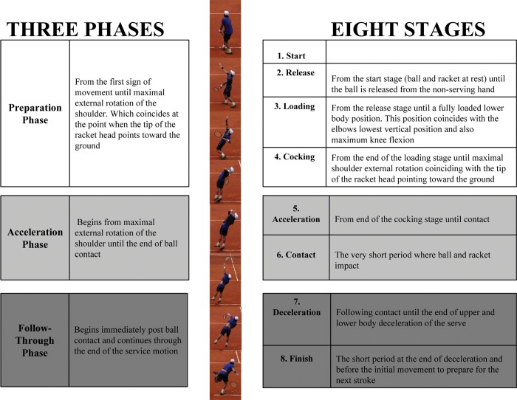

Appendix 2: A graphic representation of the difference in the total shoulder arc of motion between OH athletes and non-throwers. The normal total arc of monition in non-throwers is ~180° with approximately equal degrees of ER and IR. OH athletes develop adaptive osseous and soft tissue changes that permit increased maximum ER, in order to achieve higher velocities. (Image obtained from Lin et al., 2008)⁴

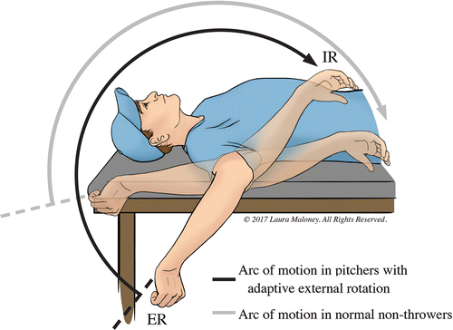

Appendix 3: Internal impingement of the undersurface of the RC against the posterior aspect of the glenoid labrum in the ABER position. (Image obtained from David J. Magee, 2013)¹¹

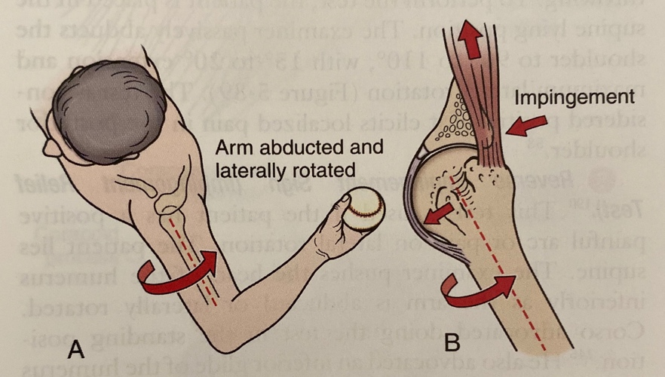

Appendix 4: The goals and interventions associated with each of the four phases of the shoulder rehabilitation program. (Image obtained from Wilk et al., 2002)³⁹

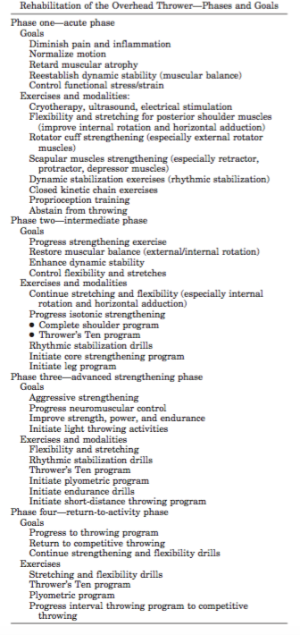
Appendix 5: Image ‘A’ represents the cross-arm stretch that can also be performed independently in standing. Image ‘B’ represents the sleeper stretch. (Images obtained from Cools et al., 2015)²

- 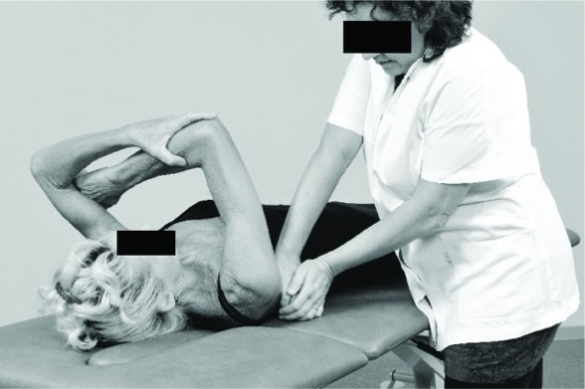 B. 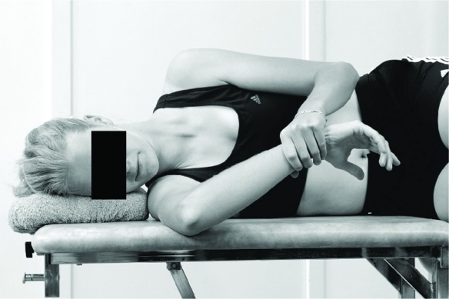

Appendix 6: Image ‘A’ represents the prone scapular push-up that is performed early in rehabilitation for scapular strengthening. Image ‘B’ represents a push-up with the feet elevated, which is performed during the intermediate phase of rehabilitation. (Images obtained from Manske et al.,2013)²⁴

- 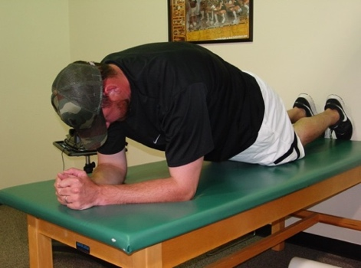 B. 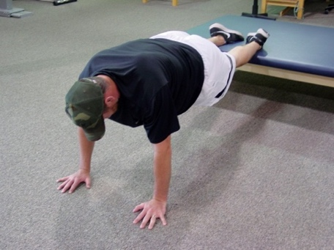

Appendix 7: Image ‘A’ represents the standing wall clocks with a resistance band and image ‘B’ represents the serratus wall slides utilizing a foam roller and resistance band, which are performed to increase scapular stability. (Images obtained from Weiss et al., 2018)¹²

- B. 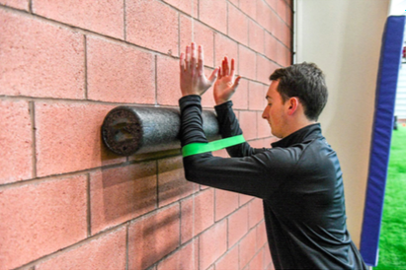
Appendix 8: Exercises from the “Advanced Thrower’s Ten Program.” Image ‘A’ represents the seated resisted shoulder ER at 0° abduction; image ‘B’ represents the second sequence of shoulder abduction to 90° in the scapular plane with the left arm remaining in the scapular plane at 90° while the right arm performs concentric/eccentric abduction; image ‘C’ represents side-lying ER with a dumbbell; image ‘D’ represents ER in the side-lying plank position; image ‘E’ represents prone horizontal abduction; image ‘F’ represents prone abduction at 105° abduction with full ER; image ‘G’ represents prone rows into ER; image ‘H’ represents bilateral shoulder extension at 45°of abduction with ER. (Images obtained from Wilk et al., 2011)⁴³

- 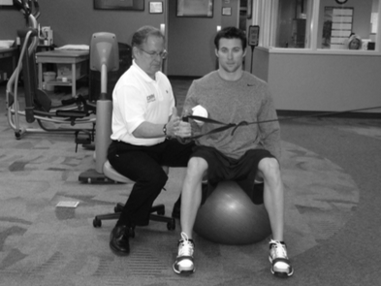 B. 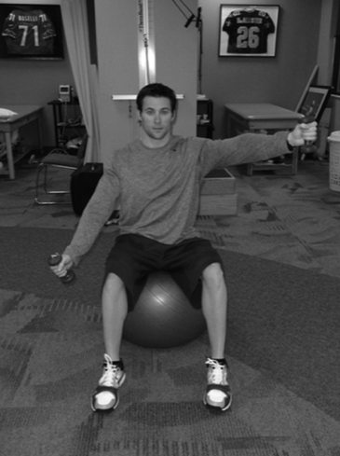

C. 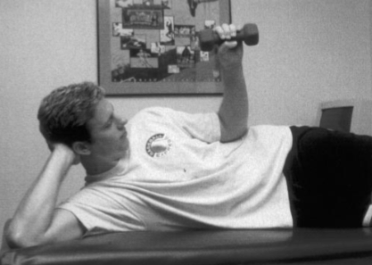 D. 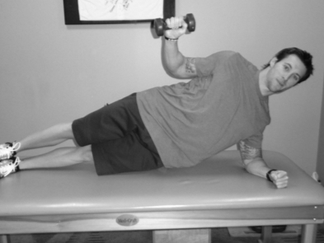

E. 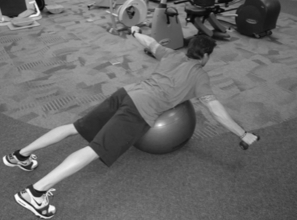 F. 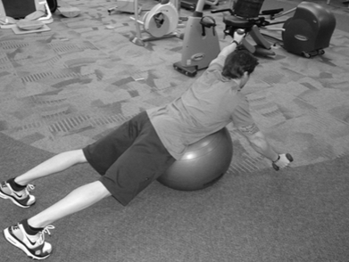

G. 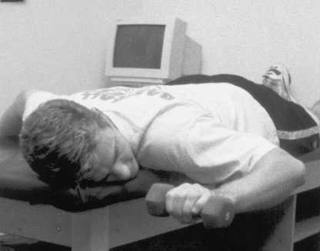 H. 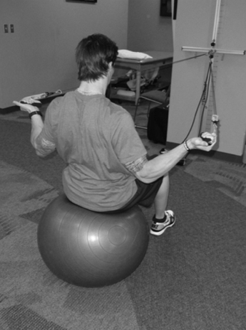

Appendix 9: Plyometric exercises performed with a medicine ball during the advanced strengthening phase of rehabilitation. Image ‘A’ and ‘B’ represent chest passes on a wall with different stance positions; image ‘C’ represents perpendicular throws; image ‘D’ represents rotary straight arm throws; image ‘E’ and ‘D’ represent forward and diagonal wood chops, respectively, in a half-kneeling position. (Images obtained from Escamilla et al., 2012)⁴⁴

- 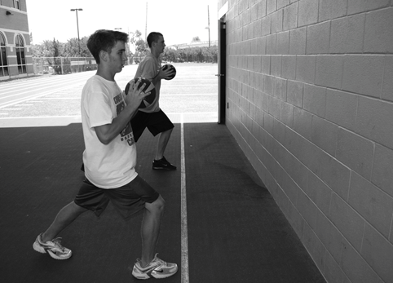 B. 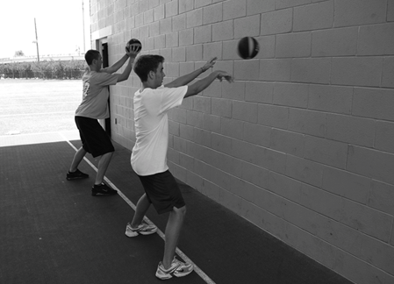

C. 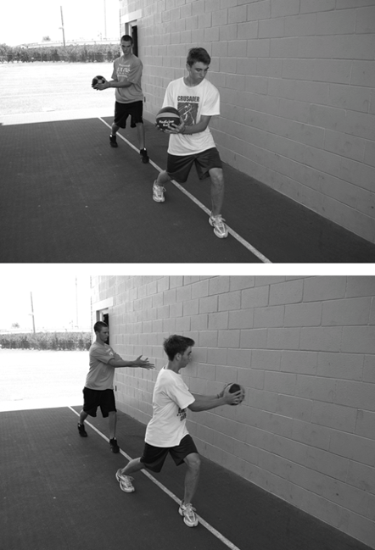 D. 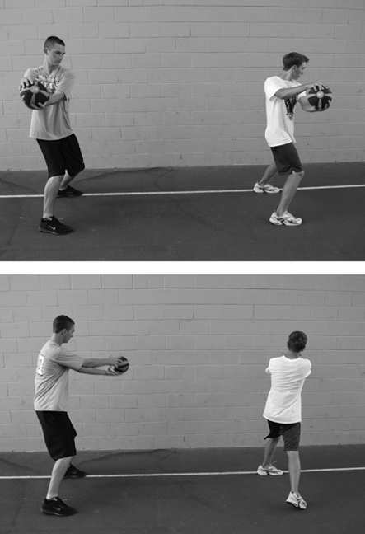
E. 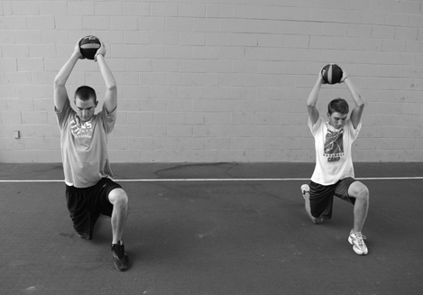 F. 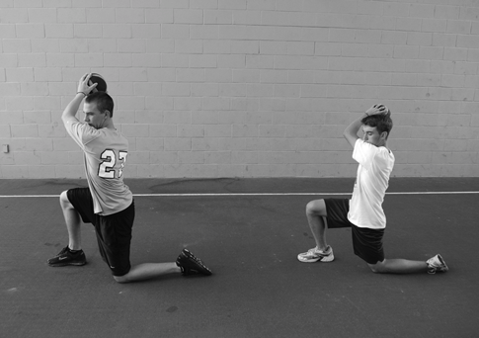

Appendix 10: The interval tennis program that is initiated in the return to playing phase of rehabilitation. (Image obtain from Reinold et al., 2002)⁴⁵

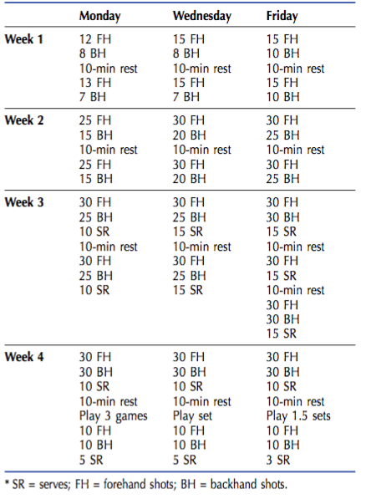

Appendix 11: The OSTRC Shoulder Injury Prevention Programme. (Images obtained from Andersson et al., 2017)⁴⁷

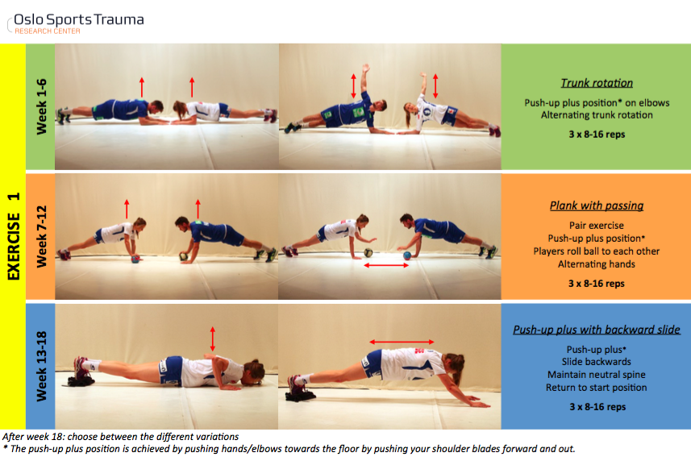

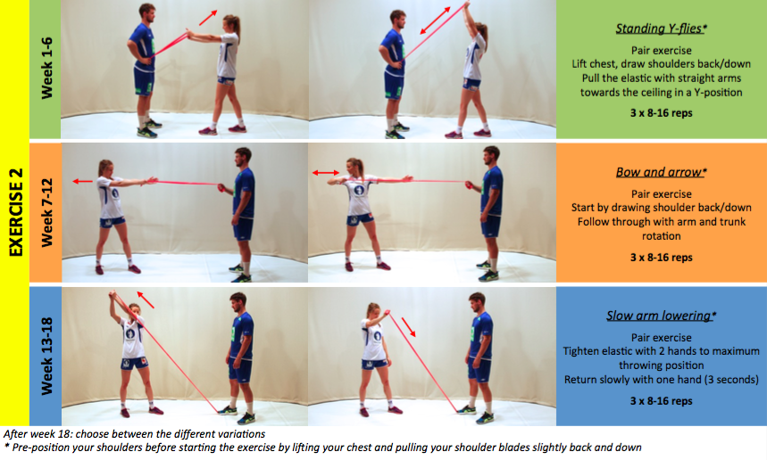
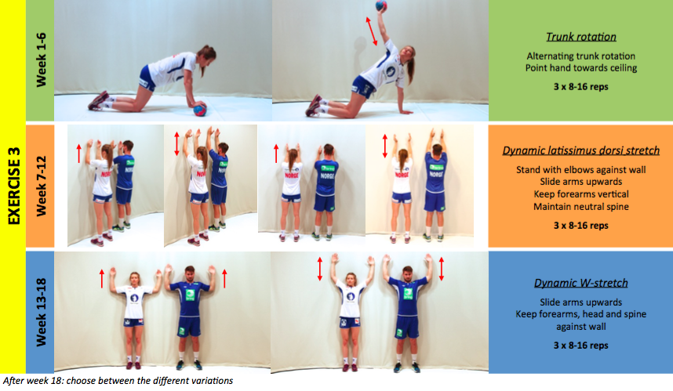

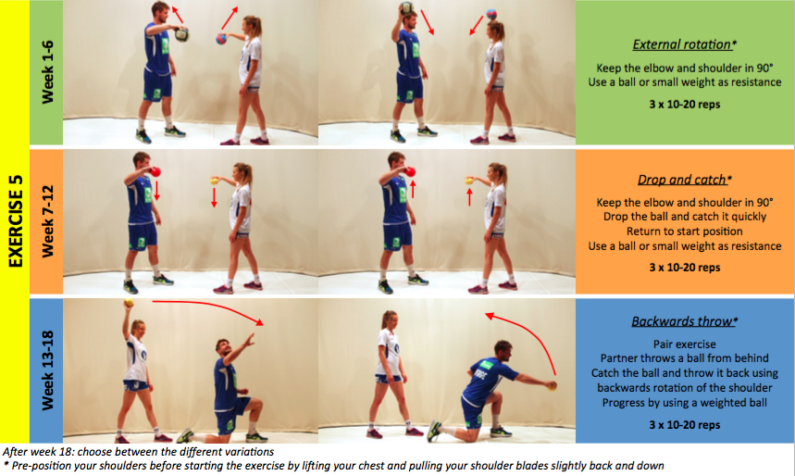
References:

- Wilk KE, Macrina LC, Fleisig GS, et al. Deficits in glenohumeral passive range of motion increase risk of shoulder injury in professional baseball pitchers: A prospective study. Am J Sports Med. 2015;43(10):2379-2385.
- Cools AM, Johansson FR, Borms D, Maenhout A. Prevention of shoulder injuries in overhead athletes: a science-based approach. Braz J Phys Ther. 2015;19(5):331-339.
- Chung KC, Lark ME. Upper extremity injuries in tennis players: diagnosis, treatment, and management. Hand Clin. 2017;33(1):175-186.
- Lynall RC, Kerr ZY, Djoko A, Pluim BM, Hainline B, Dompier TP. Epidemiology of National Collegiate Athletic Association men’s and women’s tennis injuries, 2009/2010-2014/2015. Br J Sports Med. 2015.
- Okholm Kryger K, Dor F, Guillaume M, et al. Medical reasons behind player departures from male and female professional tennis competitions. Am J Sports Med. 2015; 43(1):34–40.
- Pluim BM, Staal JB, Windler GE, Jayanthi N. Tennis injuries: occurrence, aetiology, and prevention. Br J Sports Med. 2006; 40(5):415–423.
- Asker M, Brooke HL, Waldén M, et al. Risk factors for, and prevention of, shoulder injuries in overhead sports: a systematic review with best-evidence synthesis. Br J Sports Med. 2018;52(20):1312-1319.
- Lin DJ, Wong TT, Kazam JK. Shoulder Injuries in the Overhead-Throwing Athlete: Epidemiology, Mechanisms of Injury, and Imaging Findings. Radiology. 2018;286(2):370-387.
- Peduzzi L, Grimberg J, Chelli M, et al. Internal impingement of the shoulder in overhead athletes: Retrospective multicentre study in 135 arthroscopically-treated patients. Orthop Traumatol Surg Res. 2019;105(8S):S201-S206.
- van der Hoeven H, Kibler WB. Shoulder injuries in tennis players. Br J Sports Med. 2006;40(5):435-440; discussion 440.
- David J. Magee B PhD, CM. Orthopedic Physical Assessment. 6th, illustrated ed. Elsevier Health Sciences; 2013.
- Weiss LJ, Wang D, Hendel M, Buzzerio P, Rodeo SA. Management of rotator cuff injuries in the elite athlete. Curr Rev Musculoskelet Med. 2018;11(1):102-112.
- Ruiz J, Feigenbaum L, Best TM. The thoracic spine in the overhead athlete. Curr Sports Med Rep. 2020;19(1):11-16.
- Kovacs M, Ellenbecker T. An 8-stage model for evaluating the tennis serve: implications for performance enhancement and injury prevention. Sports Health. 2011;3(6):504-513.
- Elliott B. Biomechanics and tennis. Br J Sports Med. 2006;40(5):392-396.
- Kovacs MS, Ellenbecker TS. A performance evaluation of the tennis serve: implications for strength, speed, power, and flexibility training. Strength Cond J. 2011;33(4):22-30.
- Whiteley R. Baseball throwing mechanics as they relate to pathology and performance - a review. J Sports Sci Med. 2007;6(1):1-20.
- Oyama S. Baseball pitching kinematics, joint loads, and injury prevention. J Sport Health Sci. 2012;1(2):80-91.
- Seroyer ST, Nho SJ, Bach BR, Bush-Joseph CA, Nicholson GP, Romeo AA. The kinetic chain in overhand pitching: its potential role for performance enhancement and injury prevention. Sports Health. 2010;2(2):135-146.
- Escamilla RF, Andrews JR. Shoulder muscle recruitment patterns and related biomechanics during upper extremity sports. Sports Med. 2009;39(7):569-590.
- Manske RC, Grant-Nierman M, Lucas B. Shoulder posterior internal impingement in the overhead athlete. Int J Sports Phys Ther. 2013;8(2):194-204.
- Burkhart SS, Morgan CD, Kibler WB. The disabled throwing shoulder: spectrum of pathology Part I: pathoanatomy and biomechanics. Arthroscopy. 2003;19(4):404-420.
- Wilk KE, Obma P, Simpson CD, Cain EL, Dugas JR, Andrews JR. Shoulder injuries in the overhead athlete. J Orthop Sports Phys Ther. 2009;39(2):38-54.
- Manske R, Ellenbecker T. Current concepts in shoulder examination of the overhead athlete. Int J Sports Phys Ther. 2013;8(5):554-578.
- Wilk KE, Macrina LC, Fleisig GS, et al. Correlation of glenohumeral internal rotation deficit and total rotational motion to shoulder injuries in professional baseball pitchers. Am J Sports Med. 2011;39(2):329-335.
- Rose MB, Noonan T. Glenohumeral internal rotation deficit in throwing athletes: current perspectives. Open Access J Sports Med. 2018;9:69-78.
- Greenberg EM, Fernandez-Fernandez A, Lawrence JTR, McClure P. The development of humeral retrotorsion and its relationship to throwing sports. Sports Health. 2015;7(6):489-496.
- Myers JB, Oyama S, Goerger BM, Rucinski TJ, Blackburn JT, Creighton RA. Influence of humeral torsion on interpretation of posterior shoulder tightness measures in overhead athletes. Clin J Sport Med. 2009;19(5):366-371.
- Corpus KT, Camp CL, Dines DM, Altchek DW, Dines JS. Evaluation and treatment of internal impingement of the shoulder in overhead athletes. World J Orthop. 2016;7(12):776-784.
- Valencia Mora M, Ibán MÁR, Heredia JD, et al. Physical exam and evaluation of the unstable shoulder. Open Orthop J. 2017;11:946-956.
- Kibler WB, Ludewig PM, McClure PW, Michener LA, Bak K, Sciascia AD. Clinical implications of scapular dyskinesis in shoulder injury: the 2013 consensus statement from the “Scapular Summit”. Br J Sports Med. 2013;47(14):877-885.
- Leschinger T, Wallraff C, Müller D, Hackenbroch M, Bovenschulte H, Siewe J. Internal impingement of the shoulder: A risk of false positive test outcomes in external impingement tests? Biomed Res Int. 2017;2017:2941238.
- Hegedus EJ, Goode A, Campbell S, et al. Physical examination tests of the shoulder: a systematic review with meta-analysis of individual tests. Br J Sports Med. 2008;42(2):80-92; discussion 92.
- Drakos MC, Rudzki JR, Allen AA, Potter HG, Altchek DW. Internal impingement of the shoulder in the overhead athlete. J Bone Joint Surg Am. 2009;91(11):2719-2728.
- Paley KJ, Jobe FW, Pink MM, Kvitne RS, ElAttrache NS. Arthroscopic findings in the overhand throwing athlete: evidence for posterior internal impingement of the rotator cuff. Arthroscopy. 2000;16(1):35-40.
- Sonnery-Cottet B, Edwards TB, Noel E, Walch G. Results of arthroscopic treatment of posterosuperior glenoid impingement in tennis players. Am J Sports Med. 2002;30:227-232.
- Klouche S, Lefevre N, Herman S, Gerometta A, Bohu Y. Return to Sport After Rotator Cuff Tear Repair: A Systematic Review and Meta-analysis. Am J Sports Med. 2016;44(7):1877-1887.
- Young SW, Dakic J, Stroia K, Nguyen ML, Safran MR. Arthroscopic shoulder surgery in female professional tennis players: ability and timing to return to play. Clin J Sport Med. 2017;27(4):357-360.
- Wilk KE, Meister K, Andrews JR. Current concepts in the rehabilitation of the overhead throwing athlete. Am J Sports Med. 2002;30(1):136-151.
- Stone MA, Jalali O, Alluri RK, et al. Nonoperative treatment for injuries to the in-season throwing shoulder: a current concepts review with clinical commentary. Int J Sports Phys Ther. 2018;13(2):306-320.
- McClure P, Balaicuis J, Heiland D, Broersma ME, Thorndike CK, Wood A. A randomized controlled comparison of stretching procedures for posterior shoulder tightness. J Orthop Sports Phys Ther. 2007;37(3):108-114.
- Moore SD, Laudner KG, McLoda TA, Shaffer MA. The immediate effects of muscle energy technique on posterior shoulder tightness: a randomized controlled trial. J Orthop Sports Phys Ther. 2011;41(6):400-407.
- Wilk KE, Yenchak AJ, Arrigo CA, Andrews JR. The Advanced Throwers Ten Exercise Program: a new exercise series for enhanced dynamic shoulder control in the overhead throwing athlete. Phys Sportsmed. 2011;39(4):90-97.
- Escamilla RF, Ionno M, deMahy MS, et al. Comparison of three baseball-specific 6-week training programs on throwing velocity in high school baseball players. J Strength Cond Res. 2012;26(7):1767-1781.
- Reinold MM, Wilk KE, Reed J, Crenshaw K, Andrews JR. Interval sport programs: guidelines for baseball, tennis, and golf. J Orthop Sports Phys Ther. 2002;32(6):293-298.
- Shrier I, Safai P, Charland L. Return to play following injury: whose decision should it be? Br J Sports Med. 2014;48(5):394-401.
- Andersson SH, Bahr R, Clarsen B, Myklebust G. Preventing overuse shoulder injuries among throwing athletes: a cluster-randomised controlled trial in 660 elite handball players. Br J Sports Med. 2017;51(14):1073-1080.
- Cheatham SW, Kolber MJ, Cain M, Lee M. The effects of self-myofascial release using a foam roll or roller massager on joint range of motion, muscle recovery, and performance: a systematic review. Int J Sports Phys Ther. 2015;10(6):827-838.
- Bron C, de Gast A, Dommerholt J, Stegenga B, Wensing M, Oostendorp RAB. Treatment of myofascial trigger points in patients with chronic shoulder pain: a randomized, controlled trial. BMC Med. 2011;9:8.

