Cranial Molding Deformities

Parent Handout
…………………………………………………………………………………………….

What is a cranial molding deformity?
The three most common cranial molding deformities are Plagiocephaly, Brachycephaly, Dolichocephaly.
- Plagiocephaly is the flatting of one side of the back of head.
- Brachycephaly is the symmetrical flatting of the back of the head. The skull is wider than it is long.
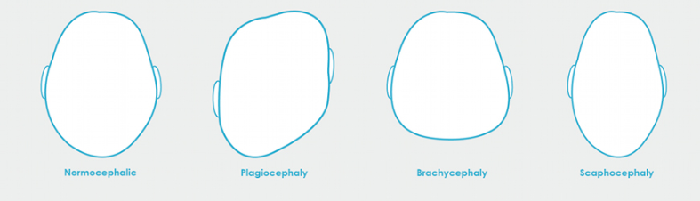
- Dolichocephaly is flattening of both sides of the head creating an elongated head shape.

Brachycephaly
Dolichocephaly
Plagiocephaly
Normal Head Shape

Is my baby at risk for a cranial molding deformity?
When a baby is born, their skull is not fully developed. During infancy, babies spent a lot of time lying on their backs in their cribs, car seats, swings, or bouncy seats. Prolonged pressure on one spot of the head can cause a flat spot. You may begin to notice that your baby has a flat spot on their head or is has a bald spot.
What can I do as a parent?
There are small changes you can do as a parent to help prevent flat spots on your baby’s head.
- Change Positions: You can turn your baby’s head from right to left or left to right as they are sleeping to vary the spot of the head that is in contact with the surface. Do not leave your baby in a car seat, swing, or bouncy chair for an extended period of time, as these devices limit your baby from moving their head and neck freely. Instead, hold your baby, and vary the position in which you hold your baby.
- Tummy Time: Practice tummy time with your baby! Tummy time takes pressure off of the head and helps to strengthen your baby’s neck and shoulder muscles.
- Remember to always place your baby on their back to sleep, as this helps to prevent sudden infant death syndrome (SIDS)
If my baby has a significant cranial molding deformity, how do we treat it?
There are various treatments for cranial molding deformities including positioning devices, positioning techniques, and helmets. Your baby’s pediatrician will prescribe the appropriate treatment for your baby.

