CRITICALLY APPRAISED TOPIC
FOCUSED CLINICAL QUESTION
Is nursing and caregiver education on cranial molding deformities for neonatal ICU patients more effective than the use of the cranial cup for preventing plagiocephaly, measured as less than 3.5 on cranial vault asymmetry index?

AUTHOR
Prepared by | Bethany Barber | Date | 12.3.2019
Email address | Bethany_Barber@med.unc.edu

CLINICAL SCENARIO
Premature infants who have prolonged stays in the neonatal intensive care unit (NICU) are prone to developing positional plagiocephaly, also referred to as deformational plagiocephaly.¹ Plagiocephaly is characterized by a flattening of the head that results in an asymmetrical head shape.^{1,2} Premature infants in the NICU are at increased risk for developing positional plagiocephaly due to the malleability of the neonate skull, weight of gravity against the infant, and unnatural, sustained supine positioning in the NICU.³ An increase in the prevalence of positional plagiocephaly was detected after the American Academy of Pediatrics launched the “Back to Sleep Campaign” in 1994 to prevent Sudden Infant Death Syndrome (SIDS) and suffocation.⁴ While the number of infant deaths related to SIDS and suffocation decreased, cranial molding deformities increased with increased time infants spend lying supine on firm surfaces.⁴ Infants in the NICU spend more time in supine than their healthy peers because their medically unstable condition may limit frequent repositioning and handling by nurses and caregivers.¹ Positional plagiocephaly, left untreated, can lead to disruptions in parent-child bonding, motor developmental, delay and motor asymmetries.^{1,3}
While the prevalence of the positional plagiocephaly in the NICU setting is well documented, there is no standard of care for preventing or treating positional plagiocephaly in the NICU. Various positioning devices including, water-bed mattresses, foam mattress, and gel pillows, have been employed with inconsistent success and limited evidence.² Nursing education regarding frequent repositioning and physical therapy have also been used to prevent positional plagiocephaly, again with low-quality evidence to support their efforts.² There is a need for an evidence-based standard of care to prevent and treat positional plagiocephaly in the NICU setting.

SUMMARY OF SEARCH
Baird et al., 2016: Systematic review including three articles, two randomized controlled trials and one cohort study, investigating the best treatment for positional plagiocephaly in infants approximately 7 weeks old and older.⁴
- Caregiver and nursing education alone is not sufficient to prevent or treat plagiocephaly.⁴
- Physical therapy interventions including cervical stretching, facilitation of non-preferred side movement, and education regarding repositioning, tummy-time, safe handling, and feeding is more effective in treating positional plagiocephaly than caregiver and nursing education alone.⁴
- Physical therapy is as effective as using the BabyDorm positioning pillow.⁴
DeGrazia et al., 2015: Single-blinded, randomized trial comparing two positioning devices in the NICU setting: moldable pillow positioning and a premanufactured cranial cup.²
- The cranial cup proved more effective in prevention of positional plagiocephaly than the moldable pillow positioner.²
- The cranial cup is feasible to use and safe for the NICU population.²
CLINICAL BOTTOM LINE
The cranial cup device is superior to caregiver and nursing education for prevention and treatment of positional plagiocephaly in NICU population.

This critically appraised topic has been individually prepared as part of a course requirement and has been peer-reviewed by one other independent course instructor
SEARCH STRATEGY
Terms used to guide the search strategy
Patient/Client Group | Intervention (or Assessment) | Comparison | Outcome(s)
Neonatal ICU  Premature infants  Premature birth | Education  Caregiver education  Nursing education | Cranial Cup | plagiocephaly severity scale  cranial vault asymmetry index  plagiocephaly

Final search strategy (history):
(“NICU” OR “neonatal ICU” OR “premature birth” OR “premature”) AND (“education” OR “caregiver education” OR “nurse education”) AND (“cranial cup”) AND (“plagiocephaly” OR “plagiocephaly severity scale” OR “cranial vault asymmetry index”)

(“NICU” OR “neonatal ICU” OR “premature birth” OR “premature”) AND (“education” OR “caregiver education” OR “nurse education”) AND (“plagiocephaly” OR “plagiocephaly severity scale” OR “cranial vault asymmetry index”)

1. (“NICU” OR “neonatal ICU” OR “premature birth” OR “premature”) AND (“plagiocephaly” OR “plagiocephaly severity scale” OR “cranial vault asymmetry index”)

(“NICU” OR “neonatal ICU” OR “premature birth” OR “premature”) AND (“cranial cup”) AND (“plagiocephaly” OR “plagiocephaly severity scale” OR “cranial vault asymmetry index”)

2. (“cranial cup”) AND (“plagiocephaly” OR “plagiocephaly severity scale” OR “cranial vault asymmetry index”)

3. (“NICU” OR “neonatal ICU” OR “premature birth” OR “premature”) AND (“cranial cup”)

Final search strategy: 1 OR 2 OR 3: ((“NICU” OR “neonatal ICU” OR “premature birth” OR “premature”) AND (“plagiocephaly” OR “plagiocephaly severity scale” OR “cranial vault asymmetry index”)) OR ((“cranial cup”) AND (“plagiocephaly” OR “plagiocephaly severity scale” OR “cranial vault asymmetry index”)) OR ((“NICU” OR “neonatal ICU” OR “premature birth” OR “premature”) AND (“cranial cup”))

PEDro search term: “plagiocephaly”

Databases and Sites Searched | Number of results | Limits applied, revised number of results (if applicable)
PubMed: | 102 | N/A
CINAHL: | 30 | N/A
Embase: | 190 | Excluded in-vitro studies, nonhuman studies, and studies published prior to 1995  Revised number of results: 165
Cochrane | 2 | N/A
PEDro: | 14 | N/A

INCLUSION and EXCLUSION CRITERIA
Inclusion Criteria
Systematic Reviews, RCT, case reports, case studies, meta-analyses
- Plagiocephaly
- Care provided in NICU setting
- Born prematurely (<37 weeks)
- Evaluates plagiocephaly using plagiocephaly severity scale or cranial vault asymmetry index
- Caregiver education and/or nursing education provided during hospital stay
- Cranial cup device
Guidelines
- Hospital guidelines, PT guidelines, nursing guidelines, OT guidelines
English language
Exclusion Criteria
- Published in a language other than English
- Studies on brachycephaly, dolichocephaly, or helmet interventions
- Studies published prior to 1995
- Animal studies

RESULTS OF SEARCH
Summary of articles retrieved that met inclusion and exclusion criteria
Author (Year) | Risk of bias (quality score) | Level of Evidence* | Relevance | Study design
Knorr, 2019¹ | Downs and Black: 15/29 | 4 (downgraded from 2b to 4 due to lower quality) | Moderate | Prospective, descriptive study
Rogers, 2008⁵ | Downs and Black: 15/29 | 4 (downgraded from 2b to 4 due to lower quality) | High | Nonrandomized prospective Study
DeGrazia, 2015² | Downs and Black: 26/29 | 2b | High | Multisite, stratified, and randomized single-blind study
Baird, 2016⁴ | AMSTAR: 8/11 | 2a (includes cohort studies) | High | Systematic Review and Guidelines
Klimo, 2016⁶ | AMSTAR: 8/11 | 2a (includes cohort studies) | Moderate-high | Systematic Review and Guidelines
Danner-Bowman, 2015⁷ | Downs and Black: 11/29 | 4 (downgraded from 2b to 4 due to lower quality) | Low | Prospective study
Van Vlimmeren, 2008⁸ | Downs and Black: 23/29 | 1b | Low | Randomized Control Trial
Knorr, 2016⁹ | Downs and Black: 21/29 | 2b | High | Prospective, descriptive study
*Level of Evidence determined using Portney & Watkins Table 16.1 (2009)

BEST EVIDENCE
The following 2 studies were identified as the ‘best’ evidence and selected for critical appraisal. Rationale for selecting these studies were:
- DeGrazia M, Giambanco D, Hamn G, Ditzel A, Tucker L, Gauvreau K. Prevention of deformational plagiocephaly in hospitalized infants using a new orthotic device. J Obstet Gynecol Neonatal Nurs. 2015;44(1):28-41. doi:10.1111/1552-6909.12523
- Baird LC, Klimo P, Flannery AM, et al. Congress of Neurological Surgeons Systematic Review and Evidence-Based Guideline for the Management of Patients With Positional Plagiocephaly: The Role of Physical Therapy. Neurosurgery. 2016;79(5):E630-E631. doi:10.1227/NEU.0000000000001429

SUMMARY OF BEST EVIDENCE
(1) Description and appraisal: Prevention of deformational plagiocephaly in hospitalized infants using a new orthotic device by DeGrazia et al., 2015
Objective:
The objective of this study was to measure the feasibility, safety, and efficacy of the cranial cup device in hospitalized infants at risk for plagiocephaly.
Study Design:
Multisite, stratified, randomized single-blinded study
Setting:
The study took place in four neonatal intensive care units (NICUs): three urban hospital NICUs and one suburban hospital NICU. The main study site was a Level IV NICU and the secondary study sites were Level III NICUs.
Participants:
Over 800 infants were screened for the study between April 2010 and July 2012. Infants were excluded from the study if they had continuous ventricular drain, subgaleal shunt, craniofacial anomaly, cervical anomaly, critical airway anomaly requiring prone positioning, cutis aplasia, craniosynostosis, significant skin breakdown of the scalp, or required scalp intravenous access. 88 infants were enrolled and 62 infants were included in the final analysis. The 26 infants not included in final analysis were discharged or transferred hospitals prior to study completion, withdrawn due to parental request, died of illness, or used the cranial cup after the study had closed. Infants who did not complete the study did not differ demographically from those included in final analysis: primary diagnosis (p=.72), gender (p=1.0), age at admission (p=.74), birth weight (p=.76), and gestational age (p=.74).
The 62 participants were born at ≥ 22 weeks gestation and began study when they were less than 14 days of age and had an expected length of stay greater than 14 days. Randomization of the infants was stratified by study site and weight (<1000 grams or ≥ 1000 grams). Two sets of randomization cards were computer-generated: <1000 grams or ≥ 1000 grams. Infants weighing <1000 grams at enrollment used the moldable positioner until they reached 1000 grams. Once these infants reached 1000 grams, they were randomized using the <1000 grams cards. Infants weighing ≥ 1000 grams at enrollment were randomized immediately using the ≥ 1000 grams cards.
Participant Characteristics
  - Chronological age at NICU admission: 0-7 days
  - Gestational age at birth: 23-39 weeks
  - Birth weight: 455-3710 grams
  - Gender: Male (64.5%); Female (35.5%)
  - Birth delivery mode: Caesarean (82%); Vaginal (18%)
  - Primary Diagnosis: Prematurity (65%), Esophageal Atresia (8%), Gastroschisis (8%), Dysplastic Kidney (3%), Congenital Heart Disease (1.5%), Other (14.5%)
Intervention Investigated
Control: Moldable Positioner
The moldable positioner is a 9” x 15”, pillow-like device designed to support an infant’s head, neck, and shoulders in supine, sidelying, and prone positions. Nurses were instructed to make a round depression in the positioner for the infant’s head in order to help facilitate normalized head shape. Infants received routine position changes every 3-4 hours.
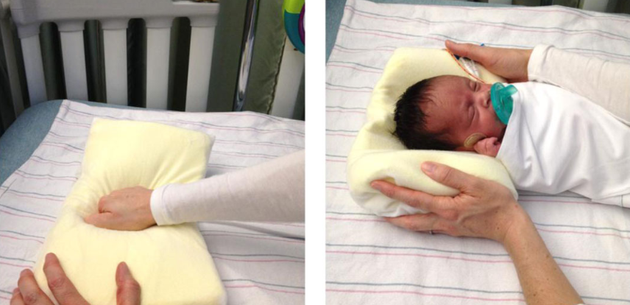 (DeGrazia et al., 2015)

Experimental: Cranial Cup
The cranial cup is polyethlene foam device designed to support an infant’s head and body in supine and sidelying. It has a round indentation to facilitate appropriate cranial shape. Removeable foam inserts allow the device to grow with the infant. Nurses were instructed to position the infants on the cranial cup in supine or semi-sidelying for at least 12 hours per day and routinely reposition the infant every 3-4 hours on the cranial cup. When the cranial cup was not being used, the moldable positioner was used.
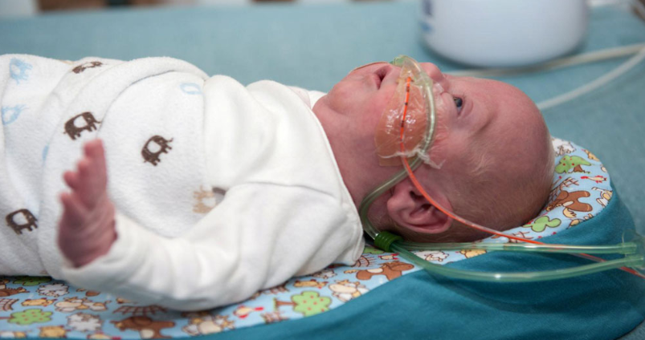
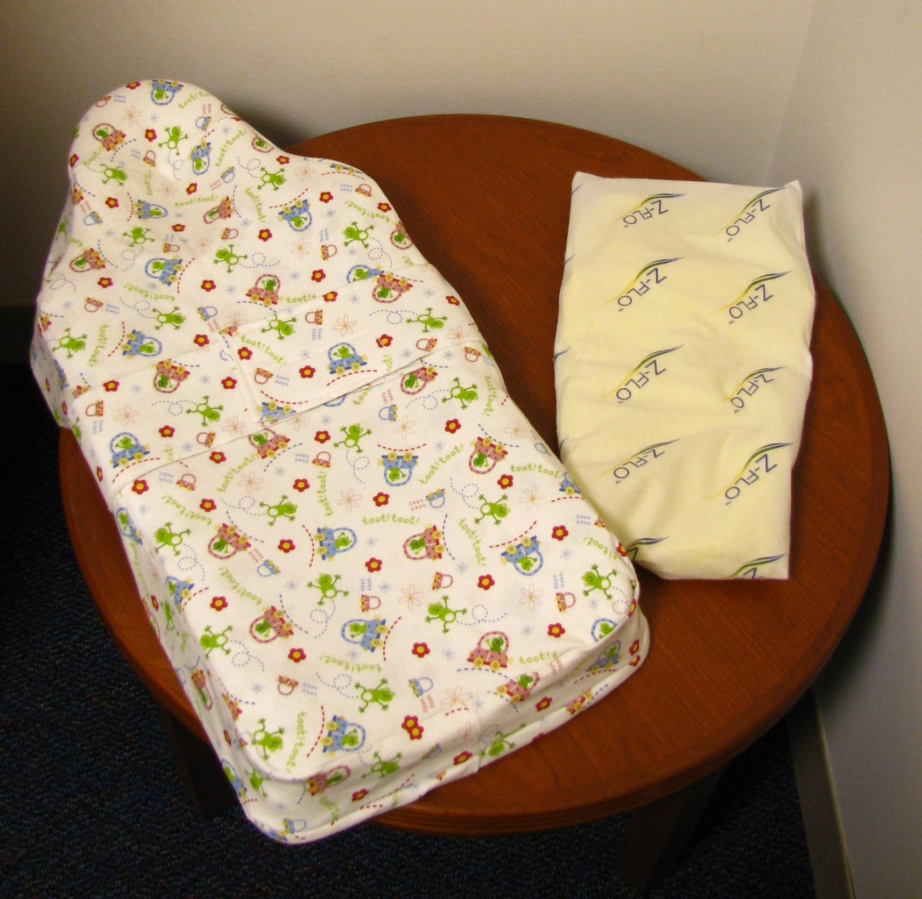
(DeGrazia et al., 2015)
Outcome Measures: Feasibility, Safety, and Effectiveness
Feasibility: device use in hours per day
Feasibility was measured by the number of hours per day the devices were used.
Safety: adverse events
Safety was measured by comparing the number of adverse cardiorespiratory adverse events and emesis events per 100 hours on the device.
Effectiveness: Cranial Measurements
Cranial measurements were taken at enrollment and hospital discharge by licensed orthotists who completed an orientation on study procedures, obtaining cranial measurements, and completion of the cranial measurement form. Orthotists were blinded to which subjects received which intervention.
Manual and laser scan cranial measurements and head circumference were obtained and recorded on the cranial measurement form. Measurements were used to calculate the Cranial Index and the Cranial Symmetry. Normal measurement on the cranial index is 73-85% and is obtained by dividing the medial-lateral by the anterior-posterior dimensions of the cranium and multiplying by 100%. Normal for cranial symmetry is <8 mm and is obtained by calculating the difference between the right and left anterior-posterior measures.
Main Findings:
Feasibility:
The median hours per day on the moldable positioner for the control group was 18.1 hours with a range of 9.7 to 21.8 hours. The median hours per day on the cranial cup device for the experimental group was 10.7 hours with a range of 4.5 to 11.7 hours. The experimental group spent a median of 9.3 hours, range of 0.8 to 11.7, on the moldable positioner.
Safety:
5.4 cardiorespiratory events occurred on the cranial cup; while, 5.9 cardiorespiratory events occurred on the moldable positioner, per 100 hours on the devices. 1.1 emesis events occurred on the cranial cup; while, 1.0 emesis events occurred on moldable positioner, per 100 hours on the devices. There were no statistically significant differences in the number of cardiorespiratory of emesis events between the moldable positioner and cranial cup.
Effectiveness: Cranial Measurements
Cranial Measurement | Moldable Positioner Group (n=35) | Cranial Cup Group (n=27)
Cranial Index Abnormality | n=15, 43% | N=5, 19%
Cranial Symmetry Abnormality | n=2, 6% | N=1, 4%
CI or CS Abnormality (total) | N=16, 46%* | N=5, 19%*
*Each group had one infant with both CI and CS abnormalities; these infants were counted once in the total.
Infants were considered to have a cranial abnormality if they had abnormal measurements on the Cranial Index or Cranial Symmetry. At discharge, 16 of the 35 infants (46%) in the moldable positioner group had abnormal cranial measures; whereas, 5 of the 27 infants (19%) in the cranial cup group had abnormal cranial measurements.
Original Authors’ Conclusions
Positional plagiocephaly is preventable. The cranial cup is a positioner that provides necessary support to the cranium in order to prevent and treat positional plagiocephaly that cannot be achieved through repositioning by nurses or the use of other positional devices. More studies are needed to determine the feasibility, safety, and efficacy for specific NICU patient populations and during commonly performed tests and procedures.
Critical Appraisal
Validity
This study received a 26/29 on the Downs and Black Checklist and is rated as 2b level evidence. Possible confounders and study limitations were discussed in the article. The evidence is limited by the small sample size and variance in nurse management with over 100 nurses treating the study participants, but the study demonstrates safety, feasibility, and efficacy of the cranial cup device for prevention and treatment of positional plagiocephaly in the NICU setting. The evidence is generalizable to many NICU patients, but more research will need to be done on infants weighing less than 1000 grams and those with other cervical, cranial, or facial abnormalities or disorders.
Confounding variables including length of hospital stay, number of days on a CPAP, and infant weight were discussed. There was no statistically significant difference between groups when controlling for number of days on a CPAP or when controlling for initial birth weight. As for length of hospital stay, when the length of stay was less than 40 days, there were more infants with abnormal cranial measurements in the moldable positioner group compared to the cranial cup group (p=.04). However, this difference was not statistically significant (p=.49) when the length of hospital stay was greater than 40 days. This may suggest gradually improving head shapes overtime, but more research is needed.
Interpretation of Results
The results of this study showed that 46% of infants using the moldable positioner had abnormal head shapes at hospital discharge; whereas, 19% of infants using the cranial cup device had abnormal head shapes at hospital discharge. This suggests that the cranial cup is more effective in treating the positional plagiocephaly. Unfortunately, initial head measurements and number of infants with cranial abnormalities in each group at enrollment were not reported in the article, making determining an accurate effect size impossible. The author does note that initial head abnormalities were evenly distributed between the two groups with a p-value=0.22.
Applicability of Study Results
This study was designed to follow a study conducted by Gary Rogers that used a custom-made cranial cup orthotic.⁵ In the study conducted by Rogers et al., an orthotist made a cranial cup individualized for the infant’s head shape.⁵ The orthotist was required to widen and deepen the depression of the cranial cup every one to two weeks to accommodate the infant’s head growth.⁵ Use of a premanufactured cranial cup that can grow with the infant, such as that described in the study by DeGrazia et al., is more financially feasible for use in the NICU.
DeGrazia et al. demonstrates that the premanufactured cranial cup is a safe and effective way to prevent and treat positional plagiocephaly in the NICU setting. Unfortunately, the study only uses the moldable positioner as a comparison, and therefore, does not directly answer the clinical question at hand.

(2) Description and appraisal: Congress of Neurological Surgeons Systematic Review and Evidence-Based Guideline for the Management of Patients With Positional Plagiocephaly: The Role of Physical Therapy by Baird, 2016
Objective
To determine if physical therapy is an effective treatment for positional plagiocephaly
Study Design
Systematic review and evidence-based guidelines
Search Strategy: The Congress of Neurological Surgeons (CNS) and Section on Pediatric Neurosurgery formed a task forced to review the literature and establish guidelines regarding the management of positional plagiocephaly. The task force searched PubMed and the Cochrane Library with a time parameter of 1966 to October 2014. Three separate searches were conducted using the following terms:
- ((“plagiocephaly, nonsynostotic”[Mesh terms]) OR ("nonsynostotic plagiocephaly" OR "Positional plagiocephaly" OR "deformational plagiocephaly" OR "flat head") AND (“physical therapy” OR “physical therapy modalities”[Mesh terms])
  - Limits: “NOT animals, English Language, NOT Comment[publication type], NOT Letter[publication type].
- (brachycephaly[tiab] OR brachiocephaly OR brachycephalic[tiab] OR brachycephalies[tiab]) AND (“physical therapy” OR “physical therapy modalities”[Mesh terms])
  - Limits: “NOT animals, English Language, NOT Comment[publication type], NOT Letter[publication type].
- Cochrane Searches
  - MeSH descriptor: [Plagiocephaly, Nonsynostotic]
  - Title, Abstract, Keywords: “positional plagiocephaly” OR “deformational plagiocephaly” OR “nonsynostotic plagiocephaly” OR “flat head”
  - Title, Abstract: “brachycephaly”
  - Limits: English language, human studies
47 articles were identified through the database search. 34 were excluded based on task force abstract review. 13 articles were fully reviewed, and 10 were excluded for lack of comparison group, potential confounding variables, lack of physical therapy as an independent variable, and lack of commercially available device. 3 articles were included in the evidence table, but 4 studies were discussed in the qualitative analysis. The Rogers et al., 2008 study evaluating the cranial cup was discussed but excluded from the evidence table because the cranial cup was not commercially available at the time. The final studies included in discussion:
  - van Vlimmeren LA, van der Graaf Y, Boere-Boonekamp MM, L'Hoir MP, Helders PJ, Engelbert RH. Effect of pediatric physical therapy on deformational plagiocephaly in children with positional preference: a randomized controlled trial. Archives of pediatrics & adolescent medicine. 2008;162(8):712-718.
  - Wilbrand JF, Seidl M, Wilbrand M, et al. A prospective randomized trial on preventative methods for positional head deformity: physiotherapy versus a positioning pillow. The Journal of pediatrics. 2013;162(6):1216-1221, 1221 e1211.
  - Rogers GF, Miller J, Mulliken JB. Comparison of a modifiable cranial cup versus repositioning and cervical stretching for the early correction of deformational posterior plagiocephaly. Plastic and reconstructive surgery. 2008;121(3):941947.
  - Ohman A, Nilsson S, Beckung E. Stretching treatment for infants with congenital muscular torticollis: physiotherapist or parents? A randomized pilot study. PM & R : the journal of injury, function, and rehabilitation. 2010;2(12):1073-1079.
Setting
Van Vlimmeren et al., 2008: Bernhoven Hospital in the Netherlands⁸
Wilbrand et al., 2013: Information not described.
Rogers et al., 2008: Craniofacial Program at Children’s National in Washington, D.C.⁵
Ohman et al., 2010: Outpatient physical therapy department in a Sweden children’s hospital¹¹
Participants
Van Vlimmeren et al.: 380 infants were referred to the study and examined at 7 weeks of age.⁸ 68 infants met inclusion criteria for positional preference.⁸ 65 infants were randomized and stratified by sex into physical therapy group or usual care group. 33 infants were assigned to the physical therapy and 32 were assigned to the usual care group. 65 infants participated in a follow up appointment between 6 and 12 months of age.
Wilbrand et al.: 50 infants younger than 5 months of age with a mean age of 4 months and a diagnosis of positional plagiocephaly.¹⁰ Infants were randomized into two groups: 25 infants were assigned to the positioning device group, and 25 infants were assigned to the physical therapy group.
Rogers et al.: 51 infants were compared. The treatment group consisted of 23 infants treated using the cranial cup device. The treatment group was prospective and nonrandomized.⁵ The control group consisted of 28 infants. The control group was historical, and the parents had been instructed in providing repositioning and cervical stretching. There were no statistically significant differences between the control and experimental groups in regards to gestational age at birth, age at initial visit, initial cervical rotation asymmetry, initial transcranial difference, and age at final evaluation.⁵
Ohman et al., 2010: 20 infants with congenital muscular torticollis, mean age of 2.1 months, randomized into physical therapy administered by parents or physical therapy administered by physical therapist. 18 of the 20 infants had plagiocephaly at the start of the study.
Intervention Investigated: Van Vlimmeren et al.
Control: Usual Care
Usual care included providing parents with written directions describing basic preventive measures including repositioning and tummy-time.
Experimental: Physical Therapy
Six experienced Pediatric physical therapists were trained to provide a standardized physical therapy program to the infants.⁸ The infants received up to eight sessions between the ages of the 7 weeks and 6 months. In the first month of therapy, sessions occurred weekly.⁸ In the second and third months, the sessions tapered to every 2 to 3 weeks.⁸ The second and fifth sessions occurred in the child’s home.⁸ Physical therapist provided exercises to reduce positional preference and facilitate gross motor movements.⁸ They also provided parents with counselling regarding counterpositioning, handling, and feeding.⁸
Intervention Investigated: Wilbrand et al.
Control: Repositioning Device
The repositioning device used was the BabyDorm bedding pillow. Parents were told to use this pillow exclusively and not utilize any other method of correcting cranial deformity.¹⁰ Parents were also encouraged to provide their child with an adequate amount of tummy-time.
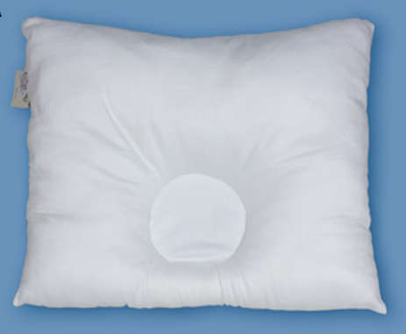 (Wilbrand et al.)
Experimental: Physical Therapy: Stretching Exercises
The physical therapy group received stretching exercises delivered by their parents 5 times per day. The picture on the left depicts cervical rotation and the picture on the right depicts lateral flexion. Parents were instructed to perform both exercises to the right and left and to hold positions for 10 seconds each.¹⁰ Parents were also encouraged to provide their child with an adequate amount of tummy-time.
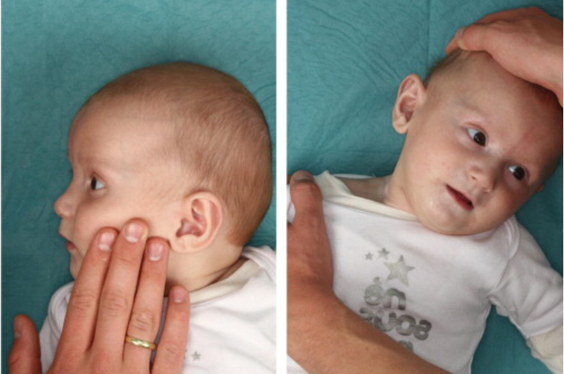 (Wilbrand et al., 2013)
Intervention Investigated: Rogers et al.
Control: Physical Therapy: Repositioning and Cervical Stretching
Parents were instructed on repositioning and cervical stretching including rotation and lateral flexion. The parents were free to use any commercially-available positioning product they liked. Infants were treated for a mean of 61.1 days.
Experimental: Orthosis: Cranial Cup
The cranial cup is a custom-made, modifiable device designed for infants who are too young for helmet therapy.⁵ It is made from a foam that is firm enough to maintain its shape but soft enough to avoid adverse skin reactions with long periods of use.⁵ It is cut and molded by a licensed orthotist who sizes each cup for the individual infant. The concave depression is increased every 1 to 2 weeks as the child’s head grows.⁵ There is an attachable torso support to lessen excessive cervical flexion.⁵ The infants used the cranial cup for a mean of 56.3 days.
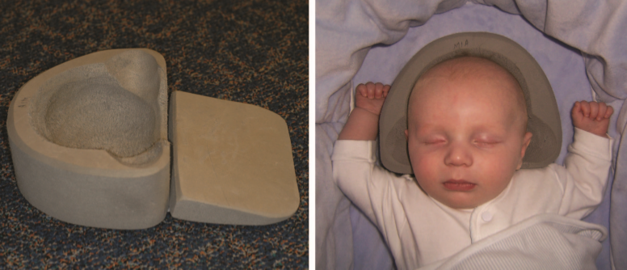
(Rogers et al., 2008)

Intervention Investigated: Ohman et al.
Control: Physical Therapy performed by Parents
Stretching for lateral flexion and rotation performed by parents twice per day, 7 days per week. Stretches were held 10-30 seconds based on infant tolerance and sessions lasted approximately 15 minutes.¹¹ Parents were provided with hands-on stretching instruction and photos for home program.¹¹ Stretching continued until cervical rotation ROM was ≥ 90 degrees and equal left and right lateral flexion was achieved.¹¹
Experimental: Physical Therapy performed by Physical Therapist
Stretching for lateral flexion and rotation performed by physical therapists 3 days per week. Stretches were held for 10-30 seconds based on infant tolerance and sessions lasted approximately 15 minutes.¹¹ Stretching continued until cervical rotation ROM was ≥ 90 degrees and equal left and right lateral flexion was achieved.¹¹
Outcome Measures:
Van Vlimmeren et al.: The primary outcome measure was severe deformational plagiocephaly defined as a score of 104% or more on the Oblique Diameter Difference Index (ODDI).⁸ The ODDI score is calculated by dividing the longest oblique diameter of the skull by the shortest oblique diameter of the skull and multiplying by 100%.⁸ Secondary outcome measures included positional preference, motor developmental milestones, and passive cervical range of motion.
Wilbrand et al.: A single, blinded examiner performed anthropometric measurements following a standardized protocol immediately prior to initiation of treatment and at 6 weeks of treatment.¹⁰ Anthropometric measurements included cranial length, cranial width, and transcranial diagonals A and B. These measurements were used to calculate the Cranial Index (CI) and Cranial Vault Asymmetry Index (CVAI).¹⁰
Rogers et al.: A single examiner assessed cranial asymmetry using cranial caliper accurate to within 1 mm to measure the transcranial difference.⁵ The transcranial difference was measure twice for each infant and the average of the measures was recorded.⁵ Measurements were taken at initial and final visits.
Ohman et al.: Primary outcome measure was treatment time (in months) needed to obtain cervical rotation ROM of ≥ 90 degrees and equal cervical lateral flexion.¹¹ Plagiocephaly was assessed as a secondary outcome measure in this study, along with muscle function test and head tilt. Plagiocephaly was assessed using 3 of the 5 items of the Severity Assessment for Plagiocephaly. The 3 items included were neck involvement, posterior flattening, and forehead asymmetry.¹¹ An infant was determined to have plagiocephaly if he or she scored 1 or greater on the posterior flattening or forehead asymmetry.¹¹
Main Findings
Van Vlimmeren et al.: At 6 months, in the physical therapy group, the number of infants with severe positional plagiocephaly decreased from 18 of 33 to 10 of 33.⁸ In the usual care group, the number of infants with severe positional plagiocephaly decreased from 20 of 32 to 18 of 32.⁸ At 12 months, in the physical therapy group, the number of infants with severe positional plagiocephaly decreased further to 8 of 33.⁸ In the usual care group, the number of infants with severe positional plagiocephaly remained 18 of 33 at 12 months.⁸ There was found to be a risk reduction of 46% (RR=0.54; 95% CI 0.30-0.98) in the physical therapy group at 6 months of age, and a risk reduction of 57% (RR=0.43, 95% CI 0.22-0.85) in the physical therapy group at 12 months of age. The number of infants with positional preference needed to treat at 6 months was 3.85, and the number of infants needed to treat at 12 months was 3.13. Therefore, between 3 and 4 infants with positional plagiocephaly must be treated with the given physical therapy protocol in order to avoid one infant having severe positional plagiocephaly between the ages of 7 weeks and 12 months. No statistically differences were found in any secondary outcome measures.
Wilbrand et al.: The number of infants with moderate and severe deformities decreased by 17.7% in the stretching group and decreased by 19.1% in the pillow group.¹⁰ Both physical therapy and the BabyDorm bedding pillow were effective in improving head shape. There was a slightly greater improvement in the pillow group; however, this difference was not statistically significant. Baird et al. notes that the pillow does not comply with the American Academy of Pediatrics recommendations to avoid soft bedding in order to prevent Sudden Infant Death Syndrome.
Rogers et al. (excluded from final evidence table): The mean transcranial difference at the final evaluation for the cranial cup group was 3.5mm with a standard deviation of 3mm.⁵ This had decreased from a mean transcranial difference of 11.2mm at the initial evaluation. The mean transcranial difference at the final evaluation for the physical therapy group was 8.0mm with a standard deviation of 3.5mm.⁵ This had decreased from 9mm at initial evaluation. The difference in the mean transcranial differences between groups was statistically significant with a p-value=0.000.⁵ The cranial cup is more effective than repositioning and physical therapy for treating plagiocephaly. Baird et al. notes the possibility of treatment bias due to the severity of the pre-treatment plagiocephaly being greater in the cranial cup group than the control group.
Ohman et al.: The time needed to achieve adequate cervical ROM was significantly shorter for the physical therapist treated group (p<.001).¹¹ The treatment duration to accomplish adequate cervical ROM (both lateral flexion and rotation) for the Parent Group was a median of 3 months (range: 1-9 months) with a standard deviation of 2.3 months.¹¹ The treatment duration to accomplish adequate cervical ROM (both lateral flexion and rotation) for the Physical Therapy Group was a median of 0.7 months (range: 0.5-2.8 months) with a standard deviation of 0.7 months.¹¹ 2 infants had plagiocephaly at end of treatment, compared to 18 at the start.
Original Authors’ Conclusions
The authors provided two evidence-based recommendations after synthesizing their findings:
- Physical therapy is recommended over repositioning education alone for infants 7 weeks to 12 months of age with positional plagiocephaly.
- While positioning devices appear to be as effective in the prevention and treatment of positional plagiocephaly as physical therapy, physical therapy is recommended over the use of a positioning pillow in order to comply with American Academy of Pediatrics recommendation for safe sleeping.
Critical Appraisal
Validity:
The literature search conducted for this systematic review is thorough and reproducible. Because high-quality evidence is limited regarding positional plagiocephaly, the systematic review evidence table includes only 3 articles: two randomized controlled trials and one cohort study, making it class 2a evidence. This systematic review received an 8/11 on the AMSTAR. The evidence lacks generalizability to infants younger than 7 weeks and or medically unstable infants.
Baird et al. discusses all of the main interventions described in the literature for infants with positional plagiocephaly: education, physical therapy, and positioning devices. However, only one article discusses education, and two articles discuss positioning devices. While all studies discuss physical therapy intervention, all physical therapy protocols are different. Variability in physical therapy is discussed, and it is noted that the ideal timing for initiation and duration of services, along with best physical therapy techniques, remain unknown.
Physical therapy interventions typically include education regarding repositioning, handling, and feeding. The overlap between education interventions alone and education provided as part of physical therapy is not discussed.
Interpretation of Results
Based on the results of this study, physical therapy, including cervical stretching, facilitation of movement of the non-preferred side, and handing, repositioning, and feeding education conducted by a physical therapist is more effective than repositioning education alone. Education provided within physical therapy sessions is generally more extensive and repeated multiple times over the course of therapy; whereas, education in the study conducted by van Vlimmeren et al., for example, was provided in the form of a pamphlet with no formal in-person education. It is likely that education interventions outside of physical therapy require improvement.
The BabyDorm positioning pillow was shown to be as effective as physical therapy intervention in preventing and treating plagiocephaly, with no statistically significance found between the BabyDorm group and the physical therapy group. However, having soft pillows and bedding in cribs does not comply with the American Academy of Pediatrics’ guidelines stating that “infants should be placed on a firm sleep surface… with no other bedding or soft objects to reduce the risk of sudden infant death syndrome and suffocation.”¹²
Applicability of Study Results
Parents should be encouraged to comply with the American Academy of Pediatrics’ recommendation to remove all soft objects from the bed for safe sleeping. However, in the NICU, infants are consistently monitored, and therefore, the risk of SIDS and suffocation is lowered. The NICU may be a more feasible and safer environment to use a positioning device. Furthermore, the cranial cup is not a soft positioning device but rather a firm surface with a cranial depression.
The cranial cup described by Rogers et al. is custom-made by a licensed orthotist, and thus is not a feasible option for every NICU infant. It is possible that a premanufactured, universal device may be more practical for NICU use.
It is important to note that the recommendations made by the Congress of Neurological Surgeons were made for older infants who are medically stable. Van Vlimmeran et al., performed initial evaluations at 7 weeks of age, the youngest reported age of the four articles discussed. Reported settings for the studies included were outpatient clinics in hospitals with patients coming in for appointments or being sent home with home exercise programs or positioning devices. Medically unstable infants would likely be seen in inpatient NICU setting, not outpatient clinics. Younger, sicker infants in the NICU will be less tolerant to the stretching exercises and handling than the older infants discussed in this systematic review.

SYNTHESIS AND CLINICAL IMPLICATIONS
There is currently very limited high-quality research discussing effects of interventions for prevention and treatment of positional plagiocephaly in the NICU. It is well documented that infants born prematurely or with diagnoses that result in long hospital stays and/or respiratory assistance are at increased risk for developing positional plagiocephaly.¹⁻³ Untreated, positional plagiocephaly can persist into childhood and adulthood resulting in neurodevelopmental abnormalities and gross motor asymmetries.¹⁻³ Most intervention-focused literature describes nursing and caregiver education, physical therapy, or positioning devices. This literature is limited by small sample sizes, low-quality study designs, and interventions studied in combination rather than as isolated variables.
The study by DeGrazia et al., is the most relevant to the clinical question at hand, as it addresses positional plagiocephaly prevention and treatment in the NICU. However, it compares two positioning devices: the moldable positioner and the cranial cup; it does not incorporate nursing and caregiver education as an intervention. This study is limited by the small sample size of 62 infants: 35 in the moldable positioner group and 27 in the cranial cup. The original study was published in 2008, but DeGrazia went on to conduct a similar study in 2010 with a larger sample size.^{2,13} The second study was terminated due to loss of equipoise.^{2,13} A larger difference than expected was detected between the moldable positioner and the cranial cup at the first interim analysis suggesting the cranial cup was much more effective than the moldable positioner at preventing and treating positional plagiocephaly.² A data safety monitoring board also discovered that nurses and doctors were observing and discussing the improved head shapes of the infants using the cranial cup and were requesting the cranial cup for infants not enrolled in the study and their own children.²
The systematic review by Baird et al., demonstrates that education alone is not as effective as physical therapy for treating positional plagiocephaly.⁴ It also demonstrates that a pillow positioner, the BabyDorm, is as effective as physical therapy for treatment of positional plagiocephaly but does not comply with American Academy of Pediatrics’ infant sleep recommendations.^{4,12} It is important to note that the studies evaluated in this systematic review were not conducted in the NICU, but in the outpatient setting and at home. The participants were also older and more medically stable in Baird et al.’s study than in DeGrazia et al.’s. It is likely that younger, sicker infants in the NICU may not tolerate physical therapy interventions including cervical stretching, handling, and facilitation of non-preferred side movement as well as older infants that have been discharged from the hospital.¹ A positioner device may be more tolerable and feasible for the NICU population. The American Academy of Pediatrics recommends against any sort of soft bedding in the crib to prevent SIDS and suffocation; however, infants in the NICU are regularly monitored and the cranial cup is a firm positioning device.¹²
The cranial cup is designed for infants weighing greater than 1000 grams. However, many premature infants weigh less than 1000 grams. Knorr et al., modified the cranial cup into a small version called the preemie orthotic device (POD).¹ A pilot study has been conducted suggesting the POD feasibility and safety for NICU infants with extremely low birth weight.¹ More research needs to be done to confirm these results. There is also not a standardized method for measuring and defining plagiocephaly. The Cranial Index, Cranial Vault Asymmetry Index, and Oblique Diameter Difference Index, along with other measures, are all used in the literature with little consensus on what scores on these measures defines plagiocephaly.⁵ Differences in definition among the literature makes it increasingly difficult to compare studies.⁵ A common definition for what constitutes as plagiocephaly, along with a standardized outcome measure to assess plagiocephaly will improve the quality of the literature.⁵

REFERENCES

    - Knorr A, Giambanco D, Staude MV, et al. Feasibility and safety of the preemie orthotic device to manage deformational plagiocephaly in extremely low birth weight infants. Adv Neonatal Care. 2019;19(3):226-235. doi:10.1097/ANC.0000000000000585
    - DeGrazia M, Giambanco D, Hamn G, Ditzel A, Tucker L, Gauvreau K. Prevention of deformational plagiocephaly in hospitalized infants using a new orthotic device. J Obstet Gynecol Neonatal Nurs. 2015;44(1):28-41. doi:10.1111/1552-6909.12523
    - McCarty DB, Peat JR, Malcolm WF, Smith PB, Fisher K, Goldstein RF. Dolichocephaly in preterm infants: prevalence, risk factors, and early motor outcomes. Am J Perinatol. 2017;34(4):372-378. doi:10.1055/s-0036-1592128
    - Baird LC, Klimo P, Flannery AM, et al. Congress of Neurological Surgeons Systematic Review and Evidence-Based Guideline for the Management of Patients With Positional Plagiocephaly: The Role of Physical Therapy. Neurosurgery. 2016;79(5):E630-E631. doi:10.1227/NEU.0000000000001429
    - Rogers GF, Miller J, Mulliken JB. Comparison of a modifiable cranial cup versus repositioning and cervical stretching for the early correction of deformational posterior plagiocephaly. Plast Reconstr Surg. 2008;121(3):941-947. doi:10.1097/01.prs.0000299938.00229.3e
    - Klimo P, Lingo PR, Baird LC, et al. Guidelines: Congress of Neurological Surgeons Systematic Review and Evidence-Based Guideline on the Management of Patients With Positional Plagiocephaly: The Role of Repositioning. Neurosurgery. 2016;79(5):E627-E629. doi:10.1227/NEU.0000000000001428
    - Danner-Bowman K, Cardin AD. Neuroprotective core measure 3: positioning & handling — A look at preventing positional plagiocephaly. Newborn and Infant Nursing Reviews. 2015;15(3):111-113. doi:10.1053/j.nainr.2015.0009
    - van Vlimmeren LA, van der Graaf Y, Boere-Boonekamp MM, L’Hoir MP, Helders PJM, Engelbert RHH. Effect of pediatric physical therapy on deformational plagiocephaly in children with positional preference: a randomized controlled trial. Arch Pediatr Adolesc Med. 2008;162(8):712-718. doi:10.1001/archpedi.162.8.712
    - Knorr A, Gauvreau K, Porter CL, Serino E, DeGrazia M. Use of the Cranial Cup to Correct Positional Head Shape Deformities in Hospitalized Premature Infants. J Obstet Gynecol Neonatal Nurs. 2016;45(4):542-552. doi:10.1016/j.jogn.2016.03.141
    - Wilbrand J-F, Seidl M, Wilbrand M, et al. A prospective randomized trial on preventative methods for positional head deformity: physiotherapy versus a positioning pillow. J Pediatr. 2013;162(6):1216-1221, 1221.e1. doi:10.1016/j.jpeds.2012.11.076
    - Ohman A, Nilsson S, Beckung E. Stretching treatment for infants with congenital muscular torticollis: physiotherapist or parents? A randomized pilot study. PM & R : the journal of injury, function, and rehabilitation. 2010;2(12):1073-1079.
    - Task force on Sudden Infant Death Syndrome. SIDS and Other Sleep-Related Infant Deaths: Updated 2016 Recommendations for a Safe Infant Sleeping Environment. Pediatrics. 2016;138(5). doi:10.1542/peds.2016-2938
    - U.S. National Library of Medicine. Cranial Cup Use for the Prevention of Positional Head Shape Deformity in the NICU. https://clinicaltrials.gov/ct2/show/NCT01218087. Last Updated: February 3, 2017

