Helping Kids with Hemiplegia Camp Manual:
Therapeutic Rationale, Handling Techniques, and Activity Recommendations

Kaitlynn Durkin, SPT
Holly Holland OT/L, ATP
Kerry Blazek, PT, DPT, PCS

Table of Contents
Car Wash 3
Lucky Duck 4
Bubbles 6
Parachute 8
Obstacle Course 9
Balance Beam 11
PIRATE DAY 12
Homeroom: Putting on Pirate Costume 12
Swab the Deck 13
Balloon Sword Fight 14
Coconut Bowling 15
Row the Boat 16
Hook Toss 17
Treasure Hunt 18
Walk the Plank 19
Raise the Sail 20
Piñata 21
FIRETRUCK DAY 22
Bucket Fill 22
Building Breakdown 23
Put out Fire 24
Ladder Climb 25
Agility Ladder 25
Stop, Drop, and Roll 26
Water Target Practice 26
Sports Day 27
Shaving Cream 30
Sensory Bin 32
Slime 34
Lemonade 36
Crafts 38
References 43

Car Wash
Campers fill small buckets with water and use sponges to clean cars.

Gross Motor Goals | Fine Motor Goals
- Squatting  - Trunk rotation  - Side-stepping | - Hand open  - Elbow and wrist extension  - Forearm supination

Goals | Proper Form/Technique | Activity Recommendations
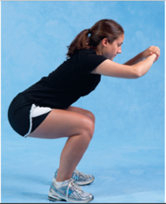  Squatting  1 | - Feet should be positioned shoulder width apart  - Equal weight bearing through both legs  - Toes should be pointed slightly outward  - Heels should stay in contact with the ground  - Knees should not pass toes and should stay in line with shoulders (they should not go in)  - Back should remain fairly straight | - Squat to grab/dunk sponge in bucket. Alter height of bucket.  - Squat to clean tires/low parts of car
Trunk rotation | - Feet should be positioned shoulder width apart  - Equal weight bearing through both legs  - Heels should stay in contact with the ground  - Help facilitate rotation by:  - Placing one hand on child’s chest and one hand on child’s back OR  - Guiding forearm with one hand and other hand on back | - Have child stand with bucket on one side and car on other  - Rotate towards bucket to wet sponge, rotate towards car to clean  - Switch sides to rotate towards and away from weak side
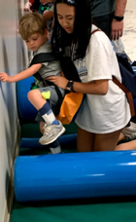  Side-stepping | - Feet should be positioned shoulder width apart  - Knees and toes should face forward  - Shift weight onto opposite leg in preparation to take side-step  - Flex at knee and hip to clear foot over obstacles  - Alternate leading with strong and weak leg | - Side-step along side of car while cleaning  - Place sponges or small buckets on ground to side-step over obstacles
Hand open | - Get hand ready to open: Provide input to fisted hand directed toward wrist, gently stretch arm into extension at elbow  - Use your fingers to provide input into the child’s palm near the base of the thumb to help open thumb  - It’s okay if the fingers are flexed (bent) loosely | - Encourage child to grab sponge from bucket or from a firm surface (may need to hold sponge steady)  - Loosely flex fingers around sponge to grip, try different sponges for the best fit  - Move sponge back and forth across car to clean  - Weight bear through extended elbow, extended wrist, and open hand by pushing sponge against car  Two-Handed: Stabilize/hold bucket with weak hand while using strong hand to clean car
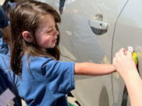  Elbow and wrist extension | - Position child’s arm close to body  - Help child straighten elbow by placing one hand above and one below the elbow  - Help child bend wrist backwards by stabilizing the forearm above the wrist, placing your fingers on the palm side of the wrist and thumb on the opposite side
Forearm supination | - Position child’s arm close to body  - Encourage neutral alignment of forearm while placing hand on side of bucket | - Stabilize side of bucket with hand in thumb up position with forearm neutral while helper fills small bucket with water

Lucky Duck
Campers fish for ducks in a swimming pool and check the markings on the bottom of the duck to see if they found the lucky duck.

Gross Motor Goals | Fine Motor Goals
- Squatting  - Trunk Rotation  - Tall and half kneeling  - Transition from kneeling to standing  - Reaching | - Hand open  - Forearm pronation/supination  - Isolated index finger movement
Goals | Proper Form/Technique | Activity Recommendations
Squatting  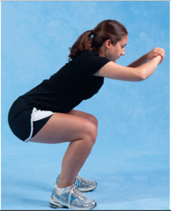  1 | - Feet should be positioned shoulder width apart  - Equal weight bearing through both legs  - Toes should be pointed slightly outward  - Heels should stay in contact with the ground  - Knees should not pass toes and should stay in line with shoulders (they should not go in)  - Back should remain fairly straight | - Squat to grab ducks  - Side-step in crouched/squat position around edge of pool  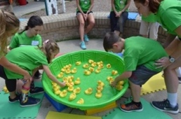
Trunk rotation | - Feet should be positioned shoulder width apart  - Equal weight bearing through both legs  - Heels should stay in contact with the ground  - Help facilitate rotation by:  - Placing one hand on child’s chest and one hand on child’s back or  - Guide forearm with one hand and other on back | - Have child stand with sideways at pool  - Rotate trunk to both sides to reach for and place duck and coin
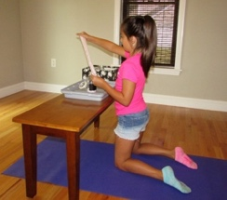  Tall kneeling  2 | - Both knees in contact with the ground  - Shoulders and hips should be in line with knees  - Place hands over child’s hips. Do not let hips bend  - Back should remain fairly straight  - Provide support at the child’s hips to help maintain balance if needed  - Tummy should not be leaning on table/surface | - Kneel at edge of pool  - Encourage reaching for ducks in all directions  - Slowly lower down without plopping
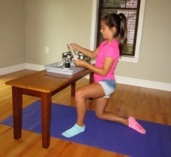  Half kneeling  3 | - Child positioned with one knee on the ground and one foot on the ground  - Shoulders should be in line with hips  - Be sure to alternate legs | - Half-kneel at edge of pool  - Encourage reaching for ducks in all directions
Transition from kneeling to standing | - Support child at hips  - From tall kneeling position, help child shift their weight over their weak leg and bring strong leg forward so foot is flat on the ground (half-kneeling)  - Push down on strong leg and move hand on weak hip up to guide child to standing  - Child may need to use arms for support or balance | - Transition to standing to move to new spot at pool or to check egg carton after finding lucky duck  - Slowly lower to half-kneel/kneel without plopping
Hand open | - Get hand ready to open: Provide input to fisted hand directed toward wrist, gently stretch arm so the elbow is straight (extension)  - Use your fingers to provide input into the child’s palm near the base of the thumb to help open thumb  - It’s okay if the fingers are flexed (bent) loosely  - Position wrist to reduce wrist flexion when grasping objects on ulnar border  - Provide support at base of thumb to open web space around duck  - Assist child with holding duck by pushing the duck gently into the child’s hand | - Encourage child to grab duck from pool or from firm surface (may need to hold duck steady)  - Loosely flex fingers around duck to grip, try different parts of duck (head, body) for the best fit
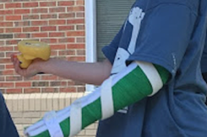  Forearm supination | - Position child’s arm close to their body initially to ensure alignment of the shoulder  - Encourage neutral alignment of forearm while reaching for and grabbing duck  - Stabilize the child’s elbow while helping rotate the wrist so the palm is facing up (supination) to check the bottom of the duck | - Encourage reaching for ducks in all directions  - Encourage child to turn duck over to look at bottom by rotating forearm  - Encourage trunk rotation to both sides during task
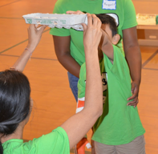  Reaching | - Standing with feet shoulder width apart and equal weight bearing through both legs  - Shoulders in line with hips  - Place hands on child’s glutes while reaching to help shift weight forwards onto balls of feet and sideways  - Help child straighten elbow when reaching  - Bend (flex) elbow while bring object back towards body | - Hold egg carton above, in front of, and to the sides of the child just out of arms reach to encourage  - Vary the height and distance but focus on reaching at shoulder height for eye hand coordination, wrist extension, and proximal strengthening
Isolated index finger movement | - Provide input to fisted hand directed toward wrist  - Use your fingers to provide stability to the web space near the base of the thumb and index finger to help open index finger | - Use index finger to open egg carton and remove object  - Flick or push ducks into water with index finger

Bubbles
Campers play with a variety of bubble toys and machines outdoors.

Gross Motor Goals | Fine Motor Goals
- Symmetrical stance  - Single limb stance  - Ankle dorsiflexion, knee extension, and hip flexion  - Reaching | - Shoulder active range of motion  - Elbow active range of motion  - Forearm pronation/supination  - Grasp: Cylindrical, Pincer, Three-point  - Isolated finger movements
Goals | Proper Form/Technique | Activity Recommendations
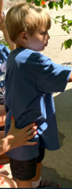  Symmetrical stance | - Feet should be positioned shoulder width apart with equal weight bearing through both legs  - Heels should stay in contact with the ground  - Shoulders should be in line with hips  - Back should remain fairly straight. | - Alternate having child blow and pop bubbles  This activity is very exciting, and the kids can easily get out of control. When playing with bubbles think of ways to slow down this game. (i.e. Red Light, Green Light; Ninja; Simon Says etc.)
Single leg stance | - Feet positioned shoulder width apart, shoulders in line with hips  - Position hands on child’s glutes to help shift weight onto stance leg to prepare to lift other leg off the ground  - Knee of stance leg should not pass toes and should stay in line with shoulder (should not go in) | - Have child stand on one leg and reach out with opposite foot to pop bubbles before they reach the ground  - Stomp on bubbles to pop them  - Kick bubbles to encourage ankle dorsiflexion, knee extension, and hip flexion  - Alternate legs
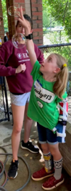  Reaching | - Standing with feet shoulder width apart and equal weight bearing through both legs  - Shoulders in line with hips  - Place hands on child’s glutes while reaching to help shift weight forwards onto balls of feet and sideways  - Help child straighten elbow when reaching | - Blow bubbles above, in front of, and to the sides of the child just out of arms reach to encourage reaching in all directions  - Vary the height and distance but focus on reaching at shoulder height for visual tracking, hand-eye coordination, and proximal strengthening
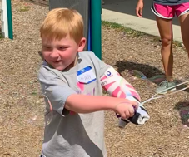  Shoulder and elbow active range of motion | - Encourage neutral alignment of wrist during shoulder and elbow movements  - May need to help facilitate overhead motion with one hand on the arm above the child’s elbow | 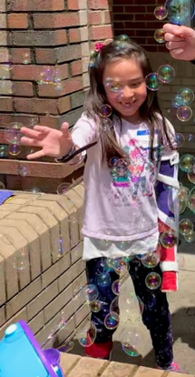  - Lift arm overhead in front of and to the side of body and swing back down to move larger bubble wands or pop bubbles  - Swing arm across body to opposite shoulder and back to move wand or pop bubbles  - Alternate bending at elbow and keeping elbow straight with arm motions
Shoulder rotation, pronation, and supination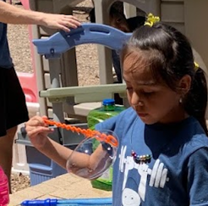 | - Position child’s arm close to their body initially to ensure alignment of the shoulder  - Encourage neutral alignment of forearm and wrist while reaching for the bubble container/wand  - Stabilize the child’s elbow while helping rotate forearm at the wrist so the palm is facing down (pronation) or up (supination).  - Help facilitate rotation at the shoulder by rotating the arm just above the elbow so that forearm and hand move up or down | - Rotate shoulder so hand/forearm are pointed down. Dip bubble wand into container with hand in thumb down position.  - Rotate shoulder so hand/forearm move up. Hold bubble wand with hand in thumbs up position to blow bubbles.
Cylindrical grasp | - Provide input to fisted hand directed toward wrist to open hand, gently stretch arm so the elbow is straight  - Use your fingers to provide input into the child’s palm near the base of the thumb to help open thumb  - It’s okay if the fingers are loosely flexed (bent)  - Provide support at base of thumb to open web space around the handle of the sword | - Hold bubble container with hand in thumb up position with forearm neutral while helper gets wand out of bubbles  - Assist child with holding by pushing the bubble container gently into their hand  - Child can hold container on support surface
Isolated finger movements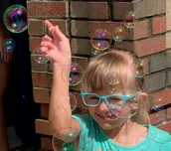 | - Provide input to fisted hand directed toward wrist to open hand  - Use your fingers to provide stability to the web space near the base of the thumb and index finger to help open index finger | - Use index finger to scoop bubble wand out of container  - Pop bubbles with isolated index finger
Three-point grasp 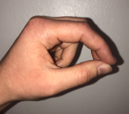  Pincer grasp  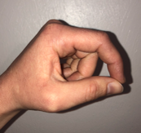 | - Three-point: Thumb is in opposition to index and long finger; index and middle are loosely flexed at middle joints. Ring and little finger are bent (finger flexion) to stabilize the hand  - Pincer: Thumb is in opposition to the index finger. Middle joint of index finger is loosely flexed to prevent web space collapse/narrowing. Middle, ring, and little finger are bent (finger flexion) to stabilize the hand.  - Provide support at base of thumb and little finger side of the hand  - Will often need to provide wrist stability on small finger side | - Grab bubble wand with index finger and thumb  - Hold bubble wand with index finger and thumb OR index finger, thumb, and middle finger while blowing bubbles

Parachute
Campers raise and lower parachute to bounce water balloon on top and allow kids to run underneath.

Gross Motor Goals | Fine Motor Goals
- Symmetrical stance  - Squatting  - Tall kneeling  - Crawling | - Hand Open  - Grip: overhand and underhand  - Shoulder active range of motion (AROM)
Goals | Proper Form/Technique | Activity Recommendations
Hand open | - Provide input to fisted hand directed toward wrist to get hand ready to open, gently stretch arm so the elbow is straight (extension)  - Use your fingers to provide input into the child’s palm near the base of the thumb to help open thumb  - It’s okay if the fingers are flexed (bent) loosely | - Encourage child to reach for parachute handle (may need to stabilize)  - Flex fingers around parachute handle to grip  - You may have help child keep hand closed  - Alternate overhand/underhand grip on the parachute handle in various stance positions  *Two-Hands: Position both hands side-by-side on parachute handle  Kids get very excited during this activity! Be sure to balance slow and fast movements so postural alignment, grasp, and participation can be successful.
Grip 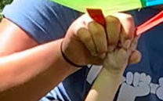 | - Position child’s arm close to their body  - Overhand: Stabilize the child’s elbow while helping rotate the wrist/ forearm so the palm is facing down (pronation) to grip the parachute handle  - Underhand: Stabilize the child’s elbow while helping rotate the wrist/forearm so the palm is facing up (supination) to grip the parachute handle  - If the child’s wrist falls into flexion, provide stability at the base of the wrist to maintain in a straight or neutral alignment
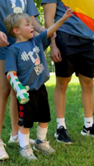  Symmetrical stance | - Feet should be positioned shoulder width apart with equal weight bearing through both legs  - Heels should stay in contact with the ground  - Shoulders should be in line with hips  - Back should remain fairly straight. | - Alternate stance so that child is facing forward OR standing sideways at parachute  - Side-step towards right and left while holding onto parachute  - Facing forward: Arm positioned in front of child at 90-degree angle to the chest. Move arm up overhead (flexion) and down to side (extension).  - Standing sideways: Start with hand at side and move arm up and away from body (abduction). Bring arm back down towards side (adduction).  - Begin with small & slow movements working towards big amplitude movements
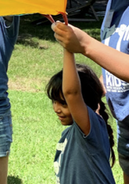  Shoulder AROM | - Keep elbow straight while moving arm  - Encourage neutral alignment of wrist during shoulder movements  *Two-Hands: Have child stand facing parachute. Encourage child to raise both arms together at the same speed and to the same height. Help facilitate lifting to the end of range of motion on the hemiplegic side.
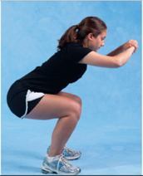  Squatting  1 | - Feet should be positioned shoulder width apart  - Equal weight bearing through both legs  - Toes should be pointed slightly outward  - Heels should stay in contact with the ground  - Knees should not pass toes and should stay in line with shoulders (they should not go in)  - Back should remain fairly straight | 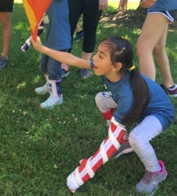  - Lower body into squat while lowering arm and parachute  - Come to standing while lifting up arm and parachute
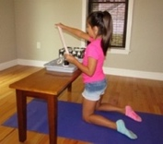  Tall Kneeling  2 | - Both knees in contact with the ground  - Shoulders and hips should be in line with knees  - Place hands over child’s hips. Do not let hips bend  - Back should remain fairly straight  - Provide support at the child’s ankles to help maintain balance if needed | - Reach for parachute put weight through hand on ground  - Raise and lower parachute while in kneeling position  - Slowly lower down without plopping
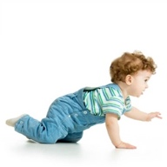  Crawling  4 | - Hands positioned in line with shoulders  - Knees positioned in line with hips  - Back should remain fairly straight  - Equal weight bearing between arms and legs, as well as right and left sides  - Help child shift weight forward while lifting/moving opposite arm and leg forward | - When their name is called, have child let go of the handle and slowly lower to their hands and kneels  - Crawl underneath parachute to other side  - Keep belly off ground!

Obstacle Course
Campers navigate a themed obstacle that requires them to crawl under and step over a variety of objects.

Gross Motor Goals
- Stepping over obstacles
- Squatting
- Crawling on hands and knees
- Rolling
- Step-ups
- Jumping from elevated surface

Goal | Proper Form/Technique | Activity Recommendations
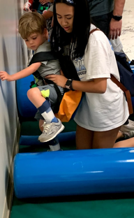  Stepping over obstacles | - Feet positioned shoulder width apart  - Shoulders should be in line with hips  - Back should remain fairly straight  - Position hands on child’s glutes to help shift weight onto opposite leg in preparation to take steps  - Flex at hip and knee to step over obstacles | 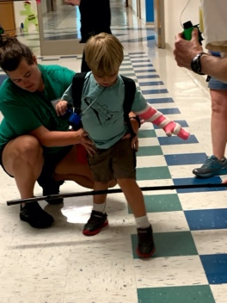  - Walk forwards stepping over obstacles  - Side-step over obstacles  - Alternate leading with strong and weak leg
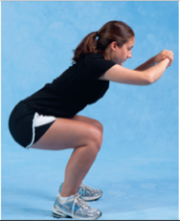  Squatting  1 | - Feet should be positioned shoulder width apart  - Equal weight bearing through both legs  - Toes should be pointed slightly outward  - Heels should stay in contact with the ground  - Knees should not pass toes and should stay in line with shoulders (they should not go in)  - Back should remain fairly straight | - Encourage child to squat to duck underneath obstacle  - Take steps forwards or side-ways in crouched position
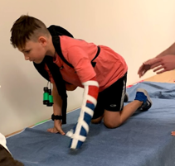  Crawling on hands and knees | - Hands positioned in line with shoulders  - Knees positioned in line with hips  - Back should remain fairly straight  - Equal weight bearing between arms and legs, as well as right and left sides  - Help child shift weight forward while lifting/moving opposite arm and leg forward | - Crawl underneath or over obstacles  - Keep belly off ground!
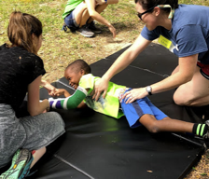  Rolling | - Flex shoulder so arms are over head  - Legs should remain fairly straight  - Help facilitate rolling with one hand one the child’s side (over obliques) and one at the glutes  - Encourage child to roll along length of mat, using core muscles to initiate movement
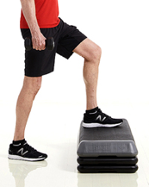  Step-Ups  5 | - Feet should be positioned shoulder width apart with equal weight bearing through both legs  - Shoulders in line with hips  - Position hands on child’s glutes to help shift weight onto stronger leg in preparation to lift weaker leg  - Flex at knee and hip to place foot on higher surface  - Help child shift weight forward and over leg on higher surface  - Push through leg on higher surface while raising leg from lower surface (flex at knee and hip)  - Stabilize at the child’s hips to help maintain balance  - Child can use arms for balance and support if needed. Encourage more pushing through legs than arms
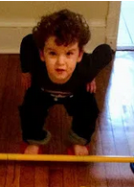  Jumping  6 | - Feet should be positioned shoulder width apart with equal weight bearing through both legs  - Shoulders in line with hips  - Toes should be pointed slightly outward  - Heels should stay in contact with the ground  - Trunk should come forward so nose is over toes, back should remain fairly straight  - Support child with downward pressure at the hips while child flexes hips and knees  - Have child push equally through both legs when extending at hips and knees to jump up/forward | - Encourage child to jump forward from one target to another (tape, tiles, etc.)  - Have child jump down from elevated surface (stacked mats)  - Jump up over low obstacles or to reach a target  - Have child jump moving feet out and bringing them back together (hopscotch)

Balance Beam
Campers walk across a balance beam to encourage dynamic stability with a narrow base of support.

Gross Motor Goals
- Forward walking with narrow base of support
- Side-stepping
- Grapevine
- Backwards walking with narrow base of support

Goal | Proper Form/Technique | Activity Recommendations
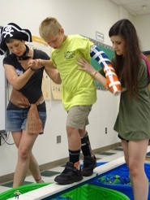  Forward walking with narrow base of support | - Shoulders should be in line with hips  - Back should remain fairly straight  - Feet will be less than shoulder width apart  - Position hands on child’s glutes to help to shift weight forward and onto stance leg in preparation to take step forward  - Step length should be equal on both sides  - Flex at knee and hip to step over obstacles | - Have child walk heel to toe on balance beam  - You may need to stabilize the child’s trunk  - Child can use arm support for balance as needed  - Try to reduce support through arms with each trial to further challenge balance  - Child can hold dowel between hand/cast OR both hands on bimanual day  - Place toys on beam to step over obstacles  - Encourage child to focus on visual stimuli forward and not downward
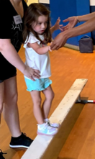  Side-stepping | - Feet positioned shoulder width apart  - Shoulders should be in line with hips  - Back should remain fairly straight  - Position hands on child’s glutes to help shift weight onto stance leg in preparation to take side-step | - Alternate leading with strong and weak leg  - You may need to stabilize the child’s trunk  - Child can use arm support for balance as needed  - Try to reduce support through arms with each trial to further challenge balance  - Place toys on beam to side-step over obstacles
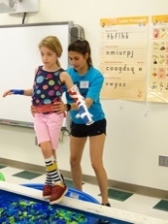  Grapevine | - Feet positioned shoulder width apart  - Back should remain fairly straight  - Position hands on child’s glutes to help shift weight onto stance leg to prepare to lift foot from beam  - Alternate crossing feet in front of and behind each other with each step | - Alternate leading with strong and weak leg  - You may need to stabilize the child’s trunk  - Child can use arm support for balance as needed  - Try to reduce support through arms with each trial to further challenge balance
Backwards walking with narrow base of support | - Shoulders should be in line with hips  - Back should remain fairly straight  - Feet will be less than shoulder width apart  - Position hands on child’s glutes to help shift weight backward and onto stance leg in preparation to take step backward  - Step length should be equal on both sides | - Some kids may be able to take backwards steps, heel to toe, on the balance beam.  - This is a more difficult task.  - You may need to stabilize the child’s trunk  - Child can use arm support for balance as needed.  - Try to reduce support through arms with each trial to further challenge balance

PIRATE DAY
Gross Motor Goals | Fine Motor Goals
- Symmetrical stance  - Sitting  - Single limb stance  - Squatting  - Reaching  - Throwing/tossing  - Forward and backwards walking with narrow base of support  - Side-stepping  - Grapevine | - Shoulder active range of motion  - Elbow active range of motion  - Forearm pronation/supination  - Upper extremity weight bearing  - Opening hand  - Grasp: Cylindrical, Pincer, Three-point  - Isolated finger movements

Homeroom: Putting on Pirate Costume
Campers get dressed up using bandanas and tattoos to get in the spirt of Pirate Day.
Goal | Proper Form/Technique | Activity Recommendations
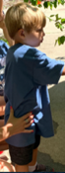  Symmetrical stance | - Feet should be positioned shoulder width apart with equal weight bearing through both legs  - Heels should stay in contact with the ground  - Shoulders should be in line with hips  - Back should remain fairly straight | - Have child squared up to table  - Encourage child to support their weight with the trunk and legs  - NO bellies on table!  - Stand facing volunteer to paint their face
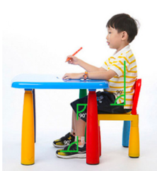  Sitting  7 | - Feet should be flat on the floor  - Hips, knees, and ankles should be at 90 degrees  - Knees should be at the same height as (or slightly lower than) the hips  - May need to put a stool or foot box under feet to help with positioning  - Table should be 1-2 inches above bent elbows  - Back should be straight  - No slouching and no bellies on table!  - Make sure child’s weight is evenly distributed on sit bones  - They shouldn’t be shifted or leaning to one side | - Have child sitting squared up to table to play with tattoos, bandanas, and face paint  - Encourage child to support their weight with the trunk and legs  - NO bellies on table!
Forearm supination | - Position child’s arm close to their body  - Stabilize the child’s elbow while helping rotate forearm at the wrist so the palm is facing up | - Place tattoo on inside or side of forearm so kids have to supinate to see it
Shoulder flexion | - Wrist should be in neutral (hand in line with arm)  - Elbow should be straight  - Have child lift arm up to 90 degrees (shoulder flexion)  - Facilitate shoulder flexion with one hand on arm above elbow | - Let child paint your face with face paint
Hand open | - Provide input to fisted hand directed toward wrist to open hand, gently stretch arm so the elbow is straight  - Use your fingers to provide input into the child’s palm near the base of the thumb to help open thumb  - It’s okay if the fingers are loosely flexed (bent) | - Open bandana on table  - With hand open and palm facing down, smooth out bandana
Isolated finger movements | - Provide input to fisted hand directed toward wrist to open hand  - Use your fingers to provide stability to the web space near the base of the thumb and index finger to help open index finger | - Point at/count different tattoos with index finger  - Slide tattoos back and forth on table using index finger or thumb  - Use index finger to pick up tattoo
Three-point grasp  Pincer grasp | - Three-point: Thumb is in opposition to index and long finger; index and middle are loosely flexed at middle joints. Ring and little finger are bent (finger flexion) to stabilize the hand  - Pincer: Thumb is in opposition to the index finger. Middle joint of index finger is loosely flexed to prevent web space collapse/narrowing. Middle, ring, and little finger are bent (finger flexion) to stabilize the hand.  - Provide support at base of thumb and little finger side of the hand  - Will often need to provide wrist stability on small finger side | - Grab sides of bandana to open it  - Pinch tattoo between index finger and thumb OR index finger, middle finger, and thumb to pick up tattoos from table  - Orient tattoo vertically to make it easier to grasp  - Hold paint brush between index finger, middle finger, and thumb to paint volunteer’s face

Swab the Deck
Campers use a broom to sweep up shredded paper in the hallway.

Goal | Proper Form/Technique | Activity Recommendations
Symmetrical Stance  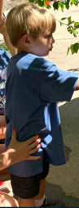 | - Feet should be positioned shoulder width apart with equal weight bearing through both legs  - Place hands on child’s glutes to help maintain equal weightbearing with sweeping  - Heels should stay in contact with the ground  - Shoulders should be in line with hips  - Back should remain fairly straight | - Push broom in front while walking forward  - Stand with equal weight bearing while sweeping  - Can stand with one foot in front of the other to shift weight forward and backwards while pushing and pulling broom forward and backward
Shoulder and Elbow Active Range of Motion | - Encourage neutral alignment of wrist during shoulder movements  - Straighten (extend) elbow while pushing broom away from body  - Bend (flex) elbow while pulling broom towards body | - Sweep broom forward and backward  - Be sure to go through full range of motion in each direction
Hand Open and Grip | - Provide input to fisted hand directed toward wrist, gently stretch arm so the elbow is straight  - Use your fingers to provide input into the child’s palm near the base of the thumb to help open thumb  - It’s okay if the fingers are loosely flexed (bent)  - Provide support at base of thumb to open web space around the handle of the broom | - Wrap fingers and thumb around the broom handle  - Assist child with holding by pushing the broom gently into their hand

Balloon Sword Fight
Campers pretend to be pirates while using a sword to jab and hit balloon targets.

Goal | Proper Form/Technique | Activity Recommendations
Symmetrical stance | - Feet should be positioned shoulder width apart with equal weight bearing through both legs  - Heels should stay in contact with the ground  - Shoulders should be in line with hips  - Back should remain fairly straight | - Have child squared up to balloon  - Stand sideways with weaker leg facing balloon  - Help shift weight onto weaker leg while reaching to punch balloon with sword
Shoulder and elbow active range of motion | - Encourage neutral alignment of wrist during shoulder and elbow movements  - Thumb should be facing up  - May need to help facilitate overhead motion with one hand on the arm above the child’s elbow  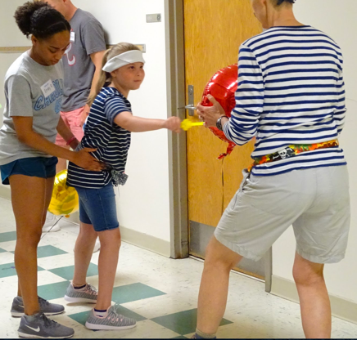 | - Straighten (extend) elbow while moving arm away from body (shoulder flexion) to hit the balloon  - Bend (flex) elbow while bring arm back towards body (shoulder extension)  - Bring arm across midline to tap back and forth on opposite sides of balloon  - This task can get out of control  - Counting or saying “body ready” first helps keep kids under control  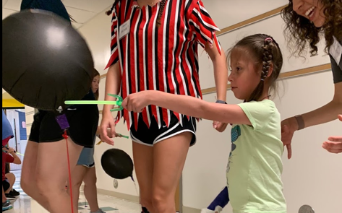
Cylindrical grip | - Provide input to fisted hand directed toward wrist to open hand, gently stretch arm so elbow is straight  - Use your fingers to provide input into the child’s palm near the base of the thumb to help open thumb  - It’s okay if the fingers are loosely flexed (bent)  - Provide support at base of thumb to open web space around the handle of the sword | - Wrap fingers and thumb around the sword handle  - Assist child with holding by pushing the sword gently into their hand  - Ponytail holders can help assist with holding  - Wrist may need to be posted  - If child is unable to maintain grasp or if their wrist bends/falls into flexion stop using sword and use hand to tap balloon instead

Coconut Bowling
Campers roll a coconut down a ramp to knock over water bottle pins.

Goal | Proper Form/Technique | Activity Recommendations
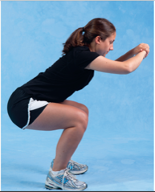  Squatting  1 | - Feet should be positioned shoulder width apart  - Equal weight bearing through both legs  - Toes should be pointed slightly outward  - Heels should stay in contact with the ground  - Knees should not pass toes and should stay in line with shoulders (they should not go in)  - Back should remain fairly straight | - Squat to pick up and set up colored water bottles  - Squat to push coconut down ramp
Hand open and grasp | - Provide input to fisted hand directed toward wrist, gently stretch arm so the elbow is straight  - Use your fingers to provide input into the child’s palm near the base of the thumb to help open thumb  - It’s okay if the fingers are flexed (bent) loosely  - Provide support at base of thumb to open web space around water bottle or coconut | - Stabilize coconut while child reaches for it  - Assist child with holding by pushing the coconut gently into their hand  - Have child grab water bottle from ground  - Stabilize water bottle while child is grabbing it  - Assist child with holding by pushing the bottle gently into their hand  - Press bottles into palm for sensory input
Wrist Extension | - Arm should be positioned close to body  - Help bend wrist backward by placing fingers on palm side of wrist and thumb on opposite side | - Set bottles upright with wrist extended (bent backwards) or neutral (hand in line with arm)
Upper Extremity Weightbearing | - Arm positioned close to body  - Bring elbow into and out of flexion while moving arm  - Wrist bent backwards (extended)  - Hand open | - Push down on coconut with palm parallel to surface of coconut while counting colored water bottles  - Roll coconut back and forth a few times before pushing down ramp with palm facing down
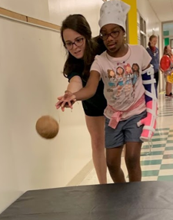  Forearm supination and shoulder external rotation | - Position child’s arm close to their body  - Encourage neutral alignment of forearm while reaching for the coconut  - Stabilize the child’s elbow while helping rotate forearm at the wrist so the palm is facing up | - If higher functioning, have child roll or toss coconut down ramp with palm facing up
Isolated finger motions | - Provide input to fisted hand directed towards wrist  - Use your fingers to provide stability to the web space near the base of the thumb and index finger to help open index finger | - Have child count the number of water bottles with their finger

Row the Boat
Campers take turns carrying a boat down the hallway and tossing balloon “cannonballs” at the boat as it passes by them.

Goal | Proper Form/Technique | Activity Recommendations
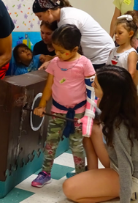  Symmetrical Stance | - Feet should be positioned shoulder width apart with equal weight bearing through both legs  - Heels should stay in contact with the ground  - Shoulders should be in line with hips  - Back should remain fairly straight | - Stand facing forward with oar parallel to child’s body and boat perpendicular to child’s side  - Walk forward while carrying oar
Squatting  1 | - Feet should be positioned shoulder width apart  - Equal weight bearing through both legs  - Toes should be pointed slightly outward  - Heels should stay in contact with the ground  - Knees should not pass toes and should stay in line with shoulders (they should not go in)  - Back should remain fairly straight | - Squat down and stand as boat goes over waves  - Squat to pick up cannon balls from ground
Hand Open and Grip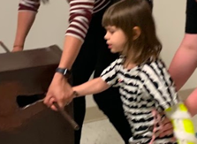 | - Provide input to fisted hand directed toward wrist, gently stretch arm so the elbow is straight  - Use your fingers to provide input into the child’s palm near the base of the thumb to help open thumb  - It’s okay if the fingers are loosely flexed (bent)  - Provide support at base of thumb to open web space around the handle of the broom | - Hold oar with neutral wrist (hand in line with arm)  - May need to place your hand over the child’s hand to assist with holding oar/maintaining neutral wrist position  - Stabilize cannon ball balloon while child reaches to grab it  - Assist child with holding by pushing the balloon gently into their hand  - Have child grasp different spots on the cannonball for the best grip
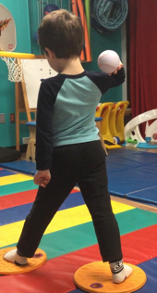  Throwing  8 | Stance:  - Feet positioned shoulder width apart with equal weight bearing through both legs.  - Toes pointed in the direction they will be throwing/direction the ball is coming from  - Shoulders should be in line with hips  - Make sure feet are set BEFORE the child throws and catches the ball!  Throwing:  - Have child “wind up” by bringing balloon up towards their ear then back forward to throw the “cannon ball” overhand at the boat  - Toss balloon underhand with palm facing upwards, elbow straight, and wrist neutral  - Swing arm backwards behind body at waist level then forward to release balloon  - Some older children may be able to step forward with opposite foot while throwing

Hook Toss
Campers toss rings at pirate hooks that are hung vertically and at cones placed on the ground.

Goal | Proper Form/Technique | Activity Recommendations
Symmetrical Stance | 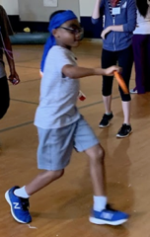  - Feet positioned shoulder width apart with equal weight bearing through both legs  - Toes pointed in the direction of the target  - Shoulders should be in line with hips  - Make sure feet are set BEFORE the child tosses the ring  - If able, have child step forward with opposite leg when tossing  - Stand sideways with weak side facing target with frisbee toss
Supination | - Position child’s arm close to their body  - Encourage neutral alignment of forearm while reaching for the ring  - Stabilize the child’s elbow while helping rotate forearm at the wrist so the palm is facing up | - Hold ring with palm facing up to toss underhand
Underhand Toss | - Palm facing upwards  - Elbow should be straight; wrist should be neutral  - Bring arm down so hand is below waist  - Swing arm backwards behind body at waist level (shoulder extension)  - Swing arm up and forward to release ring  - Some older children may be able to step forward with opposite foot while throwing | - Alternate using underhand throw and frisbee wind-up to toss rings onto hooks and cones
Frisbee Toss | - Grip ring with thumb on top on ceiling side and fingers on floor side  - Bending at elbow (elbow flexion), bring arm fully across body to opposite shoulder (shoulder adduction)  - Swing arm out and away from body (shoulder abduction) while straightening elbow (elbow extension) and releasing ring
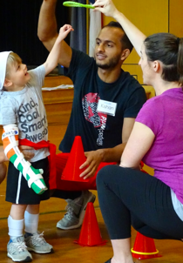  Reaching | - Standing with feet shoulder width apart and equal weight bearing through both legs  - Shoulders in line with hips  - Place hands on child’s glutes while reaching to help shift weight forwards onto balls of feet and sideways  - Help child straighten elbow when reaching | - Hold ring above, in front of, and to the sides of the child just out of arms reach to encourage  - Vary the height and distance but focus on reaching at shoulder height for eye hand coordination, wrist extension, and proximal strengthening  - Reach up to retrieve rings on higher hooks
Squatting  1 | - Feet should be positioned shoulder width apart  - Equal weight bearing through both legs  - Toes should be pointed slightly outward  - Heels should stay in contact with the ground  - Knees should not pass toes and should stay in line with shoulders (they should not go in)  - Back should remain fairly straight | - Squat to collect rings from lower hooks  - Hold vertically oriented rings at lower heights to encourage child to squat down to reach for rings

Treasure Hunt
Campers search for coins that are taped to the walls in the hallway.

Goal | Proper Form/Technique | Activity Recommendations
Reaching | - Standing with feet shoulder width apart and equal weight bearing through both legs  - Shoulders in line with hips  - Place hands on child’s glutes while reaching to help shift weight forwards onto balls of feet and sideways  - Help child straighten elbow when reaching | - Reach overhead for high coins taped to wall
Wrist extension | - Bend wrist backwards so fingers are pointed up/away from palm  - Help child extend wrist by stabilizing the forearm above the wrist by placing your fingers on the palm side and thumb on the opposite side | - Extend wrist to get coins off wall  - Tap coin by flexing/extending wrist back and forth while holding coin
Isolated finger movements | - Provide input to fisted hand directed toward wrist to open hand  - Use your fingers to provide stability to the web space near the base of the thumb and index finger to help open index finger | - Use index fingers to remove coins  - Count coins with index finger
Three-point grasp  Pincer grasp | - Three-point: Thumb is in opposition to index and long finger; index and middle are loosely flexed at middle joints. Ring and little finger are bent (finger flexion) to stabilize the hand  - Pincer: Thumb is in opposition to the index finger. Middle joint of index finger is loosely flexed to prevent web space collapse/narrowing. Middle, ring, and little finger are bent (finger flexion) to stabilize the hand.  - Provide support at base of thumb and little finger side of the hand  - Will often need to provide wrist stability on small finger side | - Pinch coin between index finger and thumb OR index finger, middle finger, and thumb to pick up coins  - Orient coins vertically to improve ability to grasp object

Walk the Plank
Campers navigate a balance beam while pretending they are walking the plank on a pirate ship.

Goal | Proper Form/Technique | Activity Recommendations
Forward walking with narrow base of support | - Shoulders should be in line with hips  - Back should remain fairly straight  - Feet will be less than shoulder width apart  - Position hands on child’s glutes to help to shift weight forward and onto stance leg in preparation to take step forward  - Step length should be equal on both sides  - Flex at knee and hip to step over obstacles | - Have child walk heel to toe on balance beam  - You may need to stabilize the child’s trunk  - Child can use arm support for balance as needed  - Try to reduce support through arms with each trial to further challenge balance  - Child can hold dowel between hand/cast OR both hands on bimanual day  - Place toys on beam to step over obstacles  - Encourage child to focus on visual stimuli forward and not downward
Side-stepping | - Feet positioned shoulder width apart  - Shoulders should be in line with hips  - Back should remain fairly straight  - Position hands on child’s glutes to help shift weight onto stance leg in preparation to take side-step | - Alternate leading with strong and weak leg  - You may need to stabilize the child’s trunk  - Child can use arm support for balance as needed  - Try to reduce support through arms with each trial to further challenge balance  - Place toys on beam to side-step over obstacles
Grapevine | - Feet positioned shoulder width apart  - Back should remain fairly straight  - Position hands on child’s glutes to help shift weight onto stance leg to prepare to lift foot from beam  - Alternate crossing feet in front of and behind each other with each step | - Alternate leading with strong and weak leg  - You may need to stabilize the child’s trunk  - Child can use arm support for balance as needed  - Try to reduce support through arms with each trial to further challenge balance
Backwards walking with narrow base of support | - Shoulders should be in line with hips  - Back should remain fairly straight  - Feet will be less than shoulder width apart  - Position hands on child’s glutes to help shift weight backward and onto stance leg in preparation to take step backward  - Step length should be equal on both side | - Some kids may be able to take backwards steps, heel to toe, on the balance beam.  - This is a more difficult task!  - You may need to stabilize the child’s trunk  - Child can use arm support for balance as needed  - Try to reduce support through arms with each trial to further challenge balance

Raise the Sail
Campers pull on a rope with a sheet attached in order to “raise the sail” of the pirate ship.

Goal | Proper Form/Technique | Activity Recommendations
Symmetrical stance | - Feet should be positioned shoulder width apart with equal weight bearing through both legs  - Heels should stay in contact with the ground  - Shoulders should be in line with hips  - Back should remain fairly straight | 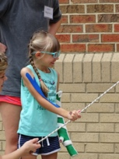  - Have child squared up to rope  - Stand sideways with weaker leg facing rope  - Reach overhead to grab onto rope  - Keeping elbow straight, pull arm and rope down towards body  - May need to assist child with pulling by placing hand over theirs or pulling on a lower spot of the rope  - Release rope and grab onto a higher spot  - Keep pulling until sail is raised
Overhead reach/shoulder flexion | - Standing with feet shoulder width apart and equal weight bearing through both legs  - Shoulders in line with hips  - Place hands on child’s glutes while reaching to help shift weight forwards onto balls of feet and sideways  - Help child straighten elbow when reaching
Pulling/shoulder Extension | - Elbow should be straight and wrist should be in neutral position (hand in line with arm)  - With arm overhead, pull down so that arm moves behind body
Grasp | - Provide input to fisted hand directed toward wrist  - Gently stretch arm so the elbow is straight  - Use your fingers to provide input into the child’s palm near the base of the thumb to help open thumb  - It’s okay if the fingers are loosely flexed (bent)  - Provide support at base of thumb to open web space around the rope | - Wrap rope around child’s hand to help with gripping  - Close fingers and thumb around the rope  - Assist child with holding by pushing the rope gently into their hand
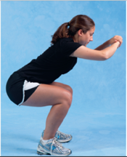  Squatting  1 | - Feet should be positioned shoulder width apart  - Equal weight bearing through both legs  - Toes should be pointed slightly outward  - Heels should stay in contact with the ground  - Knees should not pass toes and should stay in line with shoulders (they should not go in)  - Back should remain fairly straight | - Squat as needed to help pull the rope all the way down

Piñata
Campers hit a pirate piñata that is suspended in the air with a stick or their hands.

Goal | Proper Form/Technique | Activity Recommendations
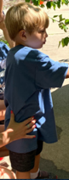  Symmetrical stance | - Feet should be positioned shoulder width apart with equal weight bearing through both legs  - Heels should stay in contact with the ground  - Shoulders should be in line with hips  - Back should remain fairly straight | - Have child squared up to piñata  - Stand tandem with heel of weaker foot in front of stronger foot  - Place hands on glutes to help shift weight onto weaker leg while reaching to hit piñata
Shoulder and elbow active range of motion | - Encourage neutral alignment of wrist during shoulder and elbow movements  - May need to help facilitate overhead motion with one hand on the arm above the child’s elbow  Standing facing the pinata:  - Lift arm up overhead, bending at elbow  - Straighten elbow while bringing arm down to hit the piñata  - Keeping elbow straight, lift arm up overheard and back down to hit piñata  - Bend at elbow to bring hand to opposite shoulder  - Straighten elbow to bring arm and stick across body to hit the piñata  - Keeping elbow straight, bring arm to opposite shoulder and back across body to hit piñata  - Punch the piñata with graded elbow flexion/extension with hand fisted with thumb up/forearm in neutral  Standing with side to pinata:  - Lift arm out to the side and overhead, bending at elbow  - Straighten elbow and bring arm down to hit piñata  - Keeping elbow straight, lift arm out to the side and overheard, then lower back down to hit piñata  - Bend at elbow to bring hand to opposite shoulder  - Straighten elbow to bring arm and sword across body to hit piñata  - Keeping elbow straight, bring arm to opposite shoulder and back across body to hit piñata
Cylindrical grip | - Provide input to fisted hand directed toward wrist  - Gently stretch arm so the elbow is straight  - Use your fingers to provide input into the child’s palm near the base of the thumb to help open thumb  - It’s okay if the fingers are loosely flexed (bent)  - Provide support at base of thumb to open web space around the piñata stick | - Wrap fingers and thumb around the pinata stick  - Assist child with holding by pushing the stick gently into their hand  - If child cannot hold the stick, they can use their fisted hand

FIRETRUCK DAY

Gross Motor Goals | Fine Motor Goals
- Squatting  - Trunk rotation  - Symmetrical stance  - Single leg stance  - Rolling  - Reaching  - Side stepping  - Climbing | - Shoulder active range of motion  - Elbow active range of motion  - Forearm pronation/supination  - Opening hand  - Grasp  - Active release  - Grip strength

Bucket Fill
Campers soak sponges in a large tub of water, then wring them out to fill up a smaller bucket.

Goal | Proper Form/Technique | Activity Recommendations
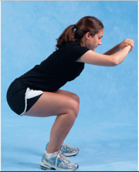  Squatting  1 | - Feet should be positioned shoulder width apart  - Equal weight bearing through both legs  - Toes should be pointed slightly outward  - Heels should stay in contact with the ground  - Knees should not pass toes and should stay in line with shoulders (they should not go in)  - Back should remain fairly straight | - Squat to grab/dunk sponge in bucket  - Alter height of bucket to assist child with maintaining the squat  - Transition to standing to squeeze sponge into smaller bucket
Trunk rotation | - Feet should be positioned shoulder width apart  - Equal weight bearing through both legs  - Heels should stay in contact with the ground  - Help facilitate rotation by:  - Placing one hand on child’s chest and one hand on child’s back OR  - Guiding forearm with one hand and other hand on back | - Have child stand with big water bucket on one side and small bucket on the other  - Rotate towards big water bucket to grab a sponge ball; rotate to small bucket to squeeze out sponge  - Alter the height of the small bucket  - Switch sides to rotate towards and away from weak side
Opening hand, grasp, and grip strength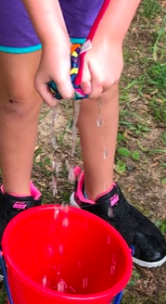 | - Provide input to fisted hand directed toward wrist  - Gently stretch arm into extension at elbow to get hand ready to open  - Use your fingers to provide input into the child’s palm near the base of the thumb to help open thumb  - It’s okay if the fingers are flexed (bent) loosely | - Encourage child to grab sponge from bucket or from a firm surface (may need to hold sponge steady)  - Loosely flex fingers around sponge to grip; try different sponges for the best fit  - Squeeze sponge with one or two hand into small bucket  - Use a wringing motion with two hands to drain sponge into small bucket

Building Breakdown
Campers knock over a stack of cardboard boxes with a toy axe to breakdown the burning building.

Goal | Proper Form/Technique | Activity Recommendations
Symmetrical stance | - Feet should be positioned shoulder width apart with equal weight bearing through both legs  - Heels should stay in contact with the ground  - Shoulders should be in line with hips  - Back should remain fairly straight | - Have child squared up to building  - Can have child stand perpendicular to building so side is facing the building
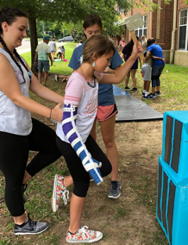  Single limb stance | - Feet positioned shoulder width apart  - Shoulders in line with hips  - Position hands on child’s glutes to help shift weight onto stance leg to prepare to lift other leg off ground  - Have child lift other leg off the ground  - Knee of stance leg should not pass toes and should stay in line with shoulder (should not go in) | - Higher functioning children can stand on one leg while hitting building boxes with axe  - Alternate standing on weak leg and strong leg
Shoulder and elbow active range of motion | - Encourage neutral alignment of wrist during shoulder and elbow movements  - May need to help facilitate overhead reaching with one hand on the arm above the child’s elbow  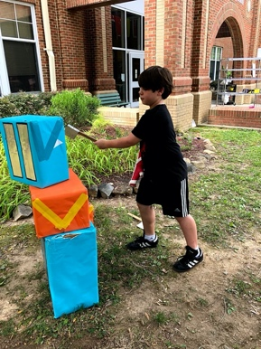  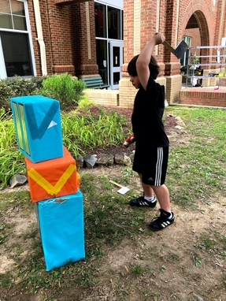 | - Stand facing the building  - Lift arm up overhead, bending at elbow  - Straighten elbow while bringing arm down to hit the boxes.  - Stand facing the building  - Keeping elbow straight, bring arm out to the side and back across body to knock down boxes  - Stand with child’s side facing building  - Lift arm out to the side and overhead, bending at elbow  - Straighten elbow and bring arm down to hit building.
Cylindrical grip | - Provide input to fisted hand directed toward wrist  - Gently stretch arm so the elbow is straight  - Use your fingers to provide input into the child’s palm near the base of the thumb to help open thumb  - It’s okay if the fingers are loosely flexed (bent)  - Provide support at base of thumb to open web space around the handle of the axe | - Wrap fingers and thumb around handle of axe  - Assist child with holding by pushing the axe gently into their hand

Put out Fire
Campers fill up a small bucket with blue sponges and then dump the bucket of “water” over the fire.

Goal | Proper Form/Technique | Activity Recommendations
Squatting  1 | - Feet should be positioned shoulder width apart  - Equal weight bearing through both legs  - Toes should be pointed slightly outward  - Heels should stay in contact with the ground  - Knees should not pass toes and should stay in line with shoulders (they should not go in)  - Back should remain fairly straight | - Squat to grab sponges from bin and pick-up sponges that were dumped on fire  - Transition into and out of squatting while grabbing sponges and placing them in small bucket
Trunk rotation | - Feet should be positioned shoulder width apart  - Equal weight bearing through both legs  - Heels should stay in contact with the ground  - Help facilitate rotation by:  - Placing one hand on child’s chest and one hand on child’s back OR  - Guiding forearm with one hand and other hand on back | - Have child stand with bin of sponges on one side and small bucket on the other  - Rotate towards bin to grab a sponge; rotate to place it in the bucket  - Alter the height of the small bucket  - Switch sides to rotate towards and away from weak side
Reaching | - Standing with feet shoulder width apart and equal weight bearing through both legs  - Shoulders in line with hips  - Place hands on child’s glutes while reaching to help shift weight forwards onto balls of feet and sideways  - Help child straighten elbow when reaching | - Hold small bucket above, in front of, and to the sides of the child just out of arms reach  - Vary the height and distance but focus on reaching at shoulder height for eye hand coordination, wrist extension, and proximal strengthening
Forearm pronation and supination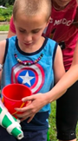 | - Position child’s arm close to their body initially to ensure alignment of the shoulder  - Encourage neutral alignment of forearm while placing hand on side of bucket  - Stabilize the child’s elbow while helping rotate the wrist so the thumb is facing up (to hold the bucket) or so thumb is facing down (to dump out bucket) | - Stabilize side of bucket with hand in thumb up position with forearm neutral while helper places sponges in small bucket. May need to place your hand over the child’s hand to help them hold the bucket  - Dump bucket of sponges over the fire
Grasp and active release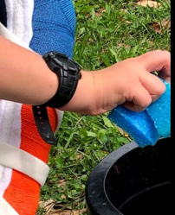 | - Provide input to fisted hand directed toward wrist  - Gently stretch arm so the elbow is straight (extension) to get hand ready to open  - Use your fingers to provide input into the child’s palm near the base of the thumb to help open thumb.  - Provide support at base of thumb to open web space around the sponge.  - It’s okay if the fingers are flexed (bent) loosely  - Assist child with holding by pushing the sponge gently into the child’s hand  - Use your fingers to provide input into the child’s palm near the base of the thumb and fingers to help with releasing | - Have child reach into bin to grab sponges/collect sponges from fire  - Loosely flex fingers around sponge to grip  - Have child drop sponges into small bucket

Ladder Climb
Campers climb an A-frame ladder to pretend they are climbing up to a building like a firefighter.

Goal | Proper Form/Technique
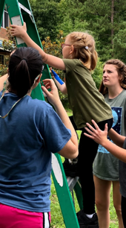  Climbing | - Feet positioned shoulder width apart  - Shoulders in line with hips  - Position hands on child’s glutes to help shift weight onto one leg  - Have child lift other leg off the ladder and lift it up to the next rung, bending at the knee and hip.  - Move opposite arm up the ladder.  - Help child shift weight onto higher leg before bringing up lower leg  - Continue climbing with opposite arm/opposite leg pattern  - Keep hands on child for safety!

Agility Ladder
Campers step in and out of an agility ladder using a variety of stepping patterns.

Goal | Proper Form/Technique | Activity Recommendations
Forwards stepping | - Feet should be positioned shoulder width apart with equal weight bearing through both legs  - Heels should stay in contact with the ground  - Shoulders should be in line with hips  - Back should remain fairly straight | - Step forward placing two feet into each box  - Take bigger steps, placing one foot into each box  - Lift leg up, bending at knee and hip, to clear ladder rungs  Zig-Zag pattern:  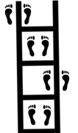  - With child facing forward at ladder have them take diagonal steps to zig-zag through the ladder rungs  9  Hopscotch pattern:  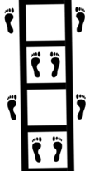  - Have child step forward, placing feet outside of the ladder.  - Step forward, placing both feet together in the next square of the ladder  9
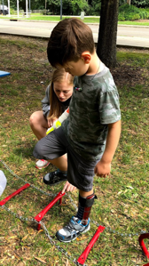  Side-stepping | - Feet positioned shoulder width apart  - Shoulders should be in line with hips  - Back should remain fairly straight  - Position hands on child’s glutes to help shift weight in opposite direction onto stance leg in preparation to take side-step  - Bend at knee and hip to lift leg off ground and clear ladders rungs | 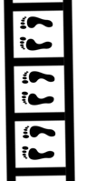  - Side-step over rungs, placing both feet in each box  - Alternate leading with strong and weak leg  9  - Child can use arm support for balance as needed  - Try to reduce support through arms with each trial to further challenge balance

Stop, Drop, and Roll
Campers roll across a mat on the ground to practice the fire safety technique: “Stop, Drop, and Roll.”

Goal | Proper Form/Technique | Activity Recommendations
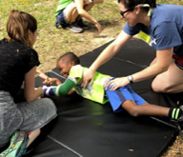  Rolling | - Slowly lower down onto the mat. DO NOT plop down!  - Have child raise arms overhead. May need to help child flex shoulders to bring arms overhead.  - Legs and elbows should remain fairly straight  - Help facilitate rolling with one hand one the child’s side (over obliques) and one at the glutes  - Encourage child to roll along length of mat, using core muscles to initiate movement

Water Target Practice
Campers shoot water squirters at targets on the side of the building to pretend they are putting out a fire.

Goal | Proper Form/Technique | Activity Recommendations
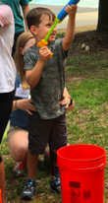  Symmetrical stance | - Feet should be positioned shoulder width apart with equal weight bearing through both legs  - Heels should stay in contact with the ground  - Shoulders should be in line with hips  - Back should remain fairly straight  - Place hands on the child’s hip bones to help maintain alignment while they are shooting the water squirter | - Have child squared up to target or bucket of water  - Make sure feet are set before they start shooting the water squirter
Staggered stance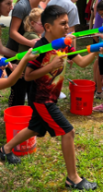 | - Feet positioned shoulder width apart  - Shoulders should be in line with hips  - Have child stand with one foot forward and the other foot back  - Heel should stay in contact with ground  - Toes should point towards target | - Have child stand in staggered stance position while shooting water squirter at target  - Make sure feet are set before they start shooting the water squirter
Shoulder and elbow active range of motion | Support arm:  - Shoulder and elbow positioned close to trunk  - Elbow should be bent  - Hand on handle of squirter  “Squirting” arm:  - Arm held out from body with elbow straight  - Hand on barrel of squirter  - Move arm forward and back to pump the water squirter  - Point arms up/to the sides to aim at different spots on the target. Point arms down to fill water squirter | - One hand: Have child hold squirter while helper pushes. Switch so that someone holds the squirter while camper pushes.  - Two-handed: child holds and pushes squirter.  - Don’t need to fill the squirter up all the way as this may make it too heavy for child to hold – fill it up to a weight the child is able to support with minimal to no assistance
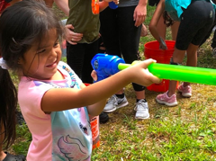  Opening hand and grasp | - Provide input to fisted hand directed toward wrist and gently stretch arm into extension at elbow to get hand ready to open  - Use your fingers to provide input into the child’s palm near the base of the thumb to help open thumb  - Provide support at base of thumb to open web space around the water squirter  - It’s okay if the fingers are flexed (bent) loosely | - Loosely flex fingers around water squirter to grip  - Assist child with holding by pushing the water squirter gently into the child’s hand

Sports Day
Gross Motor Goals | Fine Motor Goals
- Squatting  - Jumping  - Throwing  - Catching  - Hitting  - Shooting  - Passing  - Kicking | - Shoulder and elbow active range of motion  - Hand open  - Grasp  Child should use dominant hand/leg while playing sports. Non-dominant hand is doing what helper hand would do during throwing, catching, batting, shooting, putting etc.

Goals | Proper Form/Technique
Hand open to grab balls/clubs/bats | - Provide input to fisted hand directed toward wrist to help open hand  - Gently stretch arm so the elbow is straight  - It’s okay if the fingers are loosely flexed (bent)  - Use your fingers to provide input into the child’s palm near the base of the thumb to help open web space around the object
Grasp | - Wrap fingers and thumb around ball/bat/club  - Assist child with holding by pushing the object gently into their hand
Squat to pick up balls from ground  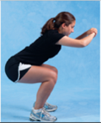  1 | - Feet should be positioned shoulder width apart with equal weight bearing through both legs  - Toes should be pointed slightly outward and heels should stay in contact with the ground  - Weight is shifted posteriorly  - Knees should not pass toes and should stay in line with shoulders (should not go in)  - Back should remain fairly straight
Jumping¹ | - Feet should be positioned shoulder width apart with equal weight bearing through both legs  - Shoulders in line with hips  - Toes should be pointed slightly outward  - Heels should stay in contact with the ground  - Trunk should come forward so nose is over toes  - Back should remain fairly straight  - Support child with downward pressure at the hips while child flexes hips and knees  - Push equally through both legs when extending at hips and knees to jump up/forward
Golf 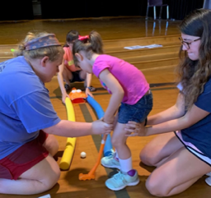 | Stance:  - Feet should be positioned shoulder width apart with equal weight bearing through both legs  - Knees should be slightly bent  - Have child square up to the ball so their weaker side is facing the hole  - Make sure feet are set BEFORE the child swings the putter!  Gripping the club:  - Wrap fingers around the club with thumbs pointing down  - Dominant hand should be positioned lower on the club, with top of nondominant hand touching bottom of dominant hand  - May need to place hands over the child’s hands to assist with gripping the putter  Swing:  - Elbow should remain as straight as possible  - Child should bring arms/club back then forward in a pendulum motion to hit the ball  - May need to stand behind child with hands and arms over theirs to help with swinging the putter
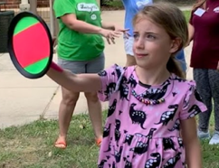  Velcro Paddles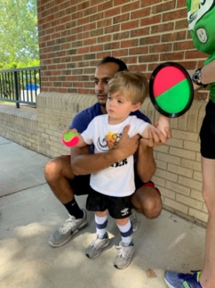 | Stance:  - Feet positioned shoulder width apart with equal weight bearing through both legs  - Toes pointed in the direction they will be throwing/direction the ball is coming from  - Shoulders should be in line with hips  - Make sure feet and core are set BEFORE the child throws and catches the ball!  Throwing:  - Overhand: Have child “wind up” by bringing ball up towards their ear then back forward to throw the ball. May need to help facilitate overhand throwing by guiding the child’s arm at the wrist while stabilizing at the chest  - Underhand: Bring arm down and back behind body at waist level then swing forward to release ball  - If child cannot throw the ball overhand or underhand, then have them roll it on the ground  - Some children may be able to step forward with opposite foot while throwing  Catching:  - Position child with shoulder externally rotated and elbow bent to 90 degrees or with arm held straight out in front of them  - Encourage child to move arm away from body/reach towards the ball instead of waiting for the ball to come to them  - May need to stabilize under the child’s shoulder and facilitate movement of the arm at the wrist to assist with catching  - One-Hand: Alternate between catching and throwing with same hand  - Two-Hands: Velcro catch goes on weaker hand; throw with stronger hand
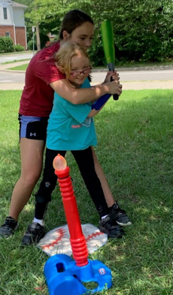  Wiffle ball  8 | Batting:  - Feet positioned shoulder width apart with equal weight bearing through both legs  - Shoulder should be in line with hips; Knees should be slightly bent  - Have child squared up to plate/tee with weaker (non-dominant) side facing the pitcher  - Fingers and thumbs should be wrapped around bat  - Dominant hand should grip bat higher than non-dominant hand  - Can place dominant hand on top of non-dominant hand to assist with maintaining grasp  - May need to place your hands over the child’s hand to help with grip/swinging motion  - Use your arm to help guide the child’s shoulders as they swing to encourage trunk rotation  - Have child bring arms/bat backward and then swing forward to hit the ball  - Make sure feet are set BEFORE batting!  - Keep eye on the ball!!  Fielding:  - Feet positioned shoulder width apart with equal weight bearing through both legs  - Shoulders should be in line with hips  - Knees should be slightly bent in the “ready position”  - Child should be squared up with toes pointing towards/body facing the batter  - Squat to pick up ball/water balloon from ground  Throwing:  - Overhand: Have child “wind up” by bringing ball up towards their ear then back forward to throw the ball. May need to help facilitate overhand throwing by guiding the child’s arm at the wrist while stabilizing at the chest  - Underhand: Bring arm down and back behind body at waist level then swing arm forward to release balloon.  - If child cannot throw the ball overhand or underhand, then have them roll it on the ground  - Higher functioning children may be able to step forward with opposite foot while throwing  - Two-Hands: Glove goes on weaker hand; throw with stronger hand
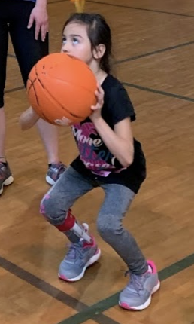  Basketball | Shooting stance:  - Feet should be positioned shoulder width apart with equal weight bearing through both legs  - Toes should be pointed towards basket  - Back should remain fairly straight  - Squat down (knees should not pass toes and should stay in line with shoulders - they should not go in)  - Push up from squat/jump while releasing the ball.  Shooting/ passing form:  - Dominant hand should be placed on the back of the ball. Non-dominant hand should be positioned on the side to guide the ball as the dominant arm pushes to shoot/pass.  - OR Both hands placed on sides of the ball and push together to shoot/pass the ball  - Ball should be held at level of the chest  - May need to stand behind child and place your hands over their hands to help guide their shot | - Have child dribble ball up and down court/around defenders using one hand at a time  - Dribble ball back and forth between hands  - Pass ball by bouncing it on the ground or throwing it through the air  - Shoot basketball (Make sure feet are set BEFORE shooting!)
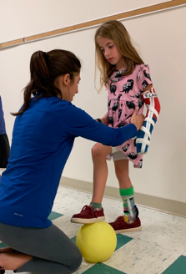  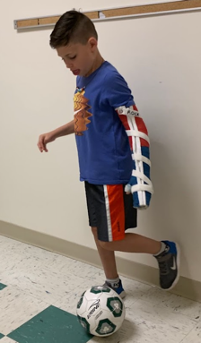  Soccer | Stopping ball:  - Feet positioned shoulder width apart, shoulders in line with hips  - Position hands on child’s glutes to help shift weight onto non-dominant leg  - Have child lift other leg dominant leg off the ground and place foot on top of ball  - Knee of stance leg should not pass toes and should stay in line with shoulder (should not go in)  Kicking ball:  - Shift weight onto non-dominant leg  - Bring dominant leg back (extending at hip and flexing/bending at knee)  - Bring dominant leg forward (flexing/bending at hip and straightening knee) to kick ball  - Point toe down/plantarflex ankle while making contact with the ball  - Can also kick and dribble with inside and outside of foot. | - Pass soccer ball back and forth; having child stop ball with one foot and setting feet before kicking back  - Have child dribble soccer ball up and down hall  - Dribble soccer ball up to goal; place foot on top of ball to stop it from rolling; wind-up leg and shoot ball  - Make sure feet are set BEFORE passing and shooting!

Shaving Cream
Campers play with shaving cream by spreading it around, drawing in it, and picking objects out of it.

Gross Motor Goals | Fine Motor Goals
- Symmetrical stance  - Sitting  - Sit to stand  - Upper extremity weight bearing | - Shoulder and elbow movements  - Wrist extension, radial deviation, ulnar deviation  - Isolated finger movements  - Grasp and grip
Goals | Proper Form/Technique | Activity Recommendations
Symmetrical stance | - Feet should be positioned shoulder width apart with equal weight bearing through both legs  - Heels should stay in contact with the ground  - Shoulders should be in line with hips  - Back should remain fairly straight | - Have child squared up to table  - Encourage child to support all their weight through the legs  - NO bellies on table!  - Experiment with orientation of workspace  - Hold tray at an angle to promote wrist extension in sitting  - Keep tray flat on table to promote weight bearing in standing
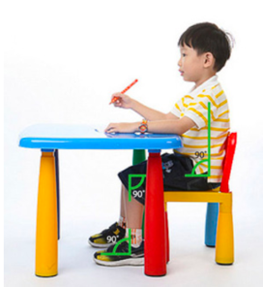  Sitting  7 | - Feet should be flat on the floor  - Hips, knees, and ankles should be at 90 degrees  - Knees should be at the same height as (or slightly lower than) the hips  - May need to put a stool or foot box under feet to help with positioning  - Table should be 1-2 inches above bent elbows  - Back should be straight  - No slouching and no bellies leaning on tables!  - Make sure child’s weight is evenly distributed on sit bones; They shouldn’t be shifted or leaning to one side. | - Have child sitting squared up to table to play in shaving cream  - Encourage child to support their weight with the trunk and legs  - NO bellies on table!
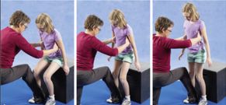  Transitioning to standing from sitting  10 | - Feet should be positioned shoulder width apart with equal weight bearing through both legs  - Toes should be pointed slightly outward and heels should stay in contact with the ground  - Knees should not pass toes and should stay in line with shoulders (they should not go in)  - Back should remain fairly straight  - Slowly lower to seated position without popping  - Lean forward so nose is over toes to come to standing  - Make sure child’s feet are in line with each other  Encourage child to push up equally through both legs with little to no hand support
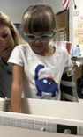  Upper extremity weightbearing | - Arm positioned close to body  - Elbow straightened (extended)  - Wrist bent backwards (extended)  - Provide input to fisted hand directed toward wrist to open hand | - Palm parallel to the surface of the plate, push down on the shaving cream.  - Move hand around in circles and rock arm back and forth/side to side while pushing through hand
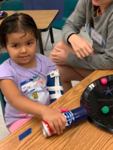  Shoulder and elbow movements | - Straighten child’s elbow while focusing on shoulder movements  - Stabilize at the shoulder while encouraging flexion and extension at the elbow  - Encourage child to move arm forward and to the side, reaching away from the body  - Stabilize the child’s elbow while helping rotate forearm at the wrist so the palm is facing up (forearm supination) | - Move shoulder to push shaving cream forwards/backwards and side to side with elbow straight  - Roll can of shaving cream back and forth on table  - Bend and straighten elbow with shoulder still to push shaving cream back and forth (window washing movement)  - Have child hold out arm with palm facing up; Place tray on child’s hand and stabilize while shaving cream is squirted
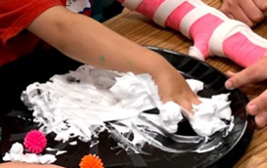  Wrist extension, radial deviation, and ulnar deviation | - Help child straighten elbow by placing one hand above and one below the elbow  - Help child extend wrist by stabilizing the forearm above the wrist, placing your fingers on the palm side of the wrist and thumb on the opposite side  - Provide support close to the wrist; allow the arm to move in space away from their body | - Bend wrist to pat surface of shaving cream  - Stabilize forearm to assist with child’s ability to move wrist back and forth in windshield wiper motion; Shoulder/elbow should be still  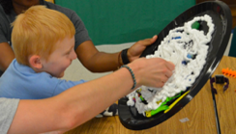  - Open fingers to rake through shaving cream  - Hold plastic tray vertical to improve wrist alignment
Isolated finger movements | - Provide input to fisted hand directed toward wrist to open hand  - Use your fingers to provide stability to the web space near the base of the thumb and index finger to help open index finger  - Further prepare hand by grasping cylindrical shaving cream container | - Draw shapes/letters in shaving cream with their index finger  - Combine index/long finger during isolated finger play  - Flick or push shaving cream/objects in shaving cream with index finger  - Use index finger to squirt shaving cream while helper holds the can still  - With hand open and flat, make “finger snow angels” by opening and closing fingers (finger abduction and adduction)  - Isolate thumb by holding fingers together and moving thumb away from/towards hand
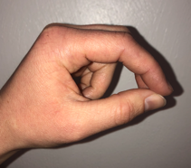  Three-point grasp | - Thumb is in opposition to index and long finger; index and middle are loosely flexed at middle joints. Ring and little finger are bent (finger flexion) to stabilize the hand  - Provide support at base of thumb and little finger side of the hand. Will often need to provide wrist stability on small finger side | - Pick up objects from shaving cream using thumb, index, and middle finger  - Hold the black tray with three-point grasp while helper rubs shaving creme
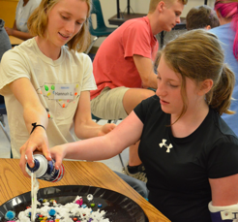  Grip and cylindrical grasp³ | - Input to fisted hand directed toward wrist, gently stretch arm so the elbow is straight  - Use your fingers to provide input into the child’s palm near the base of the thumb to help open thumb  - It’s okay if the fingers are flexed (bent) loosely  - Provide support at base of thumb to open web space around shaving cream can | - Grab and squeeze handful of shaving cream  - Have child hold the shaving cream can while helper squirts shaving cream  - Assist child with holding by pushing the can gently into their hand.

Sensory Bin
Campers dig through a bin filled with water beads, rice, noodles, etc. to find hidden objects.

Gross Motor Goals | Fine Motor Goals
- Symmetrical stance  - Tall kneel  - Half-kneel  - Sit to Stand  - Step-Stance  - Upper extremity weight bearing | - Proximal control  - Shoulder movements  - Forearm pronation/supination  - Isolated finger movements  - Three-point grasp  - Active and accurate release

Goals | Proper Form/Technique | Activity Recommendations
Symmetrical stance | 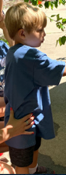  - Feet should be positioned shoulder width apart with equal weight bearing through both legs  - Heels should stay in contact with ground  - Shoulders should be in line with hips  - Back should remain fairly straight | - Have child squared up to bin; Level of bin should be positioned between the belly button and chest to ensure proper mechanics  - Encourage child to support all weight through their legs. NO bellies on bins!
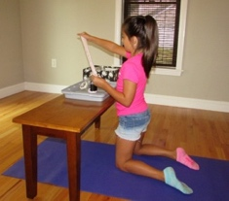  Tall kneeling¹ | - Both knees in contact with the ground  - Shoulders and hips should be in line with knees  - Place hands over child’s hips - do not let hips bend  - Back should remain fairly straight  - Provide support at the child’s ankles to help maintain balance if needed  - Tummy should not be leaning on table/bin! | - Taller kids may be able to tall- or half-kneel at sensory bins positioned on low tables for short periods  - Slowly lower down to kneeling without plopping  - From tall kneeling position, help child shift their weight over their weak leg and bring strong leg forward so foot is flat on the ground (half-kneeling)  - Push down on strong leg and move hand on weak hip up to guide child to standing  - May need to use arms for support or balance
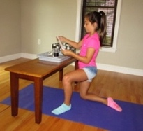  Half kneeling² | - Child positioned with one knee on the ground and one foot on the ground  - Shoulders should be in line with hips  - Provide support at child’s hips if needed  - Tummy should not be leaning on table/bin!  - Alternate legs
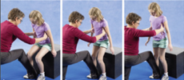  Transitioning to sitting from standing  10 | - Feet should be positioned shoulder width apart with equal weight bearing through both legs; Make sure child’s feet are in line with each other  - Toes should be pointed slightly outward and heels should stay in contact with the ground  - Knees should not pass toes and should stay in line with shoulders (they should not go in)  - Back should remain fairly straight  - Slowly lower to seated position without popping  - Lean forward so nose is over toes to come to stand | - Stand at table to grab a figure out of the sensory box  - Lower to sitting on a step stool to place item into a bucket  - Encourage child to push up equally through both legs with little to no hand support
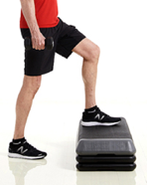  Step-stance  5 | - Standing with one foot up on step/box and one foot down on the ground with increased weight bearing through foot on the ground  - Shoulders in line with hips  - Heels should stay in contact with support surface  - Stabilize at child’s hips to help maintain balance | - Position step or box next to table so that child is facing and can reach sensory bin  - Start with weaker leg on ground  - Alternate legs
Proximal control | - Begin with big movements at shoulder and work towards small, isolated movements at hand  - Help stabilize at the child’s shoulder and elbow to allow for more motion at the wrist and hand  - If child has good motor control, you can provide less stability at the shoulder and trunk and help facilitate motions further down the arm  - Push and pull objects in sensory bin or use spoon to stir, starting with big movements at the shoulder and working to small movements at the wrist
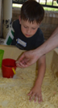  Shoulder and elbow movements | - Elbow straight and forearm in neutral position (palms facing inward, thumb up)  - Encourage child to push and pull sensory objects forwards and backwards; promote shoulder flexion and extension. Push objects side to side, keeping the elbow neutral, to promote shoulder abduction and adduction  - Holding the shoulder still, push objects back and forth initiating movement at the elbow (window washing movement) to encourage elbow flexion and extension
Forearm supination and pronation  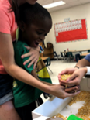 | - Position child’s arm close to their body  - Encourage neutral alignment of forearm while reaching into sensory bin  - Stabilize the child’s elbow while helping rotate forearm at the wrist to facilitate scooping and dumping with hands/shovel/cup | - With palm facing up and fingers squeezed together (finger adduction), pour objects onto hand; encourage child to open fingers to allow objects to fall through (finger abduction)  - If child is able, grip shovel or cup to scoop and dumb objects
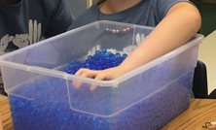  Wrist extension | - Help child straighten elbow by placing one hand above and one below the elbow  - Help child extend wrist by stabilizing the forearm above the wrist, placing your fingers on the palm side of the wrist and thumb on the opposite side  - Provide support close to the wrist, allow the arm to move in space away from their body | - Push and pull objects focusing on bending wrist back and forth from flexion into extension  - Open fingers to rake through sensory bin, bending the wrist back and forth  - Pat surface of beads, focusing on motion at the wrist
Upper extremity weightbearing | - Arm positioned close to body with elbow straightened (extended), wrist bent backwards (extended), and hand open | - Encourage child to put their palm parallel to the surface of the beads and push down to the bottom of the beads
Isolated finger movements | - Provide input to fisted hand directed towards wrist  - Use your fingers to provide stability to the web space near the base of the thumb and index finger to help open index finger | - Use index finger to scoop objects out of sensory bin  - Flick or push sensory items and objects with index finger
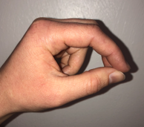  Three-point grasp | - Thumb is in opposition to index and long finger; index and middle are loosely flexed at middle joints. Ring and little finger are bent (finger flexion) to stabilize the hand. Provide support at base of thumb and little finger side of the hand. Will often need to provide wrist stability on small finger side | - Pick up objects from bin using thumb, index, and middle finger  - Use tongs to pick up objects from sensory bin pushing through thumb, middle, and index finger
Active and accurate release | - Provide input to fisted hand directed toward wrist to open hand  - Gently stretch arm so elbow is straight  - Encourage child to grasp hidden figures in the sensory play  - Provide support at base of thumb to open web space around object; assist child with holding by gently pushing object into child’s hand  - Have child drop items into sensory bin, helper’s hand, or a small a bucket, using your fingers to provide input into child’s palm near base of thumb and fingers to help with release

Slime
Campers make slime out of shaving cream, glue, glitter, and food dye and then play with slime by stretching, squeezing, rolling, and shaping it.

Gross Motor Goals | Fine Motor Goals
- Symmetrical stance  - Sitting posture  - Sit to Stand  - Upper extremity weight bearing | - Forearm pronation/supination  - Isolated finger movements  - Grip strength  - Grasp: cylindrical, three-point, pincer

Goals | Proper Form/Technique | Activity Recommendations
Symmetrical stance | - Feet positioned shoulder width apart with equal weight bearing through both legs  - Heels should stay in contact with the ground  - Shoulders should be in line with hips  - Back should remain fairly straight | - Have child squared up to table  - Encourage child to support all their weight through the legs  - NO bellies on table!
Sitting  7 | - Feet should be flat on the floor  - Hips, knees, and ankles should be at 90 degrees  - Knees should be at the same height as (or slightly lower than) the hips  - May need to put a stool or foot box under feet to help with positioning.  - Table should be 1-2 inches above bent elbows  - Back should be straight  - No slouching and no bellies leaning on tables!  - Make sure child’s weight is evenly distributed on sit bones, they shouldn’t be shifted or leaning to one side | - Have child sitting squared up to table to play with slime  - Encourage child to support their weight with the trunk and legs  - NO bellies on table!
Transitioning to standing from sitting  10 | - Feet positioned shoulder width apart with equal weight bearing through both legs; Make sure child’s feet are in line with each other.  - Toes should be pointed slightly outward  - Heels should stay in contact with the ground  - Knees should not pass toes and should stay in line with shoulders (they should not go in)  - Back should remain fairly straight. Lean forward so nose is over toes to come to standing  - Encourage child to push up equally through both legs with little to no hand support  - Slowly lower to seated position without plopping
Forearm pronation and supination | - Position child’s arm close to their body initially to ensure alignment of the shoulder  - Encourage neutral forearm alignment (palm facing inward, palm up, elbow straight) while reaching for/grabbing object  - Stabilize the child’s elbow while helping rotate the wrist so that thumb is facing down | - Reach for and grab bottle of glue/glitter/food dye or shaving cream can with thumb facing up  - Hold glue bottle upside down with thumb facing up to squeeze glue into bowl  - Have child hold can while volunteer squirts shaving cream  - Place child’s hand with thumb pointed up on the side of the bowl to stabilize while mixing ingredients
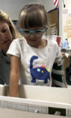  Upper extremity weightbearing | - Arm positioned close to body  - Elbow straightened (extended)  - Wrist bent backwards (extended)  - Provide input to fisted hand directed toward wrist to open hand | - Palm parallel to the surface; push down on the slime  - Pat the surface of the slime with flat hand; flatten into a “pancake”  - Roll slime into a log with flat and open hand
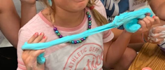  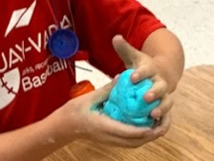  Grip strength | - Provide input to fisted hand directed toward wrist  - Gently stretch arm so the elbow is straight  - Use your fingers to provide input into the child’s palm near the base of the thumb to help open thumb  - It’s okay if the fingers are flexed (bent) loosely | - “Knead” slime with one or two hands to mix ingredients together  - Squeeze bottle of glue or food coloring  - Use two hands to shape slime into a ball  - Squeeze ball of slime with just weaker hand.  - Pull slime apart with two hands
Isolated finger movements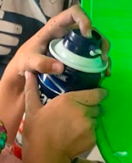 | - Provide input to fisted hand directed toward wrist to open hand  - Use your fingers to provide stability to the web space near the base of the thumb and index finger to help open index finger  - Further prepare hand by grasping cylindrical shaving cream container | - Poke holes in the slime with individual fingers  - Use index finger to squirt shaving cream while helper holds the can still OR use thumb to push trigger with fingers holding can
Three-point grasp 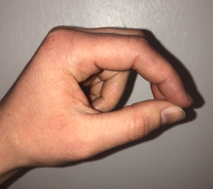  Pincer grasp  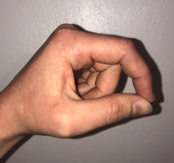 | - Three-point: Thumb is in opposition to index and long finger; index and middle are loosely flexed at middle joints. Ring and little finger are bent (finger flexion) to stabilize the hand  - Pincer: Thumb is in opposition to the index finger. Middle joint of index finger is loosely flexed to prevent web space collapse/narrowing. Middle, ring, and little finger are bent (finger flexion) to stabilize the hand.  - Provide support at base of thumb and little finger side of the hand  - Will often need to provide wrist stability on small finger side | - Pinch bit of slime between finger(s) and thumb, pull away from rest of slime  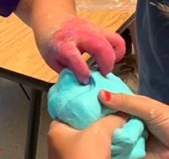  - Pinch and squeeze slime, then release
Cylindrical grasp  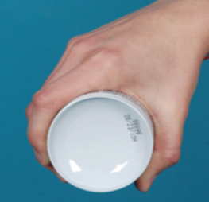  11 | - Input to fisted hand directed toward wrist  - Gently stretch arm so the elbow is straight  - Use your fingers to provide input into the child’s palm near the base of the thumb to help open thumb  - It’s okay if the fingers are flexed (bent) loosely  - Provide support at base of thumb to open web space around shaving cream can | - Have child hold the shaving cream can while helper squirts shaving cream  - Assist child with holding by pushing the can gently into their hand.  - Roll the shaving cream bottle back and forth maintaining the hand on the can

Lemonade
Campers prepare to make lemonade by rolling and squeezing lemons. Next, they cut and juice the lemons before finally getting to enjoy a cup of lemonade.

Gross Motor Goals | Fine Motor Goals | Sensory Goals
- Symmetrical stance  - Sitting posture  - Sit to Stand  - Reaching | - Shoulder flexion/extension  - Forearm pronation/supination  - Upper extremity weight bearing  - Isolated finger movements  - Grip strength  - Spherical and cylindrical grasp | - Taste: sweet and sour of lemonade  - Touch: texture of lemon peel/inside, cold  - Smell: lemon/lemonade

Goals | Proper Form/Technique | Activity Recommendations
Symmetrical stance | - Feet should be positioned shoulder width apart with equal weight bearing through both legs  - Heels should stay in contact with the ground  - Shoulders should be in line with hips  - Back should remain fairly straight | 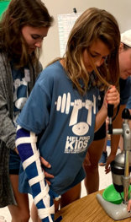  - Have child squared up to table  - Encourage child to support all their weight through the legs  - NO bellies on table!
Symmetrical sitting  7 | - Feet should be flat on the floor  - Hips, knees, and ankles should be at 90 degrees  - Knees should be at the same height as (or slightly lower than) the hips  - May need to put a stool or foot box under feet to help with positioning  - Table should be 1-2 inches above bent elbows  - Back should be straight  - No slouching and no bellies leaning on tables!  Make sure child’s weight is evenly distributed on sit bones - they shouldn’t be shifted or leaning to one side.  - Have child sitting squared up to table to drink lemonade  - Encourage child to support their weight with the trunk and legs. NO bellies on table!
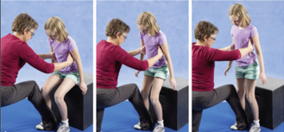  Transitioning from standing to sitting | - Feet should be positioned shoulder width apart with equal weight bearing through both legs  - Toes should be pointed slightly outward and heels should stay in contact with ground  - Knees should not pass toes and should stay in line with shoulders (should not go in)  - Back should remain fairly straight  - Slowly lower to seated position without popping  10  - Lean forward so nose is over toes to come to standing  - Make sure child’s feet are in line with each other  - Encourage child to push up equally through both legs with little to no hand support
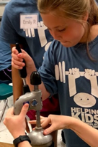  Shoulder and elbow flexion/extension | 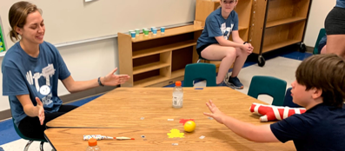  - Roll lemon back and forth on table keeping the elbow straight  - Roll the lemon side to side on the table by bending and straightening at the elbow  - Push/roll lemon across table to volunteer  - Straighten elbow to reach for cup of lemonade and & bend elbow to drink from cup  - Push/pull lever to juice lemon, keeping child’s arm close to body. May need to help stabilize at shoulder while helping facilitate movement at elbow.
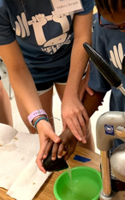  Forearm pronation and supination | - Position child’s arm close to their body initially to ensure alignment of the shoulder  - Encourage neutral forearm alignment (palm facing inward, palm up, elbow straight) while reaching for/grabbing cup of lemon juice  - Stabilize the child’s elbow while helping rotate the wrist | - Encourage child to turn their hand over (palm facing up) to look at the lemon  - Grab cup of lemon juice (thumb facing up) and rotate forearm (thumb facing down) to pour juice into bowl
Reaching | - Standing with feet shoulder width apart and equal weight bearing through both legs  - Shoulders in line with hips  - Place hands on child’s glutes while reaching to help shift weight forwards onto balls of feet and sideways  - Help child straighten elbow when reaching | - Hold lemon above, in front of, and to the sides of the child just out of arms reach to encourage reaching and trunk rotation in all directions  - Vary the height and distance but focus on reaching at shoulder height for eye hand coordination, wrist extension, and proximal strengthening
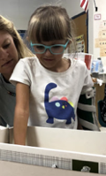  Upper extremity weightbearing | - Arm positioned close to body  - Elbow straightened (extended)  - Wrist bent backwards (extended)  - Shoulder bent to 90 degrees when at wall  - Hand open, palm parallel to surface  - Push lemon against wall or table and hold pressure | - Can be done standing at table or wall  - Encourage child to push down on the lemon through their open palm  - Can roll lemon back and forth, side to side, or in circles while pushing down on it  - Push down on lemon slicer to cut lemon  - If child cannot grasp slicer, have volunteer hold slicer and have child place their palm on top of the volunteer’s hand and push down
Isolated finger movements | - Provide input to fisted hand directed towards wrist to open hand  - Use your fingers to provide stability to the web space near the base of the thumb and index finger to help open index finger | - Use index finger to scratch the lemon peel and touch the inside of the lemon  - Have child sniff the lemon.  - Touch block of ice with individual fingers or with hand open (palm parallel to surface of block of ice)
Spherical grasp,  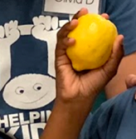  Cylindrical grasp,  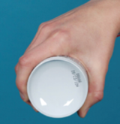  11  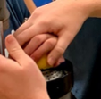  and grip strength | Hand-Open:  - Provide input to fisted hand directed toward wrist, gently stretch arm so the elbow is straight. Use your fingers to provide input into the child’s palm near the base of the thumb to help open thumb. It’s okay if the fingers are loosely flexed (bent)  - Provide support at base of thumb to open web space around lemon/cup  Grasp:  - Wrap fingers and thumb around lemon/cup/handle. Assist child with holding by pushing the lemon gently into their hand | - Open hand to grasp lemon (wrap all fingers around lemon)  - Have child squeeze whole lemon and lemon halves  - Grab and hold cup of lemonade or lemon juice  - Have child smell and sip lemonade  - Grasp lemon half and place it on juicer  - Grasp handle of lemon juicer and pull/push to juice lemon; Child may need help keeping fingers wrapped around the handle while pushing/pulling lever.

Crafts
Gross Motor Goals | Fine Motor Goals
- Symmetrical sitting  - Symmetrical stance  - Reaching  - Squatting  - Upper extremity weight bearing | - Shoulder active range of motion (AROM)  - Pronation and supination  - Wrist extension  - Hand open  - Grasp: cylindrical, three-point, pincer  - Isolated finger movements

Gross and Fine Motor Skills: Proper Form and Facilitation Techniques
Goals | Proper Form/Technique
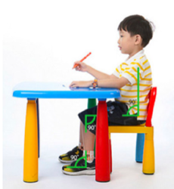  Sitting  7 | - Feet should be flat on the floor  - Hips, knees, and ankles should be at 90 degrees  - Knees should be at the same height as (or slightly lower than) the hips  - May need to put a stool under feet to help with positioning  - Table should be 1-2 inches above bent elbows  - Back should be straight. No slouching!  - Make sure child’s weight is evenly distributed - they shouldn’t be shifted or leaning to one side  - Have child sitting squared up to table to work on craft  - Encourage child to support their weight with the trunk and legs. NO bellies on table!
Symmetrical stance | - Feet should be positioned shoulder width apart with equal weight bearing through both legs  - Toes pointed forward.  - Heels should stay in contact with the ground  Shoulders should be in line with hips  - Back should remain fairly straight  - Have child standing squared up to table to work on craft  - Encourage child to support their weight with their trunk and legs. NO bellies on table!
Reaching | - Standing with feet shoulder width apart and equal weight bearing through both legs  - Shoulders in line with hips  - Place hands on child’s glutes while reaching to help shift weight forwards onto balls of feet and sideways  - Help child straighten elbow when reaching
Shoulder AROM | - Keep elbow straight while moving arm  - Encourage neutral alignment of wrist during shoulder movements
Pronation and Supination | - Position child’s arm close to their body initially to ensure neutral alignment of the shoulder  - Encourage neutral forearm alignment (palm facing inward, thumb up, elbow straight) while reaching for/grabbing object  - Stabilize the child’s forearm near the elbow while helping rotate the forearm at the wrist so that thumb is palm is facing down (pronation) or up (supination)
Hand open and grasp | - Provide input to fisted hand directed toward wrist, gently stretch arm so the elbow is straight  - Use your fingers to provide input into the child’s palm near the base of the thumb to help open thumb  - It’s okay if the fingers are flexed (bent) loosely  - Provide support at base of thumb to open web space around object  - Assist child with holding by pushing the object gently into their hand
Isolated finger movements | - Provide input to fisted hand directed toward wrist  - Use your fingers to provide stability to the web space near the base of the thumb and index finger to help open index finger
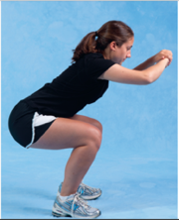  Squatting  1 | - Feet should be positioned shoulder width apart  - Equal weight bearing through both legs  - Toes should be pointed slightly outward  - Heels should stay in contact with the ground  - Knees should not pass toes and should stay in line with shoulders (they should not go in)  - Back should remain fairly straight  - Weight is shifted posteriorly
Three-point grasp  Pincer grasp | - Three-point: Thumb is in opposition to index and long finger; index and middle are loosely flexed at middle joints. Ring and little finger are bent (finger flexion) to stabilize the hand  - Pincer: Thumb is in opposition to the index finger. Middle joint of index finger is loosely flexed to prevent web space collapse/narrowing. Middle, ring, and little finger are bent (finger flexion) to stabilize the hand.  - Provide support at base of thumb and little finger side of the hand  - Will often need to provide wrist stability on small finger side
Upper extremity weightbearing | - Arm positioned close to body  - Elbow straightened (extended)  - Wrist bent backwards (extended)  - Provide input to fisted hand directed toward wrist to open hand
Wrist Extension | 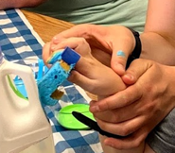  - Arm should be positioned close to body  - Help child extend wrist by stabilizing the forearm above the wrist, placing your fingers on the palm side of the wrist and thumb on the opposite side

Craft Goals and Activity Recommendations
Craft | Goals | Activity Recommendations
Birdfeeder  Campers make a birdfeeder using a milk jug, paint, string and birdseed. | Symmetrical Sitting | - Have child sitting/standing squared up to table to make birdfeeder  - Encourage child to support their weight with the trunk and legs  - NO bellies on table!  - Stand with equal weightbearing through both legs while holding birdfeeder  - Place hands on glutes to help facilitate weight shift
 | Symmetrical stance
 | 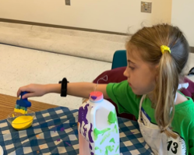  Reaching | - Position paint on table so child has to reach forward/diagonally with fully straightened (extended) elbow  - Place paint containers with vertical orientation to facilitate wrist extension  - Have child bend (flex) elbow when bringing arm back to body/birdfeeder  - Hold birdfeeder above, in front of, and to the sides of the child just out of arms reach to encourage reaching in all directions. Make sure that core is stable with reaching and that child rotates trunk when reaching across body  - Vary the height and distance but focus on reaching at shoulder height for eye hand coordination, wrist extension, and proximal strengthening
 | Shoulder active range of motion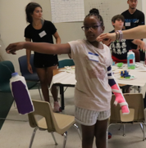 | 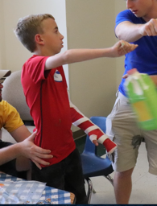  - Have child hold bird feeder out in front of them (shoulder flexion) with elbow straight (extended) and wrist in neutral  - Move arm across body (horizontal adduction) and out to the side (horizontal abduction), keeping elbow straight.
 | 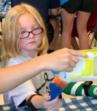  Pronation and Supination | - Scoop birdseed into funnel to fill birdfeeder  - Hold paint bottle with hand in thumbs up position to squirt paint onto plate/bowl.  - Helper can hold milk jug above table so child can paint the bottom with forearm rotated so hand is in palms up position  - Have child hold milk jug on the table and attempt to turn the milk jug so the bottom rotates up to the side to encourage supination.
 | 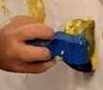  Hand open & Grasp | - Wrap fingers around sponge brush or spoon  - Hold bottle of paint and squeeze paint onto bowl/plate  - Have child wrap fingers and thumbs around milk jug (cylindrical grasp) to move and stabilize it while helper paints
Easel  Campers paint and finger paint on easel or roll of paper on the wall. | Symmetrical stance | 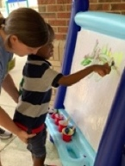  - Have child standing squared up to table to easel with equal weight bearing through both legs  - Place hands on glutes to help facilitate weight shift
 | Shoulder active range of motion | - Paint on easel with elbow straight and wrist in neutral  - Move arm up and down and side to side.
 | Hand open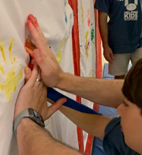 | - Hold arm with elbow straight (extended), wrist bent backwards (extended), hand open and palm parallel to the surface of the easel (See description above on how to facilitate hand opening if fisted)  - Press palm onto easel to make a handprint; May need to place your hand over child’s hand to help flatten palm and facilitate finger and wrist extension  - Open and close fingers (finger abduction/adduction) to spread paint around  - Move whole hand to spread paint across paper.
 | Grasp | - Wrap fingers around sponge/brush
 | Isolated finger movements | - Finger paint with isolated index finger, index and middle finger, or thumb  - Use index finger to point to different colors of paint
Sponge paint throwing  Campers dip sponges in paint and toss them at paper on the side of the building. | Squatting | - Squat to pick up sponge and dip sponge in paint
 | Grasp | - Wrap fingers around sponge. Try different size sponges to determine best fit
 | 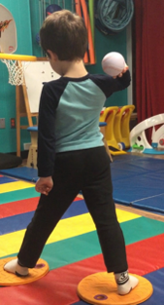  Throwing  8 | - Feet positioned shoulder width apart with equal weight bearing through both legs  - Toes pointed towards the poster board/target  - Shoulders should be in line with hips  - Make sure feet are set BEFORE the child throws the sponge!  - Encourage child to step forward with opposite foot while throwing if they are able  - Have child “wind up” by bringing sponge up towards their ear then back forward to throw the sponge  - Encourage follow through to allow for greater amplitude of shoulder flexion, shoulder abduction, and elbow extension.
Firefighter hat  Campers decorate a firefighter hat using bottle caps and string. | Symmetrical sitting | - Have child sitting/standing squared up to table to make hat  - Encourage child to support their weight with the trunk and legs  - NO bellies on table!  - Stand with equal weightbearing through both legs while holding hat  - Place hands on glutes to help facilitate weight shift
 | Symmetrical stance
 | Reaching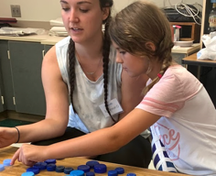 | - Place bottle caps on table so child has to reach forward/diagonally; Fully straighten (extend) elbow while reaching for bottle caps; Bend (flex) elbow while bringing bottle caps towards craft.  - Hold hat or bottle caps above, in front of, and to the sides of the child just out of arms reach to encourage reaching in all directions  - Vary the height and distance but focus on reaching at shoulder height for eye hand coordination, wrist extension, and proximal strengthening
 | Shoulder active range of motion | - Slide bottle caps back and forth and side to side on table keeping elbow straight and wrist neutral
 | Isolated finger movements | 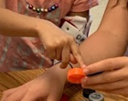  - Push bottle caps on table with index finger or thumb  - Point to bottle caps with index finger  - Use index finger to count bottle caps  - Stack bottle caps  - Transfer caps from palm to fingertips
 | Three-point and pincer grasp | 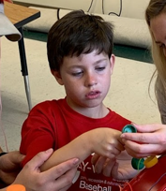  - Pick up bottle caps using thumb, index finger, and middle finger OR thumb and index finger  - Orient bottle cap vertically to assist with three-point grasp  - Stabilize thumb and index finger in web space to assist with grasp.  - Grasp string and thread through hole in bottle cap while helper holds bottle cap  - Two-handed: Have child hold bottle cap steady with weak hand while strong hand threads string through it
Picnic cushion  Campers sew together a picnic cushion using fabric, thread, and a square piece of foam. | Sitting | - Have child sitting squared up to table to make picnic cushion  - Encourage child to support their weight with the trunk and legs  - NO bellies on table!
 | Upper extremity weight bearing | 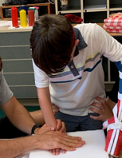  - Hand open and palm parallel to the cushion  - Push down on the cushion with elbow straight (elbow extension) and wrist bent backwards (wrist extension)  - May need to place your hand over child’s hand to help flatten palm and facilitate finger and wrist extension
 | Hand open | - Have child use weak hand to open fabric on table; Helper may need to stabilize fabric while child unfolds  - Two-handed: Have child pull fabric apart with both hands to unfold  - With hand open and palm facing down, smooth out fabric  - Place foam on fabric and fold fabric over top of foam  - Smooth fabric over top of cushion  - Helper may need to stabilize fabric/cushion while child is smoothing if one-handed activity  - Two-handed: Child should stabilize fabric/cushion with weak hand and smooth with strong hand
 | Three-point and pincer grasp | - Pick up string and fabric using thumb, index finger, and middle finger OR thumb and index finger  - Grasp string and thread through holes in fabric while helper stabilizes cushion Two-handed: Hold thread in strong hand while weak hand stabilizes cushion
 | Wrist flexion and extension | - Bend wrist forward and backward while threading string through holes in fabric to sew cushion together  - Helper may need to place fingers on palm side of wrist and thumb on posterior wrist to help facilitate flexion/extension
 | Shoulder and elbow active range of motion | 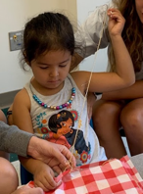  - Helper can thread string through hole  - Have child grasp the string  - With elbow bent, bring forearm up and back to pull string all the way through the hole (shoulder external rotation)  - Maintain neutral wrist while rotating at shoulder
Window hanger  Campers create a window hanger using a paper plate, tissue paper, glue, and string. | Sitting | - Have child sitting/standing squared up to table to make window hanger  - Encourage child to support their weight with the trunk and legs  - NO bellies on table!  - Stand with equal weightbearing through both legs while holding window hanger  - Place hands on glutes to help facilitate weight shift
 | Symmetrical standing
 | Reaching | - Position pieces of tissue paper on table so child has to reach forward/diagonally  - Fully straighten (extended) elbow while reaching for paper  - Bend (flex) elbow while bringing paper towards craft  - Hold window hanger above, in front of, and to the sides of the child just out of arms reach to encourage reaching in all directions  - Vary the height and distance but focus on reaching at shoulder height for eye hand coordination, wrist extension, and proximal strengthening
 | Shoulder active range of motion | - Have child hold window hanger out in front of them (shoulder flexion) with elbow straight (extended) and wrist in neutral  - Move arm across body (horizontal adduction) and out to the side (horizontal abduction)  - Straighten (extend) elbow as arm moves away from body and bend (flex) elbow when bringing arm back towards body
 | Hand open | - Have child use weak hand to open tissue paper on table; Helper may need to stabilize tissue paper while child unfolds  - Two-handed: Have child pull tissue paper apart with both hands to unfold  - With hand open and palm facing down, smooth out tissue paper  - Helper may need to stabilize tissue paper while child is smoothing if one-handed activity Two-handed: Child should stabilize tissue paper with weak hand and smooth with strong hand if two-handed activity
 | Cutting | - Cut tissue paper into smaller pieces/shapes while helper stabilizes paper  - Two-handed: Have child use scissors with strong hand while holding and turning tissue paper
 | Isolated finger movements | - Point to different colored tissue paper  - Slide folded tissue paper back and forth on table with index finger  - Use thumb or index finger to push pieces of tissue paper onto glue covered plate
 | Three-point and pincer grasp | - Pick up pieces of tissue paper using thumb, index finger, and middle finger OR thumb and index finger  - Provide stabilization at webspace and posterior wrist to assist with grasp

References
- Carolyn Kisner, Lynn Allen, Colby, John Borstad: Therapeutic Exercise: Foundations and Techniques, Seventh Edition. Copyright © F.A. Davis Company. All rights reserved.
- Tall Kneeling. Feels Like Sunshine. https://feelslikesunshine.com/simple-core-strengthening-ideas-to-get-kids-ready-for-back-to-school/. Accessed January 26, 2021.
- Half Kneeling. Feels Like Sunshine. https://feelslikesunshine.com/simple-core-strengthening-ideas-to-get-kids-ready-for-back-to-school/. Accessed January 27, 2021.
- Child Learning to Crawl . The Inspired Treehouse. https://theinspiredtreehouse.com/developmental-milestones-learning-crawl/. Accessed February 3, 2021.
- Step-up. Silver Sneakers. https://www.silversneakers.com/blog/6-ways-tone-legs-butt-standing-no-floor/. Accessed February 10, 2021.
- Child Jumping. Dinosaur Physical Therapy. https://blog.dinopt.com/teaching-children-to-jump/. Accessed February 12, 2021.
- Child Sitting at Desk. Penrose Physical Therapy. https://www.penrosetherapy.com/news/btsposturetips. Accessed March 5, 2021.
- Practicing Throwing Overhand. https://starfishtherapies.com/2019/01/practicing-throwing-overhand/. Accessed March 14, 2021.
- Agility Ladder Drills. Schramm Pediatric PT. https://www.schrammpediatricpt.com/l/agility-ladder-drills-free-printable/. Accessed March 14, 2021.
- D.W. Fell, K.Y. Lunnen, R.P. Rauk: Lifespan Neurorehabilitation: A Patient-Centered Approach from Examination to Intervention and Outcomes. Copyright © F.A. Davis Company. All rights reserved.
- Mark Dutton: Dutton’s Orthopaedic Examination, Evaluation, and Intervention, Fifth Edition. Copyright © McGraw-Hill Medical. All rights reserved.

