Aquatic Home Exercise Program for Osteoarthritis

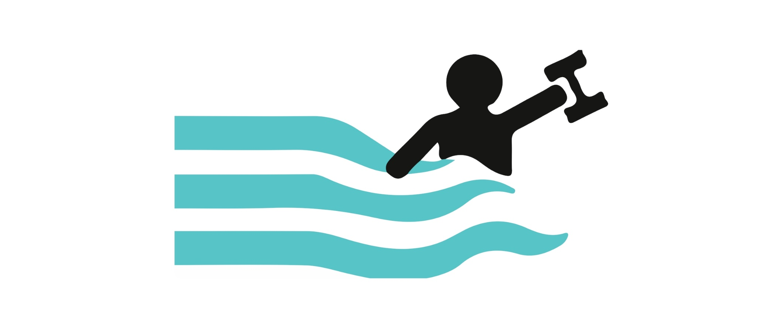

Depth depends on: Desired level of intensity, desired purpose of exercise, weight bearing tolerance, and degree of pain.

- Waist depth= 50% weight-bearing
- Shoulder depth= 10% weight-bearing
- Chest depth= 30% weight-bearing

Strengthening:

4-Way Hip (Flexion, Extension, Abduction, Adduction)
Start Position: | End Position:
 | 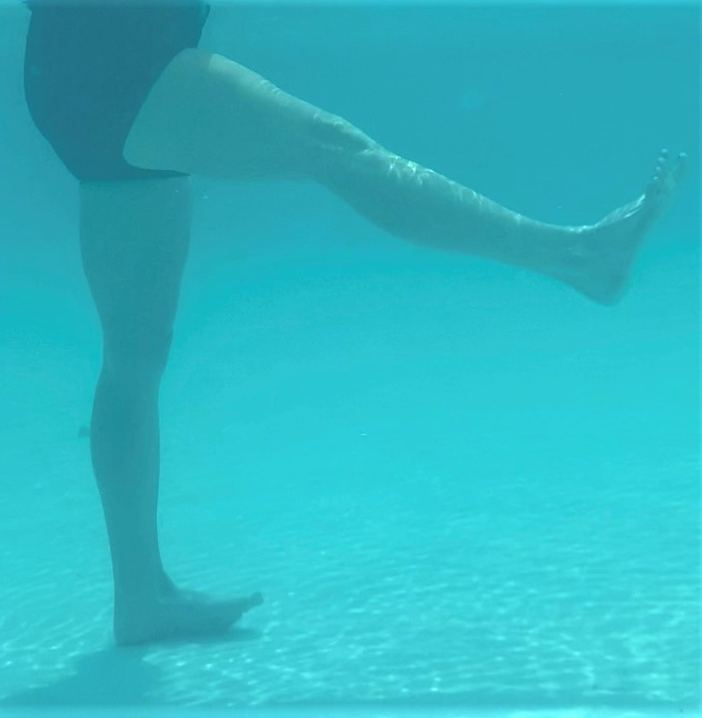 | Sets: __________  Reps: __________  Hold: __________  Rest in between sets: __________  Times per week:__________  Water Depth: __________
 | 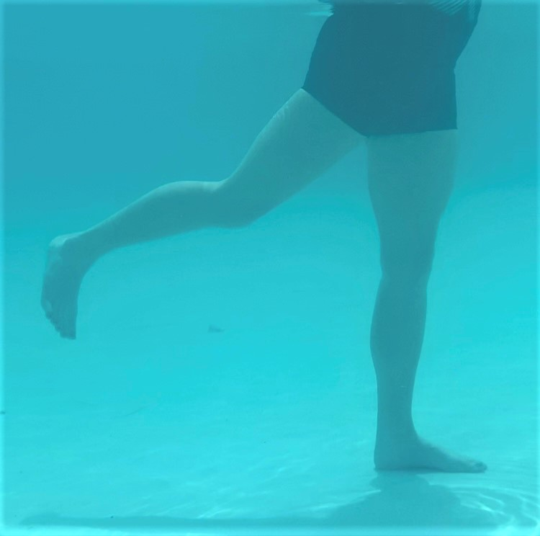 | Sets: __________  Reps: __________  Hold: __________  Rest in between sets: __________  Times per week:__________  Water Depth: __________
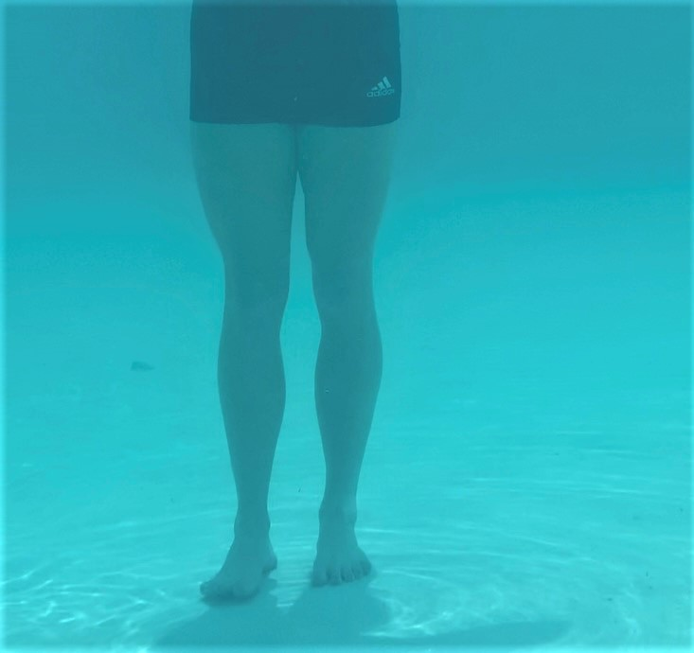 | 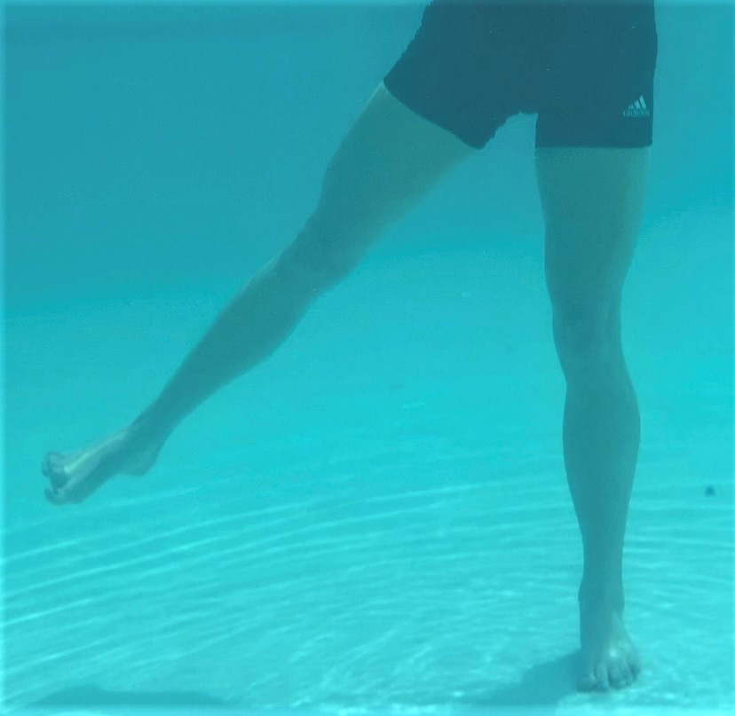 | Sets: __________  Reps: __________  Hold: __________  Rest in between sets: __________  Times per week:__________  Water Depth: __________
 | 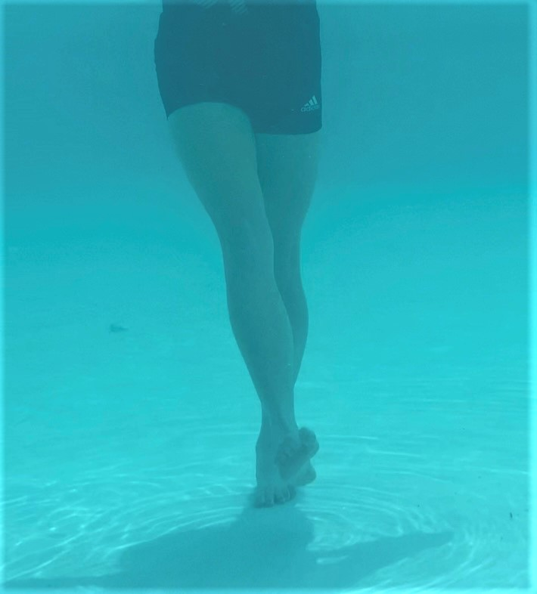 | Sets: __________  Reps: __________  Hold: __________  Rest in between sets: __________  Times per week:__________  Water Depth: __________
Instructions: Stand upright with your feet about hip width apart and planted firmly on the ground. Keeping both legs relatively straight, raise one leg forward as far as you are comfortable while keeping your back straight. Pull that leg back down to the starting position. Repeat with your leg moving out to the side, backward, and crossing the leg in front of the other. You may hold onto a wall if needed.

Squats
Start Position: | End Position:
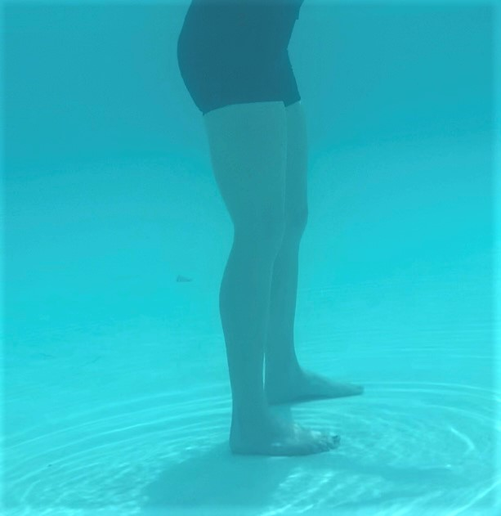 | 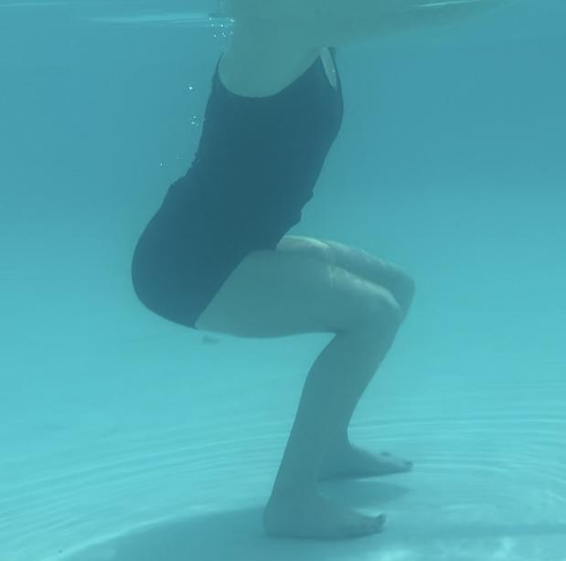
Instructions: Stand upright with your feet slightly wider than hip width and planted firmly on the ground. Move your hips back as if you were going to sit in a chair. Slowly bend your legs and lower your hips until your knees are bent at a 90 degree angle. The weight should be mostly in your heels and your knees should not move in front of your toes. Stand upright while squeezing your glutes.

Sets: __________

Reps: __________

Hold: __________

Rest in between sets: __________

Times per week:__________

Water Depth: __________
Heel Raises
Start Position: | End Position:
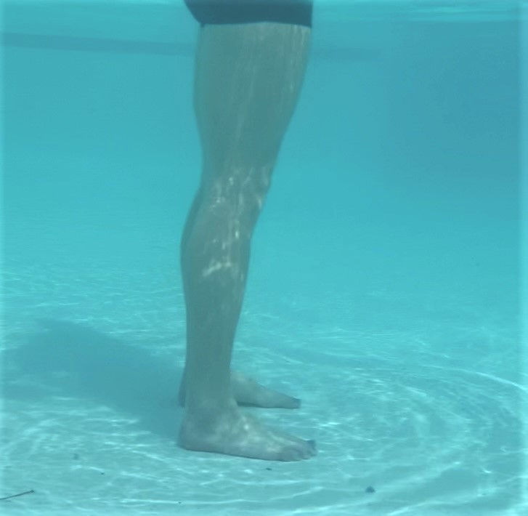 | 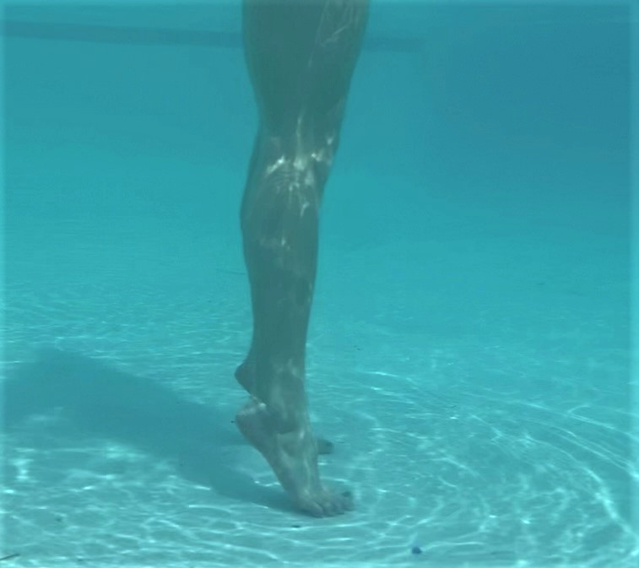
Instructions: Stand upright with your feet about hip width apart and planted firmly on the ground. Keeping your legs and body straight, raise up onto your toes so that your heels are off the ground. Go up as far as you can. Slowly lower back down and return to the starting position. You may hold onto a wall if needed.

Sets: __________

Reps: __________

Hold: __________

Rest in between sets: __________

Times per week:__________

Water Depth: __________
Lateral/Side Lunges
Start Position: | End Position:
 |  | 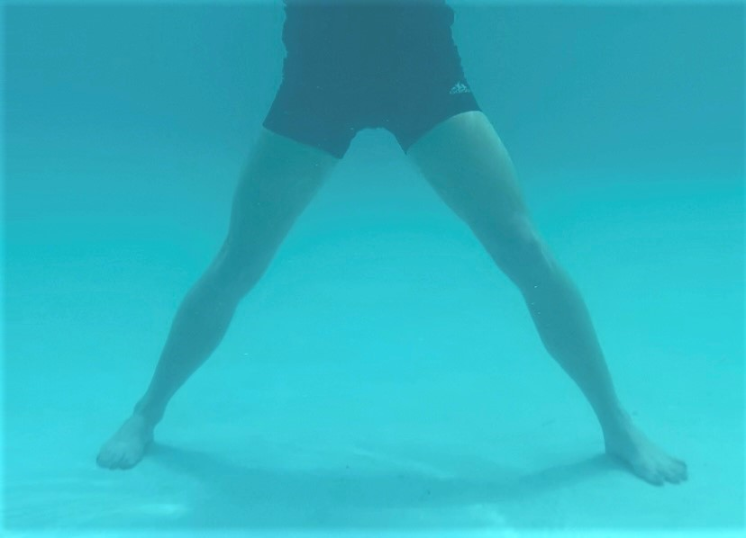 | 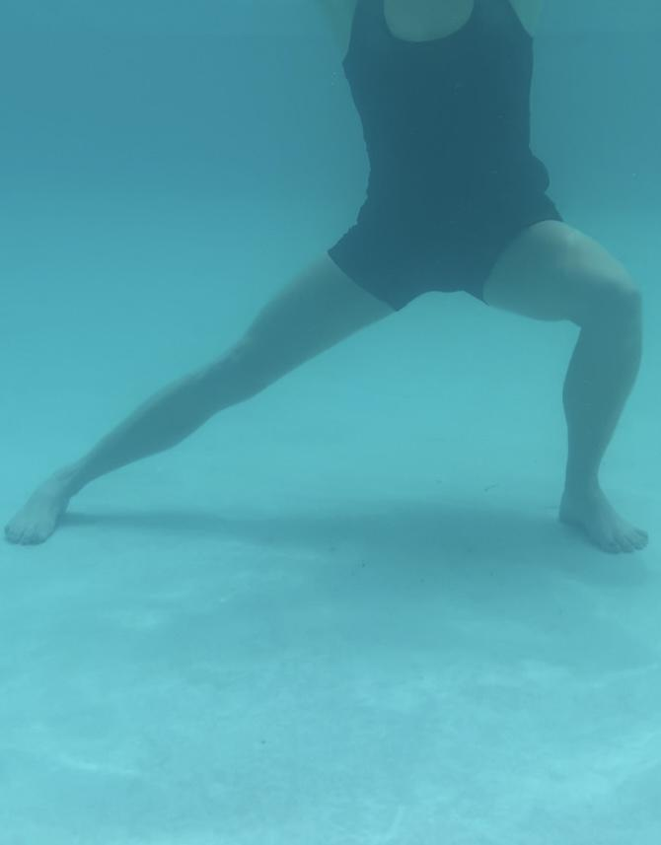
Instructions: Stand upright with your feet about hip width apart and planted firmly on the ground. Take a large step with one leg to the side and plant that foot on the ground. Keeping the far leg straight, bend the leg that you just moved and lower your hips towards the floor. Return to the starting position.

Sets: __________

Reps: __________

Hold: __________

Rest in between sets: __________

Times per week:__________

Water Depth: __________

Seated or Supine Knee Bends
Start Position: | End Position:
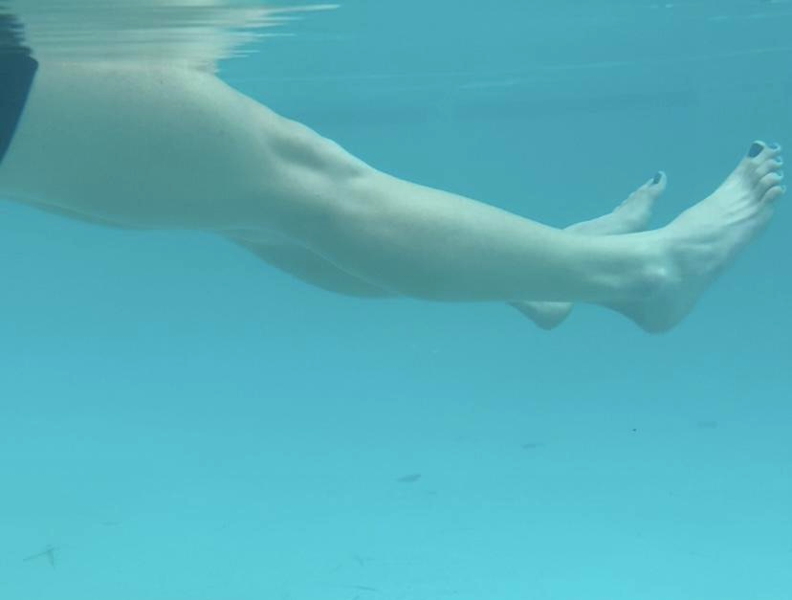
Instructions: Sit on a step or float on the top of the water with your legs extended straight out. Bend knees towards your butt as far as you can, then slowly let them straighten back out to the starting position. To make this easier, you may do one leg at a time and use upper body for support in order to maintain balance.

Sets: __________

Reps: __________

Hold: __________

Rest in between sets: __________

Times per week:__________

Water Depth: __________

Aerobic:

Walking (Forward, Backward, Side-stepping)
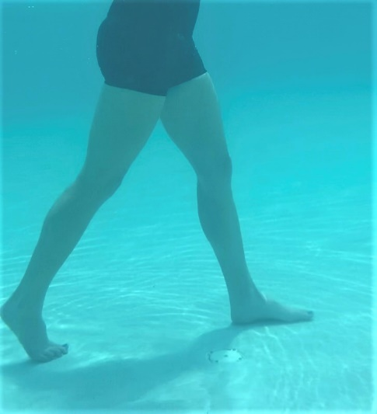 | 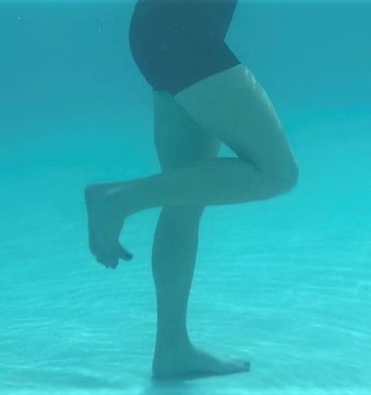 | 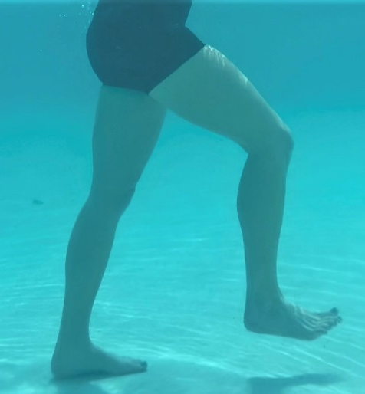
Instructions: Begin walking at a slow pace and build up to the pace at which you would like to exercise. It is important when performing backward and lateral walking to keep your feet pointed forward.

Sets: __________

Reps: __________

Hold: __________

Rest in between sets: __________

Times per week:__________

Water Depth: __________

Underwater Cycling
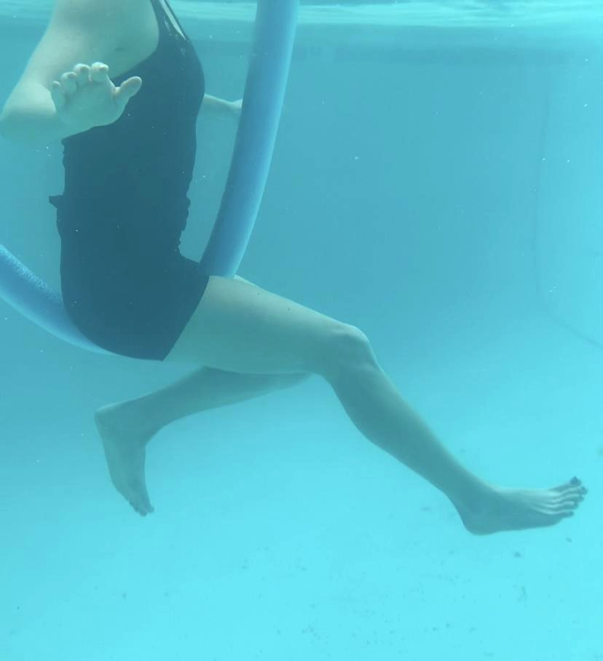
Instructions: Mount the noodle so that you are sitting in the middle of it with one leg on either side. Once you feel balanced, start moving your legs in a continuous cycling motion as if you are riding a bike.
**If using an underwater bike, safely get on the bike placing both feet on the pedals. Make sure to have your bike properly fitted in regard to seat and handlebar height. Ask your PT if you have questions about appropriate bike set up. Once you feel balanced, start moving your legs in a continuous cycling motion.

Sets: __________

Reps: __________

Hold: __________

Rest in between sets: __________

Times per week:__________

Water Depth: __________

Standing Marches
 | 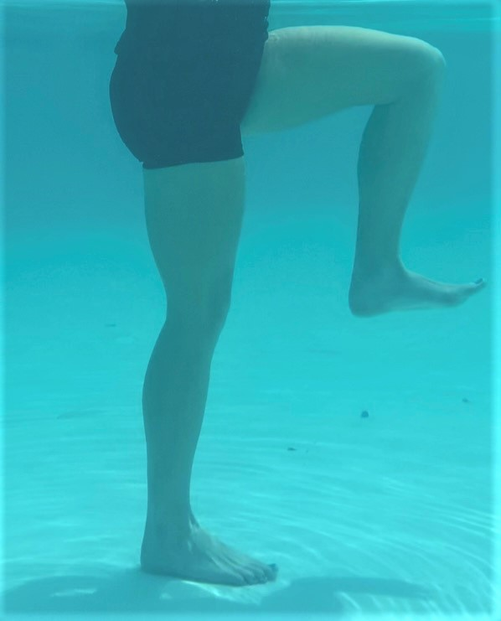 | 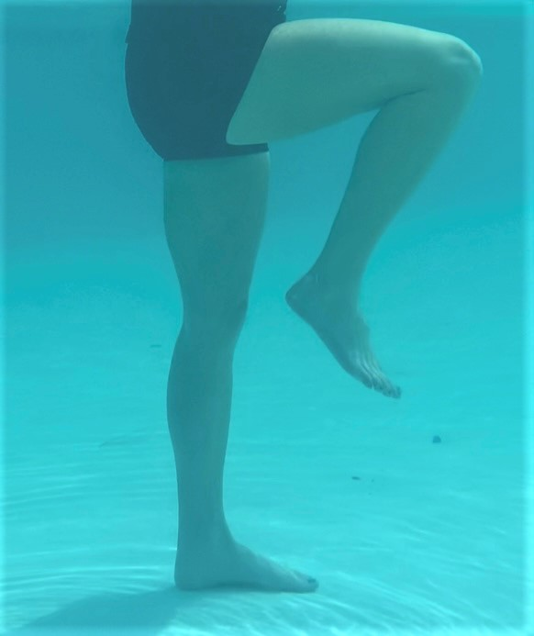
Instructions: Stand upright with both feet planted firmly on the ground. Raise one leg up at a time so that your knee and hip bend to 90 degrees. With control, lower your leg back to the ground and repeat on the other side. You may hold onto a wall if needed.

Sets: __________

Reps: __________

Hold: __________

Rest in between sets: __________

Times per week:__________

Water Depth: __________

Modified Jumping Jacks (you can use a floatation belt or pool noodle)
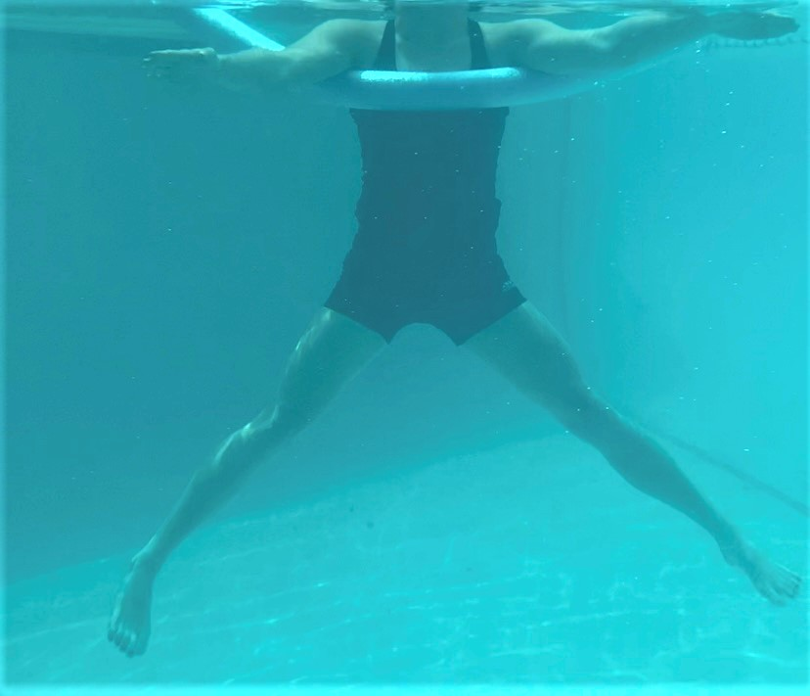 | 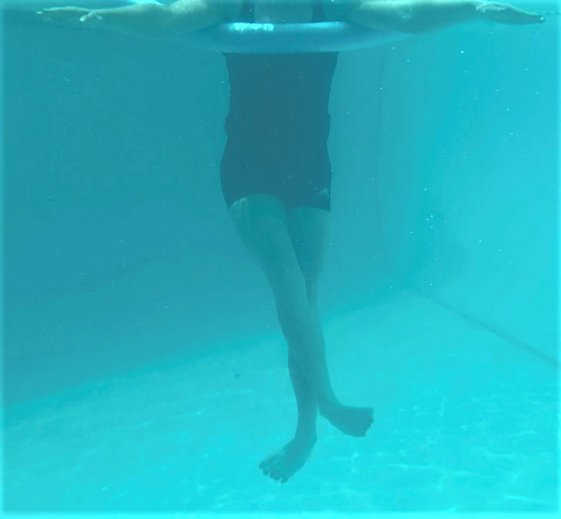
Instructions: Wearing a floatation belt or holding a pool noodle, move to an area with deep water (where feet can't touch the bottom). “Stand” up tall as if you were standing on solid ground. Move your legs outward and away from each other while keeping your body upright. Bring them back towards the starting position and continue to move them so that the legs cross in front of one another. Move legs outward again and continue to alternate which leg goes in front and which goes behind the other. You can also move your arms together and apart along with your legs to make it harder.

Sets: __________

Reps: __________

Hold: __________

Rest in between sets: __________

Times per week:__________

Water Depth: __________
Flexibility:

Standing Single Leg Quadricep Stretch
Start Position: | End Position:
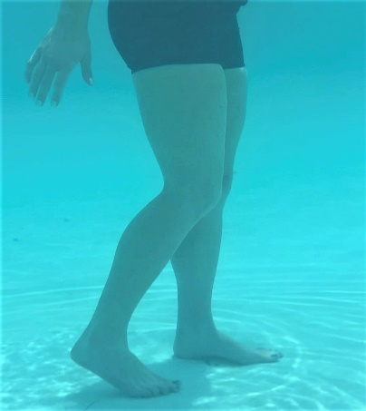
Instructions: Stand up tall and shift your weight onto one leg. Lift the other leg up and grasp it with the hand on the same side. Your grasp should be on the top of the foot so that you can pull your foot toward your bottom. Continue to pull your foot until your heel touches to your bottom or until a stretch is felt in the front of the thigh. You may hold onto a wall if needed for balance or place a strap or pool noodle under the ankle if you are having difficulty reaching your foot.

Sets: __________

Reps: __________

Hold: __________

Rest in between sets: __________

Times per week:__________

Water Depth: __________
Sitting or Standing Hamstring Stretch with Strap
Start Position: | End Position:
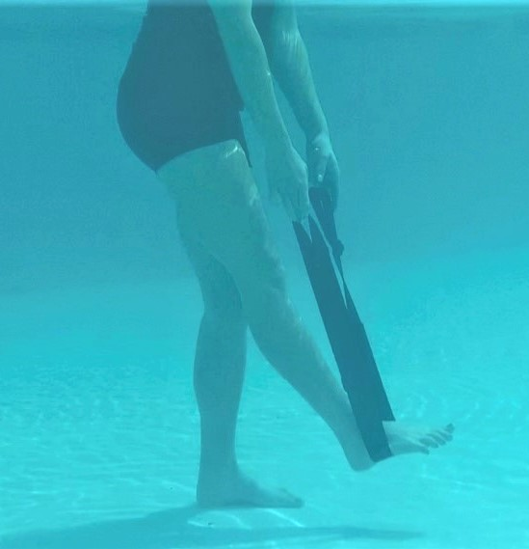 | 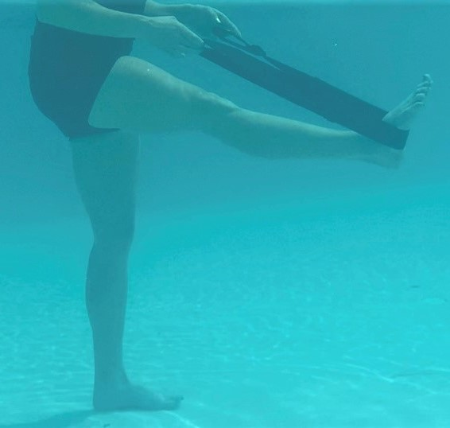
Instructions: Either sit on a step or stand with your feet hip width apart and feet firmly planted on the ground. Attach a firm strap around the bottom of your foot and hold onto the ends of the strap with both hands. Keeping your leg straight, pull on the strap so that your leg raises up. Pull up as far as you can until you feel a gentle stretch in the back of your leg. You may lean against wall if needed.

Sets: __________

Reps: __________

Hold: __________

Rest in between sets: __________

Times per week:__________

Water Depth: __________
Standing Hip Circles (clockwise and counter-clockwise)
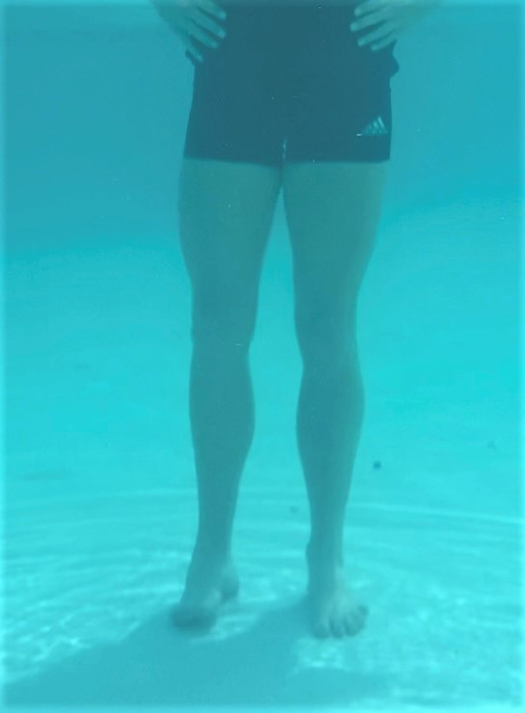 | 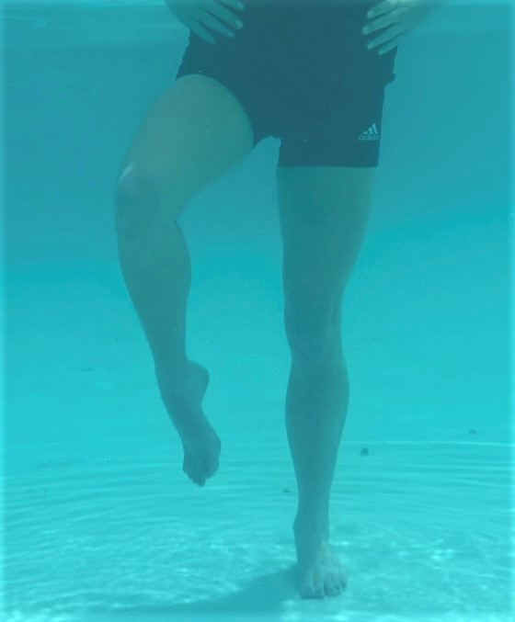 | 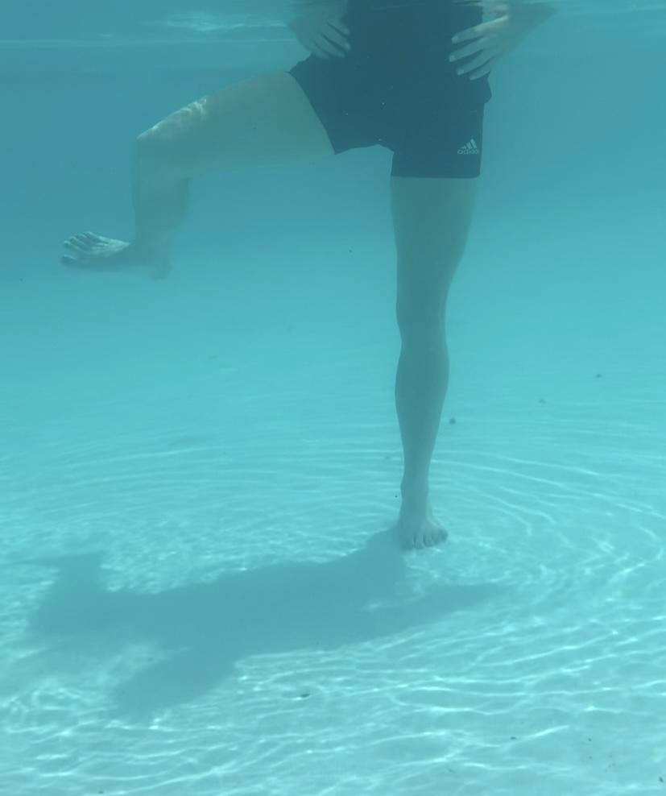 | 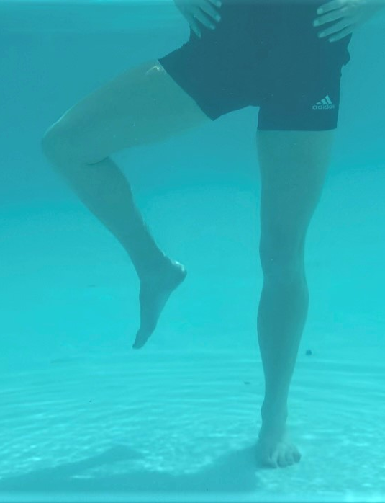
Instructions: Stand up tall and shift your weight onto one leg. Raise the other knee to 90 degrees. Open the hip as far as possible and move it around to the side, attempting to make a big circle with your knee. Repeat in the opposite direction. You may hold onto a wall if needed.

Sets: __________

Reps: __________

Hold: __________

Rest in between sets: __________

Times per week:__________

Water Depth: __________

