Sleep after Stroke

Sleep disorders are common after stroke and can put you at risk for a second stroke
Sleep disorders are treatable and the first step in management is recognition

Symptoms Common Disorders Intervention What to do
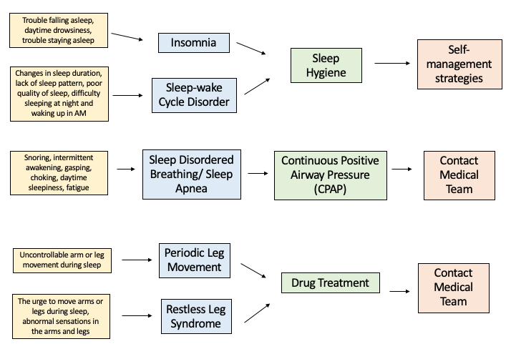

Sleep Hygiene Strategies

- Establish a consistent bedtime routine  - Go to bed and get up at the same time every night  - Use your bed for only sleep and sex  - Turn off electronics (TV, phone, computer) 1 hour before bedtime | - Avoid drinking caffeine during the afternoon and evening  - Avoid alcohol before bedtime  - Exercise daily  - Create a quiet sleep environment

