What is Chronic Pain?  - Pain is a response to nociceptive stimuli, the body’s warning system against danger.¹  - Excessive nociceptive input (long lasting pain) can cause modifications in grey and white matter involved in transmitting pain signals, making people excessively susceptible to feeling pain.²  - Chronic pain is defined as pain lasting longer than 3 months and it can occur in many areas of the body, though it is most commonly seen in the back, neck, hips, and knees.³  - When someone is experiencing chronic pain, the pain itself may not be related to the injury or illness that initially brought it on.²  - It is important to recognize that chronic pain should be treated as a disease, not a symptom.⁴  Assessment of Chronic Pain  - Get a full picture of their situation.  - Identify the type of pain the patient is experiencing. Pain can be classified as nociceptive, neuropathic, or central sensitization.⁵  - Nociceptive pain is pain that is brought on by damage to tissues of the body.  - Neuropathic pain is pain brought on by irritation or damage to sensory nerves.⁵  - Non-neuropathic central sensitization is hypersensitivity of the nervous system which often manifests as what patients experience as chronic pain.⁵ |  | 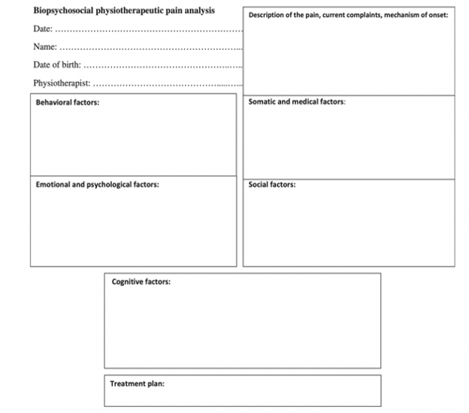  Pain Analysis and Assessment |  | 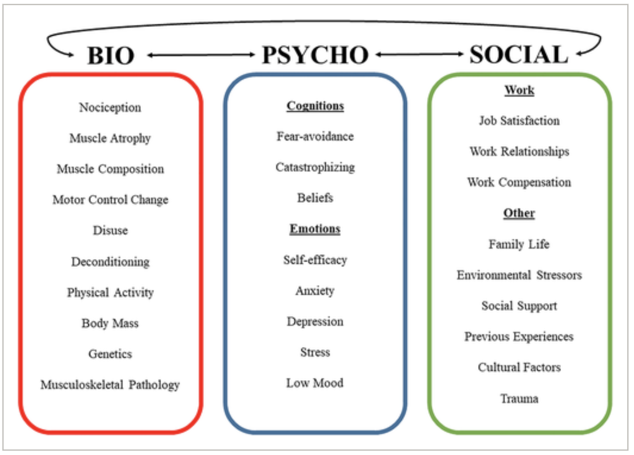  Biopsychosocial Model  The biopsychosocial model of chronic pain (image above)⁶ looks at a patient through not only a biological perspective but also psychological and social ones.⁶ Treating patients with chronic pain and looking at their pain as something that is purely due to some sort of tissue damage or physical problem is not the solution in most cases.⁶  “It is really important to address the mental health aspect of chronic pain as much as the physical aspect. Patients need to tap into the well of actually WANTING to get better.”  - Patient with Chronic Pain

Example Subjective Report Sheet⁵

3. Assess the other factors that influence chronic pain and treatment.
- Emotional Health
- Behavior
- Social Life
- Cognition
- Fear
- Sleep
- Motivation
- Workplace
4. Determine Patient Goals
- Patient goals need to be determined in order to be used as motivators to influence patients to stay dedicated and consistent with treatment.

PT Treatment of Chronic Pain  - Look for biological and/or structural impairments that can be explained and treated.  - For example, if a patient has chronic back pain and the patient’s posture is significantly compromised, it may be a good idea to work on fixing the posture and strengthening/stretching appropriate muscle groups.  - Patients need to be educated on why their posture or other impairment may be contributing to the pain they are feeling.  - During treatment it is often necessary to explain why certain methods can help improve the patient’s function and reduce their pain.  - Give the patient feedback throughout on their position since patients with chronic pain often don’t understand how their body is moving.⁷  Best Treatment Choices  - Exercise training is preferred over manual therapy in general.⁸  - Pilates, aerobic training, and stability/motor control training have the greatest effect on overall pain reduction.⁸  - Stability/motor control training and resistance training have the greatest effect on improving function.⁸  - Resistance training, aerobic training, and stability/motor control training have the greatest effect on psychological well-being.⁸ |  | Referrals to other Disciplines  - Long term outcomes of patients with chronic pain show significantly improved results with multidisciplinary programs.⁹  - It may be necessary to refer your patient to a psychologist if you believe that their cognition and/or behavior patterns need to change significantly in order for their pain to change.⁶  - A registered dietician should be brought in if excess adipose tissue is identified as an issue that is contributing to chronic pain.⁶  - Psychologists and/or sleep physicians can also help with sleep assessments and treatments if insomnia is suspected as a problem since sleep deprivation can be a significant barrier to improvement in chronic pain.^{6,10}

Fear Avoidance and Catastrophizing
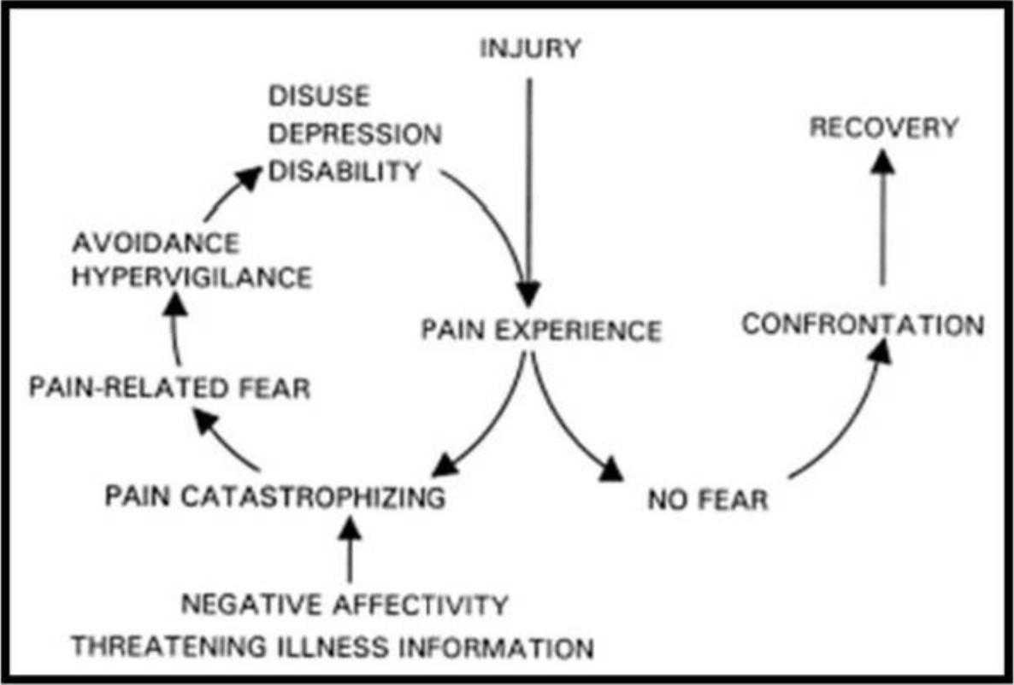
Being afraid to move because of fear of pain can lead to disuse and continued worsening of symptoms.¹¹ For example, if a patient is afraid to walk because walking brings about lower back pain, that patient may walk less and less overtime leading to increased adipose tissue and decreased mobility which can worsen lower back pain. Shown below is the fear avoidance cycle.¹¹ If a patient is caught in the loop on the left, they may require referral to a psychologist.^{6,11} Physical therapists can help by educating patients on the importance of movement and showing them that they can move successfully in particular ways without pain that is damaging them further.⁵

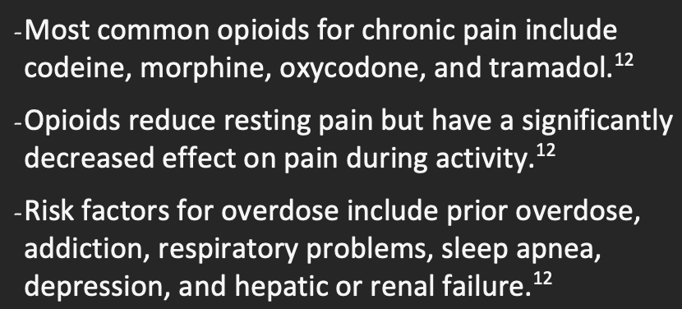
Things to Know About Opioids

References
- Simons LE, Elman I, Borsook D. Psychological processing in chronic pain: a neural systems approach. Neurosci Biobehav Rev. 2014;39:61-78. doi:10.1016/j.neubiorev.2013.12.006
- Bushnell MC, Ceko M, Low LA. Cognitive and emotional control of pain and its disruption in chronic pain. Nature reviews. Neuroscience. 2013;14:502–511.
- Treede RD, Rief W, Barke A, Aziz Q, Bennett MI, Benoliel R, Cohen M, Evers S, Finnerup NB, First MB, Giamberardino MA, Kaasa S, Kosek E, Lavand'homme P, Nicholas M, Perrot S, Scholz J, Schug S, Smith BH, Svensson P, Vlaeyen JWS, Wang SJ. A classification of chronic pain for ICD-11. Pain. 2015 Jun;156(6):1003-1007. doi: 10.1097/j.pain.0000000000000160. PMID: 25844555; PMCID: PMC4450869.
- Clauw DJ, Essex MN, Pitman V, Jones KD. Reframing chronic pain as a disease, not a symptom: rationale and implications for pain management. Postgrad Med. 2019;131(3):185-198. doi:10.1080/00325481.2019.1574403
- Wijma AJ, van Wilgen CP, Meeus M, Nijs J. Clinical biopsychosocial physiotherapy assessment of patients with chronic pain: The first step in pain neuroscience education. Physiother Theory Pract. 2016;32(5):368-384. doi:10.1080/09593985.2016.1194651
- Tagliaferri SD, Miller CT, Owen PJ, et al. Domains of Chronic Low Back Pain and Assessing Treatment Effectiveness: A Clinical Perspective. Pain Pract. 2020;20(2):211-225. doi:10.1111/papr.12846
- Magnusson ML, Chow DH, Diamandopoulos Z, Pope MH. Motor control learning in chronic low back pain. Spine (Phila Pa 1976). 2008;33(16):E532-E538. doi:10.1097/BRS.0b013e31817dfd9a
- Owen PJ, Miller CT, Mundell NL, Verswijveren SJJM, Tagliaferri SD, Brisby H, Bowe SJ, Belavy DL. Which specific modes of exercise training are most effective for treating low back pain? Network meta-analysis. Br J Sports Med. 2020 Nov;54(21):1279-1287. doi: 10.1136/bjsports-2019-100886. Epub 2019 Oct 30. PMID: 31666220; PMCID: PMC7588406.
- Gatchel RJ, McGeary DD, McGeary CA, Lippe B. Interdisciplinary chronic pain management: past, present, and future. Am Psychol. 2014;69(2):119-130. doi:10.1037/a0035514
- Nijs J, Mairesse O, Neu D, et al. Sleep Disturbances in Chronic Pain: Neurobiology, Assessment, and Treatment in Physical Therapist Practice. Phys Ther. 2018;98(5):325-335. doi:10.1093/ptj/pzy020
- Edwards RR, Dworkin RH, Sullivan MD, Turk DC, Wasan AD. The Role of Psychosocial Processes in the Development and Maintenance of Chronic Pain. J Pain. 2016;17(9 Suppl):T70-T92. doi:10.1016/j.jpain.2016.01.001
- Volkow N, Benveniste H, McLellan AT. Use and Misuse of Opioids in Chronic Pain. Annu Rev Med. 2018;69:451-465. doi:10.1146/annurev-med-011817-044739

