Difficulty and Accommodations with Relevant Recreational Activity are Associated with Physical Function, Pain, and Fatigue in Adults with Rheumatoid Arthritis
Sarah Novroski, SPT, Chris Lane, PT, DPT, Joshua Torrey, PT, DPT and Louise Thoma, PT, DPT, PhD

Abstract
Background: Rheumatoid arthritis (RA) impacts every individual differently and can limit their ability to participate in recreational activities. Recreational activities are relevant and valuable to the population however less is known about how difficulty and accommodations needed to participate in recreational activities are associated with physical function, pain, and fatigue. Purpose: (1) To describe the distribution of the relevance, difficulty, and accommodation for recreational activities and identify the recreational item that is most relevant and difficult to the population. (2) To examine the association of difficulty and accommodation of the most relevant recreational activity with physical function (PF), fatigue, and pain. Methods: In this cross-sectional study, participants with RA (n=290) completed an online survey about their current physical function, clinical information, and demographic information. Participants were eligible if they were 18 years old or older and received care between 2020-2021 from UNC Rheumatology for RA. Results: Of the selected recreational activity items from the Short-Valued Life Activities Questionnaire (SVLA), physical recreation was the most relevant and difficult for participants to complete. The associations of difficulty with physical recreation with PF, fatigue, and pain were considered significant (p < 0.001). Participants reporting no difficulty and no accommodation with physical recreation had better PF and lower pain and fatigue levels compared to all other response categories (p < 0.0001-0.023). Conclusion: Physical recreation was considered to be the most relevant and difficult recreational activity for participants to partake in. The less difficulty an individual has with physical recreation is associated with improved PF and decreased fatigue and pain levels. The option of “none with accommodation” had data that was more similar to options of increased difficulty compared to “none” indicating this could be an early sign of declining functional abilities.

Introduction
Rheumatoid arthritis (RA) is a chronic autoimmune and inflammatory disease that commonly presents with joint pain, stiffness, swelling, decreased joint range of motion and muscle loss¹. The impact of symptoms can affect each individual differently. Some have difficulty performing basic activities while others are relatively unrestricted in the activities they can perform. Physical activity is commonly impacted and is defined as any body movement that results in energy expenditure².
Recreational activities are a type of physical activity that are done for personal enjoyment during leisure time³. RA can lead to individuals experiencing increased difficulty and/or require accommodations to participate in recreational activities. Participating in recreational activity and exercise are valued life activities to these individuals and can be beneficial for managing RA symptoms as well as improving quality of life and function. Recreational activity is a more purposeful and relevant activity than physical activity and encourages normalcy within a person’s life as they may feel excluded from the community if they are not able to join friends or family in these enjoyable activities⁴. A higher total number of participation hours per a week in recreational activity as well as less sedentary time has also been associated with a reduction in fatigue and pain related to RA^{5, 6}. Participating in regular PA has many benefits for people with RA, but most do not engage for multiple reasons including socioeconomic deprivation, lack of education, and fear of exacerbating symptoms⁷⁻⁹. These factors may also play a large role why one may not participate in recreational activities.
Many patient-reported outcome measures used for assessing an individual’s ability to complete various tasks focus on their difficulty with the task. An increase in difficulty on these outcome measures are an easily identifiable indicators to the individual and healthcare provider of a decrease in function. However, many of these outcomes rarely consider the use of accommodations to complete a task as an indicator of function change. Accommodation use without any difficulty has been considered in the literature as a possible critical point at which an individual may start to experience increased disability levels¹⁰. Therefore, identifying the level of difficulty required to complete a task as well as if they use an accommodation, could be a key sign in indicating disability level for the RA population.
Prior research has focused on the relationship between RA and PA, but there has been minimal research on recreational activity participation in adults with RA. It is currently unclear how PF, fatigue, and pain are associated with an individual’s perceived ability to participate in recreational activity. The first purpose of the study was to describe the distribution of the relevance, difficulty, and accommodation for recreational activities and identify the recreational item that is most relevant and difficult to the population. The second purpose was to examine the association of the SVLA recreational activity response that was the most relevant and difficult with PF, fatigue, and pain.
Methods
Study Design and Participants
This was a cross-sectional study. Potential participants were identified through the Carolina Data Warehouse if they were 18 years old or older and received care between 2020-2021 from UNC Rheumatology for RA. Specifically, they had to have at least one encounter with UNC Rheumatology with an International Classification of Disease-10 (ICD-10) code for RA between 2020-2021 and at least one additional encounter with an ICD-10 code for RA since 2019.
Procedures
Recruitment. Potential participants were recruited by research assistants using a three-step recruitment process. Individuals were initially contacted through UNC Healthcare system’s electronic medical record system (i.e. MyChart in EPIC) followed by three emails, spaced 1-2 weeks apart. For those who did not respond, or for whom these methods were not possible, a letter was mailed to the address on file in their medical record, followed by final recruitment effort via phone call.
Data Collection. In the recruitment efforts, participants were invited to complete an online survey. Informed consent was either obtained prior to completing the online survey or verbally if conducted over the phone. All responses were recorded electronically via Qualtrics. If participants were not able to access or preferred to not take the survey online, then they had the option to complete the survey verbally over the phone.
The survey collected information on the participant’s current physical function, clinical information, and demographic information. A variety of outcome measures were included with the ones of interest described below in detail.
Outcome Measures
Short-Valued Life Activities Questionnaire (SVLA)
The SVLA is a patient-reported outcome measure that was used to evaluate one’s self-reported difficulty with completing various activities and if they used accommodations to complete the activity. Accommodations were defined as needing help from another person, needing more time to complete a task, limiting how often the individual was able to complete a task or needing equipment or an aid to perform the activity. The questionnaire contained 14 questions. The SVLA was scored by evaluating the individual’s difficulty completing an activity and if they required accommodations. This questionnaire is reliable and valid for the RA population¹¹. The specific question regarding accommodations is a unique feature of the SVLA compared to many patient-reported outcome measures. In this analysis, we were interested in the items regarding recreational activities (items 5, 7, 10, 11 and 12)¹¹. These questions asked about participating in activities such as gardening/yardwork, attending social events, leisure activities, hobbies, and physical recreation.
PROMIS
The PROMIS is a standardized patient-reported outcome measure that was used to assess the participants overall PF, pain, and fatigue levels. This study utilized the PROMIS 10a physical function (PF10a) short form which consists of 10 questions, PROMIS 6b pain (P6b) short form which consists of 6 questions and PROMIS 7a fatigue (F7a) short form which consists of 7 questions. The measure is scored by assigning a t-score based on a standardize t-score cut off that then allows the data to be generalized to the US population. An increased score on the PF10a correlates with an increased overall physical function while an increased score on the P6b and F7a correlate with an increased level of pain and fatigue. These questionnaires are considered reliable and valid for the RA population¹².
Statistical Analysis
A descriptive analysis was performed to describe the demographics and clinical characteristics of the participants in the study.
To describe the distribution for purpose 1, we created a combined variable that considered the level of difficulty the individual reported with items 5, 7, 10, 11 and 12 as well as if they used accommodations or not. The categories for the variable were: not relevant, none, none with accommodation, some, some with accommodation, a lot, a lot with accommodation and unable. We calculated the frequency and proportion of self-reported difficulty as well as if an accommodation was needed. We identified the item that was most relevant and difficult to the population which was used for further analysis for purpose 2 as this item was considered a valued activity requiring the greatest difficulty.
To analyze the association for purpose 2, the independent variable was recreational activity difficulty level (SVLA) and the dependent variables were PF, pain, and fatigue (PROMIS). We examined the association of difficulty and accommodation with recreational activity with the dependent variables using a general linear model. When the association was significant at alpha <0.05, then Tukeys tests were used to evaluate pairwise differences between groups.

Results
Participants. A total of 290 participants completed the survey. Participant characteristics were described in Table 1. Most participants were female (82.97%) and White (66.67%) and completed either a bachelor’s or post graduate degree (47.62%). A majority of the participants are working (41.15%) or retired (27.55%) and live comfortably (39.12%).
Table 1. Characteristics of the study population
 | Participants (n=290)
Gender  Female  Male | 241 (82.97%)  51 (17.35%)
Age at time of data Collection | 56.3 ± 14.2 years
Age of RA diagnosis | 46.0 ± 16.4 years
Race  White  Black/African American  American Indian or Alaska Native  Asian  Other (answer other than the ones given)  Native Hawaiian or Other Pacific Islander | 196 (66.67%)  60 (20.41%)  7 (2.38%)  4 (1.36%)  21 (7.14%)  1 (0.34%)
Hispanic  No  Yes | 258 (87.76%)  34 (11.56%)
Education  High school or less  Some college or other degree  Bachelor’s degree  Post Graduate work | 55 (18.71%)  96 (32.31%)  68 (23.13%)  72 (24.49%)
Work Status  Disabled  Retired  Working PT or FT  Unemployed  Student | 57 (19.39%)  81 (27.55%)  121 (41.15%)  27 (9.18%)  1 (0.34%)
Socioeconomic Status  Live comfortably  Meet basic expenses with little left over for extra  Just meet basic expenses  Don’t have enough to meet basic expenses  Don’t know | 115 (39.12%)  76 (25.85%)  68 (23.13%)  31 (10.54%)  3 (1.02%)

Purpose 1. The distribution of responses with the selected items from the SVLA (item 5, 7, 10, 11 and 12) were described in Table 2. Social events, leisure activities, and physical recreation were considered the most relevant recreational activities, with only 5-6 % considered these activities “not relevant” to their daily life. Gardening/ yardwork and hobbies were the least relevant items (13-14% considered it relevant). Social events and leisure activities were the activities that were considered the least difficult to participate in, with 44-49% reporting no difficulty and no use of accommodations. Of the activities that were most relevant, physical recreation was the most difficult activity, with only 20% reporting no difficulty and no use of accommodation while 29% had “some difficulty with accommodation”, 23% had “a lot of difficulty with accommodation”, and 8% were “unable” to complete.
Table 2. Distribution of identified recreational activities from SVLA
 | Not Relevant | None | None with accommodation | Some | Some with accommodation | A lot | A lot with accommodation | Unable
Item 5 (gardening/ yardwork) | 40 (14%) | 59 (20%) | 8 (3%) | 16 (5%) | 73 (25%) | 1 (0.3%) | 58 (20%) | 37 (13%)
Item 7 (Social Events) | 15 (5%) | 129 (44%) | 10 (3%) | 40 (14%) | 58 (20%) | 0 (0%) | 32 (11%) | 6 (2%)
Item 10 (Leisure Activity) | 14 (5%) | 142 (49%) | 13 (4%) | 29 (10%) | 62 (21%) | 6 (2%) | 21 (7%) | 3 (1%)
Item 11  (Hobbies) | 38 (13%) | 89 (31%) | 8 (3%) | 20 (7%) | 77 (27%) | 2 (1%) | 47 (16%) | 8 (3%)
Item 12 (Physical Recreation) | 16 (6%) | 58 (20%) | 11 (4%) | 28 (10%) | 84 (29%) | 4 (1%) | 67 (23%) | 22 (8%)
Describes the frequency of responses to the specific SVLA item. Count (%). Each category takes into consideration the difficulty an individual had with the recreational activity and if they required an accommodation. For example, “none” refers to individuals who had no difficulty completing a task and required no accommodation.
Purpose 2. The associations between difficulty with physical recreation (Item 12 from the SVLA) and PF, pain, and fatigue were described in Figure 1A, 1B, and 1C, respectively. All associations were significant (p< 0.001). The post hoc testing revealed several significant pairwise differences. In general, less difficulty with physical recreation was associated with higher PF, lower pain, and lower fatigue levels. Participants reporting no difficulty and no accommodation with physical recreation had better PF and lower pain and fatigue levels compared to all other categories (p < 0.0001-0.023). Likewise, participants reporting unable to complete recreational activities had worse PF, fatigue and pain compared to the other categories (p < 0.0001-0.047). The categories of “none with accommodation”, “some”, “some with accommodation”, ”a lot” and “a lot with accommodation” generally reported similar levels of PF, fatigue, and pain. All significant pairwise comparisons are indicated in Figure 1.

Figure 1. This figure plots the means and 95% confidence interval for (A) physical function, (B) pain, and (C) fatigue according to responses to the physical recreation item on the SVLA. The horizontal bars at the top of each figure indicate that the outcome score was significantly different between the two response categories. For example, on Figure 1A “not relevant” and “none”, “not relevant” and “some”, and “not relevant” and “unable” (indicated by the first 3 bars) were all considered significantly different in mean PROMIS PF score.
A. 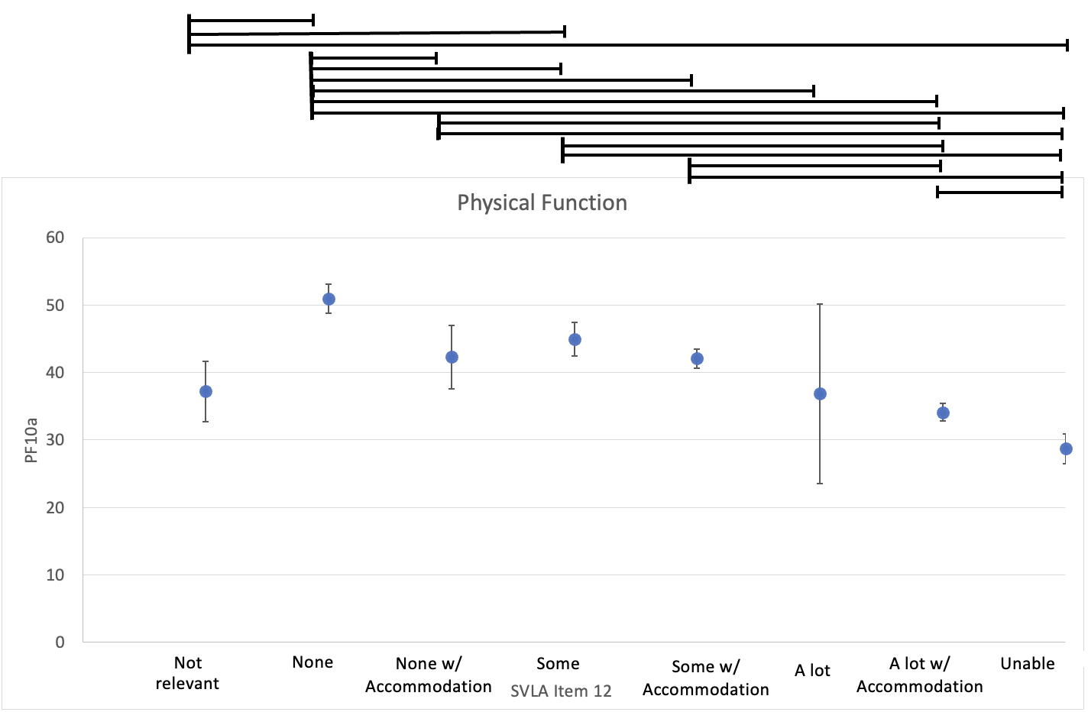
B. 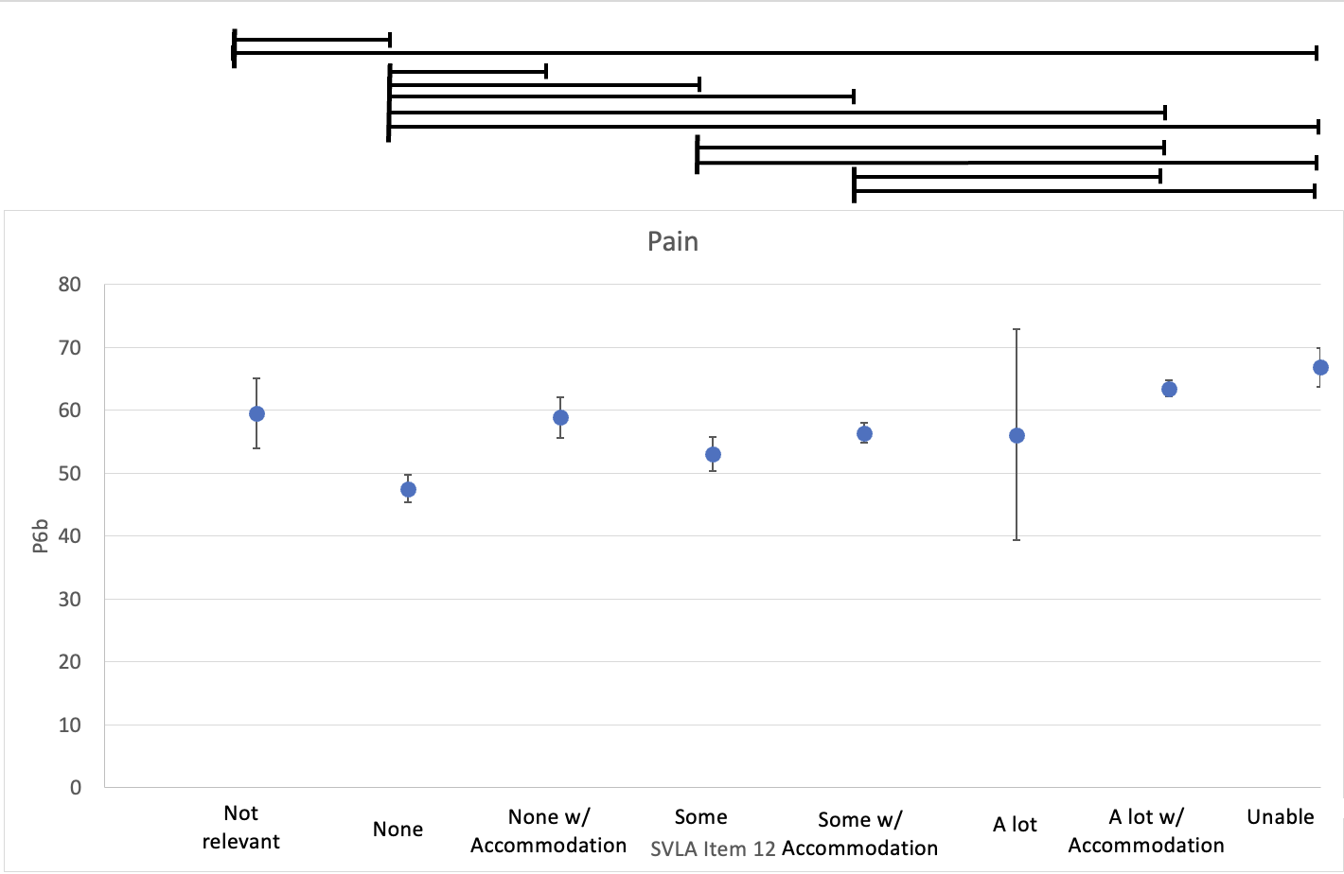C. 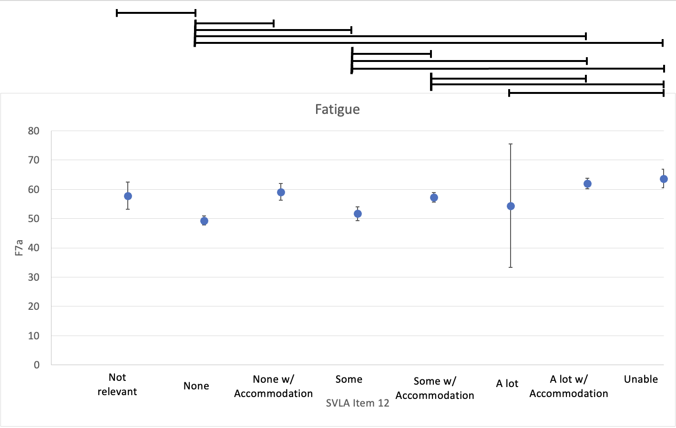

Discussion
To our knowledge this is the first study in RA that investigated the relevance, difficulty, and accommodations regarding participation in recreational activities as well as its association to PF, fatigue, and pain. For purpose 1, the findings indicate that physical recreational activities are considered the most relevant as well as most difficult for individuals with RA to perform among common categories of recreational activities. For purpose 2, the findings indicate that there was a significant association between difficulty with physical recreation on the SVLA and PF, fatigue, and pain levels with individuals who had less difficulty performing recreational activities having overall improved PF and decreased levels of fatigue and pain. The data also suggests that if an individual had no difficulty and required no accommodations for an activity then the participant had better overall outcomes. The opposite was true for if the individual was unable to complete a recreational activity.
Accommodations may be an important indicator of an individual being in an early stage of possible functional decline for performing recreational tasks. In the current analysis, the category “none with accommodation” presented as more similar to the data obtained in the “some”, “some with accommodation” and ”a lot” categories compared to “none.” Our data supports the concept previously described by Fried et al¹³. Their study had individuals answer the National Health Interview Survey which included 27 tasks of daily life and found that individuals who reported requiring “modifications but no difficulty” to complete tasks may exhibit a preclinical decline of function and have a risk of developing mobility deficits in the near future¹³. This could be a beneficial marker for healthcare providers to use with the RA population. As individuals may perceive that they are having no issues completing the activity however the use of an accommodation is an early indicator of decline in function.
Recreational activity participation is not frequently discussed in the literature. People with RA express that after being able to take care of themselves, being able to return to recreational activity, hobbies, and exercise were among the next goals many set¹⁴. The current study further supports that although recreational activities may be difficult for individuals with RA to complete, it is still a very relevant and valued activity for this population. Getting enjoyment out of life while feeling well and working to improve overall quality of life were both deemed important to the RA population in a study by Hulen et al¹⁵. These are all concepts that participating in recreational activities can provide to the individual while also working towards the goal of achieving more normalcy in their daily lives¹⁵.
The study has some limitations. The demographics of the sample mainly included White, educated individuals who live comfortably. We also were unable to provide a Spanish version of the telephone script or survey which further limited the population the study was able to reach. Therefore, this leaves a gap for future studies to better understand recreational activity in the RA population in a more demographically diverse sample. The age and sex distribution of the sample is typical of adults with RA. Additionally, since participants were able to skip survey questions, this led to some minor inconsistencies within the data since some sums did not equal each other which could lead to percentages being skewed. Lastly, the time period at which the participant had to have seen UNC rheumatology occurred within the ongoing COVID-19 pandemic. During this time there was a decrease in individuals receiving medical care and therefore this could have led to a decreased number of participants to collect data¹⁶.
In conclusion, physical recreation was considered to be the most relevant as well as most difficult recreational activity for individuals with RA to perform. Further, less self-reported difficulty with physical recreational activities were associated with better PF, fatigue, and pain levels. These findings highlight the importance for healthcare providers to incorporate questions asking about recreational activities to patients, as these activities are considered highly valuable and relevant to individuals with RA bringing a sense of normalcy back into their lives. The findings also highlight that providers should be aware of when patient’s indicate they are using accommodations but still report having no difficulty with a task as this could be a sign that the individual’s function may be in the early stages of decline.

References
1. Rheumatoid Arthritis 2021 December 2021; Available from: https://www.rheumatology.org/I-Am-A/Patient-Caregiver/Diseases-Conditions/Rheumatoid-Arthritis.
2. Thomas, R., et al., Keeping physically active with rheumatoid arthritis: semi-structured interviews to explore patient perspectives, experiences and strategies. Physiotherapy, 2019. 105(3): p. 378-384.
3. Ball, J.W., M.R. Bice, and T. Parry, Adults' Motivation for Physical Activity: Differentiating Motives for Exercise, Sport, and Recreation. Recreational Sports Journal, 2014. 38(2): p. 130-142.
4. Piva, S.R., G.J. Almeida, and M.C. Wasko, Association of physical function and physical activity in women with rheumatoid arthritis. Arthritis Care Res (Hoboken), 2010. 62(8): p. 1144-51.
5. Liu, X., et al., Long-Term Physical Activity and Subsequent Risk for Rheumatoid Arthritis Among Women: A Prospective Cohort Study. Arthritis Rheumatol, 2019. 71(9): p. 1460-1471.
6. O'Brien, C.M., et al., Pain and fatigue are longitudinally and bi-directionally associated with more sedentary time and less standing time in rheumatoid arthritis. Rheumatology (Oxford), 2021. 60(10): p. 4548-4557.
7. Gwinnutt, J.M., et al., Do people with rheumatoid arthritis maintain their physical activity level at treatment onset over the first year of methotrexate therapy? Rheumatology (Oxford), 2021. 60(10): p. 4633-4642.
8. Gwinnutt, J.M., et al., Influence of Social Support, Financial Status, and Lifestyle on the Disparity Between Inflammation and Disability in Rheumatoid Arthritis. Arthritis Care Res (Hoboken), 2022.
9. Swärdh, E., C. Opava, and N. Brodin, Physical activity in patients with rheumatoid arthritis - an agile lifelong behaviour: a qualitative meta-synthesis. RMD Open, 2021. 7(2).
10. Fried, L.P., et al., Preclinical disability: hypotheses about the bottom of the iceberg. Journal of Aging and Health, 1991. 3(2): p. 285-300.
11. Katz, P.P., et al., Development and validation of a short form of the valued life activities disability questionnaire for rheumatoid arthritis. Arthritis Care Res (Hoboken), 2011. 63(12): p. 1664-71.
12. Bartlett, S.J., et al., Reliability and Validity of Selected PROMIS Measures in People with Rheumatoid Arthritis. PLoS One, 2015. 10(9): p. e0138543.
13. Fried, L.P., et al., Preclinical mobility disability predicts incident mobility disability in older women. J Gerontol A Biol Sci Med Sci, 2000. 55(1): p. M43-52.
14. Cozad, M.J., et al., Patient Goals for Living with Rheumatoid Arthritis: A Qualitative Study. Clinical Nursing Research, 2023. 32(1): p. 40-48.
15. Hulen, E., et al., Patient goals in rheumatoid arthritis care: A systematic review and qualitative synthesis. Musculoskeletal Care, 2017. 15(4): p. 295-303.
16. Henry, T.A. Why 41% of patients have skipped care during COVID-19 pandemic. 2021; Available from: https://www.ama-assn.org/delivering-care/public-health/why-41-patients-have-skipped-care-during-covid-19-pandemic.

