Disclaimer: This table is intended to propose potential therapeutic exercise interventions for the shoulder in the presence of shoulder impairment in a specific plane of movement while inciting a frame of thinking that encourages altering exercises to meet the demands of the patient. Clinical reasoning should be utilized to determine appropriateness and difficulty of exercise. The chart is organized in a natural progression for each motion from simple to more complex. Keep in mind that many shoulder impairments benefit from therapeutic exercise prescription for proximal musculature; therefore, the end of the chart includes a few exercises to consider including when treating a shoulder impairment.

Table of Contents
Flexion 2
Extension 5
Abduction 8
Adduction 11
External Rotation 14
Internal Rotation 17
Proximal Musculature 20
Resources 21

Flexion Exercises
Exercise | Purpose | Description | Cues | Compensations
Isometric Flexion^{1,2}  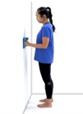 | Increase muscle recruitment, strength, and functional performance in joint angles that are tolerable and/or when dynamic contractions may be contraindicated | Utilizing a doorway or some other immovable object, keep the shoulder in neutral position and elbow in 90 degrees flexion while pushing with min effort into the object and a fisted hand. A towel can be placed between the hand and the object for comfort. The pt can push into the clinician to identify force and modulate as needed. | - Remain upright.  - Push your hand into the doorway without moving your arm or body.  - Think of raising your hand up.  - Keep your thumb pointed up. | - Leaning anteriorly/posteriorly  - Elbow flexion/extension  - IR/ER of the shoulder  - Lateral trunk lean
Regression:  - Active-assisted holds via cane, contralateral upper extremity, or therapist  - Decrease the length of hold  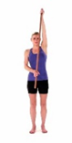  - Sidelying flexion to minimize the effect of gravity |  |  | Progression:  - Increase amount of force exerted by implementing a resistance band anchored underfoot that resists flexion when fastened around the distal humerus or held in hand  - Perform isometric holds while increasing degrees of flexion (90 degrees will pose the most resistance from gravity); add weight in hand as appropriate  - Cable column walkouts while maintaining shoulder position; increase weight as appropriate  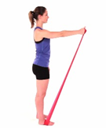

Isotonic Flexion² | Promote strengthening of musculature that drives flexion of the humerus, such as the anterior deltoid, coracobrachialis, and pectoralis major. | In standing or seated, flex the humerus in neutral position through varying degrees of motion while maintaining a straight elbow. | - Keep your thumb pointed to the sky.  - Lift your arm as if you are raising your hand to ask a question. | - Shoulder shrug  - Lateral lean  - Thoracic extension
Regression:  - Active-assisted flexion utilizing a cane, pulley, or therapist  - Decrease the range of motion through which the exercise is performed  - Sidelying flexion to minimize the effect of gravity |  |  | Progression:  - Supine flexion (unweighted)  - Add weight in the hand as appropriate (upright or supine)  - With a resistance band anchored underfoot, hold the band with the affected arm while flexing the shoulder; increase resistance as appropriate  - Cable column flexion pull outs; add weight as appropriate  - Add perturbations

Bird Dog | Promote varying degrees of flexion while stabilizing through contralateral shoulder and strengthening the core | In the quadruped position, place the hands about shoulder width apart on the ground with the feet together. Keep the knees and back aligned in neutral. Flex shoulder off ground while extending contralateral hip off ground while maintaining a neutral spine. | - Lift the opposite arm and leg up off the ground at the same time.  - Reach in front, and kick straight back.  - Keep back flat so that a glass of water would not spill off the back. | - Trunk twist  - Lumbar arch  - Shoulder shrug
Regression:  - Modify to inclined position over counter top or wall  - Maintain lower extremities on ground  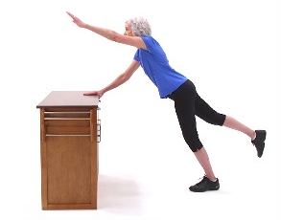 |  |  | Progression:  - Assume plank position on hands and feet  - Anchor resistance band between opposite upper and lower extremity  - Hold weight in hand  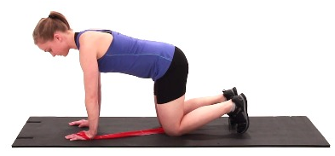  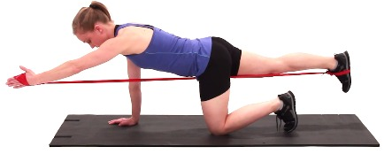

Extension Exercises
Exercise | Purpose/Potential Diagnoses | Description | Cues | Compensations
Isometric Extension^{1,3} | Increase muscle recruitment, strength, and functional performance in joint angles that are tolerable and/or when dynamic contractions may be contraindicated | Utilizing a doorway or some other immovable object, keep the shoulder in neutral position and elbow in 90 degrees flexion while pushing with min effort into the object with the posterior aspect of the upper extremity. A towel can be placed between the arm and the object for comfort. The pt can push into the clinician to identify force and modulate as needed. | - Remain upright.  - Push the back of your arm into the doorway without moving your arm or body.  - Think of pushing your arm back as if you are reaching behind you to grab something out of the back seat without turning.  - Keep your thumb pointed up. | - Leaning anteriorly/posteriorly  - Elbow flexion/extension  - IR/ER of the shoulder  - Lateral trunk lean
Regression:  - Active-assisted holds via contralateral upper extremity or therapist  - Decrease the length of hold  - Sidelying extension to minimize the effect of gravity |  |  | Progression:  - Increase amount of force exerted by implementing a resistance band tied to a fixed surface that resists extension when fastened around the distal humerus  - Perform isometric holds while increasing degrees of extension (more degrees of extension yields increased resistance from gravity); add weight in hand as appropriate  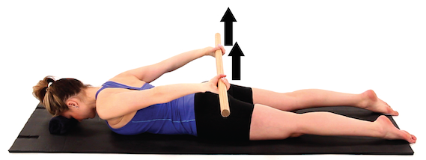  - Cable column walkouts while maintaining shoulder position; increase weight as appropriate

Isotonic Extension | Promote strengthening of musculature that drives extension, such as the posterior deltoid, latissimus dorsi, teres major, and triceps brachii. | In standing or seated, extend the humerus in neutral position through varying degrees of motion. | - Keep your thumb pointed to the ground.  - Think of pushing your arm back as if you are reaching behind you to grab something out of the back seat without turning. | - Deviating into abduction  - Shoulder shrug  - IR/ER of the shoulder  - Forward lean
Regression:  - Active-assisted utilizing a cane, pulley, or therapist  - Sidelying extension to minimize the effect of gravity  - Decrease the range of motion through which the exercise is performed  - Prone incline on bench |  |  | Progression:  - Prone extension (unweighted)  - Add weight in the hand as appropriate (upright or prone)  - With a resistance band anchored underfoot, hold the band with the affected arm while extending the shoulder; increase resistance as appropriate  - Cable column extension pull outs; add weight as appropriate  - Add perturbations

Seated or Standing Row Machine | Promote dynamic utilization of extension musculature against resistance while implementing plyometric and stabilization principles. | Grip the handles with both hands in a neutral grip position. Pull the resistance posteriorly while engaging periscapular musculature. This exercise could also be performed with fixed resistance bands anterior to the line of pull. | - Grip the handles with your thumbs pointing to the sky.  - Squeeze your shoulder blades together as if you are squishing a pencil between them.  - Drive your elbows back to the wall behind you.  - Sit/stand tall. | - Flexing/extending at lumbar region  - Rotation of the body  - Lack of scapula retraction
Regression:  - Decrease the resistance.  - Decrease the intensity of the pull. |  |  | Progression:  - Increase the resistance.  - Increase the intensity of the pull.  - Add pause/time under tension  - Implement negative or slow eccentric  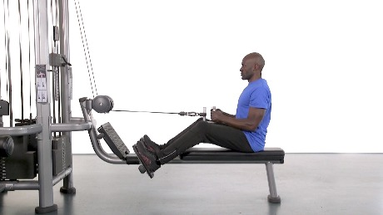

Abduction Exercises
Exercise | Purpose | Description | Cues | Compensations
Isometric Abduction^{1,4} | Increase muscle recruitment, strength, and functional performance in joint angles that are tolerable and/or when dynamic contractions may be contraindicated | Utilizing a doorway or some other immovable object, keep the shoulder in neutral position and elbow in 90 degrees flexion while pushing with min effort into the object with the lateral aspect of the humerus. A towel can be placed between the arm and the object for comfort. The pt can push into the clinician to identify force and modulate as needed. | - Remain upright.  - Push your arm into the doorway without moving your arm or body.  - Think of trying to raise your arm up like in the chicken dance.  - Keep your thumb pointed up. | - Leaning anteriorly/posteriorly  - Elbow flexion/extension  - IR/ER of the shoulder  - Lateral trunk lean
Regression:  - Active-assisted holds via cane, contralateral upper extremity, or therapist  - Decrease the length of hold  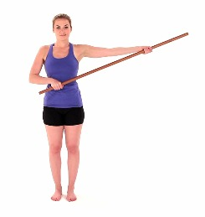  - Supine abduction to minimize the effect of gravity |  |  | Progression:  - Increase amount of force exerted by implementing a resistance band tied to a fixed surface that resists abduction when fastened around the distal humerus or held in hand  - Perform isometric holds while increasing degrees of abduction (90 degrees will pose the most resistance from gravity); add weight in hand as appropriate  - Cable column walkouts while maintaining  shoulder position; increase weight as  appropriate

Isotonic Abduction  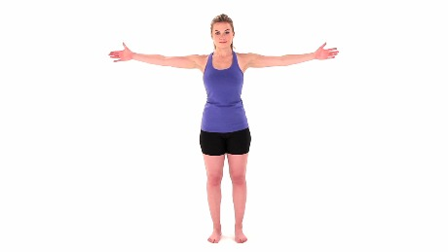 | Promote strengthening of musculature that drives abduction of the humerus, such as the middle deltoid, supraspinatus, serratus anterior, and upper trapezius. | In standing or seated, laterally raise the humerus in anatomical position through varying degrees of motion. | - Remain upright.  - Think of making a snow angel or waving your arm to get someone’s attention.  - Keep your thumb pointed to the sky. | - Shrugging the shoulder  - Lateral lean  - Deviating into flexion
Regression:  - Active-assisted utilizing a cane, pulley, or therapist  - Supine abduction to minimize the effect of gravity  - Decrease the range of motion through which the exercise is performed |  |  | Progression:  - Add weight in the hand as appropriate  - With a resistance band anchored underfoot, hold the band with the affected arm while abducting the shoulder; increase resistance as appropriate  - Cable column abduction pull outs; add weight as appropriate  - Add perturbations

Battle Ropes/Resistance Band Butterfly | Promote dynamic utilization of abduction/flexion musculature against resistance while implementing plyometric and stabilization principles. | Facing the ropes in standing, grip the ropes and perform quick, explosive shoulder movements while lifting and slamming the ropes. Perform butterfly motions with the arms going into abduction. This exercise could also be performed with resistance bands anchored under a doorway. | - Grip the ropes in both hands.  - Assume a stable base of support with your feet about shoulder width apart.  - Lift and slam the ropes quickly and explosively.  - Think of flapping your arms up and down like a bird flying against a heavy wind.  - Avoid hunching over. | - Flexing/hunching over through the lumbar region  - Avoiding shoulder motion and utilizing other musculature to move the ropes
Regression:  - Decrease the intensity of movements.  - Decrease the weight of the battle ropes.  - Step aside from the ropes and hold a light weight in each hand while performing the motion.  - Jumping jacks |  |  | Progression:  - Increase the intensity of movements.  - Increase the weight of the battle ropes.  - Orient the body so the ropes are positioned laterally to the affected upper extremity. Perform single-arm movements. This will isolate the abduction movement more effectively.

Adduction Exercises
Exercise | Purpose | Description | Cues | Compensations
Isometric Adduction^{1,5}  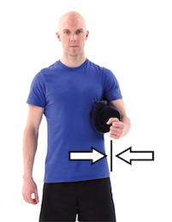 | Increase muscle recruitment, strength, and functional performance in joint angles that are tolerable and/or when dynamic contractions may be contraindicated | Utilizing the body with a pillow or towel between the distal humerus and the trunk, keep the shoulder in neutral position and elbow in 90 degrees flexion while squeezing into the pillow/towel with the medial aspect of the humerus with min effort. The pt can push into the clinician to identify force and modulate as needed. | - Remain upright.  - Squeeze your arm into your side without moving your arm or body.  - Think of trying to bring your arms to your side as if you are trying to make yourself as small as possible.  - Keep your thumb pointed up. | - IR/ER of the shoulder  - Leaning anteriorly/posteriorly  - Depression of the shoulder  - Lateral trunk lean
Regression:  - Active-assisted holds via cane, contralateral upper extremity, or therapist  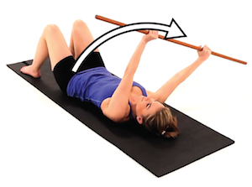  - Decrease the length of hold |  |  | Progression:  - Increase amount of force exerted by implementing a resistance band tied to a fixed surface that resists adduction when fastened around the distal humerus or held in hand  - Perform isometric holds in sidelying with the affected side on the mat (shift weight posteriorly onto the back to avoid discomfort) while varying degrees of adduction (neutral will provide the most resistance  from gravity as long as the arm is not resting on the  mat); add weight in hand as appropriate  - Cable column walkouts while maintaining shoulder  position; increase weight as appropriate  - Plank hold

Isotonic Adduction | Promote strengthening of musculature that drives adduction of the humerus, such as the pectoralis major, latissimus dorsi, teres major, subscapularis, and coracobrachialis. | In supine, approximate the humerus medially in anatomical position through varying degrees of motion. | - Think of bringing your arms to your side as if you are a soldier standing at attention. | - Lateral lean
Regression:  - Active-assisted utilizing a cane, pulley, or therapist in sitting or standing (slightly add resistance with contralateral upper extremity to counteract gravity and eccentric lowering via abductors)  - Decrease the range of motion through which the exercise is performed  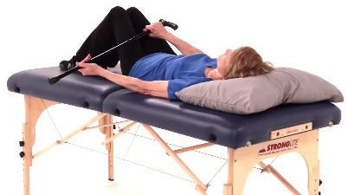  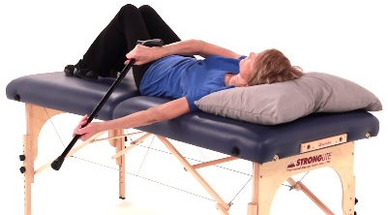 |  |  | Progression:  - With a resistance band anchored overhead or laterally, hold the band with the affected arm while adducting the shoulder; increase resistance as appropriate  - Cable column adduction pull outs; add weight as appropriate  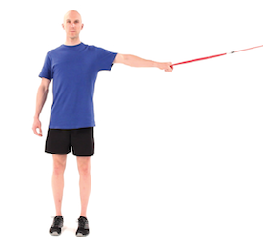  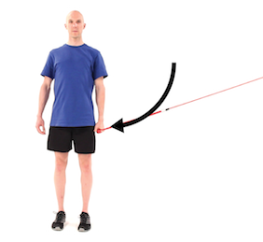  - Add perturbations

Pushup  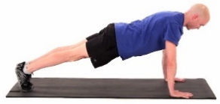 | Promote varying degrees of adduction while strengthening in a closed-chain movement. | In the quadruped position, place the hands about shoulder width apart on the ground with the feet together. Keep the knees and back aligned in neutral. Lower the body weight down until the chest is about a fist’s distance away from the ground, and push back up to full elbow extension. | - Slowly lower down, and push yourself away from the ground. | - Posterior pelvic tilt with a lack of core engagement leading to a saggy buttocks  - Head thrusts to initiate momentum  - Lateral leans
Regression:  - Knee push-ups  - Standing push-ups against a stable surface; a greater incline leads to less resistance from gravity |  |  | Progression:  - Weighted pushups placed on the back of the patient  - Add perturbations  - Narrow the base of support from the upper extremities  - Single arm  - Clap pushups  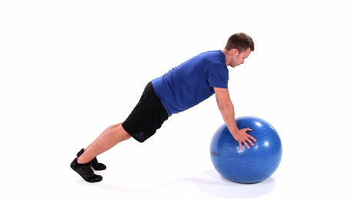

External Rotation Exercises
Exercise | Purpose | Description | Cues | Compensations
Isometric External Rotation^{1,6} | Increase muscle recruitment, strength, and functional performance in joint angles that are tolerable and/or when dynamic contractions may be contraindicated | Utilizing a doorway or some other immovable object, keep the shoulder in neutral position and elbow in 90 degrees flexion while pushing with min effort into the object with the posterior aspect of the distal forearm. A towel can be placed between the forearm and the object for comfort. Another towel can be placed between the trunk and elbow to maintain the position. The pt can push into the clinician to identify force and modulate as needed. | - Remain upright.  - Push your forearm into the doorway without moving your arm or body.  - Think of trying to move your hand to the outside of your body.  - Keep your thumb pointed up. | - Abduction of arm  - Scapular retraction  - Leaning anteriorly/posteriorly  - Elbow flexion/extension  - Lateral trunk lean
Regression:  - Active-assisted holds via contralateral upper extremity or therapist  - Decrease the length of hold |  |  | Progression:  - Increase amount of force exerted by implementing a resistance band tied to a fixed surface that resists external rotation when fastened around the distal forearm  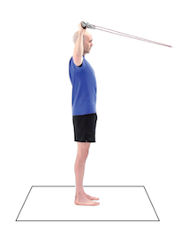  - Perform isometric holds in sidelying while varying degrees of external rotation (neutral humeral orientation in sidelying will pose the most resistance from gravity); add weight in hand as  appropriate  - Cable column walkouts while maintaining shoulder  position; increase weight as appropriate

Isotonic External Rotation | Promote strengthening of musculature that drives external rotation of the humerus, such as the infraspinatus and teres minor. | In standing or seated, flex the elbow to 90 degrees with forearm in neutral and shoulder in 0 degrees abduction. With a towel tucked between the elbow and trunk, laterally rotate the humerus through varying degrees of motion. | - Remain upright.  - Keep your elbow tucked to your side.  - Think of rotating your arm out to make a W with your body.  - Keep your thumb pointed to the sky. | - Abduction of the shoulder  - Rotating the trunk  - Protraction shoulder forward during eccentric return
Regression:  - Active-assisted utilizing a cane or therapist  - Decrease the range of motion through which the exercise is performed  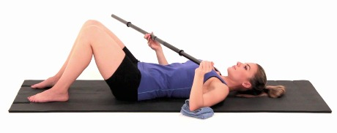  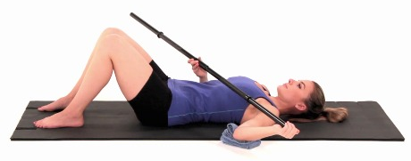 |  |  | Progression:  - Assume a side-lying or standing/prone (with 90 degrees abduction) position to implement resistance from gravity.  - Add weight in the hand as appropriate (in prone or side-lying)  - With a resistance band anchored in a doorway or held by the contralateral upper extremity, hold the band with the affected arm while externally rotating the shoulder; increase resistance as appropriate  - Cable column external rotation pull outs; add weight as appropriate  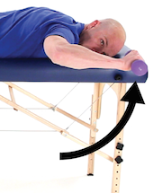  - Rebounder with weighted balls  - Add perturbations

Hang Clean to Push Press |  | Promote dynamic utilization of external rotation musculature against resistance while implementing plyometric and stabilization principles. |  | Grip the bar with an overhand grip about shoulder width apart. Perform a mini squat, and, using upward momentum from squatting, shoulder shrugging, and shoulder abduction, drive the load superiorly to catch it from underneath via external rotation and depression of the shoulders and dropping into a squat. Ensure to keep the load close to the body throughout the movement. Rise from the squat position, and thrust the load upward overhead aiming to fully extend the elbows. | - Be sure to keep the bar close to your body throughout the entire movement.  - Perform a mini squat while shrugging your shoulders and raising your elbows up on the way up to drive the load upward.  - Drop underneath the bar, and catch it in a squat position.  - Stand up with the weight with your wrists in extension and the weight somewhat resting on your shoulders/chest.  - Push the weight above your head until your elbows are extended.  - Maintain a neutral spine throughout the movement, and avoid slouching and bending over. |  | - Hang clean:  - Hunching over at the lumbar region  - Thoracic flexion, dropping of elbows  - Anterior bar bath  - Lack of momentum utilization when pulling the load  - Push press:  - Thoracic extension  - Excessive scapular retraction  - Excessive lumbar extension resulting in anterior press
Regression:  - Decrease the weight on the bar or resistance of the band.  - Utilize a dowel instead of a weighted bar. |  |  |  |  | Progression:  - Banded resistance anchored underfoot or inferior (slight anterior fixation will incorporate ER resistance into the push press as well) to the patient will require constant external rotation resistance rather than unloading with the drop component.  - Increase weight on the bar or resistance of the band.
Internal Rotation Exercises
Exercise | Purpose |  | Description |  | Cues | Compensations
Isometric Internal Rotation^{1,7} | Increase muscle recruitment, strength, and functional performance in joint angles that are tolerable and/or when dynamic contractions may be contraindicated |  | Utilizing a doorway or some other immovable object, keep the shoulder in neutral position and elbow in 90 degrees flexion while pushing with min effort into the object with the anterior aspect of the forearm. A towel can be placed between the forearm and the object for comfort. Another towel can be placed between the trunk and elbow to maintain the position. The pt can push into the clinician to identify force and modulate as needed. |  | - Remain upright.  - Push your forearm into the doorway without moving your arm or body.  - Think of trying to place your hand on your belly.  - Keep your thumb pointed up. | - Abduction of arm  - Scapular protraction  - Leaning anteriorly/posteriorly  - Elbow flexion/extension  - Lateral trunk lean
Regression:  - Active-assisted holds via contralateral upper extremity or therapist  - Decrease the length of hold |  |  |  |  | Progression:  - Increase amount of force exerted by implementing a resistance band tied to a fixed surface that resists internal rotation when fastened around the distal forearm  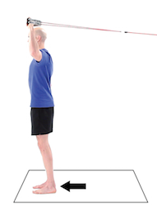  - Perform isometric holds in sidelying with the affected side on the mat (shift weight posteriorly onto the back to avoid discomfort) while varying degrees of internal rotation (neutral will provide the most resistance from gravity as long as the arm is not resting on the mat); add  weight in hand as appropriate  - Cable column walkouts while maintaining shoulder  position; increase weight as appropriate

Isotonic Internal Rotation | Promote strengthening of musculature that drives internal rotation of the humerus, such as the subscaplularis, latissimus dorsi, teres major, and pectoralis major. | In standing or seated, flex the elbow to 90 degrees with forearm in neutral. With a towel tucked between the elbow and trunk, medially rotate the humerus through varying degrees of motion. | - Remain upright.  - Keep your elbow tucked to your side.  - Think of rotating your arm in as if you are patting your tummy.  - Keep your thumb pointed to the sky. | - Shrugging of the shoulder  - Flexion of the shoulder  - Lateral lean  - Protraction during concentric phase
Regression:  - Active-assisted utilizing a cane or therapist  - Decrease the range of motion through which the exercise is performed |  |  | Progression:  - Hand liftoffs posteriorly from the thoracolumbar region  - Prone (affected extremity off mat table in 90/90 with neutral rotation start position or hand liftoff from thoracolumbar region) or side-lying (posterior weight shift to avoid irritating affected extremity) to implement resistance from gravity  - Add weight in the hand as appropriate (in prone or side-lying)  - With a resistance band anchored in a doorway, hold the band with the affected arm while internally rotating the shoulder; increase resistance as appropriate  - Cable column internal rotation pull outs; add weight as appropriate  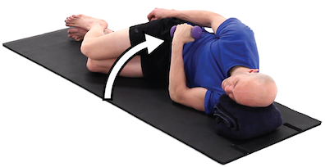  - Add perturbations

Medicine Ball Slams  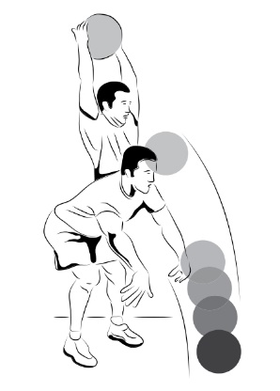 | Promote dynamic utilization of internal rotation musculature against resistance while implementing plyometric and stabilization principles. | Gripping the medicine ball between both hands, raise the ball overhead, and throw the ball down into the ground. Maintain a neutral spine. | - Hold the ball between both of your hands around head height.  - Act as if you are throwing the ball through the ground below you.  - Keep your chest up. | - Flexing/hunching over in the lumbar region  - Dropping the ball vs. actively slamming it; slow movement
Regression:  - Decrease the weight of the medicine ball (can utilize a basketball instead).  - Assist the patient in holding the ball before releasing for the slam. |  |  | Progression:  - Increase the weight of the medicine ball.  - Adding a jump with the slam can elicit eccentric control of the internal rotators while allowing for more motion to move concentrically.  - Incorporate a slam on a trampoline or a ball that will recoil upward to facilitate eccentric internal rotation control upon catching the ball.  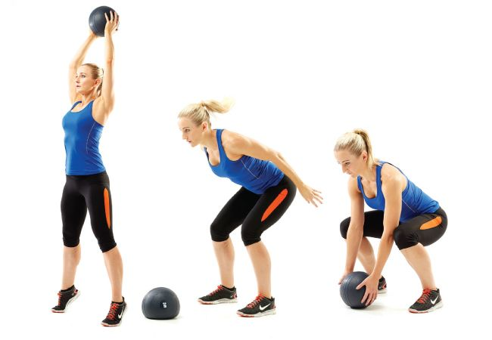  - Fix resistance bands overhead and perform this movement. The bands will provide concentric and eccentric motion through movvement while also adding perturbations.

Proximal Musculature
Exercise | Purpose | Description | Cues | Compensations
Scapula Squeezes  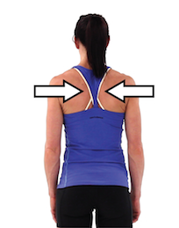 | Promote scapular retraction and periscapular control. | In seated or standing, squeeze the scapulae together. | - Squeeze your shoulder blades together.  - Pretend like you are squeezing a pencil between your shoulder blades. | - Shrugging of the shoulders  - Extension of the spine
Regression:  - Decrease length of hold  - Decrease intensity of contraction |  |  | Progression:  - Increase length of hold  - Increase intensity of contraction  - Perform in prone position.  - Incorporate I, Y, and T’s in prone.  - Increase weight as appropriate.  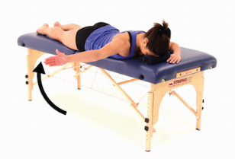  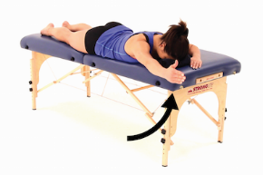  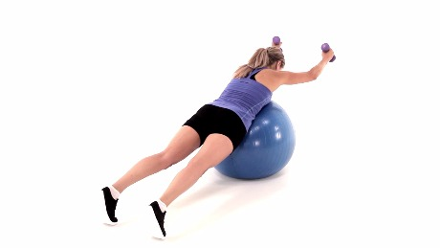

Lat Pull Down | Promote stabilization of the shoulder, especially in overhead movements. | Grip the handles of a cable machine or superiorly-fixated resistance bands, and pull down and back while internally rotating the arms. | - Pull the handles down and back behind you.  - Pretend like you are moving your arms into a position to be handcuffed.  - Remain upright, and avoid hunching over.  - Pull down toward your chest. | - Thrusting hips  - Flexing/extending the spine
Regression:  - Decrease resistance to the pull.  - Decrease intensity of the pull. |  |  | Progression:  - Increase resistance of the pull.  - Increase intensity of the pull.  - Add perturbations.  - Pull ups/variations of pull ups  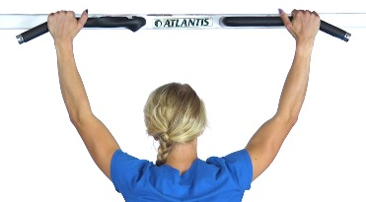  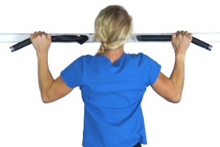

Three Point Plank with Shoulder Movements⁸ | Promote core strengthening and endurance to allow for trunk stabilization and force transference during shoulder motions. | Assume a pushup/quadruped position. Move unaffected upper extremity toward midline to serve as the base of support. Lift affected upper extremity off the ground. Perform shoulder movements with the affected upper extremity, such as horizontal abduction, external rotation, extension, row, and/or diagonal arm raise. Ensure to maintain a neutral spine. | - Get in a pushup position.  - Move your unaffected arm to midline so it can support your weight when lifting the affected arm.  - Lift your arm up and perform the shoulder motions directed while maintaining your balance.  - Make sure to avoid sagging your buttocks to the ground. | - Sagging or raising of the buttocks  - Rotation of the trunk when performing shoulder movements
Regression:  - Perform exercise more upright against a table or wall to decrease the effect of gravity.  - Perform exercise on hands and knees.  - Decrease range of motion through which exercise is performed. |  |  | Progression:  - Increase weight in hand as appropriate.  - Add perturbations.  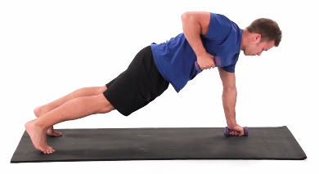

Bibliography
1. Oranchuk DJ, Storey AG, Nelson AR, Cronin JB. Isometric training and long-term adaptations: Effects of muscle length, intensity, and intent: A systematic review. Scand J Med Sci Sports. 2019;29(4):484-503. doi:10.1111/sms.13375
2. Wattanaprakornkul D, Halaki M, Boettcher C, Cathers I, Ginn KA. A comprehensive analysis of muscle recruitment patterns during shoulder flexion: an electromyographic study. Clin Anat. 2011;24(5):619-626. doi:10.1002/ca.21123
3. Wattanaprakornkul D, Cathers I, Halaki M, Ginn KA. The rotator cuff muscles have a direction specific recruitment pattern during shoulder flexion and extension exercises. J Sci Med Sport. 2011;14(5):376-382. doi:10.1016/j.jsams.2011.01.001
4. Wickham J, Pizzari T, Stansfeld K, Burnside A, Watson L. Quantifying “normal” shoulder muscle activity during abduction. J Electromyogr Kinesiol. 2010;20(2):212-222. doi:10.1016/j.jelekin.2009.06.004
5. Reed D, Halaki M, Ginn K. The rotator cuff muscles are activated at low levels during shoulder adduction: an experimental study. J Physiother. 2010;56(4):259-264. doi:10.1016/s1836-9553(10)70009-6
6. Edwards PK, Ebert JR, Littlewood C, Ackland T, Wang A. A systematic review of electromyography studies in normal shoulders to inform postoperative rehabilitation following rotator cuff repair. J Orthop Sports Phys Ther. 2017;47(12):931-944. doi:10.2519/jospt.2017.7271
7. Alizadehkhaiyat O, Hawkes DH, Kemp GJ, Frostick SP. Electromyographic analysis of shoulder girdle muscles during common internal rotation exercises. Int J Sports Phys Ther. 2015;10(5):645-654.
8. Brumitt J, Dale RB. Integrating shoulder and core exercises when rehabilitating athletes performing overhead activities. N Am J Sports Phys Ther. 2009;4(3):132-138.

Photos:
All photos retrieved from https://www.medbridge.com/ unless otherwise noted.
Battle Ropes: https://www.setforset.com/blogs/news/battle-rope-exercises-and-workouts
Med Ball Slams: https://www.pitchvision.com/medicine-ball-power-exercises-for-cricket
https://www.pinterest.com/pin/557672366332810314/

